**SQL_ASSIGNMENT_2**

**Dataset: Employee Information**

You have been given a dataset containing information about employees in a company. The dataset includes the following columns:

* employee_id (integer): Unique identifier for each employee.
* first_name (string): First name of the employee.
* last_name (string): Last name of the employee.
* department (string): The department in which the employee works.
* hire_date (date): The date on which the employee was hired.
* salary (integer): The salary of the employee.

**Table Structure:**

**Create a table named employees with the following structure**:

CREATE OR REPLACE TABLE EMPLOYEES

(

EMPLOYEE_ID INT PRIMARY KEY,

FIRST_NAME VARCHAR(50),

LAST_NAME VARCHAR(50),

DEPARTMENT VARCHAR(50),

HIRE_DATE DATE,

SALARY INT

);

**Insert Data:**

**Write SQL queries to answer the following questions using the employees table:**

1. **Retrieve the first and last names of all employees.**

SELECT FIRST_NAME, LAST_NAME FROM EMPLOYEES;

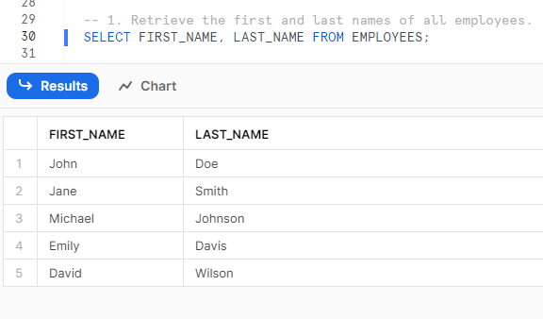

1. **Find the total number of employees in the company.**

SELECT COUNT(*) AS TOT_EMPLOYEE FROM EMPLOYEES;

1. **Get the names of employees who work in the IT department.**

SELECT FIRST_NAME || ' '|| LAST_NAME AS Emp_Name, DEPARTMENT

FROM EMPLOYEES

WHERE DEPARTMENT = 'IT';

1. **Calculate the average salary of all employees.**

SELECT ROUND(AVG(SALARY),2) AS Avg_Salary FROM EMPLOYEES;

1. **Find the employee with the highest salary.**

SELECT * FROM EMPLOYEES

ORDER BY SALARY DESC

LIMIT 1;

1. **List the employees hired before January 1, 2021, along with their hire dates.**

SELECT EMPLOYEE_ID, FIRST_NAME || ' '|| LAST_NAME AS Emp_Name, HIRE_DATE

FROM EMPLOYEES

WHERE HIRE_DATE < '2021-01-01';

**\*\*\*\*\*\*\*\*\*\*\*\*\*\* THANK YOU \*\*\*\*\*\*\*\*\*\*\*\*\*\*\***