**SQL_ASSIGNMENT_3**

**Dataset: Sales Information**

You have been given a dataset containing information about sales transactions. The dataset includes the following columns:

* order_id (integer): Unique identifier for each order.
* customer_id (integer): Unique identifier for each customer.
* product_id (integer): Unique identifier for each product.
* product_name (string): Name of the product.
* quantity (integer): The quantity of the product sold.
* unit_price (decimal): The unit price of the product.
* order_date (date): The date when the order was placed.

**Table Structure:**

Create a table named sales with the following structure:

CREATE OR REPLACE TABLE SALES

(

ORDER_ID INT PRIMARY KEY,

CUSTOMER_ID INT,

PRODUCT_ID INT,

PRODUCT_NAME VARCHAR(50),

QUANTITY INT,

UNIT_PRICE DECIMAL(10, 2),

ORDER_DATE DATE

);

**Insert Data:**

Insert the following sample data into the sales table:

INSERT INTO SALES (ORDER_ID, CUSTOMER_ID, PRODUCT_ID, PRODUCT_NAME, QUANTITY, UNIT_PRICE, ORDER_DATE)

VALUES

(1, 101, 1, 'Widget A', 5, 10.00, '2023-01-15'),

(2, 102, 2, 'Widget B', 2, 12.50, '2023-01-16'),

(3, 103, 1, 'Widget A', 3, 10.00, '2023-01-16'),

(4, 104, 3, 'Widget C', 1, 15.75, '2023-01-17'),

(5, 105, 2, 'Widget B', 4, 12.50, '2023-01-17'),

(6, 106, 1, 'Widget A', 2, 10.00, '2023-01-18'),

(7, 107, 4, 'Widget D', 3, 20.00, '2023-01-18'),

(8, 108, 2, 'Widget B', 5, 12.50, '2023-01-19'),

(9, 109, 1, 'Widget A', 1, 10.00, '2023-01-19'),

(10, 101, 3, 'Widget C', 2, 15.75, '2023-01-20');

**Instructions:**

Write SQL queries to answer the following questions using the sales table:

1. **Retrieve the total sales quantity and revenue for each product.**

SELECT PRODUCT_NAME,

SUM(QUANTITY) AS TOT_SALES_QUANTITY,

SUM(UNIT_PRICE * QUANTITY) AS REVENUE

FROM EMP_DATABASE.PUBLIC.SALES

GROUP BY 1

ORDER BY 1;

1. **Find the total revenue for each customer.**

SELECT CUSTOMER_ID,

SUM(UNIT_PRICE * QUANTITY) AS REVENUE

FROM EMP_DATABASE.PUBLIC.SALES

GROUP BY 1

ORDER BY 1;

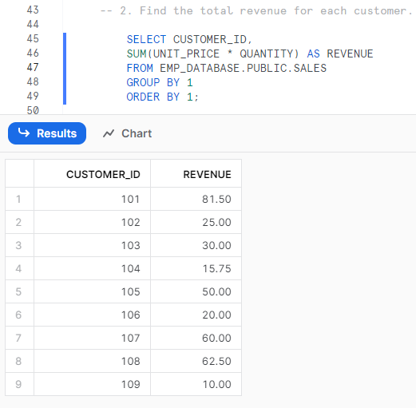

1. **Get the products with more than 10 units sold in a single order.**

SELECT PRODUCT_NAME, ORDER_ID,

SUM(QUANTITY) AS SOLD_QTY

FROM EMP_DATABASE.PUBLIC.SALES

GROUP BY 1,2

HAVING SOLD_QTY > 10;

**So there is none such a record.**

1. **List the customers who have placed orders on at least three different dates.**

SELECT CUSTOMER_ID, ORDER_ID,

COUNT(DISTINCT ORDER_DATE) AS TOT_DIFF_DATE_ORDERS

FROM EMP_DATABASE.PUBLIC.SALES

GROUP BY 1,2

HAVING TOT_DIFF_DATE_ORDERS >= 3;

**So there is none such a record.**

1. **Calculate the average unit price of products.**

SELECT PRODUCT_NAME,

AVG(UNIT_PRICE) AS AVG_UNIT_PRICE

FROM EMP_DATABASE.PUBLIC.SALES

GROUP BY 1

ORDER BY 1;

1. **Find the products with an average unit price greater than $12.00.**

SELECT PRODUCT_NAME,

AVG(UNIT_PRICE) AS AVG_UNIT_PRICE

FROM EMP_DATABASE.PUBLIC.SALES

GROUP BY 1

HAVING AVG_UNIT_PRICE > 12.00

ORDER BY 1;

1. **Retrieve the customers who have spent more than $100.00 in total.**

SELECT CUSTOMER_ID,

SUM(QUANTITY * UNIT_PRICE) AS TOT_MONEY_SPENT

FROM EMP_DATABASE.PUBLIC.SALES

GROUP BY 1

HAVING TOT_MONEY_SPENT > 100.00

ORDER BY 1;

**So there is none such a record.**

1. **List the customers who have purchased 'Widget B' and 'Widget A' in the same order.**

SELECT CUSTOMER_ID,

COUNT(ORDER_ID) AS TOT_ORDERS

FROM EMP_DATABASE.PUBLIC.SALES

WHERE PRODUCT_NAME ='Widget B' AND PRODUCT_NAME ='Widget A'

GROUP BY 1

HAVING TOT_ORDERS >= 2

ORDER BY 1;

**So there is none such a record.**

**\*\*\*\*\*\*\*\*\*\*\*\*\*\* THANK YOU \*\*\*\*\*\*\*\*\*\*\*\*\*\*\***