




Department of Computer Science and Engineering

|| Jai Sri Gurudev ||
Sri Adichunchanagiri Shikshana Trust®
SJB INSTITUTE OF TECHNOLOGY
An Autonomous Institute under VTU
Approved AICTE-New Delhi, Recognized by UGC with 2(f) & 12(B) No.67, BGS Health & Education City, Dr. Vishnuvardhan Road, Kengeri ,
Bengaluru, Karnataka 560060

FORMATIVE ASSESSMENT – 1

A report submitted in partial fulfilment of the requirements for the course Full Stack Development

“FULL STACK DEVELOPMENT – FOUNDATION MODULE”
DOMAIN: “ONLINE ENGLISH PRACTICE PLATFORM”

Subject Code: 23CSE644 Submitted by
Shivam Raj 1JB23CS144

Faculty In-Charge Head of the Department Vijayalakshmi B Dr. Krishna A.N
Academic Year: 2025-26

ACKNOWLEDGEMENT

I would like to express my profound grateful to His Divine Soul Jagadguru Padmabhu- shan Sri Sri Sri Dr.Balagangadharanatha Mahaswamiji and His Holiness Jagadguru Sri Sri Sri Dr. Nirmalanandanatha Mahaswamiji for providing us an opportunity to complete my academics in this esteemed institution.

I would also like to express my profound thanks to Revered Sri Sri Dr. Prakashnath Swamiji, Managing Director, BGS & SJB Group of Institutions, for his continuous sup- port in providing amenities to carry out this project work in this admired institution.

I express my gratitude to Dr. Puttaraju, Academic Director, BGS & SJB Group of Institutions, and Dr. K. V. Mahendra Prashanth, Principal, SJB Institute of Technol- ogy, for providing me with an excellent facilities and academic ambience, which have helped me with the satisfactory completion of project.

I extend my sincere thanks to Dr. Krishna A N, HOD, Computer Science and Engineer- ing, for providing me an invaluable support throughout the period of the course.

I extend my heartfelt gratitude to Dr. Babu N V, Dean Academics, for his unwavering support and inspiring academic environment all of which played a pivotal role in the successful completion.

I express my deepest gratitude and sincere thanks to faculty in-charge for the course Vijayalakshmi B, Assistant Professor, Department of Computer Science and Engineering, for her valuable guidance, suggestions and cheerful encouragement throughout the duration.

Finally, I take this opportunity to extend my earnest gratitude to my parents, Teaching & Non- teaching staffs of the department, all my friends, who have directly or indirectly supported me during the period of course.

Regards, Shivam Raj 1JB23CS144

ABSTRACT

The English Practice and Improvement System is a conceptual academic project aimed at demonstrating the application of fundamental software engineering and full stack development concepts. The project focuses on understanding how a real-world grant proposal system can be designed by modelling users, interactions, and data flow, rather than implementing a complete functional application.
In academic and research settings, an English Practice and Improvement System plays an important role in supporting learners to enhance their language skills. This project represents such a system by applying object-oriented programming concepts, semantic web techniques, and database design principles. The main focus is on building a well-structured system with clear design and following standard software development practices.
The project is divided into four milestones. The first milestone applies object-oriented programming concepts using Python to model different system users and their roles, demonstrating inheritance, method overriding, and polymorphism. The second mile- stone focuses on frontend structure using semantic HTML and HTTP concepts, where static web pages are designed to represent proposal submission and viewing processes, along with a justified use of the POST method for form submission.
The third milestone involves designing an Entity Relationship model that identifies key entities, their attributes, and relationships, with an emphasis on minimizing data redun- dancy. The fourth milestone demonstrates the use of the Command Line Interface and virtual environments to manage project setup and dependencies, highlighting the im- portance of environment isolation and reproducibility in collaborative development.
Overall, this project provides a structured overview of how different layers of a software system can be planned and organized. By integrating object-oriented design, web fun- damentals, data modelling, and development environment management, the English Practice and Improvement System serves as a comprehensive academic exercise aligned with real-world software development workflows.

TABLE OF CONTENTS

Acknowledgement i
Abstract ii
Table of Contents iii
List of figures v
List of Tables vi
Chapter 1
Milestone 1: Object-oriented design in Python
  - Identification of Classes 7
  - Object-Oriented Concepts Used 7
  - Source Code 8
  - Sample Output 9
  - Justification for the use of Inheritance 9
Chapter 2
Milestone 2: Semantic HTML and HTTP Concepts
  - Use of Semantic Html Elements 10
  - HTML Form Design 10
  - Use of HTTP POST Method 11
  - Justification for using POST in this Application 11
  - Comparison of GET And POST Methods 12
  - Source code 12
  - Screenshots 15
Chapter 3
Milestone 3: Entity Relationship Modeling
  - Identification of Entities 17
  - Summary of Primary and Foreign Keys 17
  - Entity Relationship Diagram 18
  - Redundancy Minimization 18
Chapter 4
Milestone 4: Command Line Interface and Virtual Environments
  - Use of Command Line Interface (CLI). 19
  - Purpose of Virtual Environments 19
  - Flow Role of Dependency Specification 20
  - Importance of CLI Proficiency in Collaborative Development 20
  - Screenshots 21
Conclusion 23

LIST OF FIGURES

SL NO | DESCRIPTION | PAGE NO
Fig 1.1 | Output of python OOP code | 9
Fig 2.1 | English practice submission page 1 | 15
Fig 2.2 | English practice submission page 2 | 16
Fig 2.3 | Submitted practice activities page | 16
Fig 3.1 | ER Diagram of English Practice and Improvement System | 18
Fig 4.1 | Creating the project and verification of Python installation | 21
Fig 4.2 | Creating and Activating the Virtual Environment | 21
Fig 4.3 | Installing the requests library using pip | 22
Fig 4.4 | Requirements.txt file contents | 22

LIST OF TABLES

SL NO | DESCRIPTION | PAGE NO
Table 2.1 | Comparison of GET and POST methods | 12
Table 3.1 | Summary of Primary and Foreign keys | 17

CHAPTER 1

MILESTONE 1:
OBJECT-ORIENTED DESIGN IN PYTHON

IDENTIFICATION OF CLASSES
The English Practice and Improvement System is designed to support learners in improving their English language skills through structured content and practice activities. To model the system using object-oriented principles, the following classes are identified:
- LearningContent (Base Class): Represents generic learning material in the system. It contains common attributes such as content ID, title, and difficulty level.
- GrammarLesson (Derived Class): Represents grammar-based learning content. This class extends the LearningContent class and includes grammar-specific information.
- VocabularyExercise (Derived Class): Represents vocabulary practice exercises. This class also extends the LearningContent class and includes word-based practice details.
The use of inheritance establishes an is a relationship, where GrammarLesson and VocabularyExercise are specific types of LearningContent.

OBJECT-ORIENTED CONCEPTS USED

Inheritance
Inheritance is used to define shared properties and behaviors in the Learning Content base class. The derived classes reuse these common attributes while adding specialized functionality, improving code reusability and maintainability.

Method Overriding
Method overriding allows derived classes to redefine the same method according to their specific behavior. Although the method name remains the same, its implementation differs for grammar lessons and vocabulary exercises.

Polymorphism
Polymorphism is demonstrated by storing different content objects in a single collection and invoking the same method, which produces different outputs based on the object type at runtime.

SOURCE CODE
The Python program demonstrates inheritance, method overriding, and polymorphism using a simple base class and derived classes, with a focus on clarity and readability.

# English Practice and Improvement System
# Milestone 1 – Object-Oriented Programming in Python

class LearningContent:
def __init__(self, content_id, title, level):
self.content_id = content_id
self.title = title
self.level = level

def get_content_details(self):
return "Generic learning content"

def show_details(self):
print("Content ID:", self.content_id)
print("Title:", self.title)
print("Level:", self.level)
print("Details:", self.get_content_details())
print("-" * 40)

class GrammarLesson(LearningContent):
def __init__(self, content_id, title, level, topic):
super().__init__(content_id, title, level)
self.topic = topic

def get_content_details(self):
return "Grammar Lesson on " + self.topic

class VocabularyExercise(LearningContent):
def __init__(self, content_id, title, level, word_count):
super().__init__(content_id, title, level)
self.word_count = word_count

def get_content_details(self):
return "Vocabulary Exercise with " + str(self.word_count) + " words"

# Main execution
if __name__ == "__main__":
g1 = GrammarLesson(1, "Tenses Basics", "Beginner", "Present Tense")
v1 = VocabularyExercise(2, "Daily Words", "Beginner", 20)
g2 = GrammarLesson(3, "Advanced Clauses", "Advanced", "Relative Clauses")

contents = [g1, v1, g2]

for content in contents:
content.show_details()

SAMPLE OUTPUT
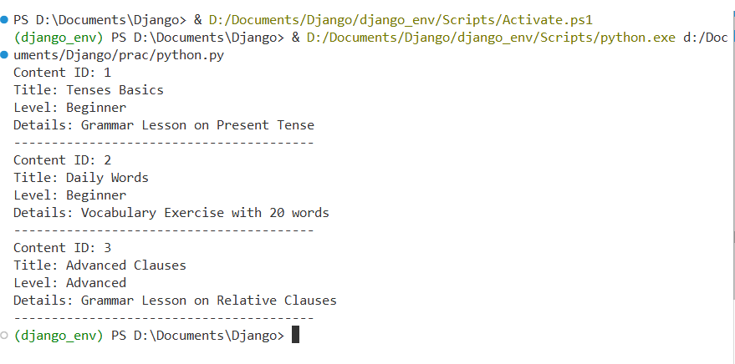

Fig 1.1: Output of python OOP code
Fig 1.1: The program processes different learning content objects such as Grammar- Lesson and VocabularyExercise together, where the same method call produces different outputs, thereby demonstrating polymorphism and method overriding.

JUSTIFICATION FOR THE USE OF INHERITANCE
In the English Practice and Improvement System, inheritance is used to model different types of learning content that share common characteristics. The Lear-ningContent base class stores shared attributes such as title and difficulty level. GrammarLesson and VocabularyExercise inherit from this base class and implement content-specific behavior.This approach reduces redundancy, improves maintainabil-ity, and allows the system to be extended easily with additional content types in future.

CHAPTER 2

MILESTONE 2:
SEMANTIC HTML AND HTTP CONCEPTS

USE OF SEMANTIC HTML ELEMENTS
Semantic HTML elements describe the purpose of content rather than its appearance. In this project, semantic tags are used to clearly separate different parts of the web page, making the structure easier to understand and maintain.
The <header> element is used to display the title and description of the English Practice and Improvement System, providing context to the user. Navigation links are placed inside the <nav> element, allowing users to move between the English practice submission page and the practice activity listing page.
The <main> element contains the primary content of the page, ensuring that the core learning information is clearly identified. Related content is grouped using <section> elements, while individual English practice activities such as grammar lessons and vocabulary exercises are represented using <article> elements. The <footer> element is used to display copyright information and system ownership details.
Using semantic HTML improves accessibility for screen readers, enhances search engine understanding, and follows best practices in modern web development.

HTML FORM DESIGN
The practice submission page includes an HTML form designed to collect essential details required for English learning activities. The form contains input fields for practice title, practice type (grammar or vocabulary), difficulty level, and user input for practice responses.Each form element is clearly labeled to ensure usability and avoid confusion during data entry. Required fields are marked to guide users and ensure that important learning information is not omitted. Different input types such as text fields, selection lists, and text areas are used to represent various data formats.

Although the form is static and does not store data, its structure accurately represents how English practice activities would be submitted in a real-world language learning system.

USE OF HTTP POST METHOD
The HTTP POST method is used for submitting the English practice form. POST is designed to send data to the server in the request body, making it suitable for operations that create new records or store user practice attempts. In the English Practice and Improvement System, practice submission involves sending user responses and learning-related information that should not be exposed in the URL.
Using the POST method ensures that the submitted practice data is transmitted securely and supports larger data sizes compared to GET. Even though backend processing is not implemented in this milestone, the correct use of POST demonstrates an understanding of standard web communication practices followed in real-world learning platforms.

JUSTIFICATION FOR USING POST IN THIS APPLICATION
The POST method is chosen for this application because submitting an English practice activity results in the creation of a new practice attempt record within the system. Additionally, practice submissions may include user-generated content such as written responses, which should not be visible in the URL.
Using the POST method aligns with HTTP standards and reflects real-world implementation practices followed in online language learning platforms. It ensures better data handling and prepares the system design for future backend integration.

COMPARISON OF GET AND POST METHODS

Aspect | GET Method | POST Method
Purpose | Used to retrieve data from the server | Used to submit  data to the server
Data Visibility | Data is appended to  the URL | Data is sent in  the request body
Security | Less secure for sensi- tive information | More suitable for confidential  data
Data Size | Limited by URL  length | Supports larger  data sizes
Typical Usage | Searching and filter- ing | Form submis- sion and data  creation

Table 2.1: Comparison of GET and POST methods

Table 2.1 Presents a comparison of the GET and POST HTTP methods, highlighting their differences in functionality, data handling, and use cases.

SOURCE CODE

Proposal_submission.html
<!DOCTYPE html>
<html lang="en">
<head>
<meta charset="UTF-8">
<meta name="viewport" content="width=device-width, initial-scale=1.0">
<title>English Practice Submission</title>
<link rel="stylesheet" href="style.css">
</head>
<body>

<header>
<h1>English Practice and Improvement System</h1>
<p>Language Learning and Practice Portal</p>
</header>

<nav>
<a href="practice_submission.html" class="active">Submit Practice</a>
<a href="practice_list.html">View Practices</a>
</nav>

<main>
<section>
<h2>Submit English Practice Activity</h2>
<p>Please provide accurate practice details. All fields marked with
<span class="required">*</span> are required.
</p>

<form id="practiceForm" method="POST">

<label for="title">Practice Title <span class="required">*</span></label>
<input type="text" id="title" name="title" required
placeholder="Enter practice title">

<p class="form-hint">Provide a clear title for the practice activity</p>

<label for="type">Practice Type <span class="required">*</span></label>
<select id="type" name="type" required>
<option value="">-- Select Practice Type --</option>
<option value="grammar">Grammar Practice</option>
<option value="vocabulary">Vocabulary Exercise</option>
<option value="reading">Reading Practice</option>
</select>

<label for="level">Difficulty Level <span class="required">*</span></label>
<select id="level" name="level" required>
<option value="">-- Select Level --</option>
<option value="beginner">Beginner</option>
<option value="intermediate">Intermediate</option>
<option value="advanced">Advanced</option>
</select>

<label for="response">Practice Content <span class="required">*</span></label>
<textarea id="response" name="response" required
placeholder="Enter practice questions or content"></textarea>

<p class="form-hint">Maximum 300 words</p>
<button type="submit">Submit Practice</button>

</form>
</section>
</main>
<footer>
<p>© 2026 English Practice and Improvement System. All rights reserved.</p>
</footer>
</body>
</html>

Proposal_list.html
<!DOCTYPE html>
<html lang="en">
<head>
<meta charset="UTF-8">
<meta name="viewport" content="width=device-width, initial-scale=1.0">
<title>Submitted Practices</title>
<link rel="stylesheet" href="style.css">
</head>
<body>

<header>
<h1>Submitted English Practice Activities</h1>
<p>Summary of available practice materials</p>
</header>

<nav>
<a href="practice_submission.html">Submit Practice</a>
<a href="practice_list.html" class="active">View Practices</a>
</nav>

<main>
<section>
<h2>Available Practice Activities</h2>
<p>Total Practices: 2 | Levels Covered: Beginner, Advanced</p>

<article>
<h3>Tenses Basics</h3>
<p><strong>Practice Type:</strong> Grammar</p>
<p><strong>Difficulty Level:</strong> Beginner</p>
<p><strong>Description:</strong> Practice exercises on present tense usage</p>
<p><strong>Status:</strong> Active</p>
</article>

<article>
<h3>Advanced Clauses</h3>

<p><strong>Practice Type:</strong> Grammar</p>
<p><strong>Difficulty Level:</strong> Advanced</p>
<p><strong>Description:</strong> Exercises on relative clauses and sentence formation</p>
<p><strong>Status:</strong> Active</p>
</article>

</section>
</main>

<footer>
<p>© 2026 English Practice and Improvement System. All rights reserved.</p>
</footer>

</body>
</html>

2.7 SCREENSHOTS

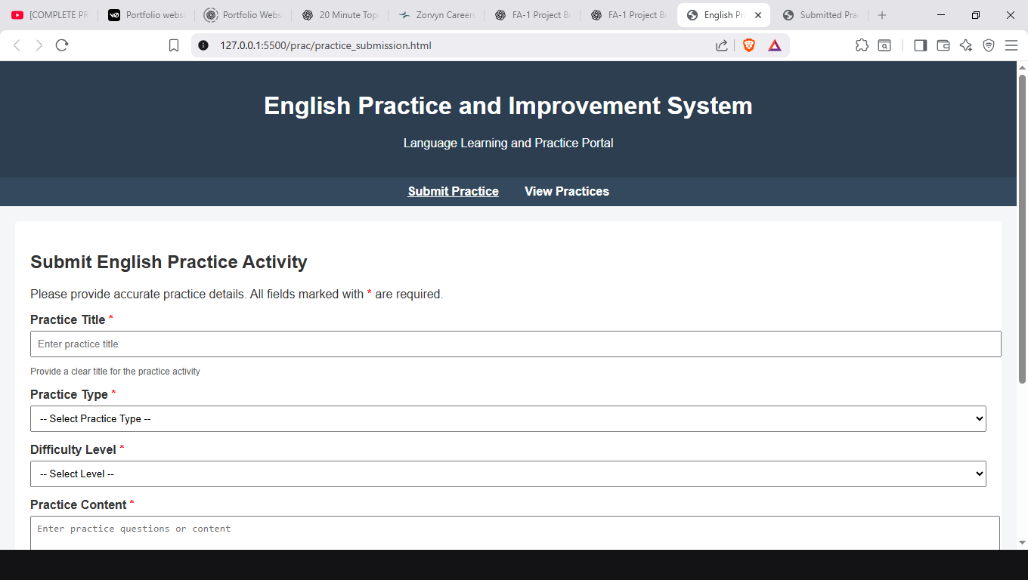

Fig 2.1: English practice submission page 1

Fig 2.1 Illustrates the first view of the English practice submission page used to collect basic practice details in the English Practice and Improvement System.

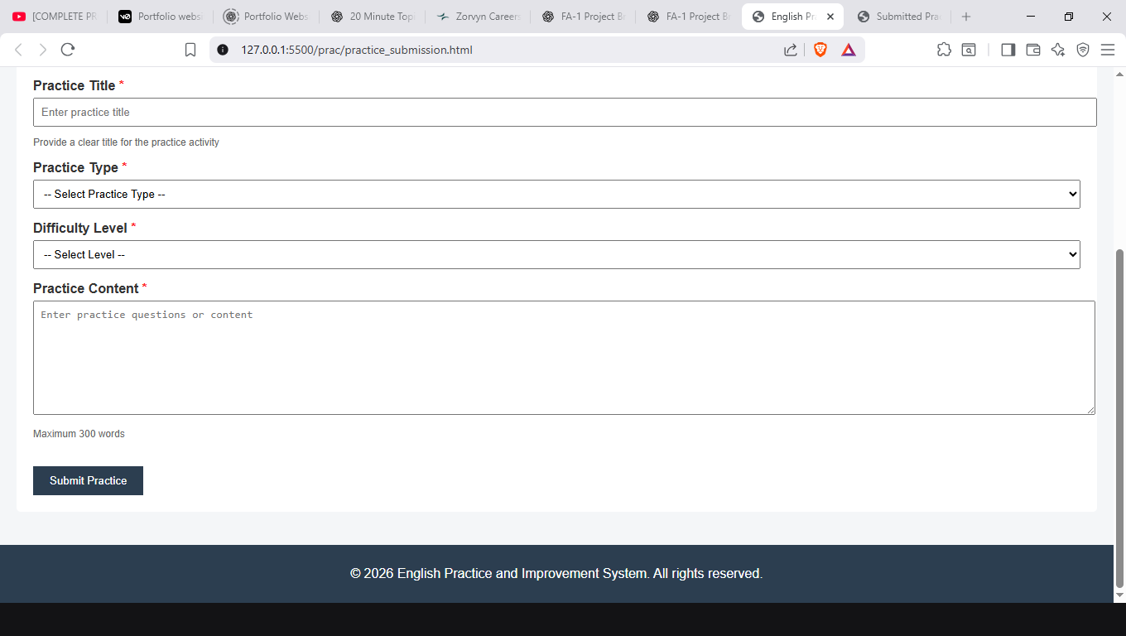

Fig 2.2: English practice submission page 2

Fig 2.2 Illustrates the English practice submission page used for entering and submitting detailed practice content in the English Practice and Improvement System.

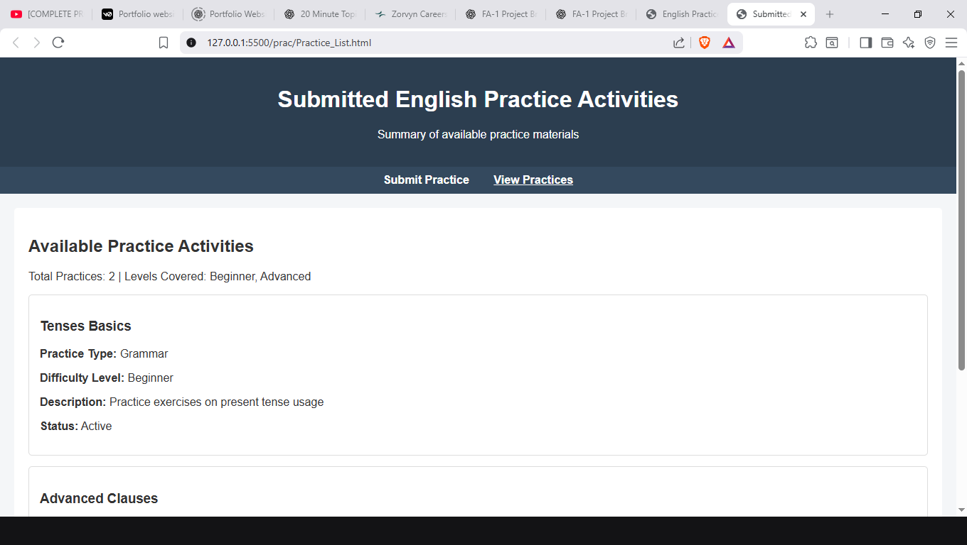

Fig 2.3: Submitted practice activities page

Fig 2.3 Illustrates the practice review page used to display submitted English practice activities for learner reference in the English Practice and Improvement System.

CHAPTER 3

MILESTONE 3:
ENTITY RELATIONSHIP MODELING

IDENTIFICATION OF ENTITIES
Based on the system requirements, the following entities are identified:
    - User: Represents learners who use the system to practice and improve their English language skills.
    - PracticeActivity: Represents English practice materials such as grammar lessons, vocabulary exercises, and reading activities available in the system.
    - PracticeAttempt: Represents user interactions with practice activities, including submitted responses and practice status.
These entities represent the core components of the English Practice and Improvement System and are sufficient to model the main data requirements without unnecessary complexity.

SUMMARY OF PRIMARY AND FOREIGN KEYS

Entity Name | Primary Key | Foreign Key(s)
User | user_id | —
PracticeActivity | activity_id | —
PracticeAttempt | attempt_id | user_id,acitivity_id

Table 3.1: Summary of Primary and Foreign keys
Table 3.1 Provides a summary of the primary and foreign keys used in the Entity Relationship design of the English Practice and Improvement System.

Each entity in the system is uniquely identified using a primary key. The user_id uniquely identifies each learner, while the activity_id uniquely identifies each English practice activity. The attempt_id uniquely identifies each practice attempt made by a user. Foreign keys are used in the PracticeAttempt entity to establish relationships with the User and PracticeActivity entities. These keys ensure referential integrity by linking practice attempts to the corresponding users and practice activities.

ENTITY RELATIONSHIP DIAGRAM
The ER diagram visually represents the identified entities, their attributes, and the relationships between them in the English Practice and Improvement System. Rectangular boxes represent entities, attributes are listed within the entities, and relationships are shown using connecting lines with appropriate cardinalities
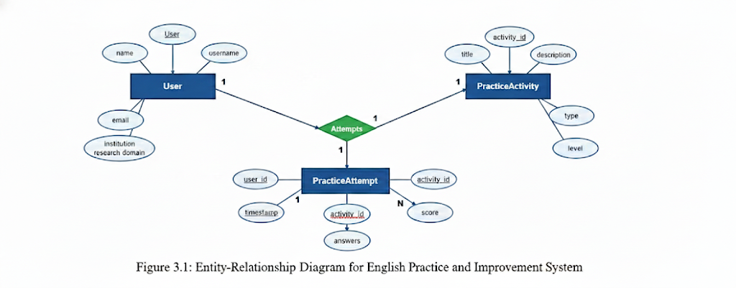

Fig 3.1: ER Diagram of English Practice and Improvement System

Fig 3.1 Illustrates the Entity Relationship diagram representing the data structure of the English Practice and Improvement System.

REDUNDANCY MINIMIZATION
The ER design minimizes data redundancy by storing user details and practice activity information only once and referencing them through foreign keys in the PracticeAttempt entity. This approach avoids duplication of user and activity data when multiple practice attempts are recorded.
By following normalization principles, the design improves data consistency, simplifies updates, and reduces storage requirements. Overall, the ER model supports a scalable and maintainable database structure for the English Practice and Improvement System.

CHAPTER 4

MILESTONE 4:
COMMAND LINE INTERFACE AND VIRTUAL ENVIRONMENTS

USE OF COMMAND LINE INTERFACE (CLI)
The Command Line Interface (CLI) is used to perform all project setup and environment management tasks in the English Practice and Improvement System. Using the CLI allows developers to execute commands efficiently, automate routine operations, and maintain better control over the development workflow. In this milestone, the CLI is used to:
    - Create and navigate project directories
    - Verify Python installation
    - Create and activate a virtual environment
    - Install required external libraries
    - Generate a dependency specification file
    - List project files and folders
These operations demonstrate familiarity with essential command-line operations required for professional software development and prepare the system for future backend integration.

PURPOSE OF VIRTUAL ENVIRONMENTS
A virtual environment is used to create an isolated development workspace for the English Practice and Improvement System. It contains its own Python interpreter and project-specific libraries, separate from the system-wide Python installation.
The primary purpose of using a virtual environment is to avoid dependency conflicts between different projects. Each project can maintain its own set of libraries and versions, ensuring consistent and predictable behavior across development environments. This is particularly important when working on multiple projects or collaborating with other developers.
By using a virtual environment, the system setup becomes more reliable and easier to reproduce, which supports best practices in professional software development.

FLOW ROLE OF DEPENDENCY SPECIFICATION
Dependency specification in the English Practice and Improvement System is achieved by generating a requirements.txt file using the pip freeze command. This file lists all installed Python libraries along with their corresponding versions used in the project.
The requirements.txt file allows the development environment to be recreated accurately on different systems. By installing dependencies from this file, consistency is maintained across various development setups, reducing environment-related issues during development and testing.
Proper dependency specification supports collaboration, simplifies project setup, and ensures reliable execution of the system, making it an essential practice in professional software development.

IMPORTANCE OF CLI PROFICIENCY IN COLLABORATIVE DEVELOPMENT
Command Line Interface (CLI) proficiency is essential in collaborative software development as it provides a consistent and efficient way to perform development tasks across different systems and environments. In the English Practice and Improvement System, CLI usage enables developers to manage project directories, set up virtual environments, install dependencies, and execute scripts efficiently.
In team-based development environments, consistent CLI usage ensures uniform project setup, reduces configuration errors, and enables quick environment reproduction. It also supports integration with version control systems and automation tools commonly used in professional workflows.

SCREENSHOTS

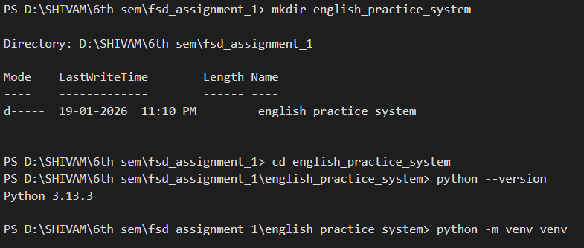

Fig 4.1: Creating the project and verification of Python installation

Fig 4.1 Illustrates the creation of the project directory and the verification of the Python installation required for the English Practice and Improvement System.

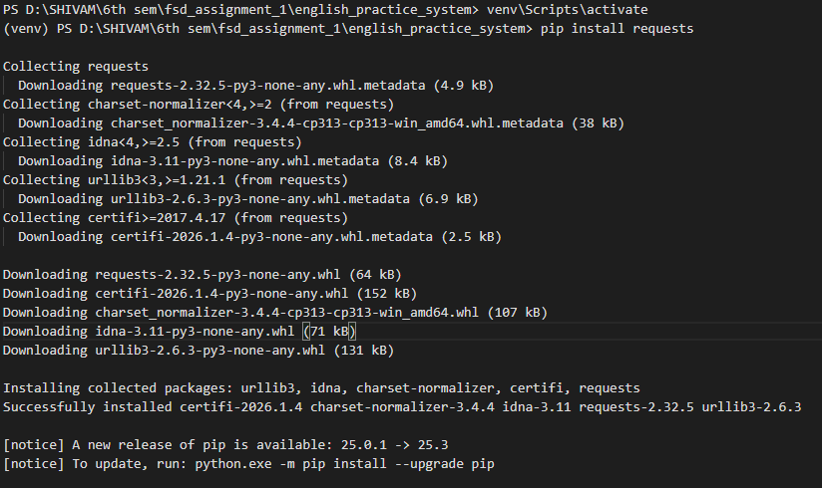

Fig 4.2: Creating and Activating the Virtual Environment

Fig 4.2 Illustrates the creation and activation of the virtual environment used for isolat- ing project dependencies in the English Practice and Improvement System.

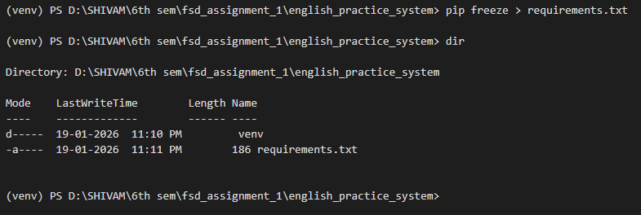

Fig 4.3: Installing the requests library using pip
Fig 4.3 Illustrates the installation of the requests library using pip within the virtual environment for the English Practice and Improvement System.

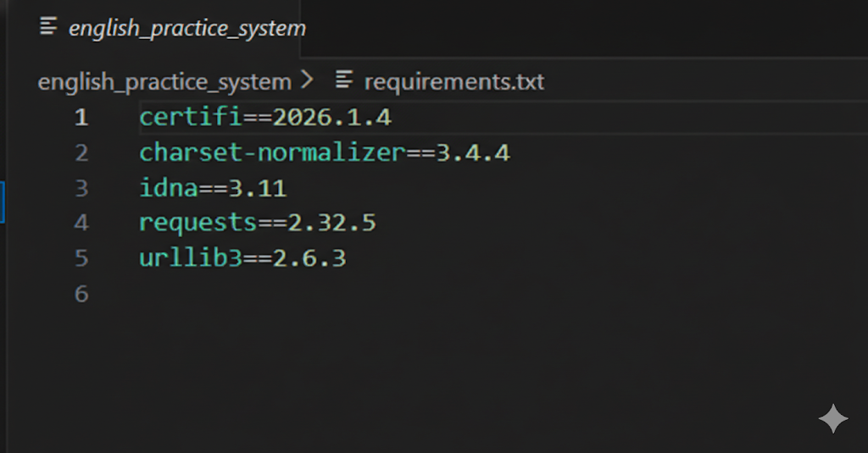

Fig 4.4: Requirements.txt file contents
Fig 4.4 Illustrates the contents of the requirements.txt file listing the project dependen- cies for the English Practice and Improvement System.

CONCLUSION

The English Practice and Improvement System project was carried out as part of the Full Stack Development course with the objective of understanding and applying fundamental software engineering and web development concepts. The project emphasized conceptual clarity, structured design, and adherence to standard development practices rather than building a fully functional system. Through a milestone-based approach, the project demonstrated how an educational problem domain can be analyzed and modeled effectively.
The first milestone applied object-oriented programming concepts using Python to represent different types of English learning content. By using inheritance, method overriding, and polymorphism, the system design became modular, reusable, and aligned with real-world learning structures. The second milestone focused on frontend structure using semantic HTML and HTTP concepts. Static web pages were designed to represent English practice submission and viewing, and the use of the POST method was justified based on data handling requirements and user interaction behavior. This milestone highlighted how learner interactions are conceptually modeled at the web interface level. The third milestone involved designing an Entity Relationship model to structure system data efficiently. Key entities, attributes, and relationships were identified, with an emphasis on minimizing redundancy and maintaining data consistency. This design provides a strong foundation for future database implementation. The final milestone demonstrated the use of the Command Line Interface and virtual environments to manage project setup and dependencies. By following standard CLI-based workflows, the project reinforced the importance of environment isolation, dependency management, and reproducibility in collaborative development. Overall, this project provided a comprehensive understanding of how different layers of a software system are planned and structured. The English Practice and Improvement System serves as a valuable academic exercise that strengthens foundational skills required for advanced full stack development and real-world software engineering practices.

