PROJECT REPORT
8-bit Adder/Subtractor using Verilog
Name: SHIVAM
College: R.D. Engineering College
Course: B.Tech (VLSI)
Tool Used: Xilinx Vivado
GitHub: github.com/shivamrana0207.com

1. Introduction
This project implements an 8-bit adder/subtractor using Verilog HDL. Subtraction is performed using 2’s complement arithmetic and verified using simulation.

2. Objective
- Design 8-bit adder/subtractor
- Understand 2’s complement
- Verify using simulation
- Analyze waveform

3. Theory
A - B = A + (~B + 1)
Mode = 0 → Addition
Mode = 1 → Subtraction

4. Verilog Code (Design)

module adder_subtractor_8bit (
input [7:0] A,
input [7:0] B,
input Mode,
output [7:0] Result,
output CarryOut
);

wire [7:0] B_mod;
wire [8:0] Carry;

assign B_mod = B ^ {8{Mode}};
assign Carry[0] = Mode;

genvar i;
generate
for(i = 0; i < 8; i = i + 1) begin
assign {Carry[i+1], Result[i]} =
A[i] + B_mod[i] + Carry[i];
end
endgenerate

assign CarryOut = Carry[8];
endmodule

4. Testbench Code

module tb;

reg [7:0] A, B;
reg Mode;
wire [7:0] Result;
wire CarryOut;

adder_subtractor_8bit uut (
.A(A),
.B(B),
.Mode(Mode),
.Result(Result),
.CarryOut(CarryOut)
);

initial begin
A = 8'd10; B = 8'd5; Mode = 0; #10;
A = 8'd10; B = 8'd5; Mode = 1; #10;
A = 8'd5; B = 8'd10; Mode = 1; #10;
$stop;
end

endmodule

4. Simulation Results

Case 1 (0–10 ns approx):
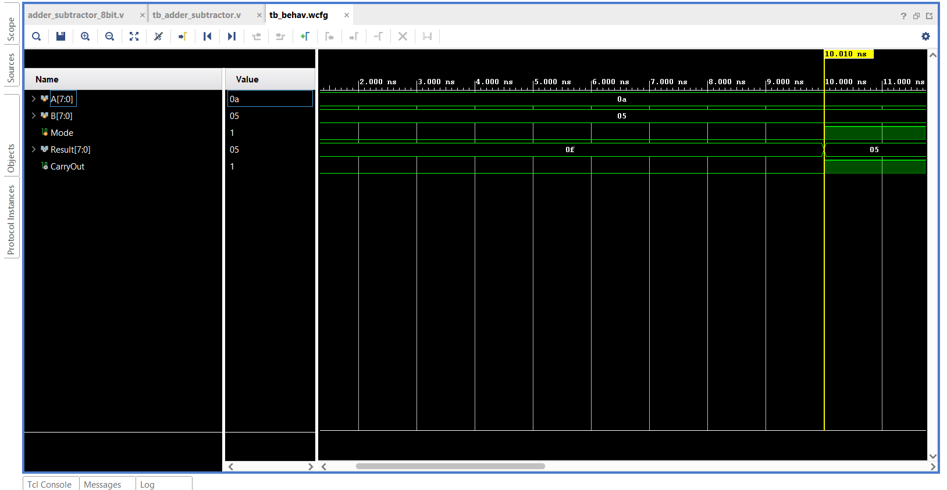

Case 2 (10–20 ns approx):
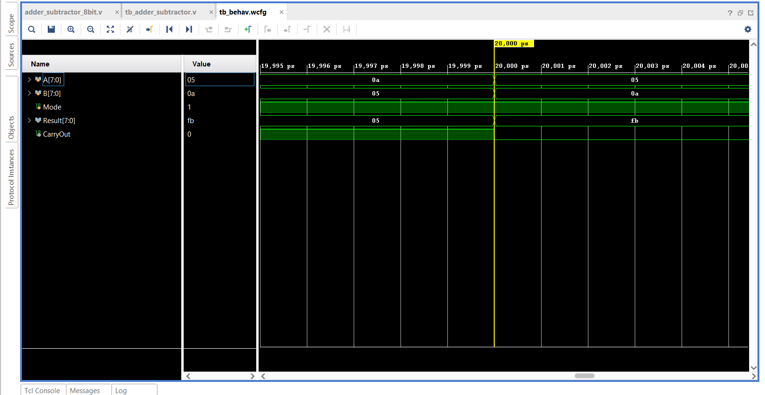

Overall waveform:
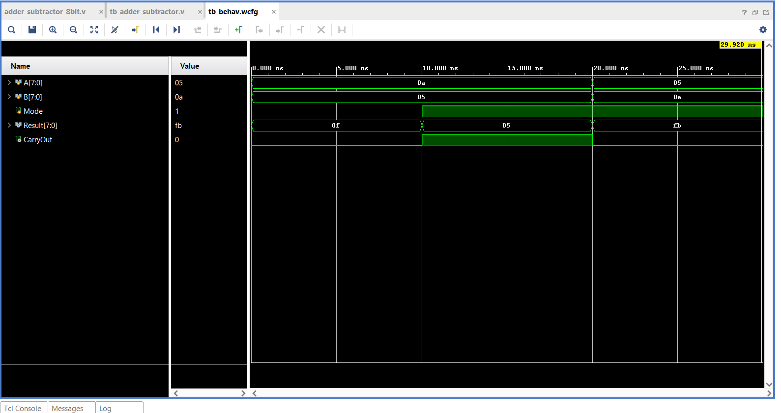

5. Observations
10 + 5 = 15
10 - 5 = 5
5 - 10 = -5 (FB in hex)
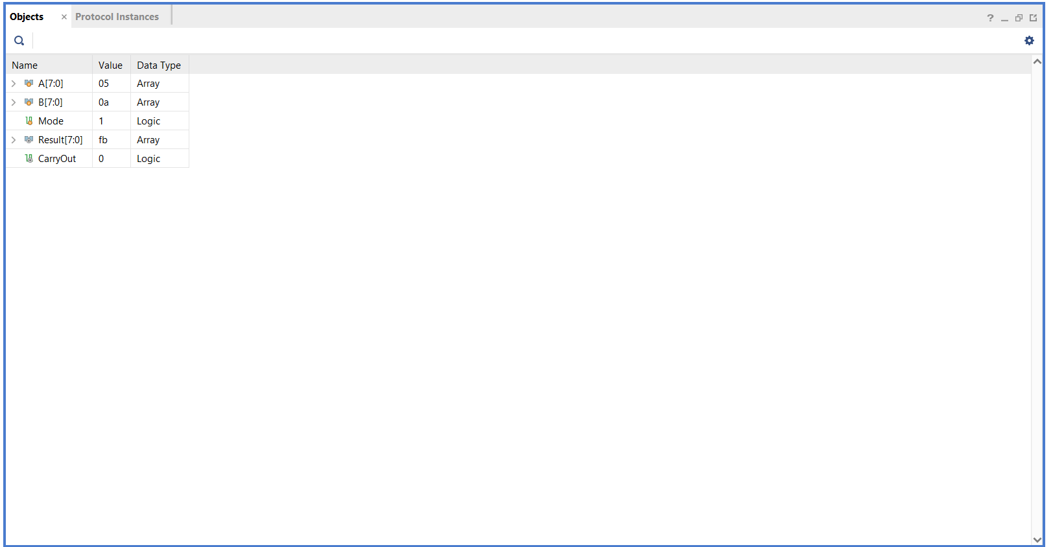

6. Conclusion
The design successfully performs addition and subtraction operations. Simulation verifies correct implementation.

