**Networking Assignment Challenge – 2**

**Approach:** Understanding the switch by verifying the configuration of switch. Checking MAC Table on switches to understand switch forwarding logics.

**Solution:** 1. Checking the connectivity between network and CAM table which store the MAC Addresses of Devices by using **show mac-address-table** command.

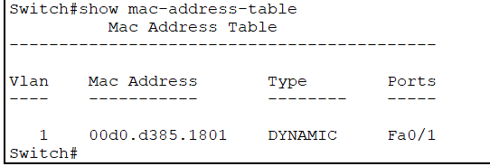 Switch - 1

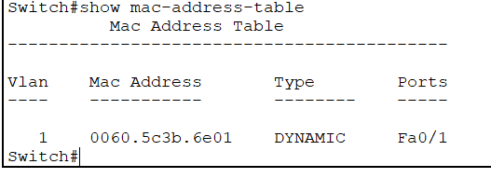 Switch - 2

2. Only Switch’s MAC Address is listed in table.

3. To get the IP Address and MAC Address of connected device, I generate traffic by **ping** Another Device IP Address command.

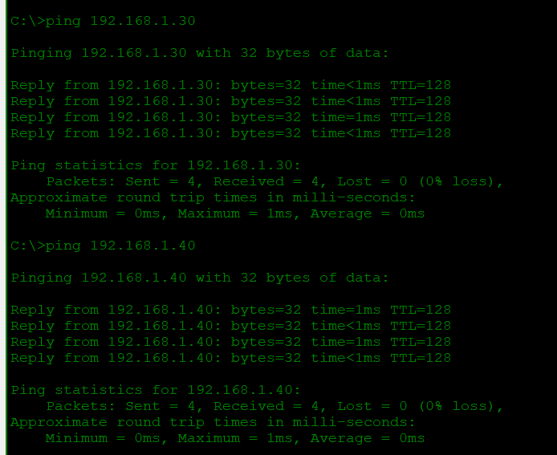

4. After I get the CAM table filled with MAC Address of connected device.

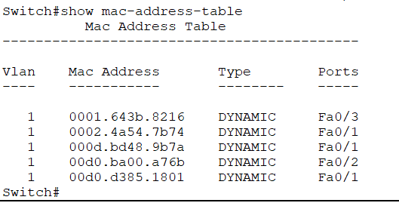 Switch - 1

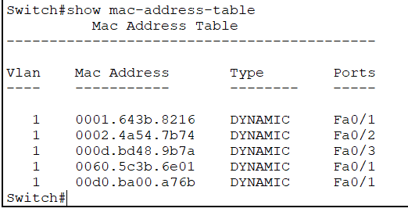 Switch - 2