**Networking Assignment Challenge – 6**

**Approach:** To solve the task, I will review and correct the IP address configuration on a switch according to VLANs. The IP Address is not configured properly.

**Solution:** 1. Starts by examining the current IP configurations made by the junior network engineer and I found that it’s not configured properly.

2. Configuring VLAN by following commands:

* Configuring vlan - int **vlan1**
* Assigning IP Address - **ip address 10.0.0.1 255.0.0.0**
* Changing Interface Status - **no shutdown** and then **end** in configuration mode. And Same commands for all vlan configurations.

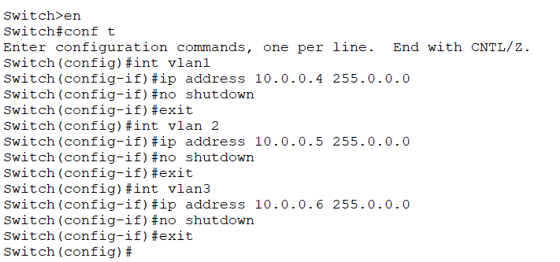

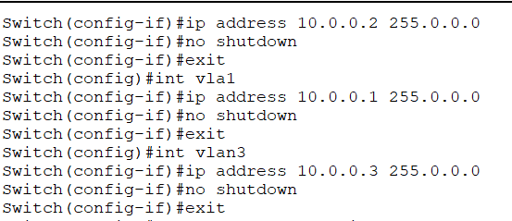

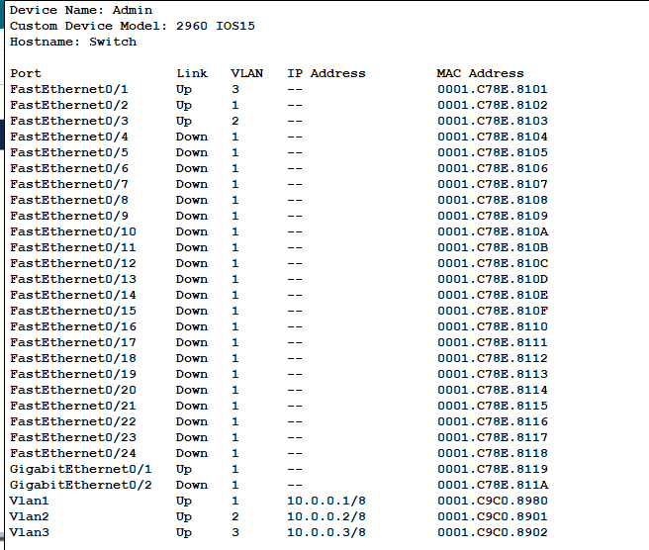

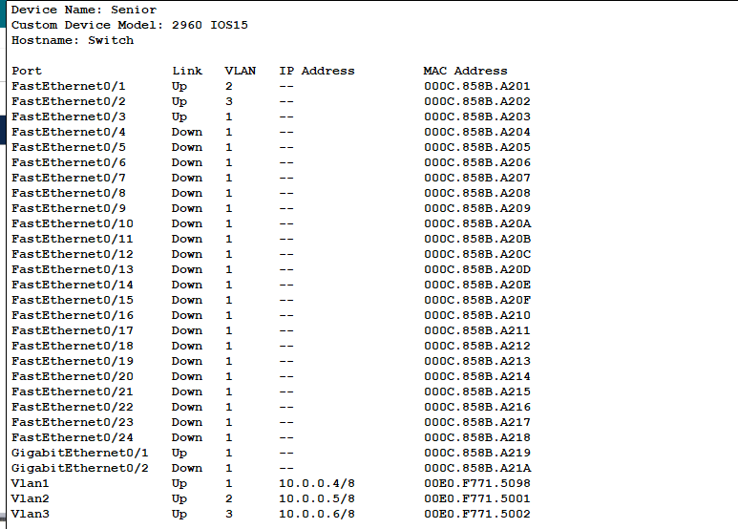

3. VLANs are configured properly.