**Networking Assignment Challenge – 7**

**Approach:** Some physical problem is present in network like Power ON/OFF.

IP Address is not configured properly on network. Status and protocol of interface is not enabled.

**Solution:** 1. Jack PC is powered off, On it manually.

2. Assigning IP and Subnet to Laptop.

3. Laptop connected with fa0/2 interface of senior switch, and the interface is down. I used **interface fa0/2** and **no shutdown** command in configuration mode to change the interface to up. 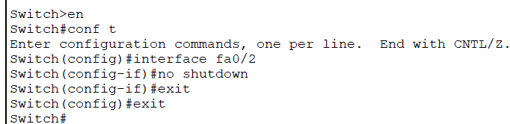

4. BOB Pc is connected with fa0/1 interface of Junior switch, and the interface is down. I used **interface fa0/1** and **no shutdown** command in configuration mode to change the interface to up. 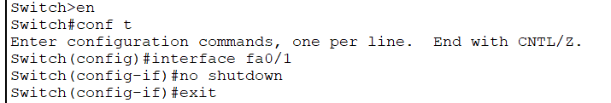

5. Duplex setting is misconfigured in Laptop, then I manually changed the duplex setting to auto in the configuration section.

6. Duplex setting is misconfigured in BOB Pc, then i manually changed the duplex setting to auto in the configuration section.

7. N/W is working properly.