**Networking Assignment Challenge – 8**

**Approach:** By Verifying SSH Configuration, Check Credentials, Testing Connectivity, Apply Encryption helps in configuring SSH Protocol network properly.

**Solution:** 1. Checking the Existing SSH configuration by **show ip ssh** command in enable mode on all switches. But no SSH is configured on all the switches.

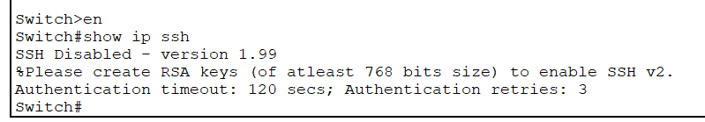

2. Configuring the SSH on routers by using the following commands in configuration mode:

* Assigning hostname - **hostname sh**
* Assigning domain name - **ip domain-name sh.com**
* Generating Encryption Key - **crypto key generate rsa** - length of key **1024**
* Assigning Username and Password - **username admin secret 0000**
* Modifying System configuration file - **line vty 0 4**
* Enabling SSH Protocol - **transport input ssh**
* Enabling Local Authentication - **login local**
* Then exiting from mode - **exit**
* Configuring vlan - **int vlan1**
* Assigning IP Address **ip address 10.0.0.1 255.0.0.0**
* Changing the Protocol Status - **no shutdown**
* Then exiting the mode - **exit**

3. For Checking the working of SSH, I used Carlos Pc to create remote connection through SSH, by using the command **ssh -l admin 10.0.01.**

4. Finally the SSH is working properly.

5. Now repeating same steps on all the switches to configure SSH on them.