**Networking Assignment Challenge – 9**

**Approach:** For Timeout configuration - running-config file is most important because it contain the details of system. To change the timeout configuration, we have to edit running-config file on switch.

**Solution:** 1. Checking the **running-config** file by using command **show running-config** in enable mode of switch. And I get the output that timeout is not configured in switch.

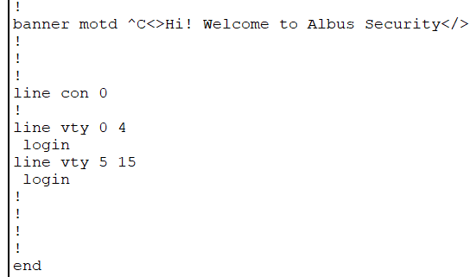

2. Configuring timeout by using the command:

* Entering line configuration mode - **line con 0**
* Configuring VTY Line 0 through 4 - **line vty 0 4**
* Setting inactivity timeout - **exec-timeout 5 30**
* Then exiting from mode **exit** in configuration mode
* To save the configuration - **write memory** in enable mode.

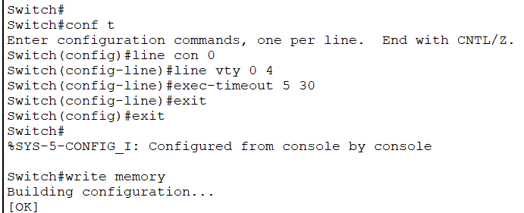

3. As a result, timeout of 5 Minute to 30 second is properly configured in Admin Switch.

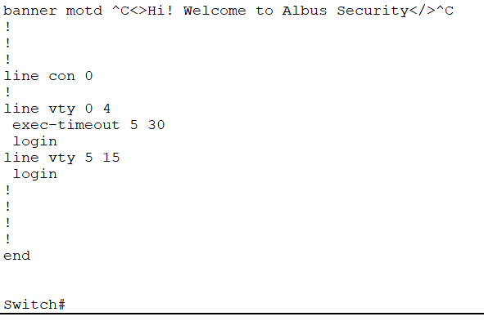

4. Same steps are followed to configure the timeout configuration on Senior Switch.