1. WAP to declare tuples in python.
t=('nicky is a good girl')
print("tuple=",t)
OUTPUT:-
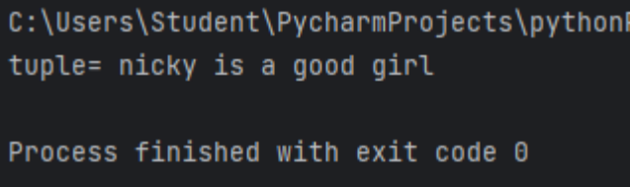
2.WAP to Calculate the total length of the tuples value by using the Len ().
set={10,20,30,'A','B','C'}
a=len(set)
print(a)
OUTPUT:-
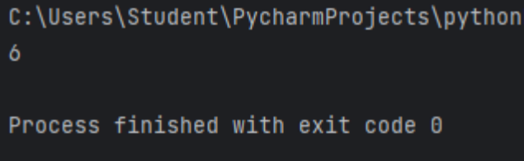
3.WAP to count the number which how many times occur in tuples by using count ().
t=(1,2,3,6,7,2,9,4,9,5,8,1,9,5,9,5,3,4,69,9,1,2)
a=t.count(9)
print("The count of 9:",a)
b=t.count(5)
print("The count of 5:",b)
c=t.count(4)
print("The count of 4:",c)
OUTPUT:-
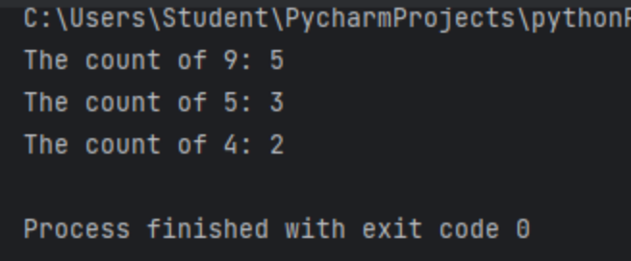
4. WAP to find the index value of the tuples value.
t=('rahul','went','his','school','very','late')
a=t.index('school')
print('a=',a)
b=t.index('went')
print("b=",b)
OUTPUT:-
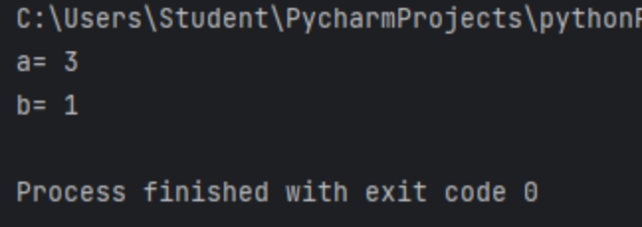
5. WAP to construct Set.
s=({'air','water','fire'})
print("set=",s)
print(type(s))
OUTPUT:-
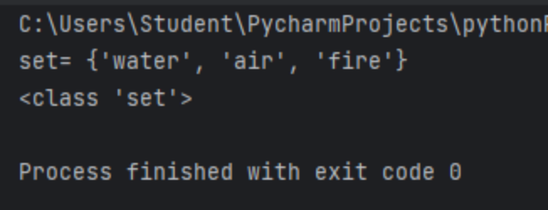
6. WAP to Calculate the total length of the Set value by using the Len ().
s=('eena','meena',1,5,9,'dika')
print("The len of set:",len(s))
OUTPUT:-
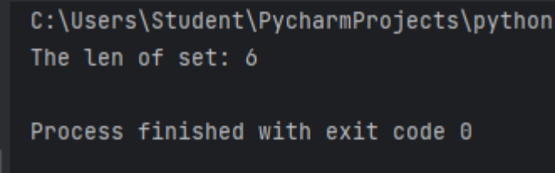
7. WAP to count the number which how many times occur in Set by using count ().
a=(3,2,3,'a','b','c',3,2,3)
b=a.count(3)
print("b=",b)
OUTPUT:-
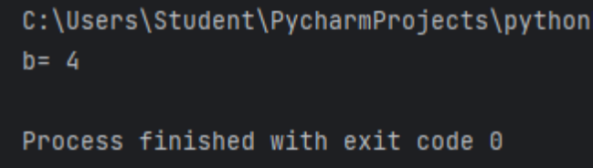

8. WAP to perform union between 2 sets.
a={1,2,3,4,5}
b={4,5,6,7,8}
c=a.union(b)
print("union of sets:",c)
c=a|b
print(c)
OUTPUT:-
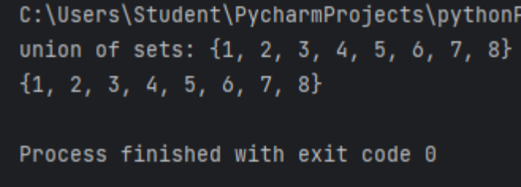
9. WAP to perform Intersection between 2 sets.
a={'a','b','c','d','e'}
b={'c','d','e','f','g'}
c=a.intersection(b)
print("intersection of sets:",c)
c=a|b
OUTPUT:-
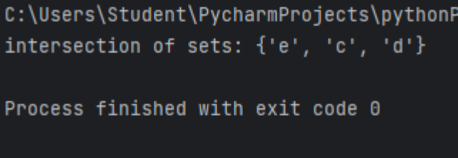
10. WAP to add any value in the set by using add () method.
set={1,2,3,4}
set.add(5)
print("set=",set)

OUTPUT:-
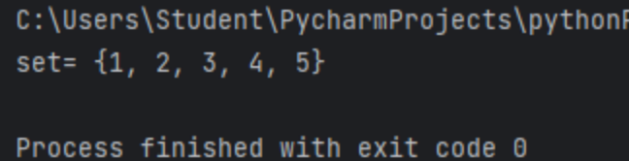
11. WAP to create directory in python.
import os
os.mkdir('shivani')
print('The directory is created.')
OUTPUT:-
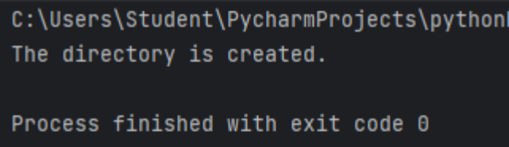
12. WAP to remove the value of the directory by using the key value of the directory.
test_dict={'a': 21, 'b': 21, 'c': 22, 'd': 21}
del test_dict['b']
print(test_dict)
OUTPUT:-
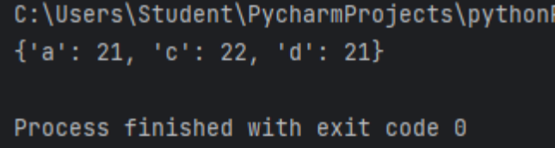
13. WAP to clear the directory values by using the clear method ().
test_dict={'a': 21, 'b': 21, 'c': 22, 'd': 21}
del test_dict['b']
print(test_dict)
OUTPUT:-
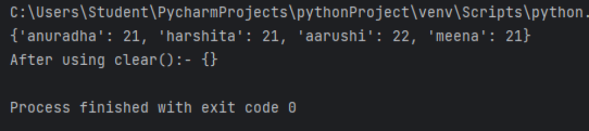
14. WAP to perform the copy of one directory into another directory using the copy () method.

