News 21

By

Shivam

Level-6

Final Project

Table of Contents

Project Proposal 3

Goals and Objectives 3

Project Scope 3

Project Specifications 3

Target Audience 3

Project Deliverables 4

Resource Requirements 4

Project Tasks and Milestones 4

Project Assumptions 5

Project Report 5

Detail Design 6

Home Page 6

Registration Page 6

Login Page 7

Categories Admin View 7

News Details Page Admin View 8

All Countries Page Admin View 8

News Comments Visitor View 9

News Comments Page Admin View 9

Project Testing 10

User Manual 10

Summary 10

System Configuration 10

User Access Levels 10

# 

# Project Proposal

## Goals and Objectives

The main goal or aim of the project is to implement an online web application named “News 21”. The main purpose of the application is help people to find news of each and every activity happens around the globe. In this application there are two types of users- admin and registered visitor. Admin has different functionalities as compare to registered visitor. Admin can add, edit, delete and check details of all news.

## Project Scope

The scope of this project is to implement an app named “News 21” with the help of which user can find news on every incident happened around the globe. The duration of the project is 20 working days which is equals to 4 weeks.

## Project Specifications

* Admin login/logout
* Add, edit, delete and check details of news.
* Admin can delete, edit and check categories.
* Admin can delete, edit and check countries.
* Admin can delete, edit and check comments.
* Admin can register new admins.
* Registered Visitor can login/logout.
* New Visitor can register.

## Target Audience

The target audience for this project is the learner who would like to enhance knowledge of their subject and their latest information. The age can go from 10 plus to 60 plus.

## 

## Project Deliverables

The deliverables of the project are:

|  |  |
| --- | --- |
| **Deliverable** | **Description** |
| Final Report | This will be the final report of the project. |
| Coding | The executable code of the project will go under this. |
| Documentation | This portrays the documentation of the project. |
| Testing | All the test details will be covered in this part. |

## Resource Requirements

* Windows Operating System.
* Microsoft word for documentation.
* Asp.net MVC Framework
* 64-bit Processor and 3 GB or more RAM
* Identity framework- ASP

## Project Tasks and Milestones

|  |  |  |  |  |
| --- | --- | --- | --- | --- |
| **Tasks** | **Week-1** | **Week-2** | **Week-3** | **Week-4** |
| Brainstorming and analysis |  |  |  |  |
| Planning and initial meeting Project Proposal document. |  |  |  |  |
| Database Design and UI Design |  |  |  |  |
| Identity framework implementation |  |  |  |  |
| Coding for admin and reporter |  |  |  |  |
| Testing |  |  |  |  |
| Final Documentation and closing |  |  |  |  |

## Project Assumptions

Following are the assumption made while implementing the project:

* One admin and registered visitor will be registered by default.
* Application will be free and open source.

# Project Report

#### Functional and Non-Functional

|  |  |
| --- | --- |
| Users | Functional |
| Admin | * Login/logout * Register new admins * Admin can add, edit, delete, check details for categories. * Admin can edit, delete and check details for posted news. * Admin can edit, delete and check details for countries. |
| Customer | * Can view details of news. * Can post comments about the news. * New customers can register for free. * Login using valid credentials |
|  | Non- Functional |
|  | * High speed * Fast Loading time * High performance and security * All browsers compatibility. |

## Detail Design

### 

### Home Page

The main landing page of the application. On navigation bar options are- Home, Register, Login.

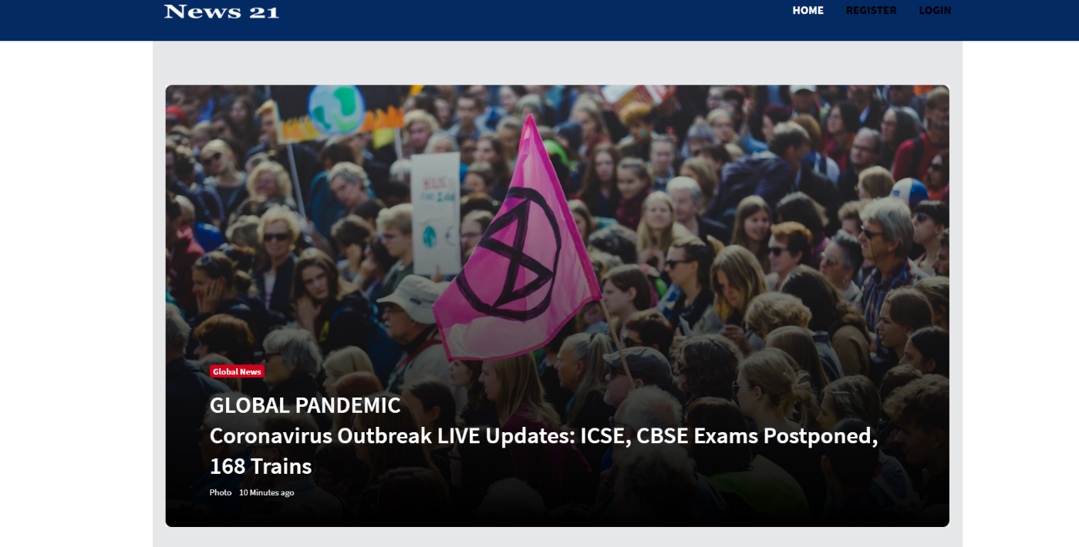

### 

### Registration Page

With the help of this page, new registered visitor can sign up for the app

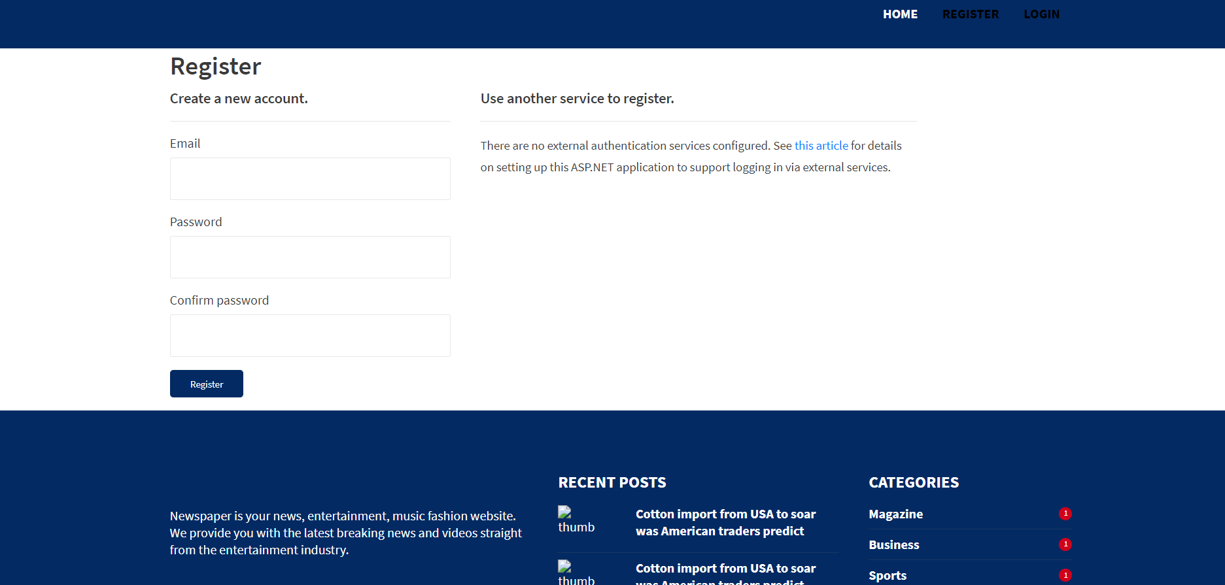

### Login Page

With the help of this page, registered visitor and admin can login to the application using their valid credentials.

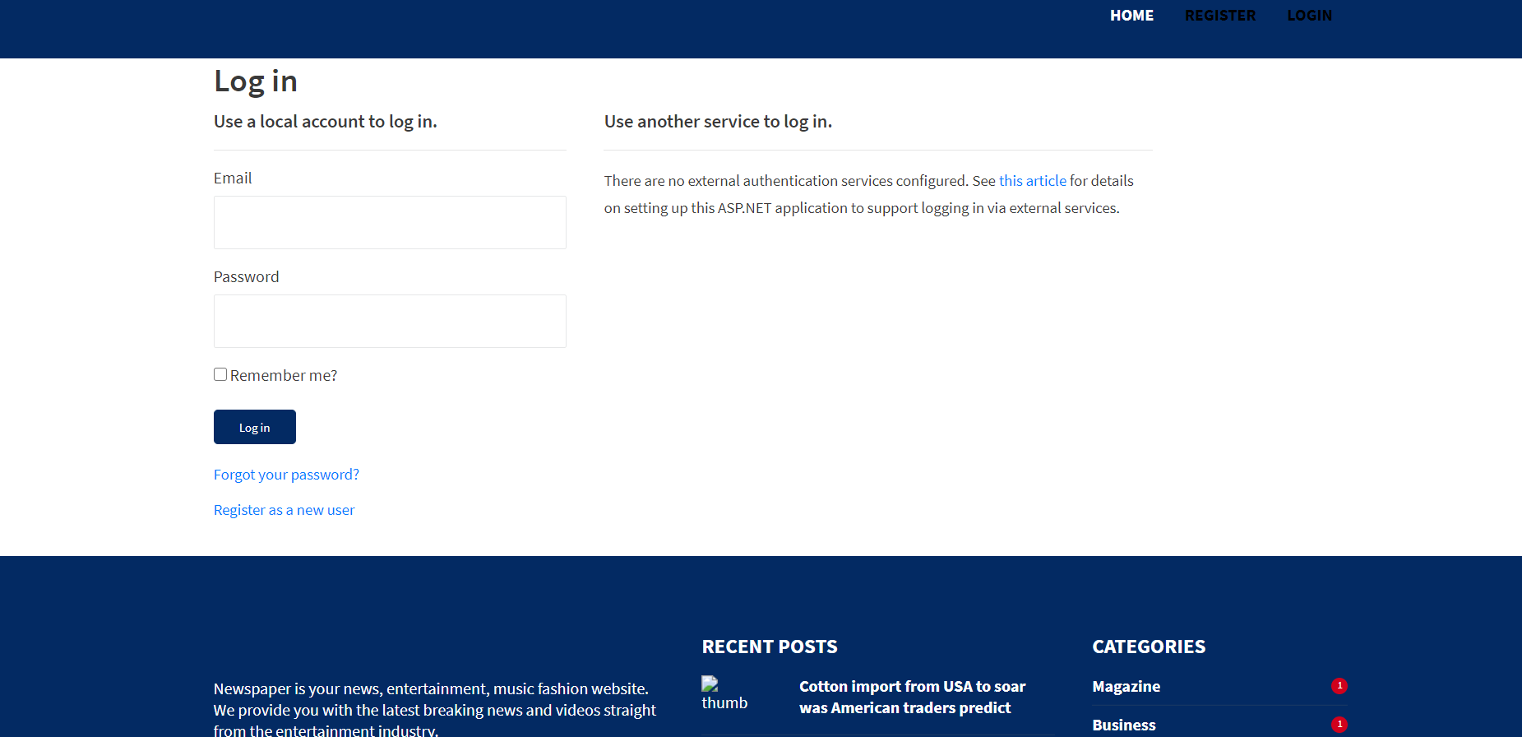

### 

### All Categories Admin View

This page highlights all the Subject Categories available on the application. Admin can add new Subject Category, edit, delete and check details of the existing ones.

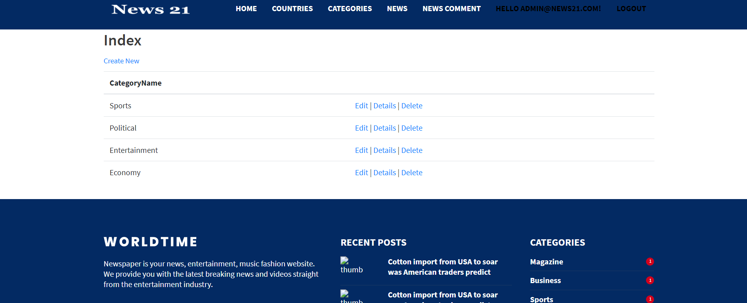

### News Details Page Admin View

With the help of this page admin can manage the posted news details by editing, deleting and checking their details.



### All Countries Page Admin View

With the help of this page Admin can edit, delete and view the countries available on the portal.

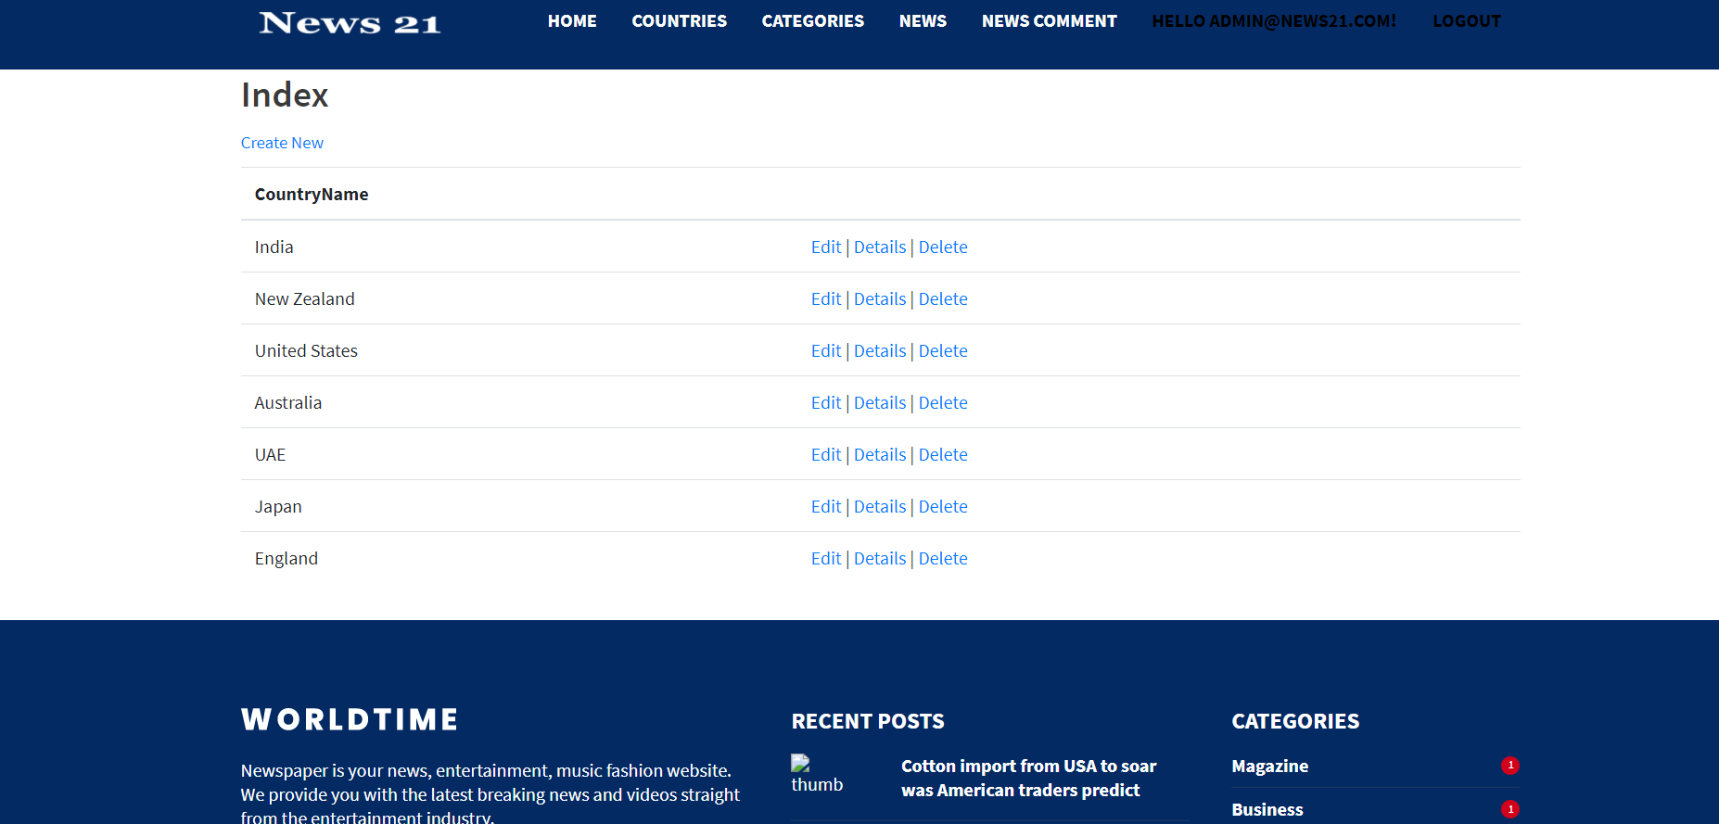

### News Comments Visitor View

With the help of this page visitor can post comments on any posted news.

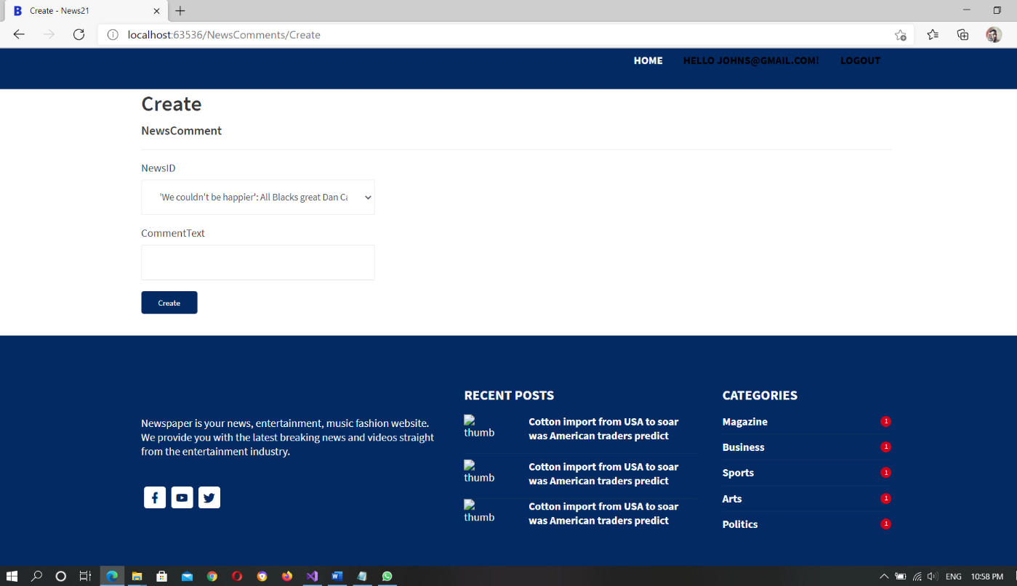

### News Comments Page Admin View

This page shows the all the comments posted by visitors and admin can read, edit and delete them.

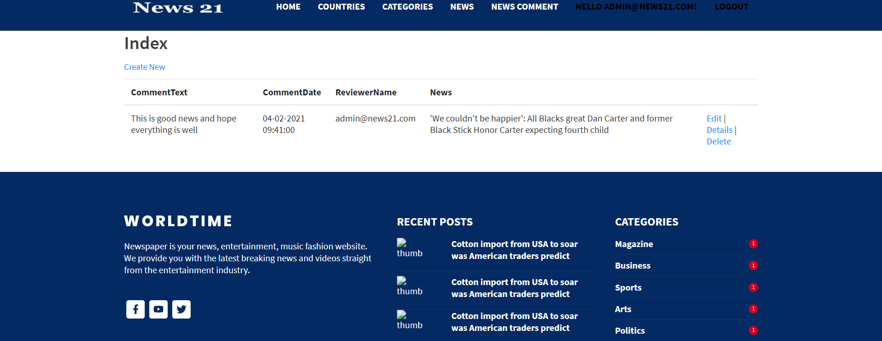

## Project Testing

The testing file for usability testing is attached as [usability test.xlsx](usability%20test.xlsx)

# User Manual

The main purpose of the application News 21 is to help people to find news of every incident happened around the globe. In this application there are two types of users- admin and registered user or visitor customer. Admin has different functionalities as compare to customers. Admin can add, edit, delete and check details of news categories. Admin can edit, delete and check details of the posted news. Also, registered user have authority to post comments on the news.

## Summary

### System Configuration

This app will be useful to provide news of each and every moment happened around the globe in presentable format.

### User Access Levels

Only registered users can access the features of this application.

* **Admin:** Admin has full access of the app can register new admins.
* **Registered Visitor:** New visitor can register and existing can login using their own credentials. They have limited access.