Get method for fetching the list of medicine:

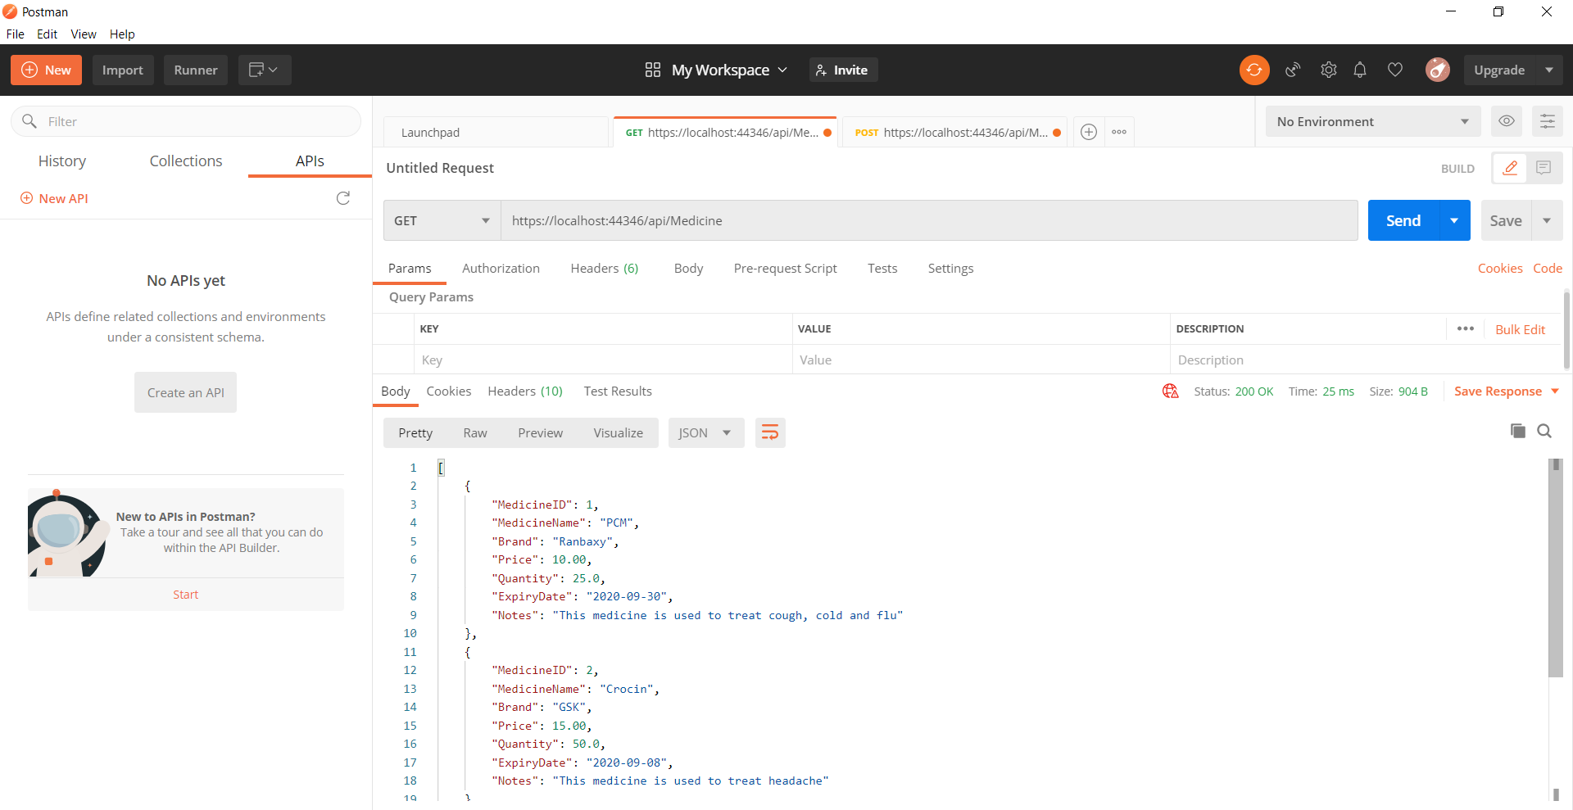

Post Method for adding the medicine:

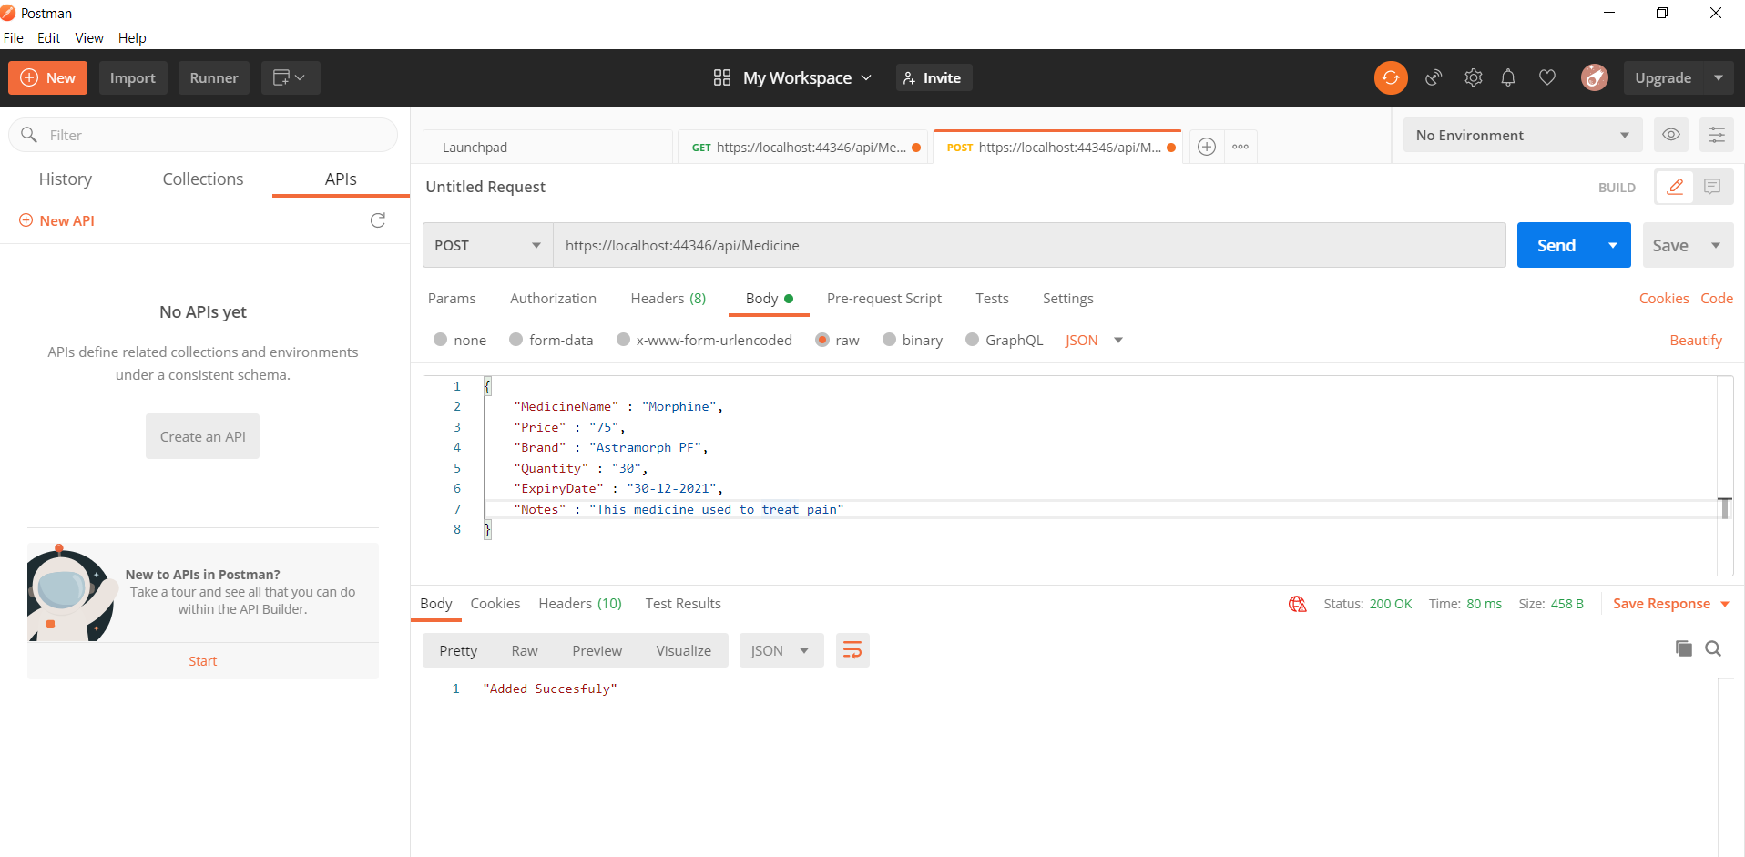

Getting the table data from API : https://localhost:44346/api/Medicine

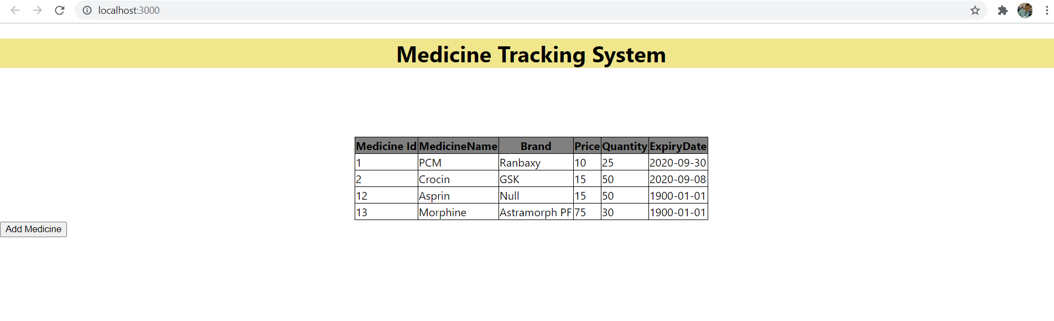

Database:

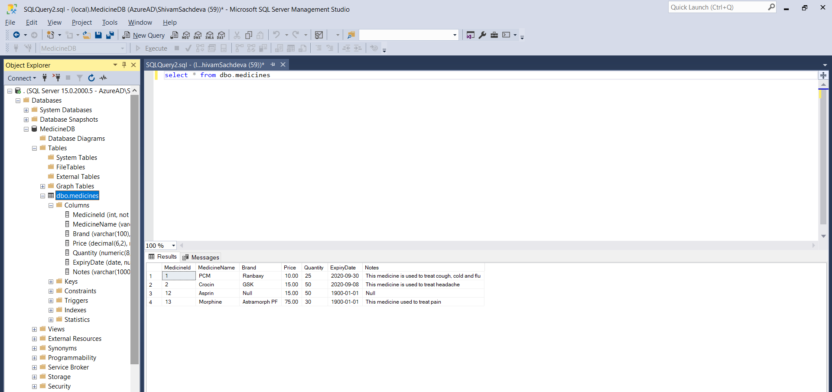

Steps to run the project:

1. Setup the database in MS SQL by running the following command:

* Create database MedicineDB
* Create table dbo.medicines (MedicineID int IDENTITY(1,1) Not Null, MedicineName varchar(100), Brand varchar(100), Price Decimal(6,2), Quantity Numeric(6), ExpiryDate date, Notes varchar(1000)
* Insert into dbo.medicines values(“PCM”, ”Ranbaxy”, “10”, “25”, “2020-09-30”, “This medicine is used to treat cough, cold and flu”)

1. Open WebApplication2.sln file in visual studio
2. Run IIS server
3. Navigate to ./WebApplication2/Frontend/Publicis
4. Run the following commands:

* npm install (To install the project dependencies)
* npm start (To start the react project)