CIVICCONNECT — A CIVIC HEALTH AND EMERGENCY
ASSISTANCE PLATFORM WITH GEOSPATIAL
FACILITY DISCOVERY
A Synopsis
Submitted
In Partial Fulfillment of the Requirements
For the Degree of
Bachelor of Technology (B.Tech)
Computer Science & Engineering

[Name of Student-1]  [Roll No.] | [Name of Student-2]  [Roll No.]
[Name of Student-3]  [Roll No.] | [Name of Student-4]  [Roll No.]

Under the Supervision of
[Guide Name]
[Designation]

G.L. BAJAJ INSTITUTE OF TECHNOLOGY & MANAGEMENT
GREATER NOIDA
DR. A P J ABDUL KALAM TECHNICAL UNIVERSITY,
UTTAR PRADESH, LUCKNOW
2026-2027

1. Introduction
Access to timely healthcare in Indian cities is limited less by the absence of facilities than by the absence of reliable information about them. A citizen facing a medical emergency at two in the morning has no dependable way to learn which nearby hospital currently has a vacant intensive-care bed, which blood bank holds the required group, or which pharmacy stocks a prescribed medicine. The prevailing recourse is a sequence of telephone calls made under acute stress, each answered inconsistently. The information exists, but it is fragmented across institutions that have no shared channel for publishing it.
CivicConnect is a full-stack web platform that addresses this fragmentation by giving verified healthcare providers a structured means of publishing live availability, and citizens a single location-aware interface for discovering it. The system unifies six civic functions that are conventionally served by separate and largely disconnected portals: hospital bed discovery, blood-bank inventory search, pharmacy medicine lookup, ambulance dispatch, municipal complaint registration, and government welfare-scheme awareness.
The project is positioned within three current technical trends. First, spatial database computation: PostGIS has made geographic proximity search a first-class database operation, so radius filtering and distance ordering execute inside the query planner over a spatially indexed column rather than in application code. Second, the maturation of open civic data infrastructure — OpenStreetMap, the Overpass API, Nominatim, and Open-Meteo now expose facility locations, geocoding, and environmental observations without licensing cost or vendor lock-in. Third, the movement of authorisation logic to the framework boundary, where a deny-by-default guard makes public exposure an explicit and auditable decision at each endpoint rather than an omission.
A defining constraint shaped the entire design. A platform that reports medical availability must never state a figure it cannot substantiate, because a citizen may act on that figure in an emergency. CivicConnect therefore maintains a strict separation of data provenance. Real facilities obtained from OpenStreetMap are served as a distinct dataset whose schema contains no availability fields whatsoever; availability figures exist only on explicitly labelled simulated organisation records created for demonstration. This separation is enforced at the API boundary, surfaced in the user interface, and asserted by the automated test suite. It is the project’s principal engineering commitment and is treated throughout as a correctness property rather than a disclaimer.

2. Objectives
The project pursues the following objectives:
- To design and implement a unified, role-aware web platform that consolidates hospital, blood-bank, pharmacy, ambulance, complaint, and welfare-scheme services within a single authenticated application.
- To implement proximity search as a database-level spatial operation using PostGIS, employing a generated geography column with a GiST index so that radius filtering and distance ordering are performed by the query planner rather than by application code.
- To establish a verifiable separation between real third-party facility data and simulated availability records, such that no genuine facility can be displayed carrying an unsubstantiated availability figure.
- To enforce a deny-by-default authorisation model across the API, in which every endpoint requires authentication unless explicitly and deliberately marked public, supported by role-based access control across eight distinct user roles.
- To provide verified healthcare providers with a console for publishing live availability, gated so that only administratively approved organisations may publish figures visible to the public.
- To integrate live environmental context — temperature and air-quality observations — from public data sources, reporting unavailability honestly when an upstream service cannot be reached.
- To implement an emergency ambulance request workflow with a constrained status-transition model, ensuring that a completed dispatch cannot be reopened and that patient contact details are disclosed only to the provider that has accepted the request.
- To validate the resulting system through automated unit tests, an end-to-end smoke suite covering authentication and authorisation boundaries, and verification of spatial query correctness against known seeded distances.

3. Existing System
Several deployed applications address portions of the problem domain. Each was examined to establish what CivicConnect must provide beyond current practice.
Existing Application | Scope and Capability | Identified Limitation
Practo | Nationwide doctor discovery, appointment booking, and teleconsultation; extensive verified practitioner directory. | Oriented to scheduled outpatient consultation. Does not report live inpatient bed or intensive-care availability, and offers no emergency dispatch pathway.
1mg / Apollo 24|7 | Medicine e-commerce with delivery, laboratory test booking, and digital consultation. | Commercial fulfilment model. Shows the vendor’s own inventory rather than stock at nearby independent pharmacies, and excludes hospital and blood-bank information entirely.
e-RaktKosh (NHM, Government of India) | National blood-bank directory with stock reporting mandated across participating centres. | Blood availability only. Update latency depends on manual entry by each centre; the interface is not location-aware and provides no proximity ordering.
Aarogya Setu / ABHA (Ayushman Bharat) | National health identity, digital health records, and government scheme linkage. | Focused on identity and record custody rather than real-time facility discovery. No live availability and no civic grievance channel.
Google Maps | Comprehensive facility geolocation, routing, opening hours, and public reviews. | A general-purpose mapping product. Carries no clinical availability data, no verified-provider notion, and no civic service integration.
Municipal grievance portals (e.g. Swachhata, state 311 systems) | Citizen complaint registration with departmental routing and status tracking. | Civic complaints in isolation. No relationship to healthcare discovery, and typically no spatial search over reported issues.
Two conclusions follow from this survey. First, no examined application unifies emergency healthcare discovery with civic grievance and welfare-scheme services; a citizen must presently hold several applications to cover the domain CivicConnect addresses. Second, and more significantly, none provides live provider-published availability with an accompanying provenance guarantee. Where availability is reported at all, as in e-RaktKosh, the reader is given no indication of the figure’s recency or reliability. The absence of an explicit provenance contract is the specific gap this project addresses.

4. Motivation
The motivating observation is that emergency healthcare failures in urban India are frequently informational rather than infrastructural. A patient is transported between hospitals not because no bed exists in the city, but because no party in the transaction knows where the vacant bed is. The delay is produced by the absence of a publishing channel, and a software system can supply that channel.
Three limitations in existing systems shaped the project’s direction:
- Fragmentation of provision. Healthcare discovery, blood availability, pharmacy stock, and civic grievance each occupy a separate application with its own account, interface, and conventions. Under emergency conditions, requiring a citizen to identify and navigate the correct portal is itself a source of delay.
- Absence of live, accountable availability. Existing directories describe facilities statically — location, category, contact number. The clinically decisive quantity is dynamic: how many beds are free at this moment. No examined platform provides this with a stated freshness guarantee and an identified publisher.
- Unlabelled data provenance. Applications in this domain routinely present values without indicating their source or reliability. In a medical context this is a safety concern, not merely an aesthetic one: a citizen cannot calibrate trust in a number whose origin is unstated. This limitation directly motivated the project’s provenance-separation architecture.
A secondary motivation arose during development. It is straightforward to construct a demonstration that appears functional by populating the interface with plausible constants — a hospital name, a bed count, a temperature reading. Such a demonstration is nonetheless dishonest, and in a healthcare application the dishonesty is consequential. The project therefore adopted the stricter discipline of rendering only substantiated values, and of stating unavailability plainly where an upstream source cannot be reached. This constraint shaped the schema, the API contract, and the test suite.

5. Proposed Methodology and Process for Implementation

5.1 Proposed Solution
CivicConnect is implemented as a four-tier web system: a Next.js client, a guarded NestJS API gateway, a modular monolithic domain layer of thirteen feature modules, and a PostgreSQL/PostGIS persistence tier, with clearly delimited egress to external public data services. A modular monolith was selected over a microservice decomposition deliberately: the domain modules share a single transactional database and a common authorisation model, and distributing them would introduce network partition and eventual-consistency concerns that the problem does not warrant at this scale.
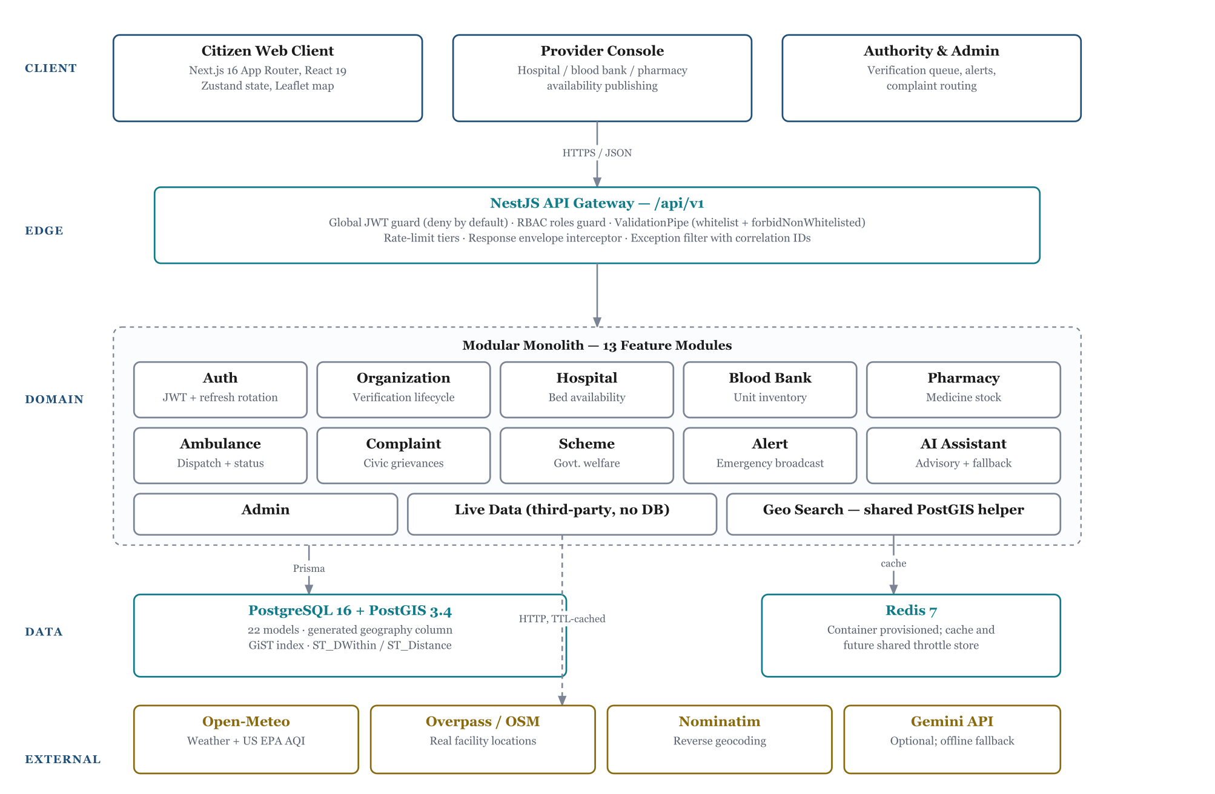
Fig. 1 — Four-tier system architecture. Every request crosses the guarded edge tier before reaching a domain module.

5.2 How the Solution Addresses the Identified Problems
Each limitation identified in Section 4 is met by a specific mechanism:
- Against fragmentation: thirteen domain modules are exposed behind one versioned API surface and one authenticated client, so a citizen holds a single account and learns a single interface. Eight roles — citizen, hospital, blood bank, pharmacy, ambulance provider, authority, NGO, and administrator — share this surface, with role-based access control determining the operations each may perform.
- Against stale availability: availability figures are written by the provider that owns the facility, through an authenticated console, and are gated so that only administratively approved organisations may publish publicly visible values. A self-registered organisation awaiting verification cannot appear in emergency search results reporting figures of its own devising.
- Against unlabelled provenance: the separation described below is enforced structurally rather than by convention.

5.3 Innovation and Uniqueness: Provenance Separation
The project’s distinguishing contribution is that data provenance is enforced by the type system and schema rather than by a displayed disclaimer. Two datasets are maintained and never merged:
- Real facilities are retrieved from OpenStreetMap through the Overpass API, cached with a time-to-live, and never persisted to the application database. The response schema for these records contains no bed, stock, or unit field — there exists no key into which a fabricated availability figure could be written.
- Simulated organisations are seeded database records marked with an explicit provenance enumeration. These alone carry availability figures, which is defensible precisely because every such organisation is fictional by construction.
Both datasets may appear on the same map, and the interface labels each accordingly: live records cite their source and fetch time together with the required Open Database Licence attribution, while simulated records are marked as such. The invariant — that a real facility can never be shown carrying a simulated availability figure — is asserted by the automated smoke suite, which fails the build if any availability key is found on a live facility record.
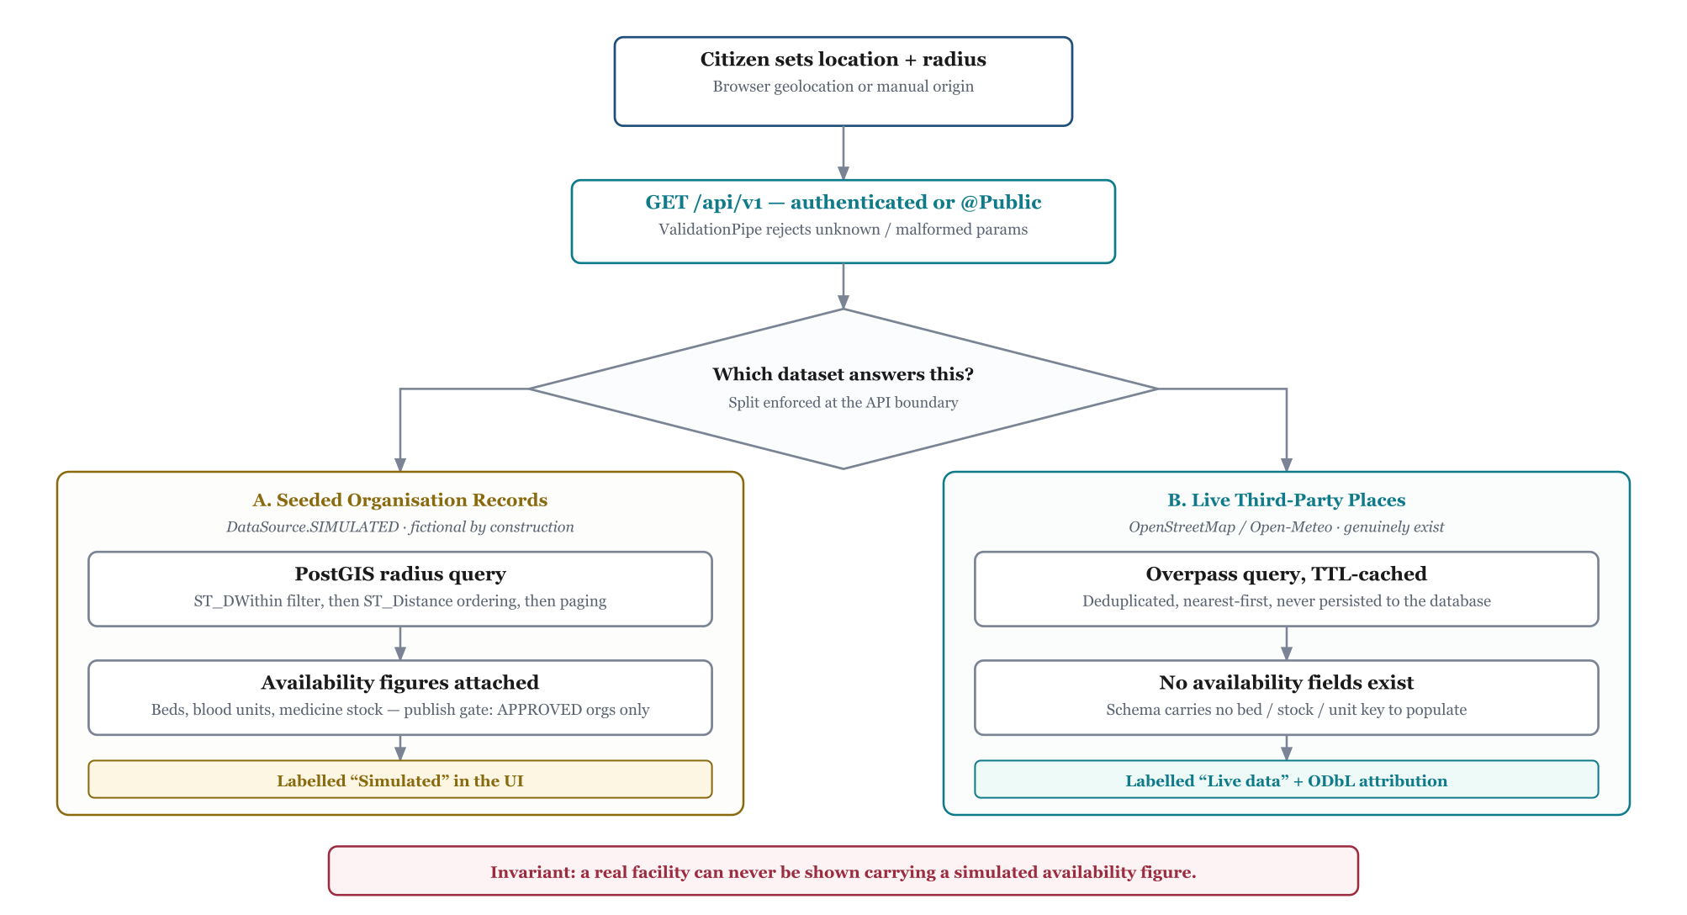
Fig. 2 — Provenance-separated data flow for a proximity search. The branch is enforced at the API boundary.

5.4 Geospatial Query Method
Proximity search is performed entirely within the database. Each organisation row carries a geography column generated from its latitude and longitude and indexed with a GiST index. A single parameterised raw SQL query applies ST_DWithin for radius filtering, computes ST_Distance for both ordering and the returned distance, and applies pagination after the spatial filter, with a deterministic secondary sort for stable ordering. This replaced an earlier application-level Haversine implementation that had been duplicated across five services and that paginated before filtering — an ordering defect that could omit genuinely nearer facilities from the first page of results.

5.5 Implementation Process
Development proceeded in sequenced phases, each verified before the next began:
Phase | Activity | Verification Applied
I | Schema design; PostGIS geography column with generated expression and GiST index; provenance enumeration; migration authored. | Migration applied and confirmed free of drift against the schema.
II | Authentication: JWT access tokens with rotating refresh tokens; deny-by-default global guard; role-based access control across eight roles. | Register, login, refresh, and logout exercised end to end by the smoke suite.
III | Domain modules for organisation, hospital, blood bank, pharmacy, ambulance, scheme, complaint, alert, and administration. | Compilation under strict TypeScript; per-endpoint manual verification.
IV | Security hardening: closure of insecure direct object reference and personally identifiable information exposure defects; restoration of request-body validation; publish gating for unapproved organisations. | Authorisation-denial assertions added to the smoke suite.
V | Migration of proximity search into PostGIS; removal of the five duplicated Haversine implementations. | Radius tiers verified against known seeded distances; unit tests over the query builder.
VI | Frontend vertical slices: authentication, dashboard, discovery, facility views, provider console, administrative views. | Type checking, linting, and production build across twenty routes.
VII | Live third-party integration for environment, geocoding, and real facility discovery, with provenance labelling throughout the interface. | Assertion that live facility records expose no availability field.

6. Potential Impact on the Target Audience

6.1 Social Impact
The primary beneficiary is the citizen seeking care under time pressure. Replacing a sequence of telephone enquiries with a single ranked, distance-ordered result set reduces the interval between the onset of need and arrival at an appropriate facility. In critical presentations — trauma, cardiac events, obstetric emergencies — this interval is clinically consequential. The provenance labelling carries its own social value: a citizen is told which figures are substantiated and which are demonstrative, which supports calibrated trust rather than either uncritical reliance or blanket scepticism.
The platform additionally serves users for whom existing portals are effectively inaccessible. A single interface with consistent conventions, in place of six applications with divergent ones, lowers the barrier for elderly users, first-time smartphone users, and users navigating an emergency on behalf of somebody else.

6.2 Economic Impact
For citizens, the immediate economic effect is the avoidance of wasted journeys — travel to a facility that cannot admit the patient, or to a pharmacy that does not hold the prescribed medicine. For providers, particularly smaller independent pharmacies and blood banks, the platform offers visibility that would otherwise require paid placement on a commercial aggregator. The technology selection reinforces this: PostgreSQL, PostGIS, Redis, OpenStreetMap, Overpass, Nominatim, and Open-Meteo are all open or freely accessible, so the system carries no per-query licensing cost and can be operated by a municipal body or public institution without a commercial mapping contract.

6.3 Administrative and Environmental Impact
For public authorities, the complaint module provides spatially aggregated grievance data, allowing recurring civic problems to be identified by location rather than by individual report. The welfare-scheme module addresses a distinct and well-documented loss: entitlements that go unclaimed because the eligible citizen is unaware of them. Environmentally, the integration of live air-quality observation gives residents actionable information about local conditions; and the platform’s browser-based delivery, requiring no application installation, keeps the client footprint small.

7. Tools and Technology Used / Hardware and Software Requirements

7.1 Software Technology Stack
Layer | Technology | Version | Purpose in the Project
Frontend | Next.js (App Router) | 16.3 | React framework; routing, server components, production build.
 | React | 19.2 | Component model and rendering.
 | TypeScript | 5.x | Static typing across the client codebase.
 | Zustand | 5.0 | Client state for authentication session and search origin.
 | Motion | 13.2 | Scroll-linked animation on the landing experience.
 | Leaflet / React-Leaflet | 1.9 / 5.0 | Interactive mapping over OpenStreetMap tiles.
 | Tailwind CSS | 4.x | Utility-first styling with a custom design-token layer.
 | Axios | 1.20 | HTTP client with interceptors for token refresh.
Backend | NestJS | 12.0 | Modular server framework; dependency injection, guards, pipes.
 | Prisma ORM | 6.19 | Type-safe data access and migration management.
 | Passport-JWT | 4.0 | JSON Web Token authentication strategy.
 | class-validator | 0.15 | Declarative request-payload validation.
 | NestJS Throttler | 6.5 | Per-route request rate limiting.
 | Swagger / OpenAPI | 12.0 | Interactive API documentation, disabled in production.
Database | PostgreSQL | 16 | Primary relational store; twenty-two data models.
 | PostGIS | 3.4 | Spatial extension; ST_DWithin and ST_Distance over a GiST-indexed geography column.
 | Redis | 7 | Caching layer and provisioned shared throttle store.
External | OpenStreetMap / Overpass API | — | Real facility locations (Open Database Licence).
 | Nominatim | — | Reverse geocoding of coordinates to place names.
 | Open-Meteo | — | Weather and US EPA air-quality observations.
 | Google Gemini API | 1.5 Flash | Optional health advisory, with a deterministic offline fallback.
Tooling | Docker Compose | — | Container orchestration for PostgreSQL/PostGIS and Redis.
 | Vitest | 4.1 | Unit and integration test runner.
 | ESLint / Oxlint | 9.x | Static analysis of frontend and backend sources.
 | Git | — | Version control.

7.2 Hardware Requirements
Development environment: an x86-64 processor with four or more cores; 8 GB RAM minimum, 16 GB recommended for concurrent container, backend, and frontend processes; 10 GB free disk space for container images, dependencies, and the database volume.
Deployment environment: a two-virtual-CPU server with 4 GB RAM is sufficient for the evaluated workload, with 20 GB of persistent storage for the database volume. Client requirements are a modern browser with JavaScript enabled and, optionally, geolocation permission.

7.3 Software Requirements
Node.js 20 or later with npm; Docker Desktop or Docker Engine with the Compose plugin; Git; and a code editor with TypeScript language support. No paid service subscription or commercial mapping licence is required to build or operate the system.

8. References
Government of India, Ministry of Health and Family Welfare. (2024). National Health Mission — e-RaktKosh: Centralised blood bank management information system. https://eraktkosh.mohfw.gov.in
Government of India, National Health Authority. (2023). Ayushman Bharat Digital Mission: Health data management policy and ABHA specification. https://abdm.gov.in
Kounadi, O., Ristea, A., Araujo, A., & Leitner, M. (2020). A systematic review on spatial crime forecasting. Crime Science, 9(1), 1–22. https://doi.org/10.1186/s40163-020-00116-7
Obe, R. O., & Hsu, L. S. (2021). PostGIS in action (3rd ed.). Manning Publications.
OpenStreetMap Foundation. (2024). Overpass API: Read-only query interface for OpenStreetMap data. https://wiki.openstreetmap.org/wiki/Overpass_API
Open-Meteo. (2024). Open-Meteo weather and air quality API documentation. https://open-meteo.com/en/docs
PostgreSQL Global Development Group. (2024). PostgreSQL 16 documentation: Indexes and query planning. https://www.postgresql.org/docs/16/
Sherif, A., & Mysliwiec, K. (2023). NestJS documentation: Security, guards, and interceptors. https://docs.nestjs.com
United States Environmental Protection Agency. (2024). Technical assistance document for the reporting of daily air quality — the Air Quality Index (AQI) (EPA-454/B-24-002). U.S. EPA Office of Air Quality Planning and Standards.
Vaidya, R., & Karnick, H. (2022). Challenges in healthcare information systems in developing economies: A review of interoperability and data quality. Health Information Science and Systems, 10(1), 1–14.
World Health Organization. (2021). Global strategy on digital health 2020–2025. World Health Organization. https://www.who.int/publications/i/item/9789240020924

