1.

First, we started planning or project. We decided to use the same L-shape connection between the wheels and the chassis in the front and the back as well. Hence, we had to define them differently in the URDF model. We defined the rear wheel suspension as a part of the chassis, while in the front revolute joints with angel limitations were defined. Between the wheel suspension and the wheels continuous revolute joints were defined, however, we do not control the front speed, which means that later no transmissions and motors were defined for them.

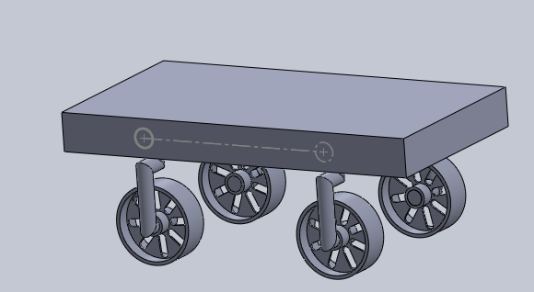
2.
In the URDF model we edited the angular limitations, and to avoid collapsing our model in Rviz we defined a dummy link and a pose for for it.
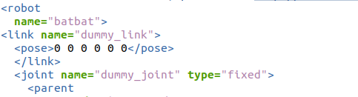

After the transmissions were added since we had two independent back wheels, we defined two transmissions to the back as well.
Adding the laser was straightforward, we just had to modify its path of it and define a joint to place it on the car, but we had to understand how the Xacro files work in general. When we tried to spawn the robot with laser the laser was on the ground after looking at the urdf we defined the point of laser in the xacro to correct it. We changed the simulation time to 0 in the competition arena world file to eliminate the spawn error we faced on ros.
In the config file, we had to implement the controllers/gains for the above-defined transmissions/motors. On the other hand, after launching the car using the given launch file we get errors regarding the ROS control gains, luckily, we were told by the TAs that we can just ignore those since it is an error on the software side not on ours.

3.
In the teleop we just defined our publisher to publish the control signals to a topic where the car in gazebo was subscribed. The sign of turn had to be negated, to achieve the proper gaming setup on the keyboard.

4.
We created a controller file that publishes to the defined topic, and using those values our robot moves along a circle. A subscriber was also created, to check the published values.

The project was very useful, planning a car from zero and controlling it in a virtual environment, we learned a lot about how ROS works, on the other hand in the future we need to concentrate on the files that were given since they made our work much easier, we understand them but next time we need to create them as well to get to know them by heart.

I worked with Patrik in this project, our contribution was equal all in all. I was more active during the while working with ros, packages, coding in python and trouble shooting the errors faced, he was more active while making the cad model and urdf. While both of us had fixed meetings on wed and all the work we did was together. It was a good learning experience.

In conclusion, we liked the task and as a development proposal in the future, we could optimize the car’s weight and design it a bit fancier, but it was fine for now.

Video 1:
https://drive.google.com/file/d/1iLMbaXpSmjRqy4bO7uBMSspzR54qYwZ7/view?usp=share_link

Video 2:
https://drive.google.com/file/d/1iLMbaXpSmjRqy4bO7uBMSspzR54qYwZ7/view?usp=share_link

