IBM HR Employee Attrition Analytics
Complete Project Documentation, Analytics Results & Feature Guide
CSV-driven full-stack analytics application

1. Project Overview
IBM HR Employee Attrition Analytics is a full-stack, CSV-driven data analytics project designed to understand employee attrition patterns, identify factors associated with employee turnover, produce employee-level risk scores, and present the results through an interactive frontend and a reproducible Python/Jupyter analytics pipeline.
The project is intentionally data-driven rather than hard-coded. The same workflow can be applied to another compatible employee CSV: the uploaded dataset becomes the active dataset and the descriptive statistics, charts, model results, risk scores, and generated documentation outputs are recalculated from that data.

2. Project Objectives
- Analyze the distribution and overall rate of employee attrition.
- Explore relationships between attrition and demographic, job, compensation, satisfaction, tenure, overtime, and work-environment variables.
- Identify important variables associated with the attrition target using a machine-learning model.
- Generate employee-level attrition risk scores for analytical prioritization.
- Provide an interactive frontend where users can inspect KPIs, charts, filters, and employee-level results.
- Provide a backend API for dataset upload and analysis access.
- Keep the analysis reproducible through a single all-in-one Jupyter notebook.
- Generate professional graph, report, and presentation outputs from the active CSV.

3. Key Features
Feature | Description
CSV Upload & Validation | Accepts a compatible employee CSV and validates the required analytical structure before processing.
Dynamic Dataset Analysis | All dataset-dependent calculations are regenerated from the active CSV instead of relying on fixed values.
Automated Data Cleaning | Handles categorical encoding, numerical preparation, missing-value treatment where applicable, and modeling-ready transformations.
Exploratory Data Analysis | Produces attrition distributions and relationship-focused charts for major HR dimensions.
KPI Dashboard | Displays employee count, attrition count/rate, and other derived indicators from the current dataset.
Interactive Filtering | Allows users to inspect subsets of employees using available frontend filters.
Predictive Modeling | Trains an attrition classification model and reports standard test metrics.
Employee Risk Scoring | Generates employee-level predicted probabilities/risk scores from the trained model.
Visual Reporting | Stores graph images and analysis-result images for inclusion in project documentation.
DOCX & PPTX Reporting | Creates a detailed written report and executive presentation containing project context, results, and visuals.
Reproducible Notebook | A single all-in-one notebook contains the complete analytical workflow and can be rerun with a different CSV.

4. System Architecture
The project consists of four connected layers:
Data Layer: Input employee CSV, cleaned dataset, analysis summary, model metrics, and employee risk scores.
Analytics Layer: Python/pandas preprocessing, exploratory analysis, feature engineering, model training, evaluation, and risk scoring.
Backend Layer: API responsible for accepting uploaded CSV data and exposing current employee/analysis data to the application.
Frontend Layer: Interactive dashboard for KPIs, charts, filters, employee analysis, and visualization of the current dataset.

5. How the CSV Upload Changes the Analysis
This is a central feature of the project. The application should not display the old IBM HR numbers after a new compatible CSV is uploaded. Instead, the newly uploaded CSV becomes the source dataset.
- Upload a new CSV through the frontend.
- Backend validates the file and loads the dataset.
- The active dataset is replaced by the newly supplied data.
- KPI values are recalculated from the new rows.
- Charts and distributions are recalculated from the new columns/values.
- The analytical/modeling pipeline uses the new data when its required target and features are available.
- Employee-level risk results are generated from the current dataset.
- Notebook/report outputs can be regenerated so the documentation reflects the new CSV.
Therefore, the numerical results in this report describe the currently supplied IBM HR CSV only; they are not universal constants and will change when a different dataset is used.

6. Current CSV / Dataset Details
Dataset item | Current value
Records | 1,470
Columns | 36
Attrition count | 237
Attrition rate | 16.12%
Overtime attrition rate | 30.53%
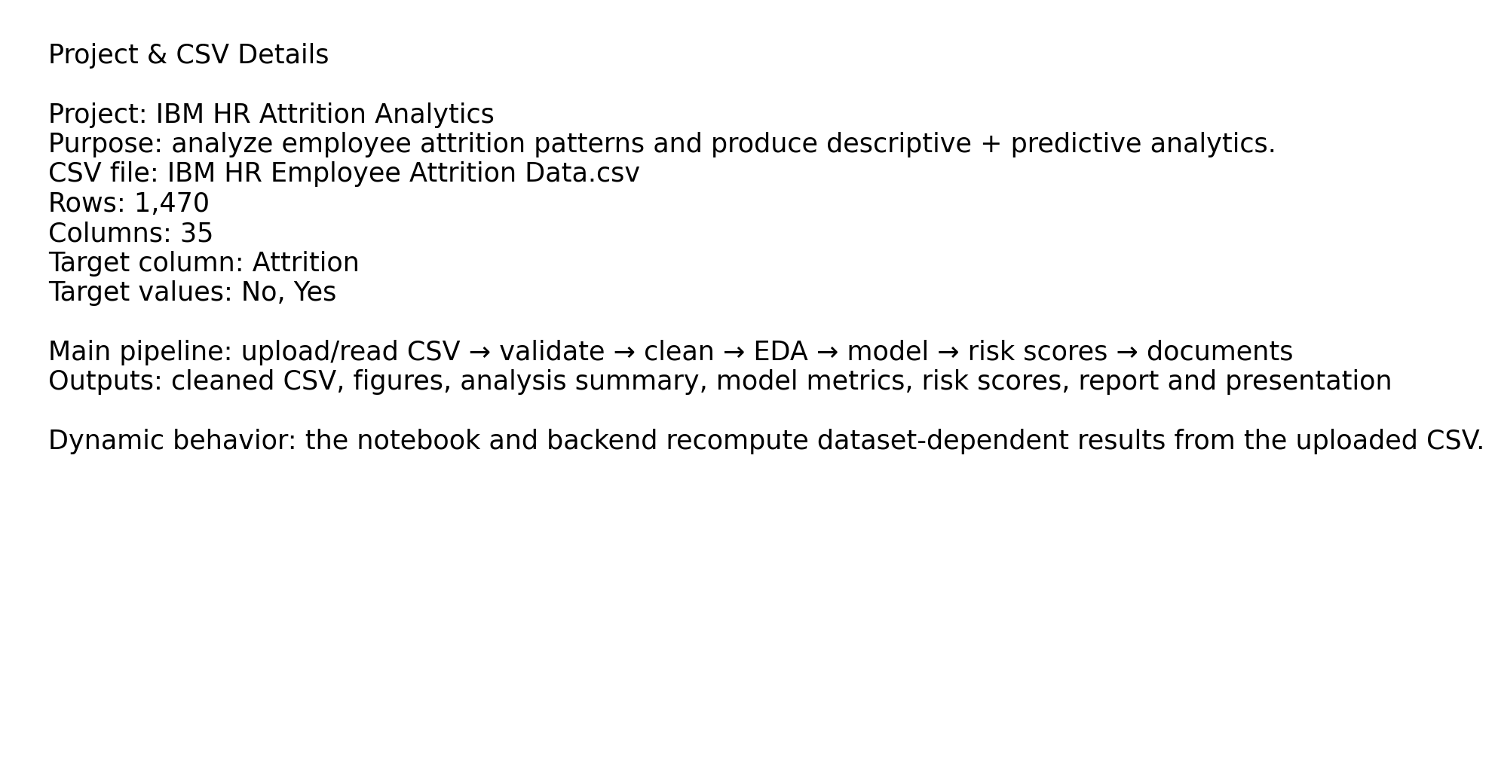
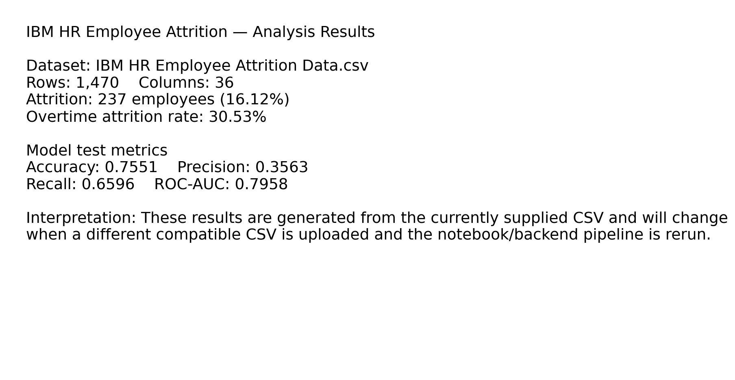

7. Analytics Methodology
Data ingestion: Read the supplied CSV and identify the target and usable analytical fields.
Data preparation: Separate target from predictors and prepare numerical/categorical variables for analysis and modeling.
Exploratory analysis: Calculate counts, rates, distributions, and group-level attrition patterns.
Feature processing: Transform categorical features and prepare the modeling matrix.
Model training: Train a classification model using a train/test split.
Evaluation: Calculate accuracy, precision, recall, ROC-AUC, and the confusion matrix on the test set.
Risk scoring: Produce employee-level predicted probabilities where the required model inputs are available.
Reporting: Save charts, metrics, risk scores, and presentation/document artifacts.

8. Current Model Results
Metric | Current result
Accuracy | 0.7551
Precision | 0.3563
Recall | 0.6596
Roc Auc | 0.7958
Training records: 1,176
Test records: 294
Confusion matrix: [[191, 56], [16, 31]]

9. Visual Analytics
The project includes graph images generated from the current dataset. These images are also embedded in the project report and presentation so the document can be reviewed without opening the application.
01 Attrition By Tenure
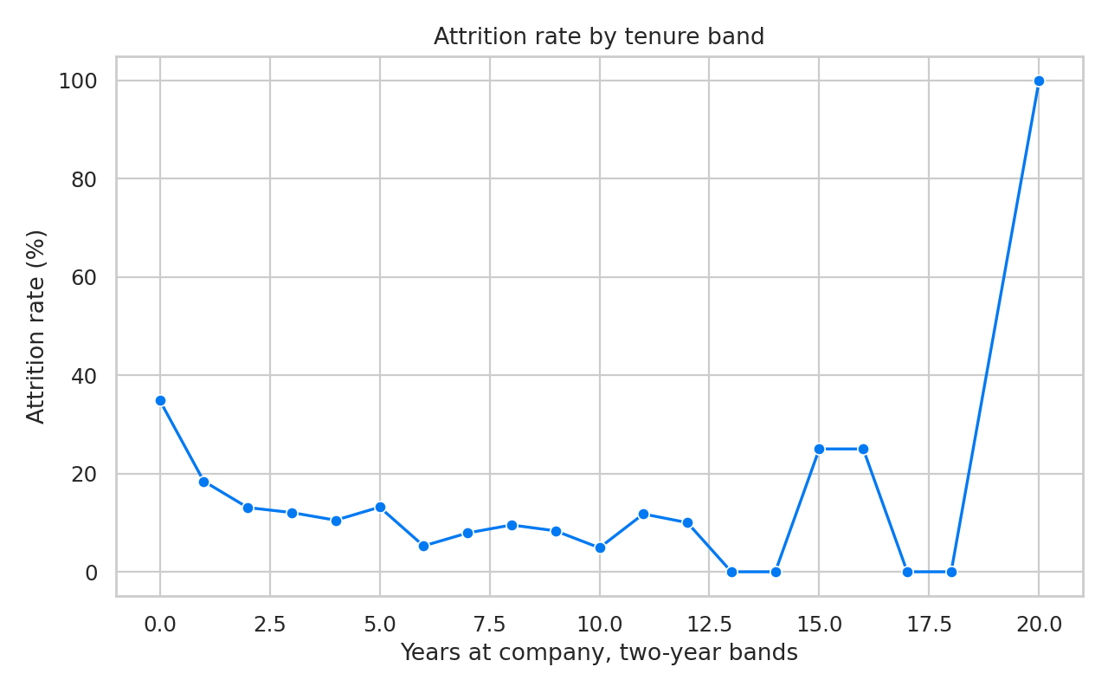
02 Attrition By Department
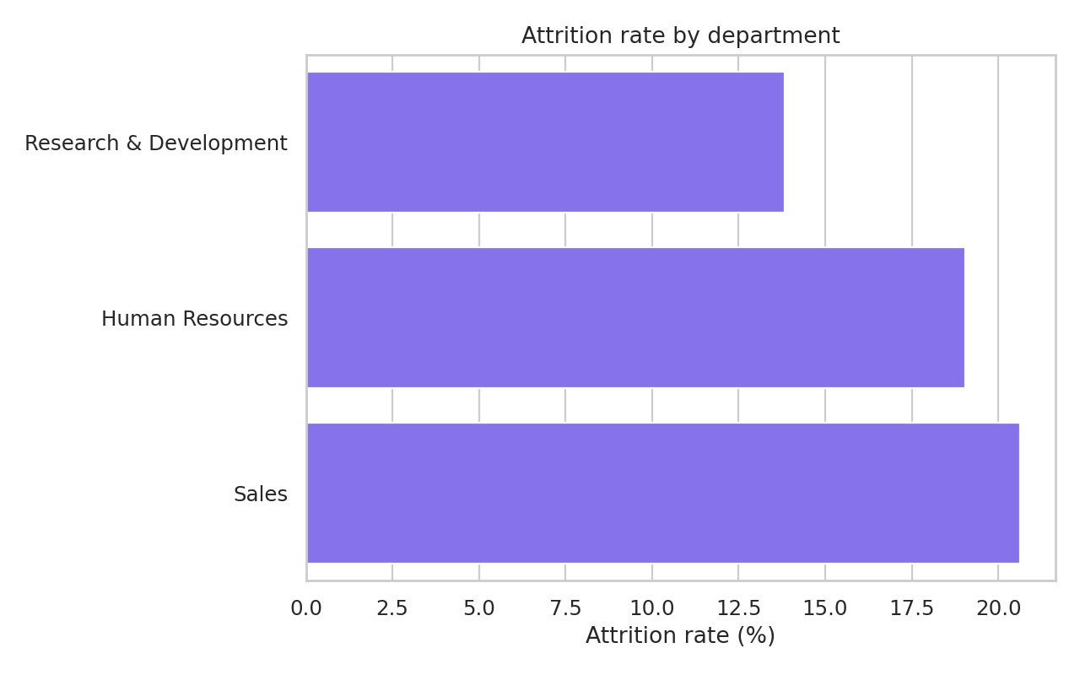
03 Attrition By Overtime
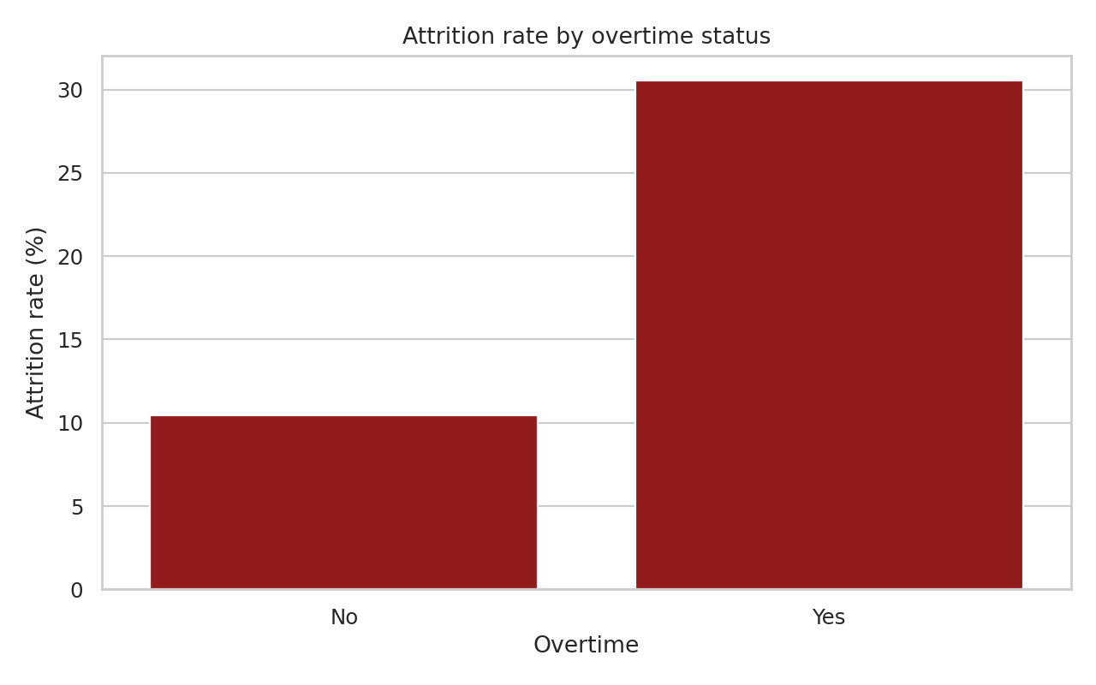
04 Attrition By Role
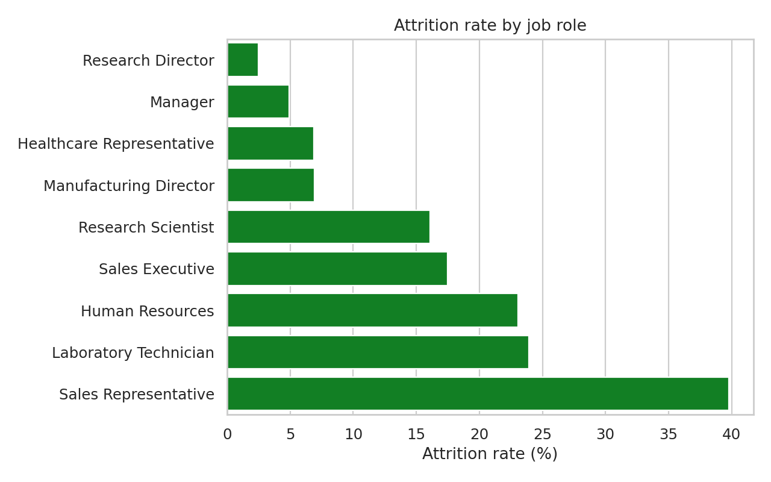
05 Attrition Split Overtime
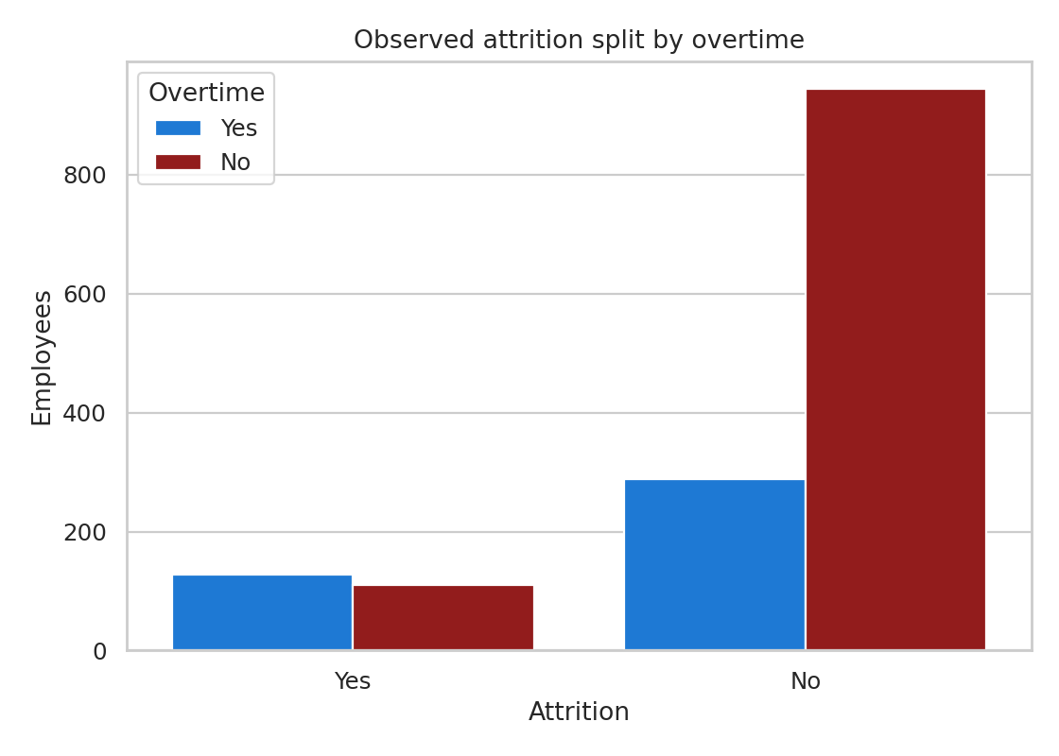

10. Frontend Features
- Dashboard-style KPI presentation.
- Interactive attrition charts and analytical visualizations.
- Employee-level filtering and inspection.
- CSV upload workflow.
- Refresh of the active dataset after upload.
- Display of current dataset-driven employee and attrition information.
- Use of backend API data rather than permanently fixed dashboard values.

11. Backend Features
- CSV upload endpoint.
- Input validation and dataset handling.
- Current employee-data access for the frontend.
- Dataset-dependent analysis behavior.
- Automated test coverage for backend behavior.
- Support for the workflow in which a newly uploaded CSV changes the analysis.

12. Notebook
The project includes a single all-in-one Jupyter notebook containing the complete analytical workflow. It is intended to make the project easy to demonstrate, reproduce, audit, and rerun with a different CSV.
Recommended notebook flow: configure/select CSV → validate → load → clean → explore → visualize → train/evaluate model → generate risk scores → export analysis outputs.

13. Project Deliverables
- All-in-one Jupyter notebook
- Frontend application
- Backend API
- Input and cleaned CSV data
- Generated graph images
- Analysis summary and model metrics
- Employee risk scores
- Comprehensive DOCX project report
- Executive PPTX presentation
- Testing/validation documentation

14. Interpretation & Limitations
Attrition modeling identifies statistical patterns in the supplied dataset; model probabilities should not be treated as certain outcomes about individual employees. Results depend on the quality, structure, time period, population, and feature availability of the uploaded CSV.
If a different CSV has different column names or lacks the required target/features, the project may need a compatible mapping or configuration before the complete modeling workflow can run.

15. Reproducibility & Usage
- Open the all-in-one notebook.
- Select or replace the CSV input.
- Run the notebook from the beginning to regenerate the analysis.
- For application use, start the backend and frontend and upload the CSV through the dashboard.
- Review the regenerated figures, metrics, risk scores, DOCX report, and PPTX presentation.

16. Conclusion
This project provides an end-to-end HR attrition analytics workflow: data ingestion, preparation, exploration, visualization, predictive modeling, risk scoring, API integration, interactive frontend presentation, and professional reporting. Its key design principle is that the analysis is driven by the active CSV, allowing the same project to be reused for a different compatible employee dataset.

17. Dataset Source & Kaggle Reference
The IBM HR employee attrition dataset used as the reference dataset for this project is available through Kaggle. The project documentation uses the following Kaggle dataset page as the source/reference link:
Kaggle dataset: IBM HR Employee Attrition Analysis
https://www.kaggle.com/datasets/nibeditasahu/ibm-hr-employee-attrition-analysis?hl=en-GB
The project is designed so that the supplied CSV remains replaceable: users can upload another compatible employee-attrition CSV and rerun the analysis. Therefore, the Kaggle link identifies the reference dataset used for this project and does not restrict the application to that dataset.
The broader IBM HR Analytics Employee Attrition & Performance dataset is commonly described as a fictional IBM data-science dataset containing employee/job attributes and an Attrition target; the Kaggle ecosystem also contains analyses using this dataset. Reference: Kaggle dataset documentation and related Kaggle analyses.

