E-commerce - mCart
High-Level Design Document

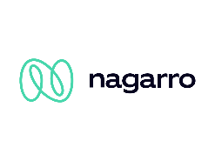
Nagarro Software Pvt. Ltd.

Revision History
Version | Date | Author/Contributor | Comments
1.0 | 24th Nov 2025 | Shivam Sharma | define the key sections in the hld
1.1 | 05th Dec 2025 | Shivam Sharma | intro, overview, considerations and nfrs
1.2 | 15th Dec 2025 | Shivam Sharma | architecture and external integrations
1.3 | 28th Dec 2025 | Shivam Sharma | deployment and tech stack
1.4 | 1st Jan 2026 | Shivam Sharma | add more context via diagrams
2.0 | 15th Jan 2026 | Shivam Sharma | design changes
2.1 | 16th Apr 2026 | Shivam Sharma | WAF and Cloud armor discussion
2.2 | 17th Apr 2026 | Shivam Sharma | Event-driven service level use cases
2.3 | 19th Apr 2026 | Shivam Sharma | Technology discussions

Contents
1. Introduction 5
2. System Overview 5
3. Design Considerations 6
3.1. Assumptions and Dependencies 6
3.2. General Constraints 6
3.3. Goals and Guidelines 6
4. NFR Considerations 7
4.1. User Experience & Usability 7
4.2. Reliability & Availability 7
4.3. Performance & Scalability 7
4.4. Security & Compliance 7
4.5. Operability & Supportability 8
4.6. Infrastructure & Runtime Environment 8
4.7. Implementation Constraints 8
5. Solution Architecture 9
5.1. Logical Architecture Overview 9
5.2. High-Level Solution Architecture Diagram 10
5.3. Components Description 11
5.3.3. Authentication & Authorization Service 12
5.3.4. Product Catalog Service 12
5.3.5. Product Indexer Service (Search Synchronization) 13
5.3.6. Search Service 13
5.3.7. Cart Service 14
5.3.8. Order Service 14
5.3.9. Payment Service 14
5.3.10. Inventory Service 14
5.3.11. Notification Service 15
5.3.12. Reporting & Analytics Service 15
5.3.13. External Integrations 15
5.4. Event-Driven Asynchronous Workflows (Service-Level Use Cases) 16
5.5. Key Interaction Flows (Sequence Diagrams) 20
5.5.1. Auth flow - Signup 20
5.5.2. Auth flow - Login 21
5.5.3. Checkout flow 22
5.5.4. Product Search flow 23
5.5.5. Search Architecture & Product Index Synchronization 24
6. External Systems Integration 25
6.1. Integration Components Description 25
6.1.1. Payment Gateway 25
6.1.2. Notification Providers 25
7. Deployment Architecture 27
7.1 Deployment Diagram 27
7.2 Components Description 28
7.2.1 Cloud Build 28
7.2.2 Artifact Registry 28
7.2.3 Google Kubernetes Engine 28
7.2.4 API Gateway / Load Balancer 28
7.2.5 Databases & Storage 29
7.2.6 Warm Cluster & Failover Strategy 29
7.2.7 Cloud Armor & WAF Protection 30
7.3 DevOps & CI/CD Pipeline 32
8 Technology Stack 33
9 Data Architecture 34
9.1 Data Technology Discussions 35
9.1.1 PostgreSQL 35
9.1.2 Firestore 35
9.1.3 Redis 36
9.1.4 Elasticsearch 37
9.2 High-Level Entity Relationship Diagram 38
9.2.1 Auth Domain ER Diagram 38
9.2.2 User Domain ER Diagram 39
10 References 39

Introduction
This High-Level Design (HLD) describes the proposed architecture and design principles for the e-commerce platform. The objective is to deliver a scalable, secure, and high-performance online shopping system supporting product discovery, cart management, checkout, payments, and post-order workflows.

The design emphasizes:
- High availability and scalability
- Secure payment processing
- Modular, independently deployable services
- Smooth customer experience across devices

System Overview
The e-commerce platform will be available as a web application with a responsive UI supporting desktop, tablet, and mobile browsers.
The backend follows a microservices-based architecture, deployed on cloud infrastructure, and integrates with external services for authentication, payments, email, and search.
Key capabilities include the following:
- User authentication & profile management
- Product catalog, search, filtering, and recommendations
- Cart, checkout, coupon, and order lifecycle
- Inventory and pricing management
- Admin operations and reporting
- Notifications and emails
- Data Storage and Analytics
- Backups and DR

Design Considerations
Designed for millions of users and high traffic peaks (sales, promotions).
Key considerations include the following:
- Stateless services for horizontal scalability.
- Database-per-service and polyglot persistence.
- Event-driven workflows for checkout, notifications, and inventory updates.
- Strong consistency for orders, payments, and inventory reservations.
- Source code management and code quality checks.
- Containers for microservices
- Event driven system for asynchronous communication

Assumptions and Dependencies
- Web application only (mobile app is future scope).
- Cloud-hosted deployment in a single region initially.
- Payments handled via PCI-compliant external gateway (no card data stored).
- Product images and static assets are stored in object storage and CDN for faster delivery.
- English language and USD currency initially.
- Inventory managed centrally by admin.
- Some operations are strongly consistent (orders, payments), others are eventually consistent (analytics, recommendations).

General Constraints
- Microservices increase operational complexity initially.
- Network latency between services must be managed via caching and async events.
- Distributed data consistency requires careful orchestration (Saga patterns).
- Initial deployment limited to one cloud region.

Goals and Guidelines
- Loose coupling and independent deployments
- Horizontal scalability and auto-scaling
- High availability with no single point of failure
- Secure-by-design (Zero Trust, least privilege)
- Observability-first (logs, metrics, traces)
- Clear separation of read vs write workloads

NFR Considerations
Following are the key constraints that specify the quality attributes of the e-commerce application.

User Experience & Usability
- Responsive UI for desktop, tablet, and mobile browsers.
- Clear navigation and consistent look & feel across pages.
- Strong client-side validations to prevent user errors.
- Guest checkout supported.
- Minimal steps to complete purchase.
- Help pages, FAQs, and contextual error messages.

Reliability & Availability
- Target availability: 99.9% uptime (excluding planned maintenance).
- No single point of failure at the application or database level.
- Automatic retries for transient failures.
- Graceful degradation for non-critical features (reviews, recommendations).
- RTO ≤ 4 hours, RPO ≤ 15 minutes.

Performance & Scalability
- Home page load ≤ 3 seconds on standard broadband / 4G.
- The Search API is designed to achieve a ≤ 500 ms response time (P95) to ensure the overall page load stays within the 3-second NFR.
- Support 5,000+ concurrent users initially.
- Horizontal auto-scaling of stateless services.
- Caching (Redis/CDN) for catalog, pricing, and static assets.
- Asynchronous processing for emails, notifications, and analytics.

Security & Compliance
- TLS 1.2+ for all external and internal communication.
- Token-based authentication (JWT / OAuth2).
- Role-based access control (RBAC) for admin features.
- Encryption at rest for sensitive data.
- Secure password hashing (bcrypt/argon2).
- No storage of payment card data (PCI-DSS compliance).
- Automatic logout after inactivity.

Operability & Supportability
- Containerized services for predictable deployments.
- CI/CD pipelines with automated tests and quality gates.
- Centralized logging and monitoring.
- Alerts for failures, latency spikes, and resource exhaustion.
- Blue-green or rolling deployments for zero downtime.
- Clear runbooks and deployment documentation.

Infrastructure & Runtime Environment
Clients
- Modern browsers: Chrome, Firefox, Safari, Edge
- Responsive design for multiple screen sizes
Backend
- Containerized microservices
- Managed databases (RDBMS + NoSQL)
- Managed messaging and caching
Platform
- Cloud-based IaaS / PaaS
- Auto-scaling compute
- Load balancers and API gateway
- Centralized observability stack

Implementation Constraints
- Java-based backend (portable across OS).
- RESTful APIs with well-defined contracts.
- Database-per-service pattern enforced.
- Sensitive data encrypted at rest and in transit.
- Eventual consistency accepted for non-transactional data.
- Archival and data retention policies enforced.
- Frontend compatible with evergreen browsers.

Solution Architecture
The solution architecture follows a cloud-native, microservices-based architecture deployed on Google Cloud Platform (GCP). The solution is designed to be highly scalable, reliable, secure, and suitable to cater to the features of a typical ecommerce application.

Logical Architecture Overview
This section presents the logical architecture of the platform, highlighting major layers, domains, and responsibilities independent of deployment or infrastructure concerns.
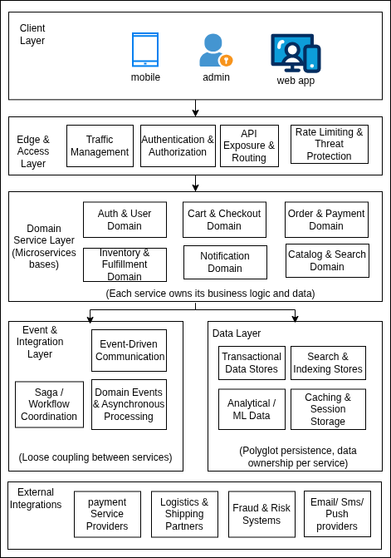
The high-level architecture diagram illustrates the following:
- Client applications interacting via an API Gateway with security aspects in place.
- Independent microservices communicating synchronously (REST) and asynchronously (event-driven messaging)
- Asynchronous messaging wherever possible for a highly performant system.
- Databases that meet requirements and analytics for insights.
- Trusted external payment systems for reliability and industry-level security and compliance.

High-Level Solution Architecture Diagram
The following diagram illustrates the high-level solution architecture, showing how logical components are realized using concrete technologies, infrastructure layers, security boundaries, and integrations.
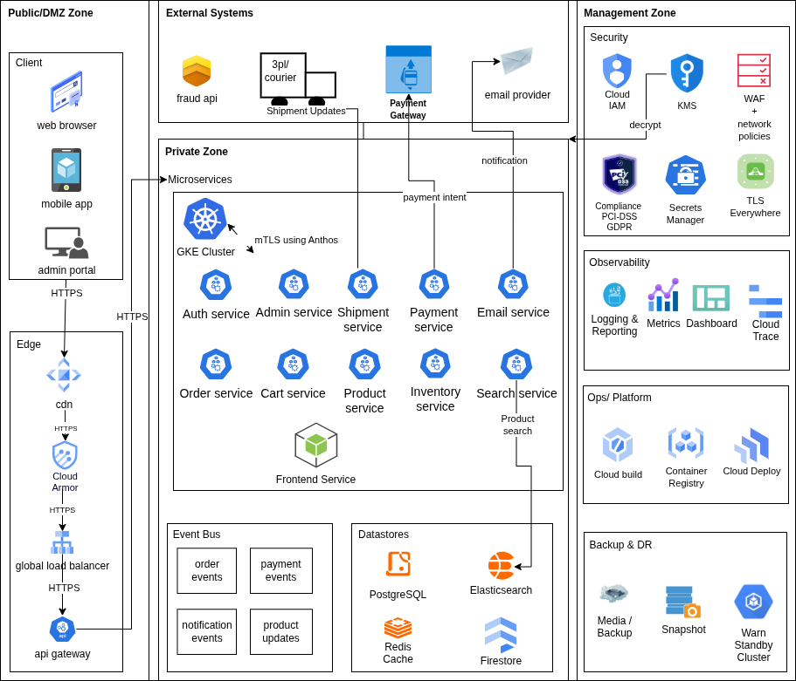

Components Description
The following components are part of the overall application structure:
    - E-Commerce Frontend (Web & Mobile)
This component is a customer-facing web application built using Angular and a mobile application (Android/iOS). The frontend application is deployed as a containerized service inside the Kubernetes cluster to support server-side rendering (SSR).
It supports:
- Product browsing and search
- User authentication and profile management
- Cart management and checkout
- Order tracking and notifications

SSR enables:
- Faster initial page loads
- Improved SEO for product and search pages
- Better performance on low-end devices

Role-based access ensures that:
- Customers can browse, place orders, and manage profiles
- Admin users access administrative dashboard (via separate Admin UI or secured routes)

The frontend SSR service communicates with backend APIs via the internal API gateway using secure HTTPS.
    - API Gateway
The API Gateway acts as the single entry point for all client requests.
Responsibilities:
- Request routing to appropriate backend services
- Authentication and authorization enforcement
- Rate limiting and request throttling
- Request/response transformation where required
JWT validation is performed at the GCP API Gateway before requests are forwarded to backend services.

Authentication & Authorization Service
Given the NFR requirement for explicit Argon2/bcrypt password hashing and the need to avoid vendor lock-in for core identity data, we propose a backend-managed authentication and authorization service. The system supports boe-commercerd-based and social logins using OAuth 2.0 while retaining full ownership of user data, tokens, and security policies.

Users are always created in our system regardless of authentication method. Social logins create a user without a password credential, linked via a provider-specific identity. This allows us to store carts, orders, and history consistently while supporting multiple login mechanisms per user.
Responsibilities:
- User registration and login
- Issuance of JWT tokens
- Integration with social identity providers

Authorization:
- Token validation is enforced at GCP API Gateway
- Backend services enforce role-based access control (RBAC)
- Custom claims are used to represent user roles
This approach decouples identity management from business services and improves security and scalability.

Product Catalog Service
This service manages:
- Product information
- Categories
- Pricing metadata
- Product availability
It supports optimized read operations for product search and listing and publishes product update events consumed by downstream services.
Persistence is handled using a nosql database, while frequently accessed data is cached.

Product Indexer Service (Search Synchronization)
This service is responsible for maintaining synchronization between the product catalog (Firestore) and the search index (Elasticsearch).
It ensures that search queries are served entirely from Elasticsearch without runtime dependency on the product catalog service.
Responsibilities:
- Consume product change events from Pub/Sub (product.events)
- Transform product data into a denormalized search document
- Update Elasticsearch index (create/update/delete)
- Handle retries and failures with DLQ support

Data Flow:
- Product Catalog Service writes product data to Firestore
- An event is recorded via the Outbox pattern
- Events are published to Pub/Sub
- The product indexer consumes events and updates Elasticsearch

Consistency Model:
- Eventual consistency (typically < few seconds delay)

Reliability:
- Idempotent event processing using eventId/productId
- Retry with exponential backoff
- Dead Letter Queue (product.events.dlq) for failed events
- Periodic reindex job for recovery/backfill

Search Service
The Search Service provides full-text and faceted search capabilities.
Responsibilities:
- Handling keyword-based and filtered searches
- Supporting autocomplete and relevance ranking
The service maintains a search index using a dedicated search engine.

Cart Service
This service manages:
- User carts
- Item additions/removals
- Cart price calculations
Cart data is stored in a low-latency data store and is scoped per user session or authenticated user.

Order Service
This service manages:
- Order creation and lifecycle
- Order status transitions
- Order persistence
It orchestrates interactions with:
- Payment Service
- Inventory Service
- Notification Service
Orders are persisted in a transactional relational database.

Payment Service
The payment service handles:
- Payment initiation
- Interaction with external payment gateways
- Payment status updates
This service does not store sensitive payment data and relies on tokenized responses from external providers.

Inventory Service
This service manages:
- Stock levels
- Inventory reservations during checkout
- Stock reconciliation
It reacts to order placement and cancellation events.

Notification Service
This service is responsible for:
- Sending email, SMS, and push notifications
- Order confirmations and status updates
It integrates with third-party notification providers and stores delivery logs.

Reporting & Analytics Service
This service aggregates data from multiple services to generate the following:
- Sales reports
- Order analytics
- Customer behavior insights
Data is generated asynchronously and optimized for read-heavy workloads.

External Integrations
The system integrates with:
- Payment Gateways
- Email/SMS Providers
- Analytics platforms
- Shipment Operator
All integrations are isolated within dedicated services to reduce coupling.

Event-Driven Asynchronous Workflows (Service-Level Use Cases)
To achieve scalability, loose coupling, and resilience, the platform leverages event-driven asynchronous communication using a messaging system (Google Pub/Sub). This section details key service-level asynchronous workflows, including event producers, consumers, delivery guarantees, and failure handling strategies.

    - OrderPlaced Flow
Trigger: The user completes checkout, and the order is successfully created.
Event:
{
"eventId": "uuid",
"eventType": "OrderPlaced",
"orderId": "12345",
"userId": "u123",
"items": [...],
"totalAmount": 250.00,
"timestamp": "..."
}

Publisher: Order Service
Topic: order.events
Subscribers & Side Effects:
- Inventory Service → reserves stock
- Payment Service → initiates payment workflow
- Notification Service → sends order confirmation
- Analytics Service → records order metrics
Idempotency: Key: orderId + eventId. Consumers maintain processed event logs to avoid duplicates
Retry Policy: Exponential backoff (max retries: 5)
DLQ: Topic: order.events.dlq. Manual replay via admin tooling after issue resolution
Consistency Model: Strong consistency for order creation
Failure Handling: Inventory reservation failure triggers compensating action (order cancellation)

    - PaymentCaptured Flow
Trigger: Payment gateway confirms successful payment (via webhook)
Publisher: Payment Service
Topic: payment.events
Subscribers & Side Effects:
- Order Service → updates order status to CONFIRMED
- Inventory Service → converts reservation to final deduction
- Notification Service → sends payment confirmation
Idempotency: Key: paymentId (from gateway)
Failure Handling: Duplicate webhooks handled via idempotent processing (prevents double-charging)
DLQ & Replay: Failed events moved to payment.events.dlq

    - InventoryAdjusted Flow
Trigger: Inventory changes due to order, cancellation, or admin update
Publisher: Inventory Service
Topic: inventory.events
Subscribers:
- Search Service → updates product availability index
- Product Catalog Service → updates availability metadata
Consistency: Eventual consistency acceptable (minor delay in stock visibility)
Idempotency: Key: productId + version
Failure Handling: Search index lag tolerated temporarily

    - ProductUpdated Flow
Trigger: Product creation/update in Catalog Service
Publisher: Product Catalog Service
Topic: product.events
Subscribers:
- Search Service → updates Elasticsearch index
- Cache layer → invalidates stale entries
Consistency: Eventual consistency (search results may lag briefly)
Retry & DLQ:
- Failed indexing → retried
- Persistent failures → moved to product.events.dlq
Recovery:
A full reindex job available for repair

    - Notification Dispatch Flow
Trigger: Any business event requiring user communication
Publisher: Multiple services (Order, Payment, Shipment)
Topic: notification.events
Subscriber: Notification Service
Processing:
- Sends email/SMS/push via external providers
- Logs delivery status
Idempotency: Key: notificationId
Failure Handling:
- Retry on transient provider failures
- DLQ for permanent failures
- Manual resend supported

    - Cross-Cutting Concerns
Idempotency Strategy
All consumers implement idempotent handlers using:
- Event ID tracking
- Database constraints (unique keys)
- Redis-based short-term deduplication (optional)
Outbox Pattern
To avoid dual-write issues:
- Events are stored in the service database (outbox table)
- Background process publishes to Pub/Sub
- Guarantees atomicity between DB write and event publish
Dead Letter Queue (DLQ) Strategy
- Each topic has a corresponding DLQ
- Poison messages are isolated after retry exhaustion
- Admin tooling supports:
  - Inspection
  - Replay
  - Discard

Key Interaction Flows (Sequence Diagrams)

Auth flow - Signup

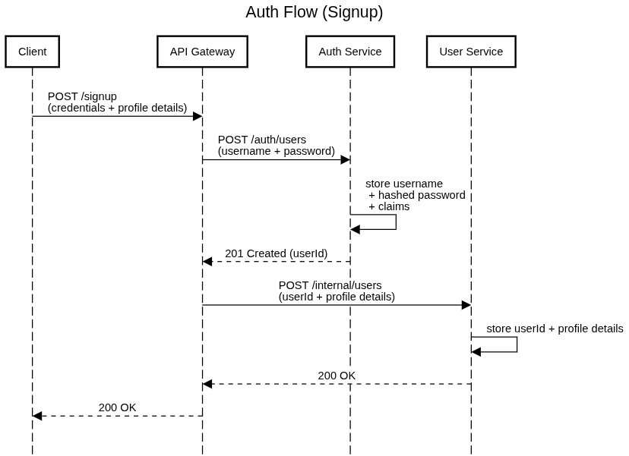

Auth flow - Login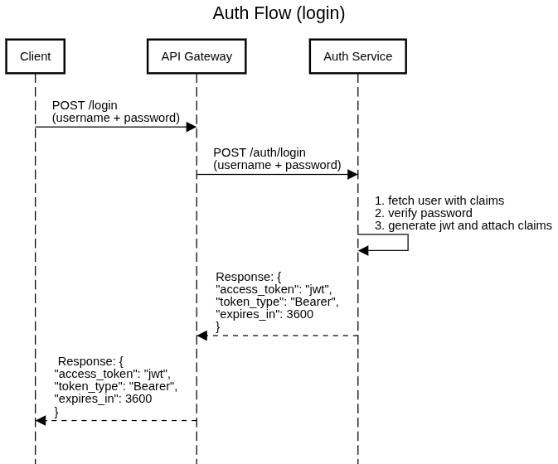

Checkout flow
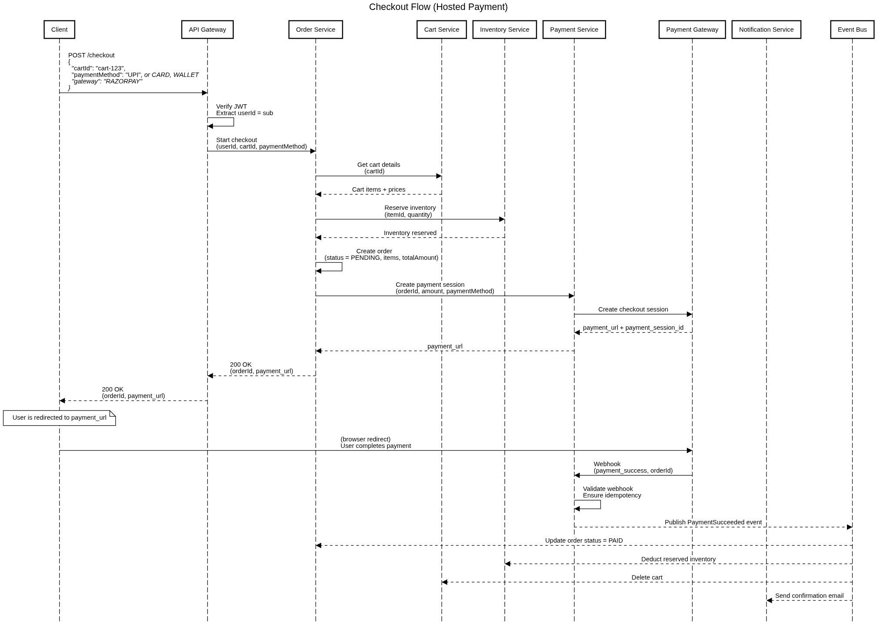

Product Search flow

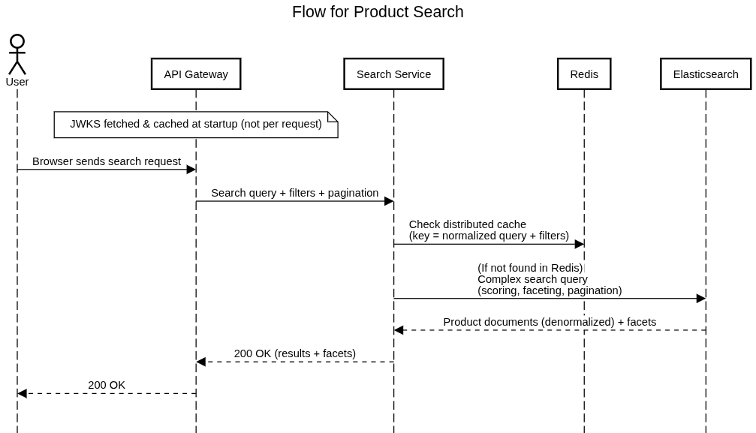

Search Architecture & Product Index Synchronization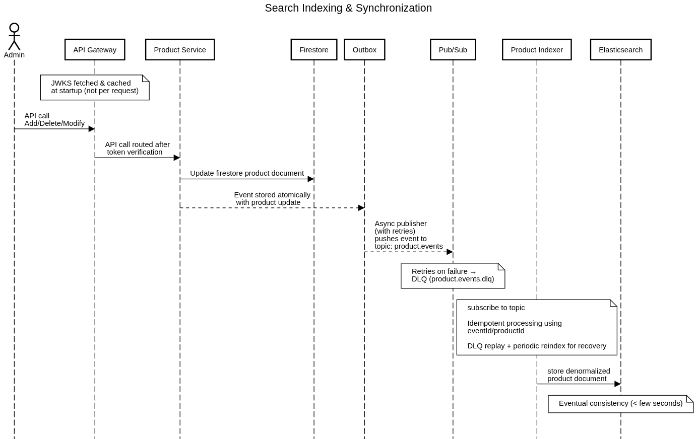

Product Image Upload
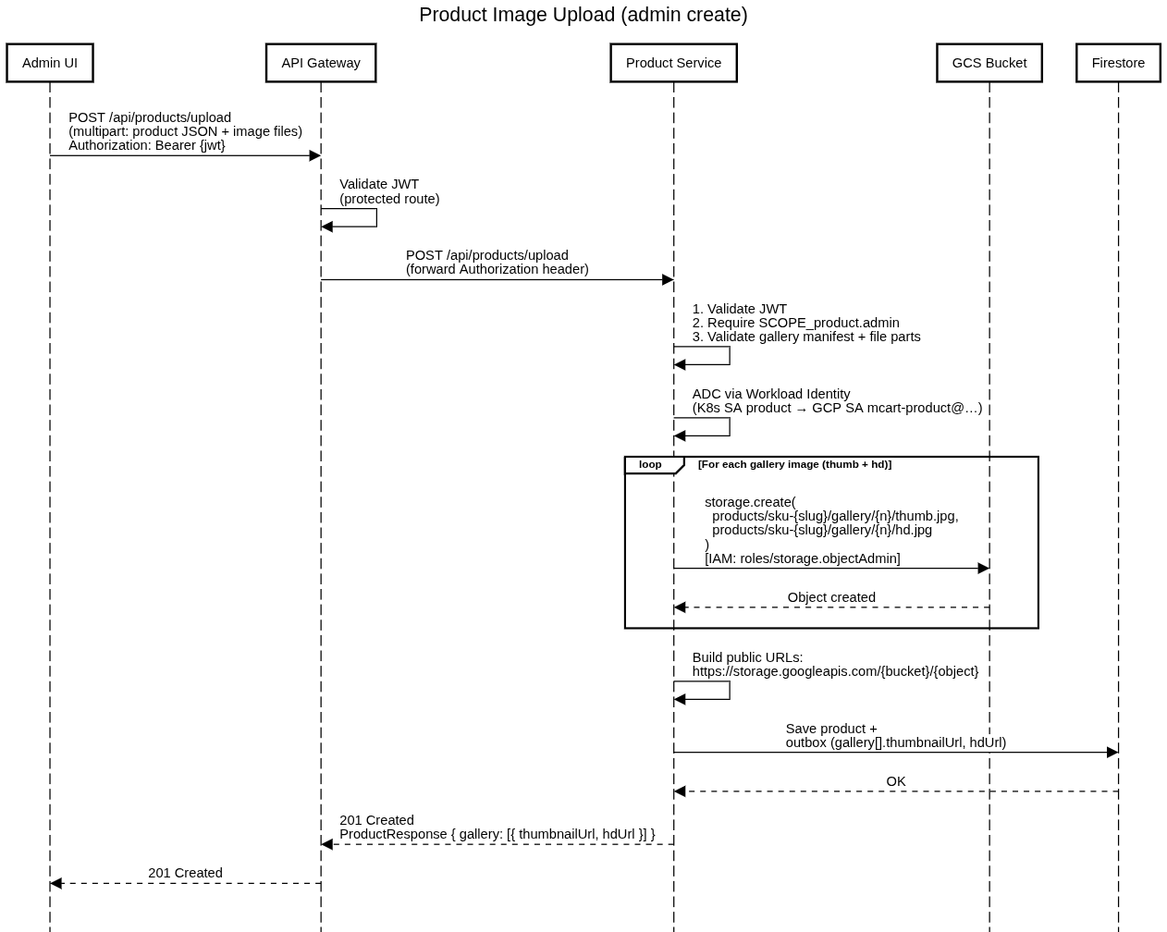

Product Image Read
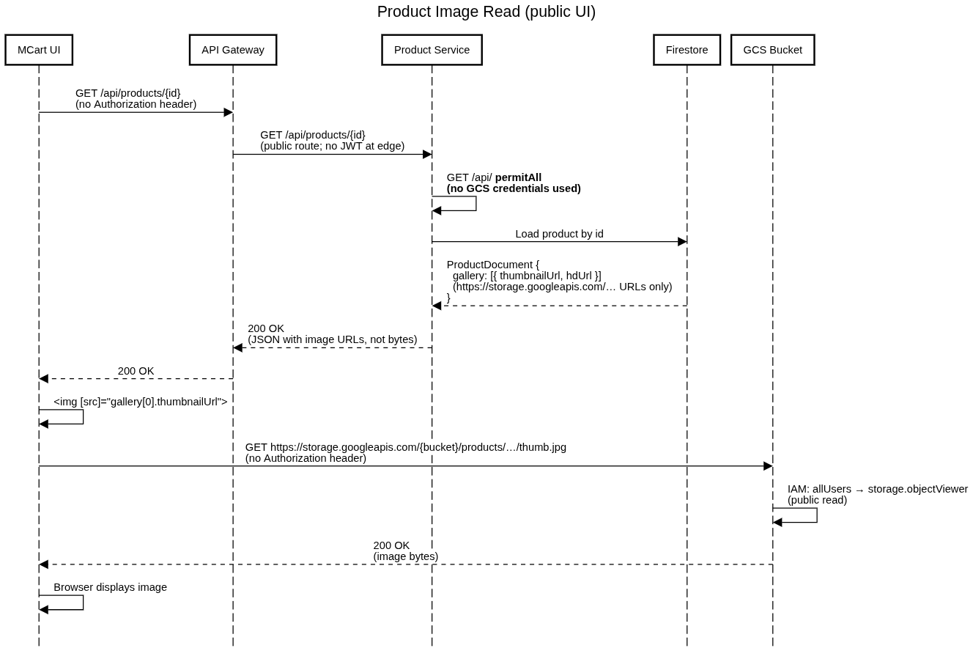

Gateway install
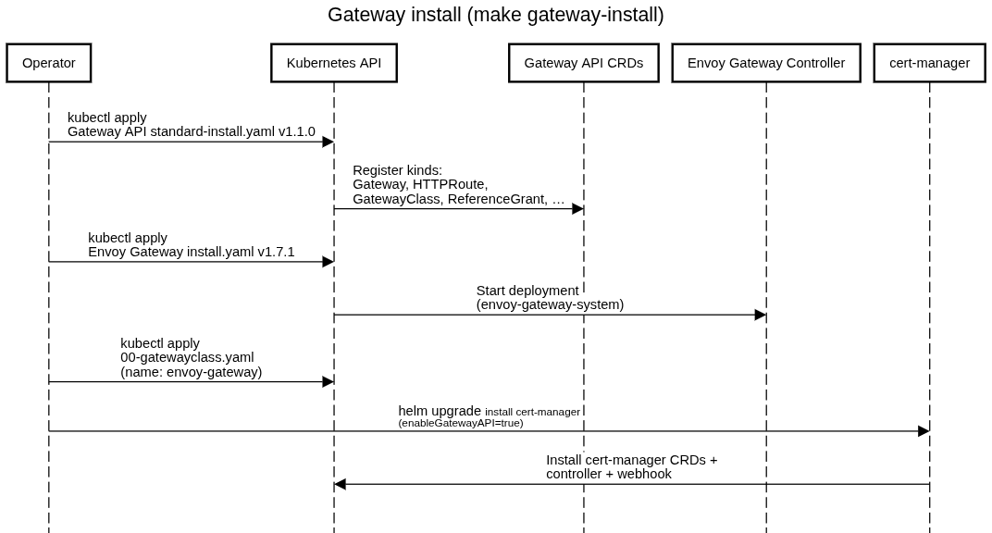

External Systems Integration
The e-commerce platform integrates with multiple external systems to support payments, shipment, notifications, and analytics.
All external integrations are isolated behind dedicated internal services to minimize coupling, improve resilience, and enforce security boundaries.

Integration Components Description
This section describes logical integration patterns with external systems. A detailed integration diagram is omitted as integrations are point-to-point and service-isolated.

Payment Gateway
The platform integrates with one or more third-party payment gateways to process customer payments.
Responsibilities:
- Payment authorization
- Payment capture
- Refund processing
Integration characteristics:
- Secure REST APIs over HTTPS
- Token-based payment handling
- No storage of sensitive payment details within the platform
The payment service abstracts gateway-specific logic from the rest of the system.

Notification Providers
External providers are used for:
- Email delivery
- SMS notifications
- Push notifications
The Notification Service integrates with these providers to send:
- Order confirmations
- Payment status updates
- Shipment notifications
Delivery attempts and responses are logged for auditing and troubleshooting.
    - Analytics & Monitoring Platforms
Analytics platforms are integrated to:
- Track user behavior
- Capture business metrics
- Monitor application performance
- Events are emitted asynchronously to avoid impacting user-facing latency.

    - Trade-offs and Design Considerations
- External systems introduce latency and availability dependencies
- All integrations are designed to be non-blocking where possible
- Circuit breakers, retries, and timeouts are applied
- Failures in external systems do not bring down core user flows

Deployment Architecture
The e-commerce platform is deployed on cloud infrastructure using a containerized, automated CI/CD approach. Infrastructure provisioning and application deployment are fully automated to ensure consistency across environments.

Deployment Diagram
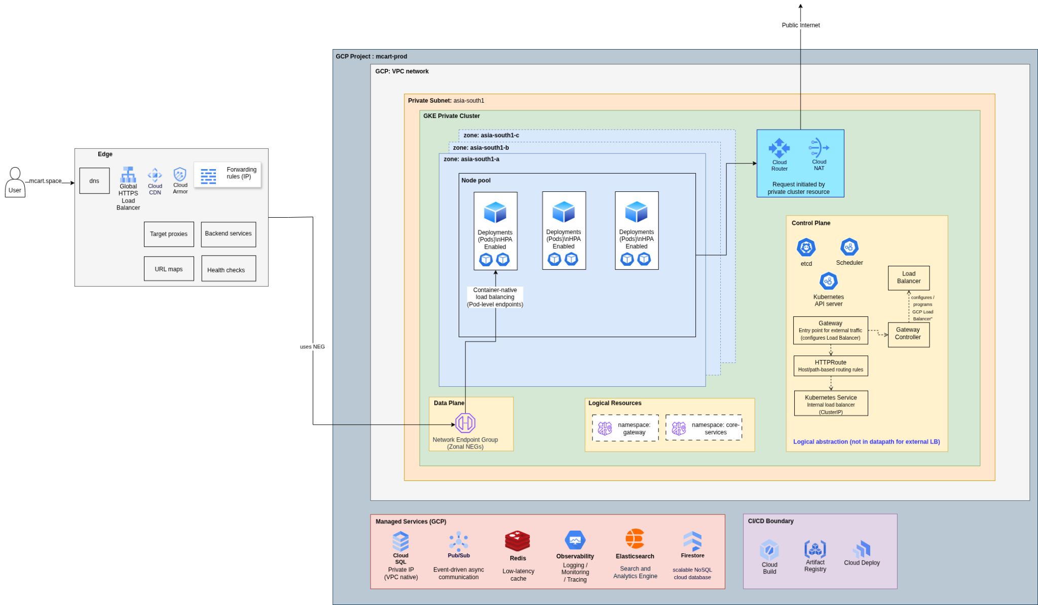
The deployment diagram highlights:
- CI/CD pipeline flow
- Container image lifecycle
- Runtime orchestration
- Environment isolation

Components Description

Cloud Build
Cloud build is used as the CI/CD tool for the mcart application
Responsibilities:
- Build and test microservices
- Build Docker images
- Push images to container registry
- Trigger deployments to target environments
Pipeline behavior:
- Feature branch → CI build & tests
- Develop branch → Deployment to Dev environment
- Release branch → Deployment to Staging
- Tagged release → Deployment to Production

Artifact Registry
GCP Artifact Registry is used as the image repository in all the environments.
Characteristics:
- One repository per microservice
- Images tagged using:
- Semantic version
- Commit hash

Google Kubernetes Engine
Microservices are deployed as containers on a managed GKE cluster.
Capabilities:
- Service discovery
- Auto-scaling
- Health checks
- Rolling deployments
- Zero-downtime releases
Each microservice runs independently with its own configuration.

API Gateway / Load Balancer
Acts as the single public entry point.
Responsibilities:
- TLS termination with re-encryption to backends
- Routing requests to backend services
- Load balancing
- Health-based traffic routing

Databases & Storage
- Each microservice owns its database
- Relational databases are used for transactional data
- Nosql for flexible data like product catalog
- Object storage is used for static assets and documents
- Backups and high availability are configured per environment

Warm Cluster & Failover Strategy
To meet availability (99.9%) and disaster recovery targets (RTO ≤ 4 hrs, RPO ≤ 15 mins), the platform adopts an active-passive (warm) multi-region failover strategy.
Definition of Warm Setup
- Primary Region: Fully active GKE cluster serving all traffic
- Secondary Region (Warm):
  - GKE cluster provisioned with minimal baseline capacity
  - Scales up on failover (node auto-scaling)
  - No regular production traffic

This avoids the cost of active-active while ensuring faster recovery than cold standby.

Traffic Routing Strategy
- Global HTTP(S) Load Balancer (GCP) is used (not DNS failover)
- Both regions are configured as backends
- Only primary is active under normal conditions

Why LB over DNS:
- Faster failover (no TTL delays)
- Built-in health checks
- Transparent to clients
Health Checks & Failover Trigger
Failover is triggered when:
- GKE ingress / service endpoints fail health checks
- OR critical services (Order/Payment APIs) are unavailable

Mechanism:
- LB health checks mark primary backend as unhealthy
- Traffic is automatically routed to secondary region

Fallback: Manual SRE-triggered failover (runbook-driven)

Data Replication Strategy
- PostgreSQL (Orders, Payments):
  - Cross-region read replica / backup replication
  - Promote replica during failover
- NoSQL (Catalog - Firestore):
  - Multi-region / replicated by provider
- Redis:
  - Treated as cache → rebuilt after failover
- Search (Elasticsearch):
  - Rebuilt via async events or periodic reindex

Consistency & Data Loss (RPO)
- Up to 15 minutes of data lag possible (as per RPO)
- Critical flows (orders/payments) rely on:
  - DB durability
  - Idempotent retries post-recovery

Recovery & Failback
- Primary region restored after issue resolution
- Traffic gradually shifted back via LB
- Data re-synced before failback

Cloud Armor & WAF Protection
The platform uses Google Cloud Armor as a web application firewall (WAF) and DDoS protection layer deployed at the edge.
Cloud Armor policies are attached to the external HTTP(S) load balancer, which fronts the GKE cluster.
Coverage:
- OWASP threats (SQLi, XSS)
- Layer 7 DDoS
- IP reputation filtering
- Rate limiting (per IP)
- Optional geo restrictions
Why not API Gateway alone:
GCP API Gateway handles auth, routing, and quotas but does not provide full WAF or edge DDoS protection. Cloud Armor filters malicious traffic before it reaches the cluster, reducing the blast radius.
WAF Rules
Individual security rules/policies inside a WAF (like Cloud Armor).
Examples:
- Block requests with SQL injection patterns
- Allow only certain IP ranges

DevOps & CI/CD Pipeline
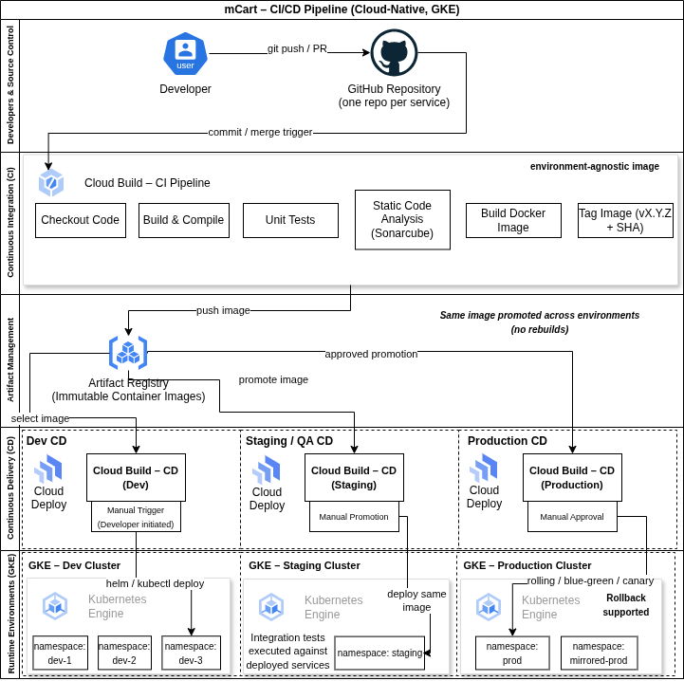
The CI/CD pipeline follows a build once, deploy many principle.
Pipeline Stages:
- Source code checkout
- Static code analysis
- Unit and integration tests
- Docker image build
- Image push to registry
- Environment-specific deployment
- Post-deployment health verification

Key Principles:
- Infrastructure as Code
- Environment parity
- Automated rollbacks
- Immutable deployments

Technology Stack
The e-commerce application is built using a cloud-native, scalable, and industry-standard technology stack.
The chosen technologies are widely adopted, well supported, and suitable for building highly available, distributed systems on Google Cloud Platform (GCP).
The application follows a microservices architecture, with independent deployment, scalability, and technology flexibility where required.
8.1 Technology Stack Overview
Area | Technology Used
IDE | IntelliJ IDEA
Presentation Layer | Angular, HTML5, CSS3, TypeScript
Backend Language | Java (JDK 17)
Backend Framework | Spring Boot, Spring Security
API Communication | REST (JSON), Event-driven messaging
Containerization | Docker
Container Orchestration | GKE
Cloud Platform | Google Cloud Platform (GCP)
API Gateway | GCP API Gateway
Databases (Polyglot) | PostgreSQL, Firestore, Redis
Search Engine | Elasticsearch
Object Storage | Cloud Storage
Messaging / Eventing | Google Pub/Sub
Source Code Management | Github
Build Tool | Gradle
CI/CD | Cloud Build
Infrastructure as Code | Terraform
Logging & Monitoring | Cloud Logging, Cloud Monitoring
Static Code Analysis | SonarQube

Data Architecture
The e-commerce platform follows a database-per-service pattern to ensure loose coupling, independent scalability, and clear data ownership.
Transactional Data:
- PostgreSQL is used for highly consistent transactional data, such as orders, payments, and users.
- Each core service owns its database schema.
Catalog & Flexible Data:
- NoSQL databases are used for product catalog data to support flexible schemas and high read throughput.
Caching:
- Redis is used for low-latency access to frequently used data such as carts and catalog lookups.
Search & Analytics:
- Search indexes are maintained separately for full-text search.
- Analytical data is generated asynchronously using events to avoid impacting transactional workflows.
Consistency Model:
- Strong consistency is enforced for orders, payments, and inventory reservations.
- Eventual consistency is accepted for analytics, reporting, and recommendations.

Data Technology Discussions

PostgreSQL
PostgreSQL is used as the primary transactional data store for services requiring strong consistency and ACID guarantees.
PostgreSQL Use Cases by Service
Consumer Service | Data Stored | Access Pattern | Failure Mode
Authentication Service | credentials, roles | Read-heavy + writes on login/signup | Service unavailable → login/signup fails
User Service | profile data, address | Read-heavy + writes on profile creation/updates | Profile data unavailable. Email delivery delayed  Blocked at shipment address
Order Service | Orders, order items, status | Write-heavy (checkout), read by users | Checkout blocked (critical path)
Payment Service | Payment transactions, status | Write + async updates | Payments retried / reconciled
Inventory Service | Stock levels, reservations | High write contention | Prevent overselling via DB constraints

Firestore
Firestore is used as a flexible, horizontally scalable NoSQL database for high-read, semi-structured data.
Firestore Use Cases by Service
Consumer Service | Data Stored | Access Pattern | Consistency | Failure Mode
Product Catalog Service | Products, categories, metadata | Read-heavy | Eventual (read optimized) | Fallback to cache miss → slower
Cart Service | User carts | Read/write | Eventual | The cart may be temporarily inconsistent

Redis
The platform uses Redis as a low-latency, distributed cache and ephemeral data store to improve performance and reduce load on primary databases. Redis is not treated as a generic cache but as a multi-purpose component with clearly defined responsibilities per service, as detailed below.
Redis Use Cases by Service
Consumer Service | Use Case | Key Pattern | TTL | Invalidation Strategy | Failure Mode
Cart Service | User cart storage (primary fast-access store) | cart:{userId} | 30 min – 24 hrs (sliding TTL) | On checkout / cart clear / item update | Fallback to DB (if used) or empty cart → user may lose cart (acceptable UX trade-off)
Product Catalog Service | Frequently accessed product data | product:{productId} | 5–30 mins | Invalidation on product update | Cache miss → fetch from NoSQL DB (slower)
Search Service | Search result caching (query-based) | search:{hash(query+filters)} | 1–10 mins | TTL-based (no manual invalidation due to high churn) | Cache miss → query Elasticsearch
Authentication Service | Session/token blacklist / refresh tokens | session:{tokenId} | Token lifetime | On logout / token revocation | Users may need to re-login
Order / Inventory | Short-lived locks / idempotency keys | lock:{resourceId} | Few seconds | TTL expiry | Duplicate processing risk (handled via DB safeguards)

Elasticsearch
Elasticsearch powers the search service for full-text search, filtering, and relevance ranking.
Redis Use Cases by Service
Consumer Service | Data Indexed | Access Pattern | Consistency | Failure Mode
Search Service | Product search index | Query-heavy | Eventual | Fallback limited / degraded search
Autocomplete | Keywords, suggestions | Low-latency reads | Eventual | Suggestions unavailable

High-Level Entity Relationship Diagram
The following ER diagrams represent the core business entities and their relationships for a few domains separately at a conceptual level.
It is intended to illustrate domain ownership and data boundaries, not physical database schemas.

Auth Domain ER Diagram

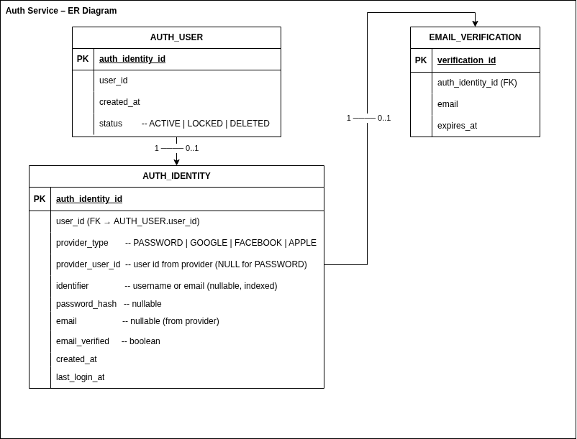

User Domain ER Diagram

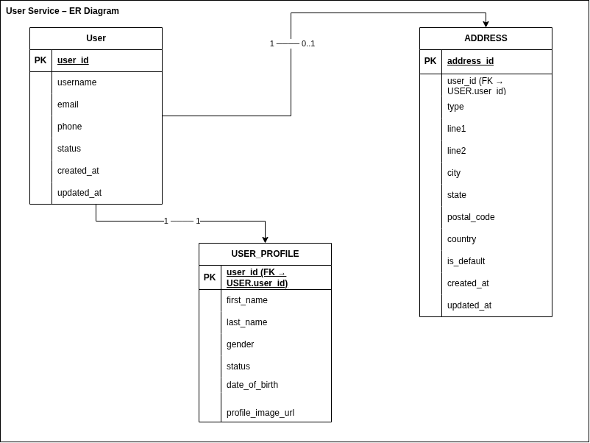

References
- https://firebase.google.com/
- https://docs.docker.com/
- https://cloud.google.com/
- https://docs.spring.io/spring-boot/
- https://kubernetes.io/docs/home/

