MANUAL TO USE THIS PROJECT

This Application basically contains three Runnable files:

1.astar.cpp
2.dijkstra.cpp
3.run.sh

1.Running astar.cpp

Dependencies:
1.astar.hpp
2.GNU/G++ compiler

How to Run :
1.Compile the file in terminal using following command:

Command: g++ astar.cpp

2.Run the file using the following command and please remember to provide the destination node to which shortest path is to be found as command line input :
Command: ./a.out destinstion_node_id

Ouput :

After the above mentioned steps are followed output will be displayed in the terminal which tells the path length to the destination node and time taken by the algorithm to calculate the path.
Example

[1.] g++ astar.cpp

[2.] ./a.out 6759

3.Output:

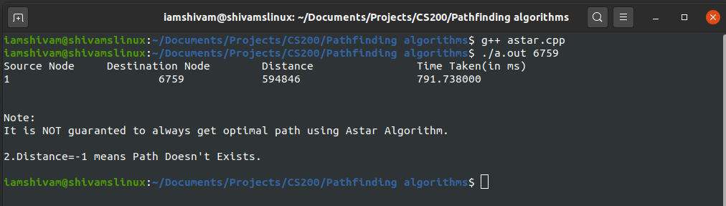

2.)Running dijkstra.cpp

Dependencies:
1.GNU/G++ compiler
2.OS:Ubunut/Mac OS

How to Run :
1.Compile the file in terminal using following command:

Command: g++ dijkstra.cpp

2.Run the file using the following command and please remember to provide the destination node to which shortest path is to be found as command line input :

Command: ./a.out destinstion_node_id

Output :

After the above mentioned steps are followed output will be displayed in the terminal which tells the path length to the destination node and time taken by the algorithm to calculate the path.

Example:

[1.] g++ dijkstra.cpp

[2.] ./a.out 4577

[3.]Output:
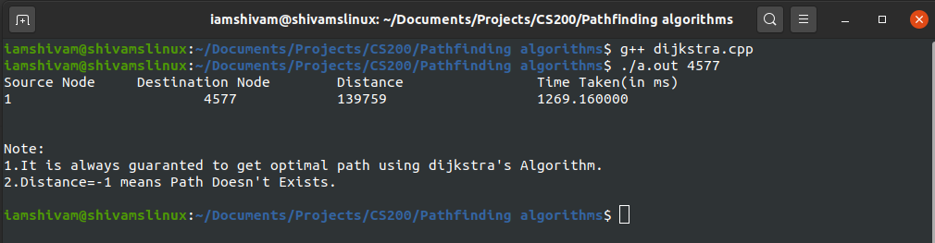

3.)Running run.sh

This file is used to compare dijkstra and astar algorithm over a large dataset of almost 5 lac+ nodes and 20 lac+ edges.This file is used to plot curve between no. Of nodes and time taken by the algorithm to find the shortest path to that specified node.

Dependencies:

1.astar.cpp
2.astar.hpp
3.dijkstra.cpp
4.OS:Ubuntu/Mac OS

How to run :

1.Give the permission to the file by using following command:

command: chmod 777 run.sh

2.Run the file by using following command:

command: ./run.sh

Output:

