OS ASSIGNMENT

CS-231

GROUP ID : 21

GROUP MEMBERS :

1.SHIVAM SHARMA -18010121

2.EBTESAM AHMAD KARIMI -18010113

Question ID -> 11
OBJECTIVE :

A program to display video files (all) exists in a filesystem with complete path.Display a menu to select .3gp files, .flv files, or .mp4 files and play with specific player. For example, use all .3gp files as play-list to Totem player, and .flv files as play-list to VLC player and so on.

INDIVIDUAL RESPONSIBILITIES:

**Most part of task 1 of the objective , that was to display video files (all) exists in a filesystem with complete path was completed by Ebtesam Ahmad Karimi – 18010113 and rest was done by Shivam Sharma-18010121.

**Task 2 of the objective , that was to display a menu to select .3gp files , .flv files , or .mp4 files and play with specific player. For example, use all .3gp files as play-list to Totem player, and .flv files as play-list to VLC player and so on , was completed by Shivam Sharma -18010121.

RUNNING INSTRUCTIONS/ASSUMPTIONS:

1.Everytime after downloading or receiving new file ,we should update our database for locate to work properly.

Command to update Database:

sudo updatedb

2.Filenames should not contain any white space between them.

3.VLC player and totem player should be installed and configured.
EXPLANATIONS:

1. Assumption 1 was made because locate command works on databases so the database should be updated to list every video file .

2. Assumption 2 was made because filenames with spaces between are difficult to handle because commands like locate filename, vlc pathname etc. doen’t work well with them.

TASK A:

In this task we have to list all the video file of all extension with complete path.

1.We have used locate command to locate the video files and then saved its output to file vid.txt and then we extract out the names and path of every video into the files name.txt and path.txt .
2.And then merged the content of file name.txt and path.txt into the file namepath.txt and then dispalyed the file namepath.txt

TASK B:

In this task we have to display a menu to select .3gp files , .flv files , or .mp4 files and play with specific player.

1.We have first displayed all the videos and then a menu to list all the videos of a specified extension and saved all videos in a file named ext.txt.

2.And then I displayed all the video file belonging to specified extension , then the program asks for video no. of the Video user wish to play.

3.As the user enters the video no. The program will asks for the desired video player to play video.

4.User enters his choice and Video starts playing in the desired video player.

ABOUT THE PROJECT :

This Progarm is written in Shell script.

HOW TO RUN ?

1.tar -xvf group_21.asgn.tar

2.cd group_21.asgn

3.chmod 777 assgn.sh

4.sudo ./assgn.sh

Steps to Prevent Errors:

1.If the video player opens but can't play the video , make sure the extensions(.3gp,.mp4,.flv) are supported.

2.If video player does’nt open , make sure the player is not corrupted.

OUTPUT:
1.Listing all the video files :
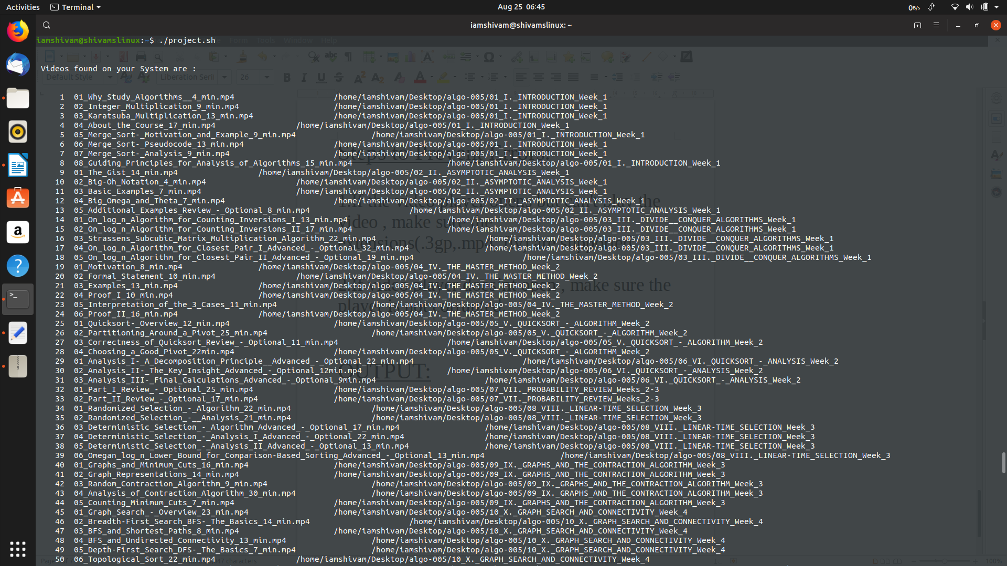
2.Listing video of a extension:
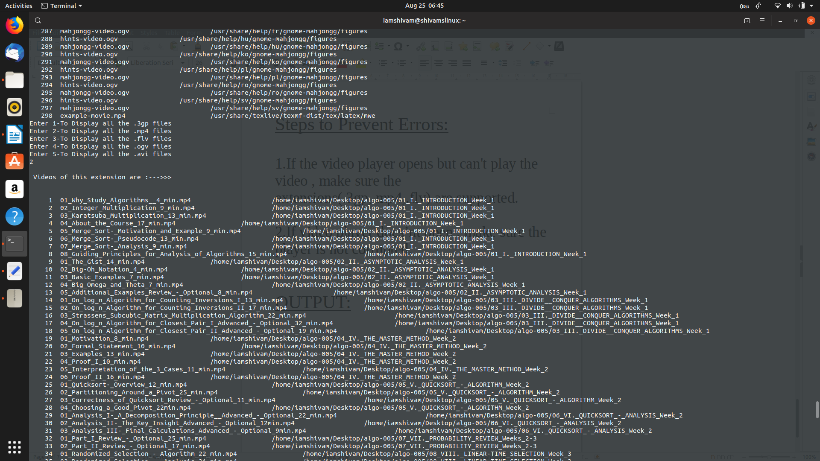
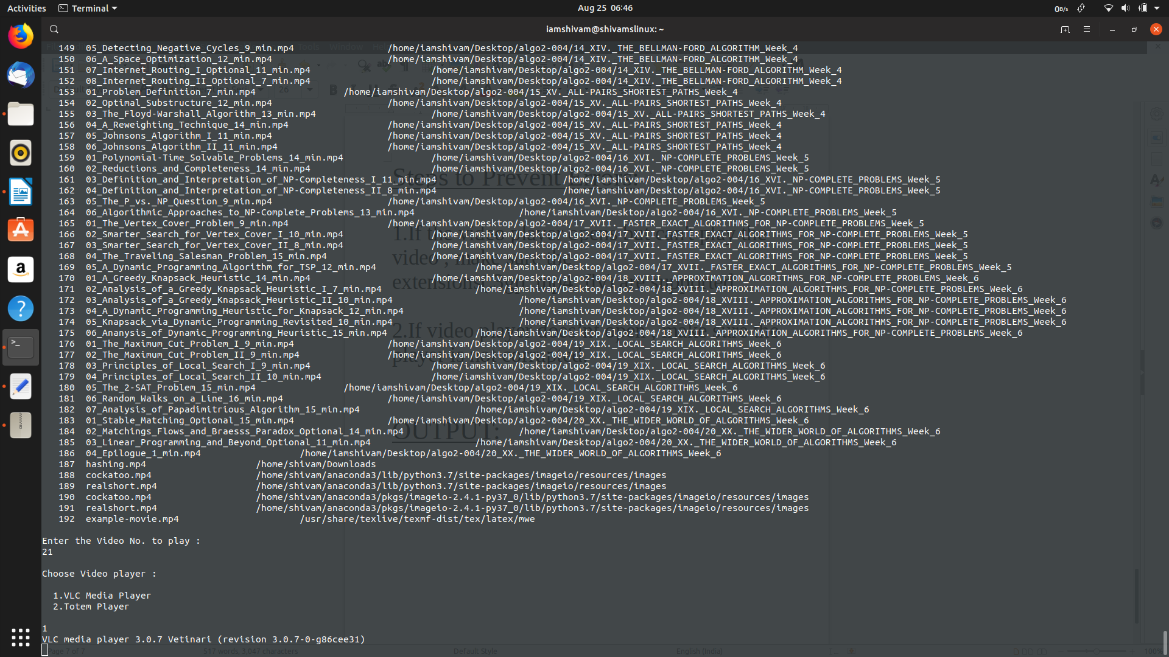
3.Selecting Video No. And Video player:
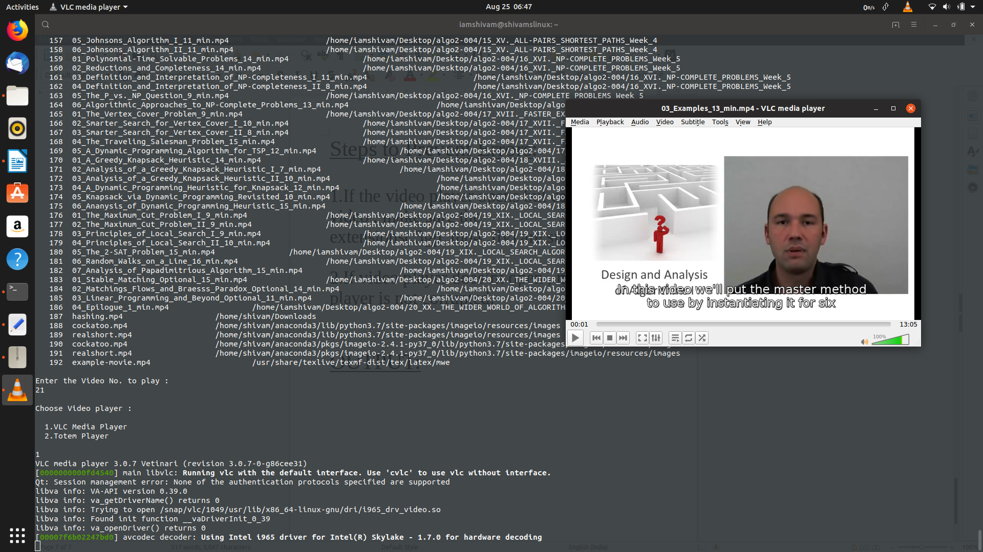
4.Our Video starts playing !!!

THANK YOU!

