**Scania Truck Failures Predictions**

Wireframe Document

Home Page

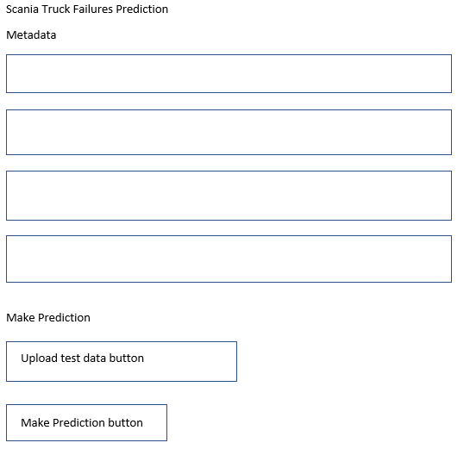

We can upload the test file using a button. Predictions will be made and stored in ‘predictions.csv’ file once we click on the button ‘Make Prediction’. We can download the predictions using a button which appears after a prediction is made.

