Personal Knowledge Graph Agent
A Fully Local, Privacy-First System for Cross-Source Personal Knowledge Retrieval and Relationship Discovery

Technical Report
Prepared 2026-09-03

Abstract
The Personal Knowledge Graph Agent is a fully local, single-user system that continuously ingests personal data from six independent sources - local files, Notion, Gmail, GitHub, Google Calendar, and browser history - normalizes it into a common representation, detects meaningful relationships between items across sources, and answers natural-language questions about the resulting knowledge base through a LangGraph-orchestrated retrieval-augmented generation agent. It is built primarily as a portfolio project demonstrating applied depth in LangChain, LangGraph, and LangSmith, and secondarily as a genuinely useful personal tool. Unlike server-hosted knowledge-management products, every component - the relational store, the vector store, the graph store, and (optionally) the language model itself - runs on the user's own machine, with no multi-tenant layer, no hosted database, and no authentication layer, by design. This report documents the system's full architecture, every source-extraction and filtering rule, the relationship-detection algorithm and its positioning against state-of-the-art approaches such as Microsoft's GraphRAG, the storage and query design, the Docker-based deployment model, and the engineering process that produced it - including a candid account of real defects found only by running the system end to end, not by unit testing alone.

1. Introduction and Motivation

1.1 The Problem
A single person's digital life is scattered across systems that do not talk to each other: source code and its history live in GitHub; structured notes and plans live in Notion; correspondence lives in Gmail; commitments live in Google Calendar; working documents live on the local filesystem; and a record of what was actually researched lives, largely unexamined, in browser history. None of these systems can answer a question that spans more than one of them - 'what did I work on related to RAG pipelines in the last two months' requires synthesizing a commit, an email thread, and a Notion planning page into one coherent answer, and no single source's own search box can do that. Nor can any of them tell you that a commit *implements* something *discussed in* an email, or that a Notion page *planned* a meeting that later became a calendar event - relationships that only become visible once the sources are considered together.

1.2 Goals
- Ingest all six sources on a fixed daily schedule with zero ongoing manual work once configured.
- Answer natural-language questions with a single synthesized, cited answer, not a ranked list of search hits.
- Automatically detect and surface cross-source relationships between items.
- Run entirely on the user's own machine, for a single user, with no hosted database and no authentication layer.
- Support a genuine choice between a fully local model stack (Ollama) and a fully cloud one (OpenRouter), switchable at will.
- Be installable and fully connectable - credentials, OAuth, source scope - without ever hand-editing a configuration file.

1.3 Non-Goals
Several plausible sources and capabilities were deliberately excluded after evaluation. YouTube watch history, Kaggle activity, Slack, and Kindle highlights were all considered and rejected because none of them has a fully automatable, zero-manual-work ingestion path - the project's own scoping rule is that a source must be ingestible without the user performing any recurring manual step, and each of these four requires one (a browser extension export, a manual data-download request, a workspace-admin-gated API, or no API at all, respectively). Multi-tenant support, hosted storage, and continuous (as opposed to daily-batch) ingestion were excluded as out of scope by design, not by oversight - see Section 12 for the reasoning behind the daily-batch cadence specifically.

2. System Architecture
The system is organized into six layers, each depending only on the layer immediately below it. This one-way dependency rule is enforced structurally, not just by convention: the extractors package has no import path back into the pipeline or storage packages, and the agent package never imports from extractors or pipeline directly.
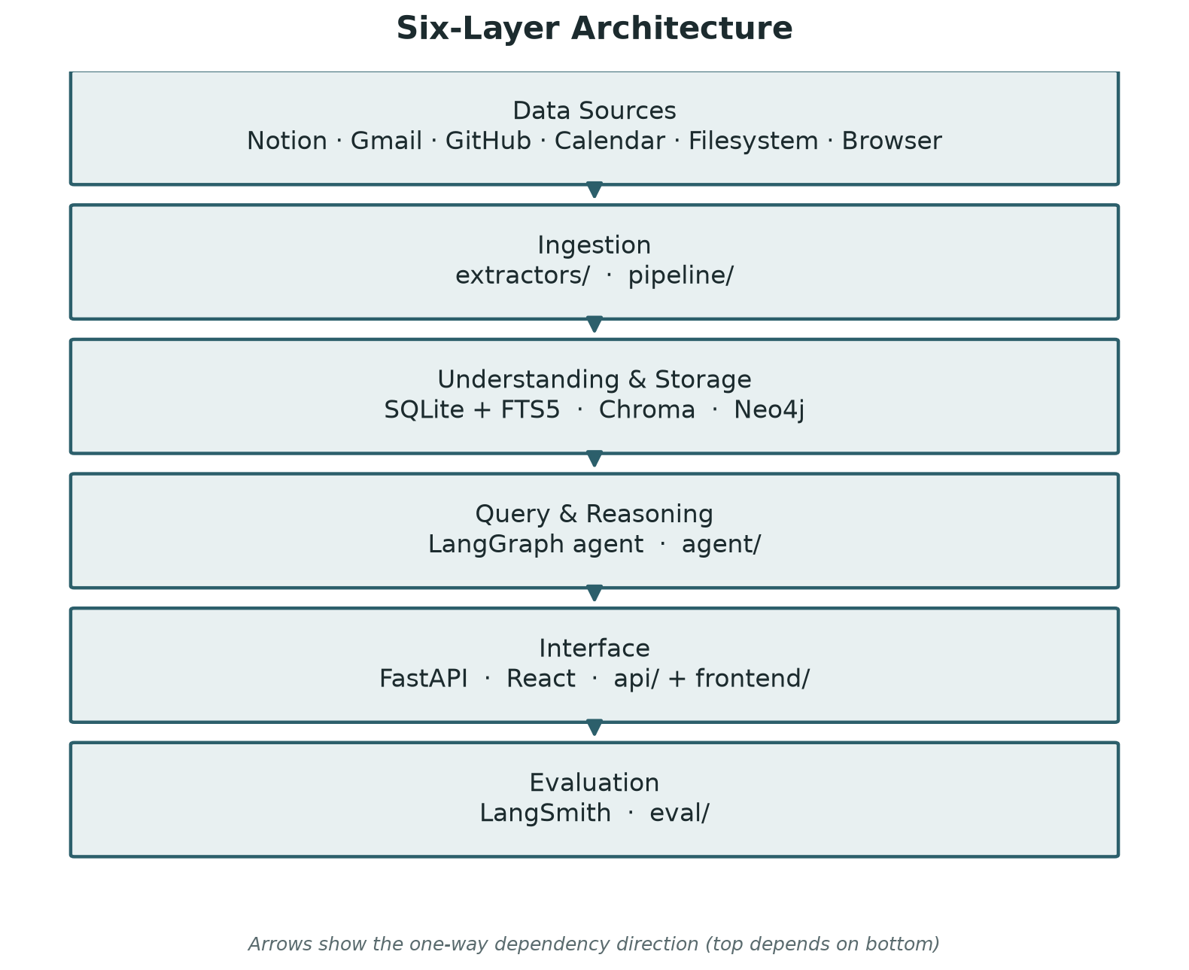
Figure 1. The six-layer architecture and its one-way dependency direction.

Layer | Responsibility | Location in repository
Data Sources | Notion, Gmail, GitHub, Google Calendar, local filesystem, browser history | external
Ingestion | Extraction, noise filtering, chunking, metadata generation, embeddings | extractors/, pipeline/
Understanding & Storage | SQLite + FTS5, Chroma (embedded vector store), Neo4j Community Edition (graph store) | storage/
Query & Reasoning | LangGraph agent: Router, Vector Search, Keyword Search, Graph Traversal, Merger, Synthesizer | agent/
Interface | FastAPI backend and a React frontend (chat, settings, guided setup wizard, relationship graph view) | api/, frontend/
Evaluation | LangSmith tracing, a fixed evaluation dataset, and automated evaluators | eval/

A single narrow exception to the one-way rule exists by design, not oversight: a handful of agent-facing endpoints (Settings' source-scope editing, the guided setup wizard's Google OAuth and browser-history pickers) need capability that is conceptually extractor-layer logic - OAuth token mechanics, mounted-path listing. In every such case the real implementation still lives in the extractors layer (extractors/google_oauth.py), and the agent layer holds only a thin re-export wrapper (agent/google_oauth.py) that adds no logic of its own - the same pattern already established by agent/browse.py before this project's guided-setup work began.

2.1 Data Flow: Ingestion
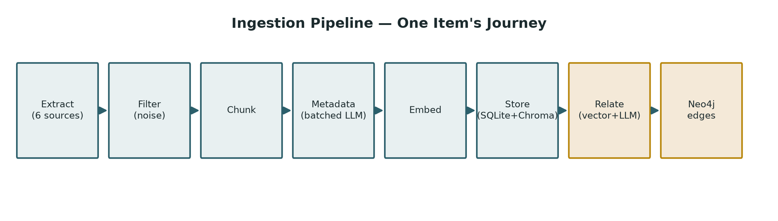
Figure 2. One item's journey through the ingestion pipeline. The final two steps (amber) run once per newly stored item, not once per source.

- scheduler/daily_batch.py's main() is invoked once daily (registered with the OS's own cron or Task Scheduler in a manual install, or run by a dedicated Docker sidecar container, scheduler/loop.py, that polls the configured cron schedule every 30 seconds under Docker) or on demand via POST /api/ingest/trigger.
- For each of the six extractors, extract_new_items() normalizes whatever it pulls into a common ExtractedItem shape (title, raw text, timestamps, a source-specific reference id) and applies its own source-specific noise-filtering rules, since only the extractor has access to that source's native metadata.
- Everything that survives extractor-level filtering passes through one universal filter (pipeline/filters.py): anything empty, or shorter than config.yaml's filters.min_content_length, is dropped as noise regardless of source.
- Surviving text is chunked (pipeline/chunking.py) at natural paragraph boundaries where possible, falling back to a fixed sliding window with overlap only when no natural boundary exists within the target chunk size.
- Metadata (a project name and a topic) is generated for the whole source's surviving items in one or a few batched LLM calls (pipeline/metadata.py), not one call per item, to control cost.
- Each chunk is embedded (pipeline/embeddings.py) and the resulting vector stored in Chroma; the item's raw text and metadata are stored in SQLite.
- Once storage completes for a batch, relationship detection (pipeline/relationships.py) runs once per newly stored item: its nearest neighbors are found by vector similarity first, and only that narrowed candidate set is judged by an LLM, which assigns a relationship label and a confidence score. Confirmed relationships become edges in Neo4j.

2.2 Data Flow: Query
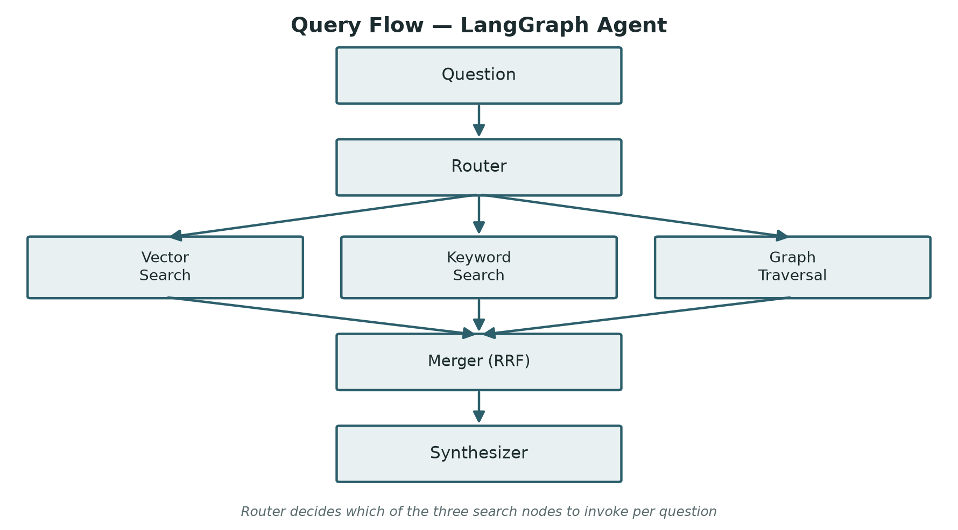
Figure 3. Query flow through the LangGraph agent.

- POST /api/query is validated and handed to agent/graph.py's run(), the compiled LangGraph state machine.
- The Router node inspects the question and decides which of Vector Search, Keyword Search, and Graph Traversal to invoke - a question naming a specific item or asking about relationships routes differently than an open-ended semantic question.
- Whichever search nodes ran return their own ranked candidate lists; the Merger combines them via Reciprocal Rank Fusion rather than a naive score concatenation, since the three retrieval methods produce scores on incomparable scales.
- The Synthesizer fetches the full text of the top merged results from SQLite (not from the necessarily-truncated chunks alone) and calls the active LLM provider to produce one synthesized, cited answer, with each citation resolvable back to the original item via a SourceChip in the frontend.

3. Data Sources and Extraction
Every extractor normalizes what it pulls into the same shape before handing it to the shared pipeline - title, raw text, created/last-edited timestamps, a source-type-scoped reference id, and (where applicable) a URL or filesystem path and an author/sender. The following subsections document each source's exact extracted fields and filtering rules, since these were the subject of a number of real defects found only through live testing (Section 11).

3.1 Local Files
Supports .txt, .md, .pdf, and .docx files under one or more configured watch directories (LOCAL_FILES_WATCH_DIRS). One item per file. Under Docker, an unset watch-directory list defaults to the whole mounted volume rather than watching nothing, so the out-of-the-box behavior is not silently empty.

3.2 Notion
Extracts page and subpage title and block text, along with the page's last-edited timestamp. Scoped to a configured list of page or database IDs (NOTION_PAGE_IDS); an unscoped configuration ingests every page the integration has been shared with. Subpages are extracted as their own separate items rather than merged into their parent page's text - this was a deliberate correction of an earlier behavior that flattened subpage content into the parent, losing the subpage's own identity as a citable item.

3.3 Gmail
Extracts subject, body, thread grouping (all messages in a thread are fetched and combined into one item, so a reply is never embedded without the context of the message it replies to), sender, and date. Messages under configured excluded labels (CATEGORY_PROMOTIONS, CATEGORY_SOCIAL by default) are dropped before the universal filter ever sees them. Scoped to a configurable date range, defaulting to the last 15 days when unset - a deliberately narrow default, since an unbounded Gmail backfill on a real, long-lived account is exactly the kind of expensive first run Section 5.3 discusses.

3.4 GitHub
Extracts commit messages (with commit diffs represented selectively - only changed file names, never raw diff content, since summarizing a diff is a pipeline-layer LLM concern, not an extractor's), PR titles, descriptions, and review comments, issues, periodically re-checked READMEs, and starred repositories (name, description, and topics only - deliberately lightweight, since a star is a much weaker signal than an owned repository's own activity).
GitHub repository scope (GITHUB_REPOS) and the configured date range (GITHUB_DATE_RANGE_START/_END) are mutually exclusive by design, repo scope winning outright when set. This was not the original behavior - it was corrected after a real end-to-end test surfaced that a date range configured for one purpose (bounding an unscoped, whole-account backfill) was silently also narrowing a deliberately small, scoped test repository's own commit history, when the entire point of scoping to a specific repository is normally to get all of it. Starred-repository extraction is similarly scoped: it is account-wide by nature (there is no owner/repo-shaped scope to apply to a personal star list), so it is now only pulled when the repository list is genuinely unscoped - an earlier version pulled the user's entire star list unconditionally, defeating the purpose of narrowing to a small test dataset. The incremental watermark from the previous successful run is applied regardless of scope in both cases; only the user-configured date range is affected by the mutual-exclusivity rule.

3.5 Google Calendar
Extracts event title, description, start and end time, and attendee list. Recurring events with no description are dropped by default (config.yaml's skip_recurring_without_description) on the reasoning that an undescribed recurring event is almost always a standing reminder, not a real, ingestion-worthy meeting; a recurring event that does carry a description is kept. Scoped to a configurable date range, defaulting to today through 30 days out - a forward-looking default, unlike every other source's backward-looking one, since a calendar's useful signal is what is coming up, not what already happened.

3.6 Browser History
Deliberately the lightest-weight source in the system: title, URL, visit count, and visit time only, with no page content ever fetched. A minimum-visit-count filter and a domain blocklist (search engines, social media, by default) remove low-signal entries before the universal filter. Browser history items are excluded from relationship detection entirely (Section 6) - a single visited URL carries too little context to meaningfully relate to anything else in the knowledge base, and running relationship detection over potentially hundreds of history entries per day would be a poor use of the LLM-call budget for the value returned.

4. Ingestion Pipeline Detail

4.1 Noise Filtering
Filtering happens in two layers, deliberately. Source-specific rules run first, inside each extractor, because only the extractor has access to that source's own native signals - a visit count, a Gmail label, a recurrence rule. A single universal rule then runs across everything that survives: anything empty, or shorter than config.yaml's filters.min_content_length (20 characters by default), is dropped as noise regardless of which source it came from. This two-layer split keeps source-specific knowledge out of the shared pipeline code, and keeps the shared pipeline from needing to know anything about any individual source's data shape.

4.2 Chunking
Text is chunked at natural paragraph boundaries, packed toward a target chunk size (config.yaml's chunking.target_chunk_size_tokens, 400 tokens by default) with a configured overlap between chunks (chunk_overlap_tokens, 40 by default). A single paragraph too long to fit inside one chunk on its own falls back to a fixed sliding window with the same overlap, since there is no natural break to prefer within it. Token counting is a plain word-count approximation, deliberately, to keep the chunking step fully offline with no network or model dependency.

4.3 Metadata Generation
A project name and a topic are derived per item via an LLM call, but batched across several items per call (config.yaml's ingestion.batch_metadata_group_size, 10 by default) rather than one call per item - a direct cost-control measure, since metadata generation happens on every single ingested item, unlike relationship detection which only runs per new item once. If a batch's metadata call fails (a transient provider error, an empty or unparseable response), the affected items are logged and left unclassified rather than aborting the run - the system was observed doing exactly this live, during a real ingestion test, when OpenRouter returned an empty response body for one metadata batch; ten items were left without a project name and topic, and the run continued and completed successfully otherwise.
project_name is not a field every item is guaranteed to receive. The prompt sent to the LLM asks it to identify a project name and topic 'if apparent from the content,' explicitly instructing it to return null for either field when it cannot be determined from the text alone - this is a best-effort inference from the item's own content, not a lookup against any structured project registry. In practice this means the field is populated unevenly across sources: a local file or Notion page whose content explicitly names a project can reliably be classified; browser history, by contrast, is the source most likely to come back null for nearly every item, since a history entry is only ever a title and a URL (per its own lightest-weight-source design in Section 3.6) and rarely carries enough text for the LLM to infer a project from in the first place. A null project_name is therefore an expected, unremarkable outcome for a browser-history item, not a sign that classification failed.

4.4 Embeddings
An embedding is a fixed-length numeric vector that represents a piece of text's meaning, positioned so that texts with similar meaning end up close together in that vector space. Embedding a chunk is what makes the later semantic (vector) search possible at all: at query time, the question itself is embedded the same way, and Chroma finds whichever stored chunk vectors sit nearest to it.
Each chunk is embedded individually, with the resulting vector inserted directly into Chroma, keyed by a freshly generated embedding_id that SQLite's own chunks table also stores, so the two stores stay joined by a plain foreign key. Unlike metadata generation, embedding calls one provider call per chunk rather than batching several chunks into one call, since the embedding APIs used are not batched the same way chat-completion calls are.
Which embedding model actually runs is decided by provider_mode, the same toggle that decides the generation model (Section 5.2): under fully_local, embedding goes through Ollama's own embeddings endpoint (nomic-embed-text by default); under fully_cloud, it goes through OpenRouter's own embedding models (openai/text-embedding-3-small by default). This was not always the case: for a period, embedding always went through OpenRouter regardless of mode, which meant fully_local still required an OpenRouter API key and still incurred embedding cost on every ingested item, undermining the point of a genuinely local mode. This was corrected specifically to make fully_local a real zero-cost, zero-network mode again.
Because Local and Cloud embedding models produce vectors in different, mutually incompatible spaces (and can differ in dimensionality entirely), every vector already stored in Chroma becomes meaningless the moment the active embedding model changes underneath it, whether by switching provider_mode or by editing either mode's own configured embedding model in place. Neither backend layer guards against this automatically; it is treated entirely as a frontend responsibility, which is why the Settings screen requires a confirmation before either kind of change and then triggers a full data reset before letting the new model be used.

5. Provider Abstraction and Cost Model

5.1 The Provider Interface
Every LLM and embedding call anywhere in the codebase passes through providers/base.py's ProviderInterface. No other module imports the Ollama or OpenRouter SDKs directly - this is enforced as a hard convention specifically so the system can offer a genuine choice between a fully local stack and a fully cloud one without that choice leaking into business logic scattered across the codebase.

5.2 Provider Mode
provider_mode is a single toggle that selects both the generation model (used for metadata extraction, relationship judging, and answer synthesis) and the embedding model together, since the two must remain compatible: Local mode routes both through Ollama with no per-call cost and no network dependency; Cloud mode routes both through OpenRouter, at real per-call cost, for higher-quality output. Switching between the two modes is treated as a destructive action, not a quiet setting change - because the two modes' embedding models are never compatible with each other in vector space, a switch requires confirming twice through a deliberately alarming prompt, then automatically wipes all previously ingested data. It does not automatically re-trigger ingestion afterward; the user decides when to run it again.

5.3 The Real Cost Shape of Ingestion
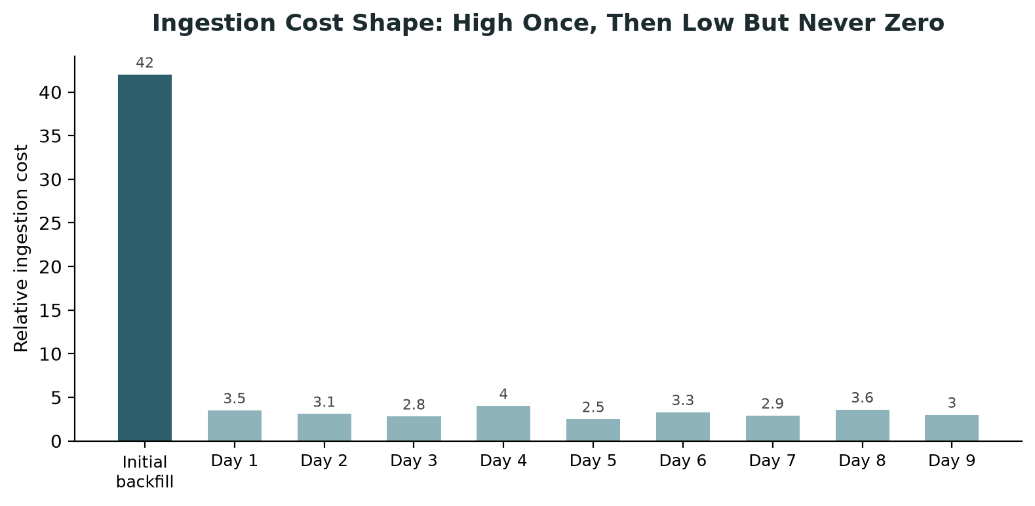
Figure 5. Illustrative ingestion cost per run: the initial backfill dwarfs every subsequent incremental run, which never reaches zero.

The first ingestion run against a source is categorically more expensive than every run after it. It must work through everything the source has ever produced - every file, every email in the configured range, every commit and issue a repository has ever had - and every one of those items needs its own embedding call, its own candidate-narrowed relationship check, and a share of a batched metadata call. Under Cloud mode this is where real dollar cost appears concretely: this project's own testing, run against a real, actively-developed repository with well over a hundred commits accumulated across a single working session, produced ingestion runs processing well over a hundred items in one pass, each with its own generation and embedding cost. After the initial backfill, each day's run only has to consider what changed since the previous run's watermark - a handful of new items, not the whole history again - so both time and cost drop sharply once the backlog clears, though never to zero: new content still arrives daily, and chatting with the system is its own separate per-question cost under Cloud mode. This shape - high once, then low but never zero - is the direct reason Local mode is the recommended default for ongoing use, with Cloud mode reserved for a deliberate, scoped first backfill.

6. Relationship Detection

6.1 Algorithm
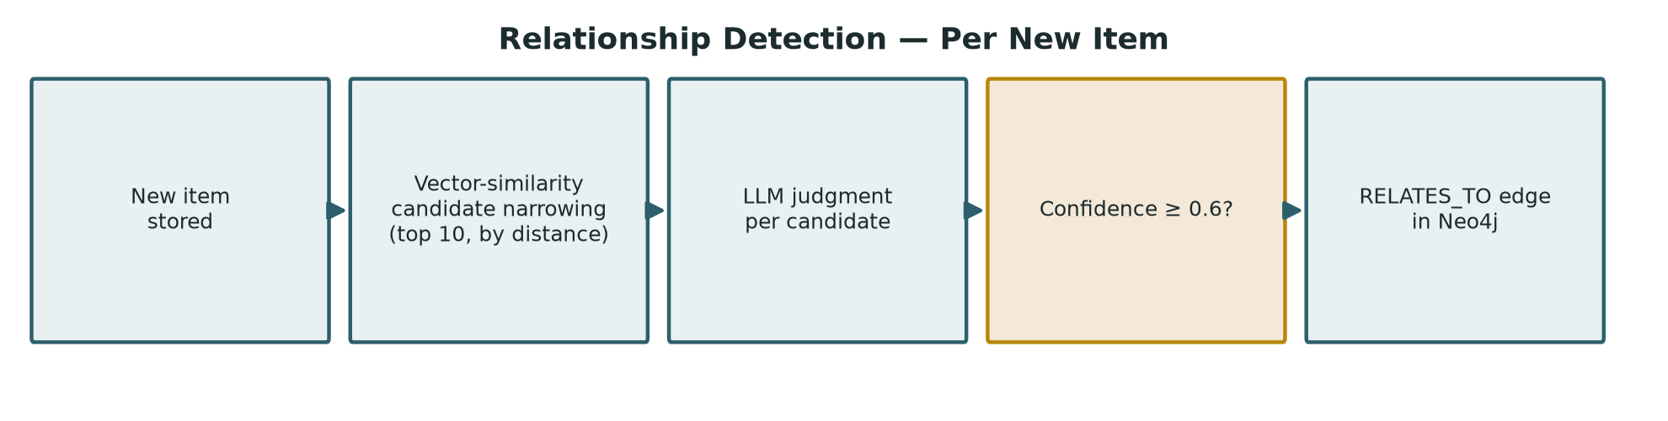
Figure 4. The relationship-detection pipeline, run once per newly stored item.

After a new item is stored, its nearest neighbors across the whole existing knowledge base are found by vector similarity first - never a full-dataset comparison, which would be both prohibitively expensive and unnecessary, since two items with no semantic overlap at all are extremely unlikely to have any real relationship worth recording. Only that narrowed candidate set (config.yaml's retrieval.relationship_candidate_count, 10 by default, optionally further bounded by relationship_candidate_max_distance) is then judged by an LLM, which either declines to confirm a relationship or assigns it one label from a closed vocabulary - implements, discussed_in, planned_in, companion_to - along with a confidence score. Judgments below a configured confidence threshold (relationship_confidence_threshold, 0.6 by default) are discarded rather than stored. Confirmed relationships become RELATES_TO edges in Neo4j; an item with no confirmed relationship to anything else simply never receives a graph node at all, since an unconnected node would add nothing to a relationship-exploration view.

6.2 Why a Closed Label Vocabulary
An earlier version of this system allowed the LLM to generate a free-form relationship label per confirmed pair. A real ingestion run against actual project data produced sixteen near-duplicate label variants across ninety-four edges - 'implements', 'is an implementation of', 'implementation of', and similar paraphrases of the same underlying relationship, none of which the graph-traversal or synthesis logic could meaningfully treat as equivalent. The fix was to constrain the LLM to a fixed, closed set of labels, chosen to cover the relationship types this project's own data actually exhibits, rather than attempting free-form label canonicalization after the fact.

6.3 Candidate Narrowing: Whole-Document, Not First-Chunk
An earlier version narrowed relationship candidates using only each item's first chunk's embedding as the query vector sent to Chroma. This produced a second real defect, found the same way as the label-vocabulary issue: a real re-ingestion run showed the companion_to relationship label sweeping eighty-four of ninety-four edges, because many of this project's own design documents share nearly identical boilerplate in their opening lines (a title, a 'Prepared for' line, a 'Companion to' line), which dominated the first-chunk similarity score regardless of what the rest of each document actually discussed. Two documents look highly similar by cosine distance on chunk zero alone if that chunk is mostly shared boilerplate, even when nothing else about them is actually related - the narrowing step was effectively ranking on formatting noise, not content.

6.3.1 How Mean-Pooling Works, Step by Step
Chroma itself never stores one vector per document - it stores one vector per chunk, for every item in the whole knowledge base. Mean-pooling is something computed on the fly, only when needed, not a change to what is stored. The full sequence, for one newly ingested item:
- The new item already has each of its own chunks individually embedded, from ingestion (Section 4.4).
- Those chunk vectors are averaged together into one single vector for the whole item. This is the only averaging done before searching.
- That one averaged vector is used to search Chroma. The search compares it against every other item's individual chunk vectors, not against any pre-averaged vector for those other items - there is no such thing stored anywhere.
- A document with five chunks has five separate chances to show up as a match, so several of the nearest results often belong to the same other item. Duplicates are collapsed down to a short list of distinct candidate items.
- For only that short list - not the whole knowledge base - the same averaging happens a second time: each candidate's own chunks are fetched and averaged into its own single vector.
- That candidate-level average is used to pick which one of the new item's own chunks best matches this specific candidate, so that chunk (not an arbitrary one) is what actually gets shown to the LLM for the yes/no relationship judgment.
Example: a project document has three chunks. The first is mostly boilerplate - a title and a 'Prepared for' line. The second describes a chunking strategy for a RAG pipeline. The third describes generating embeddings through OpenRouter. Averaging all three produces one vector where the boilerplate is only a third of the signal and the real subject matter - chunking and embeddings - makes up the rest. Searching with that averaged vector finds other documents that are also about chunking or embeddings, rather than simply any document that happens to share the same title formatting.

6.4 Positioning Against GraphRAG and Current Practice
The vector-narrowing-then-LLM-confirmation pattern used here is not a simplification invented for this project; it mirrors the pattern used by Microsoft's GraphRAG and described broadly in current entity-resolution literature as the standard way to get LLM-quality relationship judgments without an O(n squared) full-dataset LLM comparison. Where this system differs from a full GraphRAG-style pipeline is real, not accidental: GraphRAG additionally extracts named entities from within each document as their own graph nodes (a person, a project, a technology mentioned across many items, rather than only the items themselves), and clusters the resulting graph into topical communities that an LLM summarizes, enabling broad thematic questions ('what have I been working on lately') that a purely item-to-item graph cannot answer well. This project's current design deliberately stops short of that additional machinery - entity-level extraction and community summarization add real engineering weight aimed at large, multi-user corpora, which is a reasonable trade-off against a single-user dataset re-ingested once daily, but it is documented here as a genuine capability gap and a candidate direction for future work (Section 13), not a limitation the project is unaware of.

7. Storage Layer

7.1 SQLite Schema
CREATE TABLE items (
id TEXT PRIMARY KEY,
source_type TEXT NOT NULL,
source_ref_id TEXT NOT NULL,
title TEXT,
url_or_path TEXT,
author_or_sender TEXT,
created_at TIMESTAMP,
last_edited_at TIMESTAMP,
ingested_at TIMESTAMP NOT NULL,
project_name TEXT,
topic TEXT,
UNIQUE(source_type, source_ref_id)
);
CREATE TABLE chunks (
id TEXT PRIMARY KEY,
item_id TEXT NOT NULL REFERENCES items(id) ON DELETE CASCADE,
chunk_index INTEGER NOT NULL,
text TEXT NOT NULL,
token_count INTEGER,
embedding_id TEXT NOT NULL UNIQUE
);
-- chunks_fts: an FTS5 virtual table over chunks.text, kept in sync via
-- AFTER INSERT/DELETE/UPDATE triggers, providing BM25 keyword search.
CREATE TABLE ingestion_runs (
id TEXT PRIMARY KEY,
run_started_at TIMESTAMP NOT NULL,
run_completed_at TIMESTAMP,
status TEXT NOT NULL, -- running|success|partial_failure|failed|cancelled
items_processed INTEGER DEFAULT 0,
error_log TEXT,
current_item TEXT,
cancel_requested INTEGER DEFAULT 0,
pid INTEGER
);
CREATE TABLE sessions ( id, title, created_at, updated_at );
CREATE TABLE messages ( id, session_id, role, text, sources, created_at );

7.2 Chroma
A single collection, using cosine similarity as its distance metric. One vector per chunk, keyed by the chunk's own embedding_id so SQLite and Chroma stay joined by a plain foreign key rather than any implicit ordering assumption. No embedding function is attached to the collection itself; vectors are computed explicitly by the pipeline and inserted directly, keeping the choice of embedding model entirely under this project's own provider abstraction rather than Chroma's own defaults.

7.3 Neo4j
Item nodes carry a uniqueness constraint on id and an index on project_name, to keep relationship-graph queries and the provider-mode-aware retrieval path both fast without a full scan. RELATES_TO edges carry the confirmed label. Deliberately, no session or message data lives in the graph at all - conversation history is purely a SQLite concern, since it has no relationship-graph semantics of its own.

7.4 Why Three Separate Stores
Each store is chosen for the one thing it is genuinely good at, rather than forcing one general-purpose database to serve all three roles poorly: SQLite with FTS5 gives fast, zero-infrastructure keyword (BM25) search and durable relational storage for exactly the structured fields items and conversations actually have; Chroma gives approximate nearest-neighbor vector search with no server process to run or maintain; Neo4j gives real, efficient graph traversal queries that a relational join could express but not execute nearly as naturally or quickly as a native graph store. All three are free, local, and require zero hosted infrastructure - a hard constraint of the project, not merely a cost-saving default.

8. Query and Reasoning Layer
The agent is a LangGraph state machine with five meaningful nodes.
Node | Responsibility
Router | Inspects the incoming question and decides which retrieval nodes to invoke
Vector Search | Semantic similarity search over Chroma
Keyword Search | BM25 keyword search over SQLite's FTS5 index
Graph Traversal | Relationship-graph lookups against Neo4j, for questions about how items relate
Merger | Combines whichever search nodes ran via Reciprocal Rank Fusion
Synthesizer | Fetches full text for the top merged results and calls the active LLM provider for one cited answer

Reciprocal Rank Fusion, rather than a raw score merge, is used specifically because vector similarity, BM25, and graph-traversal relevance are not comparable on the same numeric scale - RRF only needs each method's own ranking, not a cross-calibrated score, to combine them fairly.

9. Interface Layer

9.1 Backend
A FastAPI application (api/main.py) exposing chat, session-history, settings, source-configuration, ingestion-control, relationship-graph, and guided-setup endpoints. The full endpoint list is documented in docs/API_Specification.docx.

9.2 Frontend
A React 19 application built with Vite. The chat screen is the primary interface, per the project's chat-first design principle: a question and a synthesized, cited answer, with clickable source chips resolving back to the original item. A relationship graph screen renders the whole knowledge base's confirmed relationships as a live, force-directed d3-force graph - dragging a node resettles its neighbors, clicking one highlights its connections, and a toolbar filters by source. A settings screen exposes every configurable value, saving each field immediately on commit rather than requiring an explicit save action.

9.3 The Guided Setup Wizard
A later addition (issue #92) specifically to remove every manual configuration-file-editing step a new user would otherwise face. It walks through provider mode, a live-validated OpenRouter/Notion/GitHub credential entry (each credential is checked against the real API before being saved, never saved blind), a fully in-browser Google OAuth flow (a popup-based consent screen driven by the backend's own published callback endpoint, replacing an older flow that required running a standalone script and placing a downloaded credentials file by hand), and source scope for every remaining source. Two manual steps remain, deliberately, because they are structurally impossible to remove: under Docker, which host folder is exposed for local files or browser history must be decided before the containers are created, since a running container cannot mount a new host path into itself - this is a Docker Compose configuration decision, not an application-level one, and no in-app wizard step can change that.

10. Deployment Model

10.1 Docker Compose Packaging
The recommended deployment path is a single docker compose up -d --build command bringing up backend, a scheduler sidecar container (replacing a manually-registered cron/Task Scheduler entry), a frontend, and Neo4j (plus Ollama, under an opt-in profile, when running in Local mode). Every value needed to bring the stack up has a working default, including the Neo4j password, making the zero-configuration case a genuine one-command start.

10.2 Why SQLite and Chroma's Data Lives in a Real Host Folder
SQLite and Chroma's data is bind-mounted from a real, plain host folder (HOST_STORAGE_DIR, defaulting to ./docker/storage) rather than a Docker-managed named volume. This was a deliberate choice over the originally-shipped named-volume design: a named volume is opaque to the host filesystem, inspectable only through Docker's own volume tooling, whereas a real host folder is directly visible and relocatable by changing one variable. Neo4j and Ollama's own data remain on named volumes, since their own on-disk formats are not meant to be inspected or modified directly on the host the way a SQLite file or Chroma's persisted collection safely can be.

10.3 config/.env Must Be a Real Bind Mount, Not env_file:
The single most consequential infrastructure defect found this project's whole development history was here. docker-compose.yml originally used env_file: to inject config/.env's contents into the backend and scheduler containers. Docker's env_file: directive injects every key as a real, frozen operating-system environment variable at container start - and pydantic-settings, the configuration library this project uses, always prefers a real environment variable over the same key's value read from its own dotenv file, no matter how many times that file is rewritten afterward. The practical consequence: every runtime settings write this application makes to its own configuration - every credential saved through the guided wizard, every Google OAuth token, every source-scope change - succeeded at the file-write level and was then completely invisible to the running process, silently, for the entire lifetime of the container. This went undetected through several completed phases of feature work because none of that work had yet been verified against a real, running Docker container end to end; it was found only by actually running the stack and observing that a PUT immediately followed by a GET returned the pre-write value. The fix required two attempts: replacing env_file: with a single-file bind mount of just config/.env fixed the frozen-value problem but introduced a new one, since python-dotenv's own write mechanism uses an atomic rename that requires its temporary file and its target to live on the same filesystem mount, which a single-file mount does not guarantee; bind-mounting the whole config/ directory, rather than one file inside it, resolved both problems at once.

10.4 GitHub-Only Distribution
A deliberate decision was made not to publish prebuilt images to Docker Hub. The reasoning is threefold: this is primarily a portfolio project whose real audience reads the repository itself, not a registry listing; docker compose up -d --build from a clone already delivers a genuine one-command start with no gap a registry would close; and for a tool that ingests this much personal data, being able to read and build the source directly is a better trust posture than an opaque prebuilt image from a third-party registry, even one the same author controls.

11. Engineering Process and Lessons Learned
A recurring theme across this project's later development is that unit tests alone, however thorough, did not catch a class of real defects that only manifest in the actual multi-container, real-network-boundary environment the system runs in. Every defect in this section was found by literally running the real system - the real Docker stack, real credentials, a real Google account, a real GitHub repository - and observing behavior that differed from what the design intended, not by code review or static reasoning about the code. This is recorded here as a deliberate practice, not an embarrassing gap: live end-to-end verification is treated in this project as a required step for infrastructure-adjacent changes, specifically because of how many real defects it has surfaced that no other verification method did.
Defect | How it was found | Root cause
Every runtime settings write silently no-op'd under Docker | A PUT/GET round trip against a real running stack | env_file: freezes config/.env's values as real OS env vars, which pydantic-settings always prefers over the file
Neo4j auth failure on container start | Backend failed to start against a real stack | config/.env's own NEO4J_PASSWORD and the root .env's NEO4J_PASSWORD are two unrelated files with the same key; nothing kept them in sync
Google OAuth token exchange failed outright | Clicking Connect Google in a real browser | oauthlib refuses a non-https callback URL unless OAUTHLIB_INSECURE_TRANSPORT is set; this app's callback is always plain http
Browser-history picker never visibly selected anything | Clicking the radio button live | The picker compared a full saved path against a bare relative filename from a different, inconsistent listing endpoint
Gmail/Calendar extraction silently failed for guided-OAuth-only setups | A real calendar event, known to exist, never appeared after ingestion | An early, unconditional gate required an older env var the guided OAuth flow never sets, short-circuiting extraction before the correct shared-token logic ever ran
GitHub star extraction and date-range filtering ignored repository scope | A repo-scoped test run still pulled 50+ unrelated starred repos | Starred-repo extraction and the configured date range were both applied unconditionally, with no gate on github_repos_list at all
Ingestion progress bar appeared frozen during relationship detection | Watching a real run for several minutes with no visible change | The relationship-detection loop never called the same progress-update function the extraction phase already used

One incident is recorded here in full because it is instructive beyond this project: while live-testing the credentials-save endpoint against a real running stack, a test API call intended to verify a round trip was issued against the real, live config/.env file on the development machine - the same file holding the author's actual GitHub personal access token - without first taking a backup. The call overwrote the real token with a placeholder test value. The value was recovered from an earlier, unrelated terminal output in the same session that had printed the real token in cleartext (a docker compose config invocation), the mistake was disclosed to the project owner immediately and in full rather than silently corrected, and a standing practice of backing up config/.env before any further live-credential testing was adopted from that point forward.

12. Key Design Decisions
The following decisions are locked in and treated as settled unless a clear new reason emerges to revisit them:
- Ingestion runs once daily in a scheduled batch, not continuously - an accepted trade-off for cost and simplicity over real-time freshness.
- Only sources with a fully automatable, zero-manual-work ingestion path are included; several plausible sources were evaluated and explicitly rejected for lacking one.
- All storage is local and free - no hosted or paid storage service is used anywhere, as a hard constraint rather than a cost-driven default.
- Search is hybrid: semantic (Chroma) and keyword (SQLite FTS5/BM25), merged via Reciprocal Rank Fusion, since neither retrieval method alone reliably outperforms the other across all question types.
- Relationships are detected via vector-similarity candidate narrowing followed by LLM confirmation, never a full-dataset LLM comparison.
- The LLM provider is fully configurable between local and cloud, and the abstraction boundary enforcing this is never bypassed anywhere in the codebase.
- Browser history is intentionally the lightest-weight source in the system, both in what it extracts and in being excluded from relationship detection.
- Distribution is GitHub-only; no prebuilt images are published to a container registry.

13. Testing Strategy
Unit and integration tests mirror the source tree exactly under tests/, run via uv run pytest. Storage-layer tests for Neo4j are a real integration suite against a live Neo4j instance, automatically skipped when none is reachable, rather than a mocked substitute - a deliberate choice, since a graph store's real query semantics are exactly the kind of thing a mock tends to get subtly wrong. Every extractor is tested against a faked version of its real external API (a MockTransport for GitHub and Google Calendar's REST APIs, a fake Gmail service object), shaped to match the real API's actual response format, not merely a plausible-looking stand-in. As Section 11 documents at length, this test suite - however thorough at the unit level - did not catch a distinct category of defects that only manifest in the real multi-container runtime environment; live end-to-end verification against the actual Docker stack is treated as a required complement to it, not a redundant extra step.

14. Future Work
- Entity-level extraction: pulling named entities (people, projects, technologies) out as their own graph nodes distinct from the items that mention them, moving closer to a GraphRAG-style knowledge graph without adopting its full community-summarization machinery.
- Manual end-to-end verification of the Gmail and Calendar extractors against real, large-volume accounts (the guided OAuth connection itself has been verified live; sustained real-data extraction volume has not).
- A numeric current/total counter for the relationship-detection phase's progress display, beyond the item-title label it already shows.
- Addressing a known test-isolation gap: a connections-status test does not fully mock the guided-OAuth token file's real on-disk existence check, so it can fail on a machine that has completed the guided flow, despite correctly mocking every credential-bearing setting.

15. Conclusion
The Personal Knowledge Graph Agent demonstrates that a genuinely useful, cross-source personal knowledge system can be built entirely on local, free infrastructure, with a real choice between local and cloud model providers, and with an onboarding experience - a guided setup wizard, live credential validation, a one-command Docker deployment - that asks nothing of a new user beyond the two structurally-unavoidable Docker mount decisions. Its relationship-detection design is aligned with, not behind, current practice in LLM-based knowledge graph construction, while remaining honest about the specific capabilities (entity-level extraction, community summarization) a more elaborate system like GraphRAG adds on top. Perhaps most instructively, the project's own development history - documented candidly in this report and in the repository's own DECISIONS.md - shows that a substantial class of real, user-impacting defects in a system this shape (multi-container, multiple external OAuth integrations, a real filesystem boundary) surfaces only when the system is actually run end to end, not when its components are merely tested in isolation.

