Personal Knowledge Graph Agent
Component Map Document
Prepared for: Shivam Shinde
Companion to: System Architecture Document

1. Purpose
This document maps every component in the system, its responsibility, and its direct dependencies on other components. It complements the layered view in the System Architecture Document with a component-to-component dependency view.
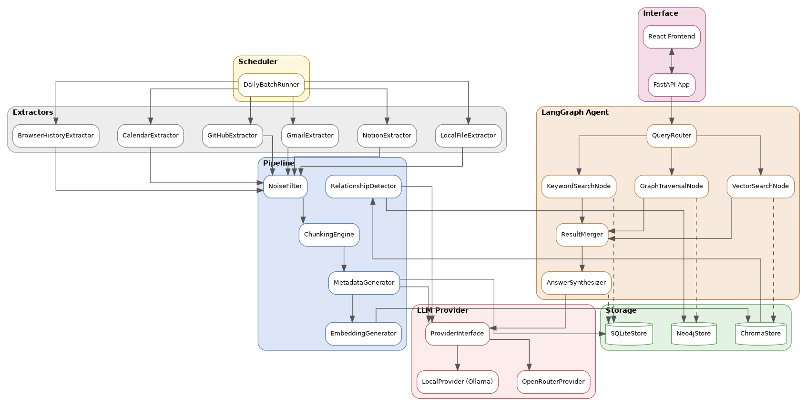
Figure 1: Full component dependency map

2. Component Groups

2.1 Scheduler
Component | Responsibility | Calls
DailyBatchRunner | Triggers all six extractors once daily and coordinates the ingestion pipeline run | All six Extractors

2.2 Extractors
Component | Responsibility | Calls
LocalFileExtractor | Watches folders, reads new/modified files | NoiseFilter
NotionExtractor | Polls Notion API for edited pages | NoiseFilter
GmailExtractor | Pulls new emails since last run | NoiseFilter
GitHubExtractor | Pulls new commits, PRs, issues | NoiseFilter
CalendarExtractor | Pulls new/updated events | NoiseFilter
BrowserHistoryExtractor | Reads local browser history file | NoiseFilter

2.3 Pipeline
Component | Responsibility | Calls
NoiseFilter | Removes low-value items per source-specific rules | ChunkingEngine
ChunkingEngine | Splits long text into chunks at natural boundaries | MetadataGenerator
MetadataGenerator | Attaches free metadata; calls LLM for project/topic fields | ProviderInterface, SQLiteStore, EmbeddingGenerator
EmbeddingGenerator | Converts chunks into vectors using a local embedding model | ChromaStore
RelationshipDetector | Finds candidate related items via Chroma, confirms via LLM, writes edges | ChromaStore, ProviderInterface, Neo4jStore

2.4 Storage
Component | Responsibility | Used By
SQLiteStore | Persists raw text, item metadata, and ingestion run logs | MetadataGenerator, KeywordSearchNode, AnswerSynthesizer
ChromaStore | Persists chunk embeddings with attached metadata | EmbeddingGenerator, RelationshipDetector, VectorSearchNode
Neo4jStore | Persists item nodes and relationship edges | RelationshipDetector, GraphTraversalNode

2.5 LLM Provider
Component | Responsibility | Implements / Implemented By
ProviderInterface | Shared contract: generate_metadata, generate_relationship, generate_answer | Implemented by LocalProvider and OpenRouterProvider
LocalProvider | Routes calls to a locally running Ollama model | ProviderInterface
OpenRouterProvider | Routes calls to a user-selected model via the OpenRouter API | ProviderInterface

2.6 LangGraph Agent
Component | Responsibility | Calls
QueryRouter | Decides which retrieval nodes to invoke for a given question | VectorSearchNode, KeywordSearchNode, GraphTraversalNode
VectorSearchNode | Runs semantic search | ChromaStore
KeywordSearchNode | Runs keyword search | SQLiteStore
GraphTraversalNode | Retrieves connected nodes/edges | Neo4jStore
ResultMerger | Combines and ranks results via Reciprocal Rank Fusion | (pure function, no external calls)
AnswerSynthesizer | Generates the final cited answer | ProviderInterface, SQLiteStore

2.7 Interface
Component | Responsibility | Calls
FastAPI App | Exposes the agent over HTTP, serves the frontend | QueryRouter (via agent/graph.py entrypoint)
React Frontend | Chat UI, session list, settings screen | FastAPI App (HTTP only)

3. Dependency Rules
- Extractors depend only on the Pipeline layer's shared interfaces, never on Storage or the Agent directly.
- Storage components have no outgoing dependencies on other layers; they are the system's leaf/foundation layer.
- The LLM Provider layer has no outgoing dependencies other than the external model runtime (Ollama) or API (OpenRouter); all other components depend on it through ProviderInterface only, never on a concrete provider directly.
- The Agent layer depends on Storage and the LLM Provider, but never on Extractors or the Pipeline layer.
- The Interface layer depends only on the Agent layer's public entrypoint, never reaching into Storage or Providers directly.

End of document.

