Personal Knowledge Graph Agent
Database Schema Document
Prepared for: Shivam Shinde
Companion to: System Architecture Document

1. Purpose
This document defines the concrete schema for all three storage backends: SQLite (raw text and reference metadata), Chroma (vector embeddings), and Neo4j (relationship graph), including field types, keys, and how records relate across the three stores.
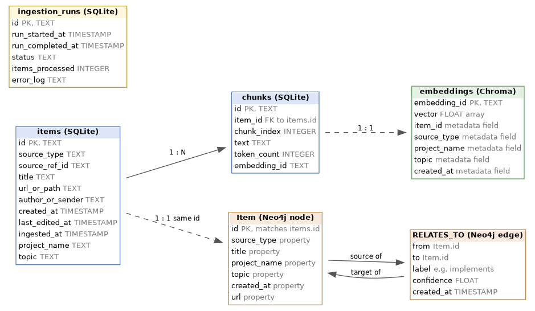
Figure 1: Cross-store entity relationship diagram

2. SQLite Schema

2.1 Table: items
One row per ingested item (a Notion page, an email, a commit, a calendar event, a local file, or a browser history entry).
CREATE TABLE items (
id TEXT PRIMARY KEY,
source_type TEXT NOT NULL, -- local_file | notion | gmail | github | calendar | browser_history
source_ref_id TEXT NOT NULL, -- source-native id (path, page id, message id, commit hash, event id, url)
title TEXT,
url_or_path TEXT,
author_or_sender TEXT,
created_at TIMESTAMP,
last_edited_at TIMESTAMP,
ingested_at TIMESTAMP NOT NULL,
project_name TEXT, -- LLM-derived
topic TEXT, -- LLM-derived
UNIQUE(source_type, source_ref_id)
);

2.2 Table: chunks
One row per chunk of an item's text; each chunk has a corresponding embedding stored in Chroma under the same embedding_id.
CREATE TABLE chunks (
id TEXT PRIMARY KEY,
item_id TEXT NOT NULL REFERENCES items(id) ON DELETE CASCADE,
chunk_index INTEGER NOT NULL,
text TEXT NOT NULL,
token_count INTEGER,
embedding_id TEXT NOT NULL UNIQUE
);
CREATE INDEX idx_chunks_item_id ON chunks(item_id);
CREATE VIRTUAL TABLE chunks_fts USING fts5(text, content='chunks', content_rowid='rowid');

2.3 Table: ingestion_runs
One row per daily batch execution; used for reliability tracking and to source last_run_timestamp.
CREATE TABLE ingestion_runs (
id TEXT PRIMARY KEY,
run_started_at TIMESTAMP NOT NULL,
run_completed_at TIMESTAMP,
status TEXT NOT NULL, -- running | success | partial_failure | failed
items_processed INTEGER DEFAULT 0,
error_log TEXT
);

2.4 Column notes
Column | Notes
items.source_type + source_ref_id | Composite unique key; prevents the same source item from being ingested twice
chunks.embedding_id | Foreign reference into Chroma; Chroma is the source of truth for the actual vector
chunks_fts | SQLite FTS5 virtual table backing the keyword search side of hybrid search
ingestion_runs.status | last_run_timestamp for the next batch is only advanced when status = success

3. Chroma Schema (Vector Store)
Chroma is used in embedded local mode with a single collection.
Field | Type | Description
id | string | Equal to chunks.embedding_id in SQLite
embedding | float[] | Vector produced by the local embedding model
document | string | The chunk text itself (duplicated from SQLite for fast retrieval without a join)
metadata.item_id | string | Foreign reference to items.id
metadata.source_type | string | Used for source-type filtering at query time
metadata.project_name | string | Used for relationship candidate narrowing and filtered search
metadata.topic | string | Used for filtered search
metadata.created_at | ISO timestamp string | Used for time-based filtering and ranking

4. Neo4j Schema (Relationship Graph)

4.1 Node label: Item
(:Item {
id: string, // matches items.id in SQLite
source_type: string,
title: string,
project_name: string,
topic: string,
created_at: datetime,
url: string
})

4.2 Relationship type: RELATES_TO
(:Item)-[:RELATES_TO {
label: string, // e.g. 'implements', 'discussed_in', 'planned_in'
confidence: float, // optional, if the LLM is prompted to self-rate certainty
created_at: datetime
}]->(:Item)

4.3 Constraints and indexes
CREATE CONSTRAINT item_id_unique IF NOT EXISTS
FOR (i:Item) REQUIRE i.id IS UNIQUE;

CREATE INDEX item_project_name IF NOT EXISTS
FOR (i:Item) ON (i.project_name);

5. Cross-Store Consistency Rules
- items.id (SQLite), the Chroma metadata.item_id field, and the Neo4j Item.id property are always the same value, allowing any of the three stores to be joined back to the others.
- An item is only written to Neo4j once it has at least one confirmed relationship; items with no detected relationships exist in SQLite and Chroma but not necessarily as a graph node, until a future run finds a relationship for them.
- Deleting an item (rare, manual operation) cascades to its chunks in SQLite (via ON DELETE CASCADE) and must be mirrored by an explicit delete call against Chroma and Neo4j, since neither enforces foreign key cascades against SQLite.

End of document.

