Personal Knowledge Graph Agent
System Architecture Document
Prepared for: Shivam Shinde
Companion to: Complete Project Design Document and Product Requirements Document

1. Purpose and Scope of This Document
This document describes the concrete system architecture of the Personal Knowledge Graph Agent: its components, how they are organized into layers, how data flows through the system during ingestion and during a user query, the technology stack, the deployment model on a single local machine, and the non-functional characteristics the system is designed around (privacy, reliability, scalability, and cost). It is the architectural counterpart to the Product Requirements Document (which defines what to build and why) and the Complete Project Design Document (which captures the full discussion and reasoning behind each decision).

2. Architectural Style
The system follows a layered, pipeline-oriented architecture with a clear separation between data ingestion, data understanding and storage, query-time reasoning, and presentation. Each layer only depends on the layer below it, and communicates through well-defined interfaces (API clients, a shared LLM provider interface, and three storage backends), so any single layer can be modified or replaced without rewriting the others.
Layer | Responsibility | Runs When
Data Sources | External systems holding the user's raw personal data | Always (owned by Notion, Google, GitHub, OS)
Ingestion Layer | Extracts, filters, chunks, and tags new data | Once daily, scheduled batch
Understanding & Storage Layer | Embeds, stores, and links content across sources | Once daily, as part of the batch job
Query & Reasoning Layer | LangGraph agent that retrieves and synthesizes answers | On demand, whenever a question is asked
Interface Layer | FastAPI backend + React frontend | Continuously, whenever the laptop is on
Evaluation Layer | LangSmith tracing, datasets, and evaluators | During development/testing runs and scheduled evaluation passes
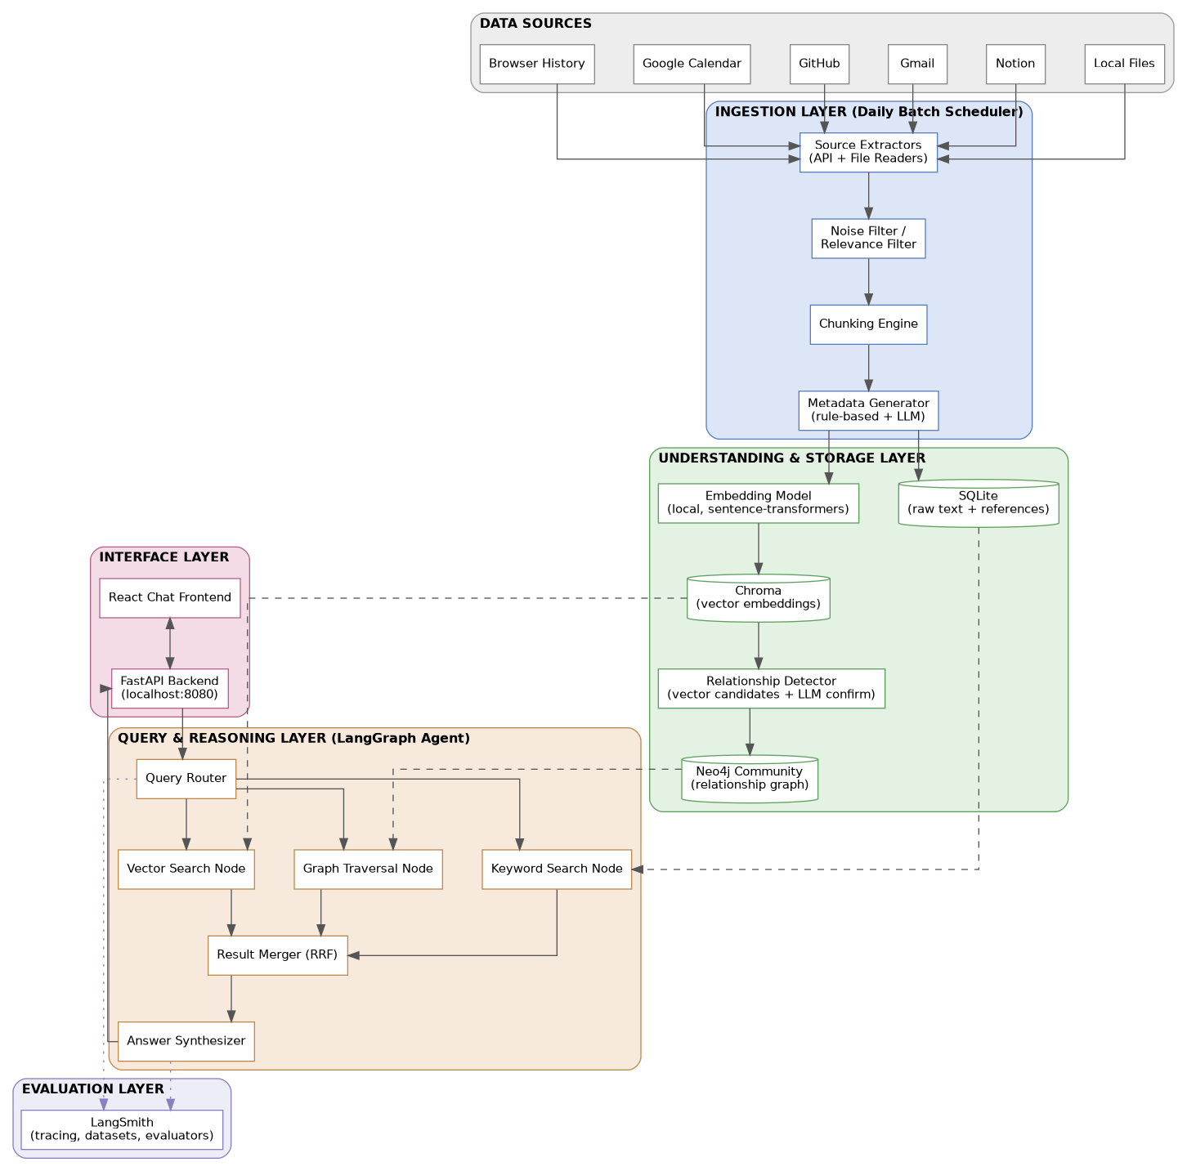
Figure 1: High-level layered system architecture

3. Component Breakdown

3.1 Source Extractors
One extractor module per data source, each responsible only for pulling raw data and normalizing it into a common intermediate format (text plus free metadata) before handing off to the shared pipeline.
Component | Responsibility | Key Interface
LocalFileExtractor | Watches configured folders, reads new/modified files, extracts text (PDF, DOCX, plain text) | Filesystem (watchdog)
NotionExtractor | Polls Notion API for pages edited since last run, fetches block content, converts to plain text | Notion REST API
GmailExtractor | Pulls new emails since last run, extracts subject/body/sender/thread ID, filters promotional content | Gmail REST API
GitHubExtractor | Pulls new commits, PR titles/descriptions, issues, and README updates per tracked repo | GitHub REST API
CalendarExtractor | Pulls new/updated events with title, description, attendees, time | Google Calendar REST API
BrowserHistoryExtractor | Reads the browser's local SQLite history file, applies noise filtering | Local SQLite file

3.2 Ingestion Pipeline Components
- Noise / Relevance Filter: applies per-source rules (e.g. skip Promotions/Social Gmail tabs, skip low-visit-count browser entries, skip pure recurring calendar events).
- Chunking Engine: splits long text into smaller chunks at natural boundaries (headings, paragraphs) for embedding.
- Metadata Generator: attaches free metadata from each API directly (dates, IDs, senders), and calls the LLM Provider only for semantic fields such as project name and topic.
- Embedding Generator: converts each chunk into a vector using a local embedding model.
- Relationship Detector: queries Chroma for similar existing content, then calls the LLM Provider to confirm and label genuine relationships, writing confirmed edges to Neo4j.

3.3 Storage Components
Component | Technology | Stores
Relational Store | SQLite | Raw extracted text, source reference IDs, free metadata
Vector Store | Chroma (embedded, local) | Chunk embeddings plus attached metadata for filtering
Graph Store | Neo4j Community Edition (local service) | Nodes per content item and labeled relationship edges between them

3.4 LangGraph Agent Nodes
Node | Input | Output
Query Router | User question | Decision on which retrieval node(s) to invoke
Vector Search Node | Question embedding | Top-K semantically similar chunks from Chroma
Keyword Search Node | Question text | Top-K keyword-matched chunks (BM25 / SQLite FTS)
Graph Traversal Node | Entities/topics in the question | Connected nodes and edges from Neo4j
Result Merger | Outputs of the above nodes | Single ranked list via Reciprocal Rank Fusion
Answer Synthesizer | Ranked results plus original question | Final natural language answer with source citations

3.5 Interface Components
- FastAPI Backend: exposes the LangGraph agent over HTTP at localhost:8080, serves the React build, and exposes a /api/query endpoint plus a session/history mechanism (full endpoint list in the API Specification Document).
- React Chat Frontend: single-page chat interface, sends questions to /api/query, renders synthesized answers with clickable source references.

3.6 LLM Provider Abstraction
A single internal interface (generate_metadata, generate_relationship, generate_answer) is implemented by two concrete providers, selected via configuration:
- LocalProvider — routes calls to a locally running Ollama model, no network or per-call cost.
- OpenRouterProvider — routes calls to a user-selected model (e.g. Claude, GPT, Llama, Mistral) via the OpenRouter API.
Configuration determines, per task (metadata extraction, relationship detection, answer synthesis), which provider and model is used, supporting fully local, fully cloud, or mixed setups.

4. Data Flow: Daily Ingestion
The ingestion pipeline runs once per day as a scheduled batch job (cron on Mac/Linux, Task Scheduler on Windows). Every new or changed item across all six sources moves through the same ten-step pipeline shown below, from detection through to relationship creation in the graph store.
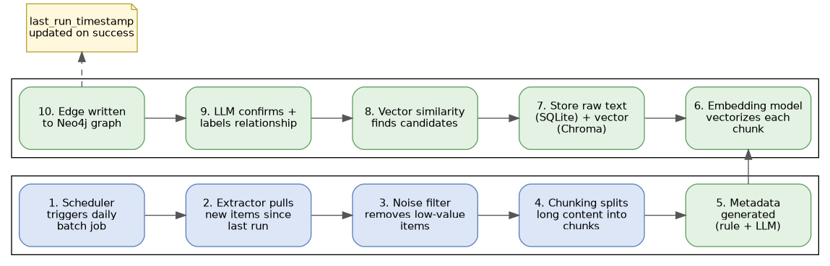
Figure 2: End-to-end ingestion pipeline, executed once per day
A single stored value, last_run_timestamp, is the comparison point every extractor uses to determine what counts as "new." It is only updated after a run completes successfully, so a failed or interrupted run does not cause data to be silently skipped on the next run.

5. Data Flow: User Query
When the user asks a question through the React interface, the request flows through the LangGraph agent, which decides dynamically which retrieval methods are actually relevant, merges results from whichever were used, and synthesizes a single grounded answer.
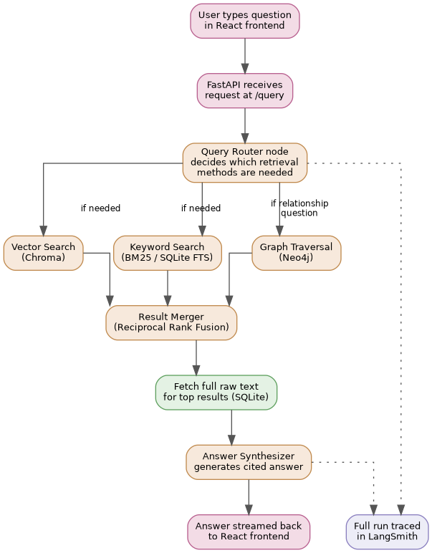
Figure 3: Query-time flow from question to synthesized answer

6. Deployment Architecture
The entire system is deployed on a single local machine, with no cloud hosting for the application itself. This was a deliberate architectural decision given the sensitivity of the data being processed (personal Gmail content, browser history, private notes).
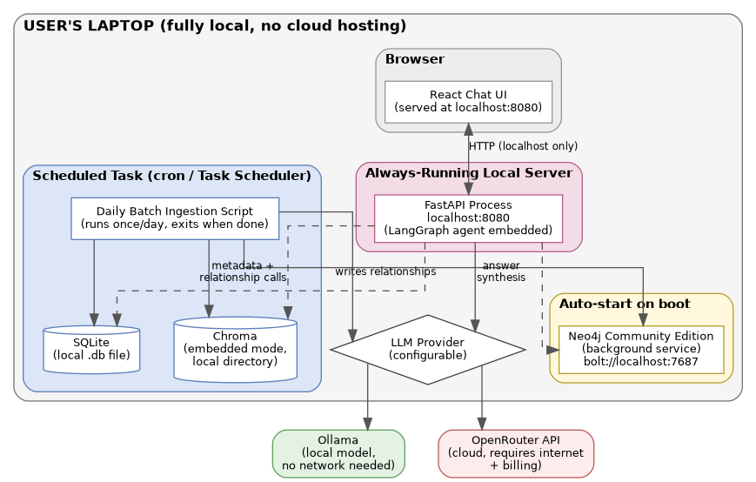
Figure 4: Deployment view — processes, storage, and network boundaries on the local machine

6.1 Process model
Process | Lifecycle | Trigger
Neo4j Community Edition | Long-running background service | Auto-starts on machine boot
Daily batch ingestion script | Short-lived, runs once and exits | Scheduled task (cron / Task Scheduler), once daily
FastAPI + LangGraph agent | Long-running server process | Auto-starts on machine boot, listens on localhost:8080
Chroma | Embedded within the calling process (batch script or FastAPI process) | Starts and stops with the calling process
SQLite | Not a process — a local file opened per operation | N/A

6.2 Network boundaries
- The React frontend and FastAPI backend communicate only over localhost; the system is not exposed to the local network or the internet by default.
- Outbound network calls only occur for: (a) the six source APIs during the daily batch, and (b) the LLM Provider, when configured to use OpenRouter rather than a local model.
- If a fully local LLM (Ollama) is configured, the system can run with zero outbound network dependency after initial setup, aside from the source API calls themselves.

7. Technology Stack
Concern | Technology | Notes
Orchestration / agent framework | LangGraph | State machine for the query-time reasoning agent
LLM tooling | LangChain | Prompting, chains, and provider integration utilities
Observability / evaluation | LangSmith | Tracing, dataset management, automated evaluators
Backend API | FastAPI (Python) | Serves the agent and the frontend
Frontend | React | Chat-style single-page interface
Relational storage | SQLite | Raw text and reference metadata
Vector storage | Chroma | Local, embedded mode
Graph storage | Neo4j Community Edition | Local background service
Embeddings | sentence-transformers (e.g. all-MiniLM-L6-v2) | Local, free, no API cost
Keyword search | BM25 / SQLite FTS | Combined with vector search via Reciprocal Rank Fusion
Local LLM runtime | Ollama | Runs open source models (Llama, Mistral, Qwen, etc.) locally
Cloud LLM access | OpenRouter | Unified API across many hosted model providers
Scheduling | cron (Mac/Linux) / Task Scheduler (Windows) | Triggers the daily batch ingestion job
File watching | Python watchdog | Detects new/changed local files
Python package/environment management | uv | Sole dependency and virtual environment manager for all Python code; replaces pip/venv/Poetry

8. Non-Functional Architecture Considerations

8.1 Privacy and data locality
All raw data, embeddings, and relationship data remain on the local machine at all times. No source content is sent anywhere except: (a) the minimal text needed for a given LLM call (metadata extraction, relationship confirmation, or answer synthesis), and only if a cloud provider (OpenRouter) is configured rather than a local model.

8.2 Reliability
- The batch job only advances last_run_timestamp after a fully successful run, preventing silent data loss on partial failures.
- Each source extractor fails independently; a failure in one source (e.g. Gmail API timeout) does not block ingestion of the other five sources.
- Neo4j running as an auto-starting background service ensures the graph store is available whenever the agent is queried, without manual intervention.

8.3 Scalability considerations
The system is scoped for a single user's personal data volume, not multi-user or internet scale. Within that scope, the main growth dimension is the size of the vector and graph stores over time. Chroma and Neo4j Community Edition are both capable of handling a single user's multi-year personal data volume on commodity laptop hardware. If data volume grows large enough to affect batch run time, the primary mitigation is narrower per-source filtering (already in place for Gmail and Browser History) rather than a change in storage technology.

8.4 Cost architecture
Storage and embeddings are entirely free (local, open source). The only recurring cost is LLM API usage when a cloud provider is selected, and this is minimized through batched metadata calls, a cheaper model for high-frequency ingestion tasks, vector-similarity pre-filtering before relationship-detection LLM calls, and skipped relationship detection for low-value sources such as Browser History. Full detail is in Section 11 of the Complete Project Design Document.

8.5 Extensibility
New data sources can be added by implementing a new extractor that conforms to the shared intermediate format (text plus metadata) and registering it with the ingestion scheduler; no changes are required to the storage layer, the LangGraph agent, or the interface layer. New LLM providers can similarly be added by implementing the shared provider interface.

9. Module Structure
This is the authoritative repository layout; full folder-by-folder responsibilities are in the File and Folder Structure Document.
pkg-agent/
├── extractors/
│ ├── __init__.py
│ ├── base.py # shared extractor interface
│ ├── local_files.py
│ ├── notion.py
│ ├── gmail.py
│ ├── github.py
│ ├── calendar.py
│ └── browser_history.py
├── pipeline/
│ ├── __init__.py
│ ├── filters.py # noise / relevance filtering rules
│ ├── chunking.py
│ ├── metadata.py # rule-based + LLM metadata generation
│ ├── embeddings.py
│ └── relationships.py # candidate narrowing + LLM confirmation
├── storage/
│ ├── __init__.py
│ ├── sqlite_store.py
│ ├── chroma_store.py
│ ├── neo4j_store.py
│ └── schema/
│ ├── sqlite_schema.sql
│ └── neo4j_constraints.cypher
├── providers/
│ ├── __init__.py
│ ├── base.py # shared provider interface
│ ├── local_provider.py # Ollama
│ └── openrouter_provider.py
├── agent/
│ ├── __init__.py
│ ├── graph.py # LangGraph node wiring
│ ├── router.py
│ ├── search_nodes.py # vector + keyword search nodes
│ ├── graph_traversal.py
│ ├── merger.py # Reciprocal Rank Fusion
│ └── synthesizer.py
├── api/
│ ├── __init__.py
│ ├── main.py # FastAPI app entrypoint
│ ├── routes/
│ │ ├── query.py
│ │ ├── health.py
│ │ ├── sources.py
│ │ └── settings.py
│ └── schemas.py # Pydantic request/response models
├── frontend/ # React app
│ ├── src/
│ │ ├── components/
│ │ │ ├── ChatWindow.jsx
│ │ │ ├── MessageBubble.jsx
│ │ │ ├── SourceChip.jsx
│ │ │ ├── Sidebar.jsx
│ │ │ └── SettingsPanel.jsx
│ │ ├── api/client.js
│ │ ├── App.jsx
│ │ └── index.jsx
│ ├── public/
│ └── package.json
├── eval/
│ ├── test_questions.json # 20-30 hand-written evaluation questions
│ ├── run_evaluation.py # LangSmith evaluation runner
│ └── evaluators.py # faithfulness / relevance / recall scorers
├── scheduler/
│ └── daily_batch.py # entrypoint triggered by cron / Task Scheduler
├── config/
│ ├── config.yaml # non-secret configuration
│ └── .env.example
├── tests/
│ ├── test_extractors/
│ ├── test_pipeline/
│ ├── test_storage/
│ ├── test_agent/
│ └── test_api/
├── docs/ # full design document set
├── pyproject.toml # uv-managed dependencies
├── uv.lock # uv lockfile (committed)
└── README.md

10. Related Documents
- Personal Knowledge Graph Agent — Complete Project Design Document: full decision history, per-source extraction rationale, storage and search strategy, relationship detection logic, and evaluation methodology.
- Personal Knowledge Graph Agent — Product Requirements Document: problem statement, goals, user stories, scope, success metrics, risks, and phased rollout plan.

End of document.

