Personal Knowledge Graph Agent
UI/UX Wireframe Document
Prepared for: Shivam Shinde
Companion to: System Architecture Document

1. Design Principles
- Chat-first interface: the primary interaction is a natural-language question and a synthesized, cited answer, not a search-results list.
- Source transparency: every answer shows which sources it drew from as clickable chips, so the user can verify or jump to the original item.
- Minimal chrome: no unnecessary navigation, dashboards, or settings exposed by default; settings live behind a single link.
- Session continuity: prior conversations are listed and reopenable, supporting the multi-turn, follow-up-question use case.
- Local-first framing: the interface makes no assumptions about cloud sync or multi-device access, consistent with the fully local architecture.

2. Screen 1: Main Chat Window
This is the default screen at localhost:8080. It contains a session sidebar on the left and the active conversation on the right, with an input box pinned to the bottom.
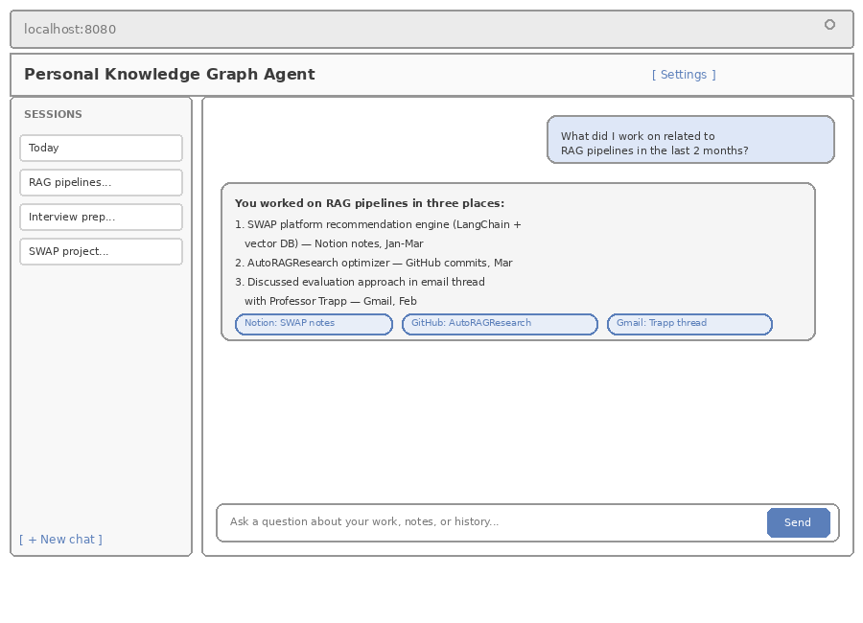
Figure 1: Main chat window wireframe

2.1 Element inventory
Element | Behavior
Session sidebar | Lists past conversations by auto-generated title; clicking one reloads that session's history
New chat button | Starts a fresh session with empty LangGraph state
Settings link | Navigates to the Settings screen (Screen 2)
User message bubble | Right-aligned, shows the question as typed
Agent response bubble | Left-aligned, shows the synthesized answer text
Source chips | One chip per cited source; clicking opens the original Notion page, email, commit, or file
Input box | Free text entry; Enter or Send button submits the question to /api/query

3. Screen 2: Settings / Provider Configuration
Accessible via the Settings link in the header. Lets the user choose the LLM provider mode and confirm which data sources are connected.
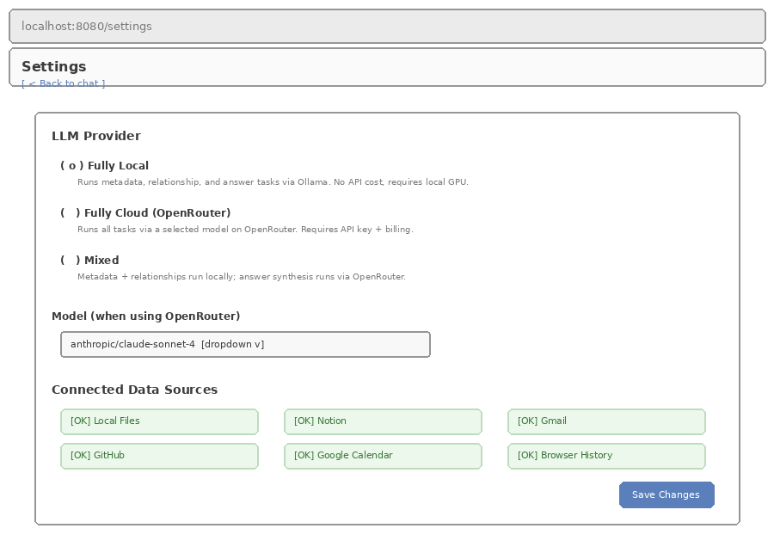
Figure 2: Settings screen wireframe

3.1 Element inventory
Element | Behavior
LLM Provider radio group | Selects Fully Local, Fully Cloud (OpenRouter), or Mixed; each option shows a one-line explanation of cost/quality trade-off
Model dropdown | Only enabled when Fully Cloud or Mixed is selected; lists OpenRouter-supported models
Connected Data Sources grid | Read-only status indicators (OK / not connected) for each of the six sources, reflecting the most recent batch run
Save Changes button | Persists provider configuration to the local config file; takes effect on the next agent run

4. Interaction Flow
- 1. User opens localhost:8080, sees the main chat window (Screen 1), either continuing the most recent session or starting a new one.
- 2. User types a question and submits; the FastAPI backend routes it to the LangGraph agent (see System Architecture Document, Section 5).
- 3. The response streams into the chat as an agent bubble, followed by source chips for every cited item.
- 4. Clicking a source chip opens the original item in a new browser tab (Notion page, Gmail thread, GitHub commit/PR, or local file).
- 5. User can follow up with another question in the same session; LangGraph state carries prior context.
- 6. If the user wants to change how the agent is powered, they navigate to Settings, adjust the LLM Provider mode, and save.

5. States Not Yet Wireframed (Future Screens)
- Ingestion status / last batch run detail view (per-source item counts, errors).
- Relationship graph visual explorer (browsing Neo4j connections visually rather than only through chat).
- Evaluation dashboard showing LangSmith Recall@K and faithfulness scores over time.
These are explicitly out of scope for the V1 interface per the Product Requirements Document, and are noted here only as known future extension points.

End of document.

