Advanced Data Analysis and Visualization in Logistics
Week 3 Task — Analysis & Visualization Report
Scenario: Regional E-Commerce Distribution Network (continued from Weeks 1-2)

1. Dataset Overview
This analysis uses the cleaned shipment dataset resulting from the Week 2 preprocessing pipeline: 1,200 shipment records spanning four warehouses (WH_A - WH_D) and four carriers (FedEx, UPS, DHL, USPS). Key variables include shipment distance (km), package weight (kg), shipping cost (USD), transit time (days), the promised delivery window, and the resulting on-time delivery flag. This structure mirrors real-world shipment datasets used for carrier performance and cost analysis.

2. Exploratory Data Analysis

2.1 Central Tendency and Spread
Summary statistics for the four core numeric variables are shown below. The mean transit time of 3.06 days sits close to the median of 3 days, suggesting a roughly symmetric distribution, while cost shows a wider relative spread (std. dev. of $35.67 against a mean of $105.62), driven mainly by the range of shipment distances.
Metric | Mean | Median | Std Dev | Max
Distance (km) | 235.0 | 229.1 | 79.6 | 489.7
Weight (kg) | 9.9 | 8.4 | 7.1 | 50.6
Cost (USD) | 105.6 | 101.6 | 35.7 | 244.3
Transit Days | 3.06 | 3 | 0.90 | 6

2.2 On-Time Delivery Rate by Carrier
Grouping shipments by carrier reveals meaningful performance differences:
Carrier | On-Time Delivery Rate
FedEx | 89.4%
UPS | 79.4%
DHL | 77.6%
USPS | 67.2%
FedEx delivers on time nearly 90% of the time, while USPS falls well short of the 95% target used in the Week 1 KPI framework, at just 67.2%.

2.3 Correlation Analysis
A correlation matrix was computed across the four numeric variables to understand which factors are most strongly associated with cost and delivery time. Distance and cost show a very strong positive correlation (0.91), confirming that distance is the dominant cost driver. Distance also correlates moderately with transit time (0.55), while package weight shows little relationship with either cost or transit time in this dataset.

3. Visualizations
Six visualizations were produced to examine distributions, relationships, and trends relevant to logistics performance. Each chart type was chosen deliberately to match the analytical question being asked.

3.1 Distribution of Transit Times
A histogram is well suited to showing the shape of a single continuous/discrete variable. This chart reveals that most shipments are delivered within 2-4 days, with a right-skewed tail toward longer transit times.
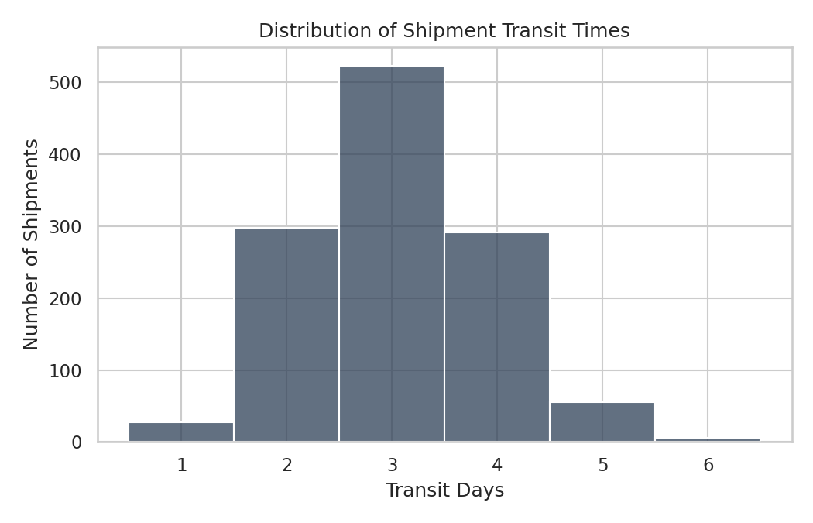
Figure 1: Distribution of Shipment Transit Times

3.2 Cost Distribution by Carrier
A boxplot was chosen because it compares both the central tendency (median) and variability (interquartile range, outliers) of cost across multiple categories simultaneously. DHL shows the highest median cost and widest spread, while USPS is the most economical but also the most variable at the low end.
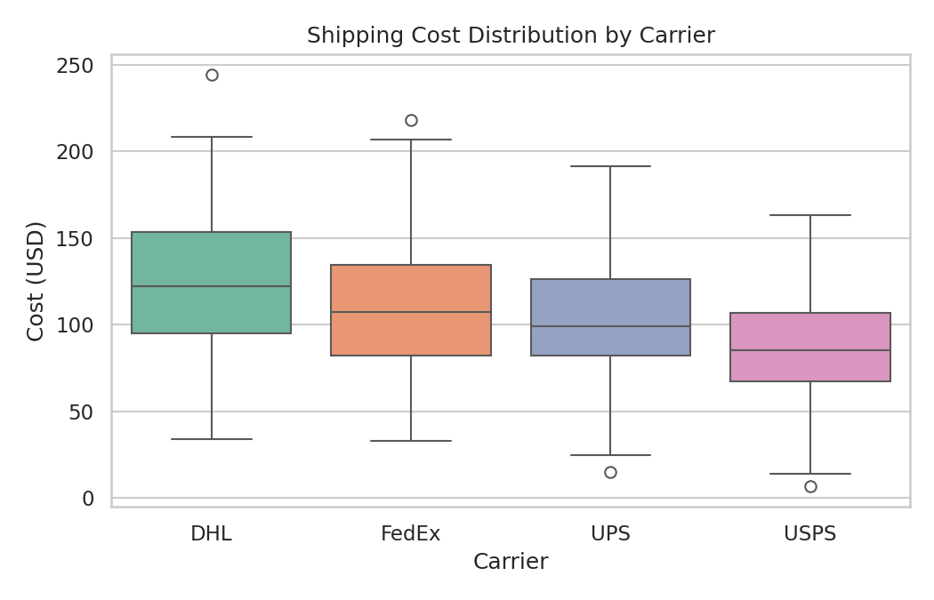
Figure 2: Shipping Cost Distribution by Carrier

3.3 Distance vs. Cost Relationship
A scatter plot is the appropriate choice for visualizing the relationship between two continuous variables, with color used to add a third (categorical) dimension. The near-linear relationship confirms distance as the primary cost driver identified in the correlation analysis, and also shows DHL consistently pricing above other carriers at the same distance.
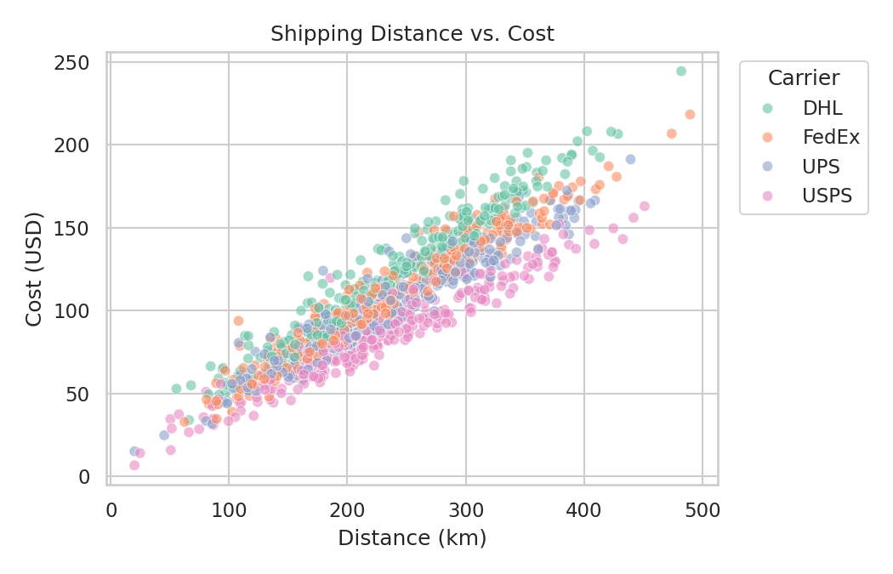
Figure 3: Shipping Distance vs. Cost, by Carrier

3.4 Correlation Heatmap
A heatmap communicates the full correlation matrix at a glance, using color intensity to represent the strength and direction of relationships across all variable pairs simultaneously — more efficient than reading a numeric table alone.
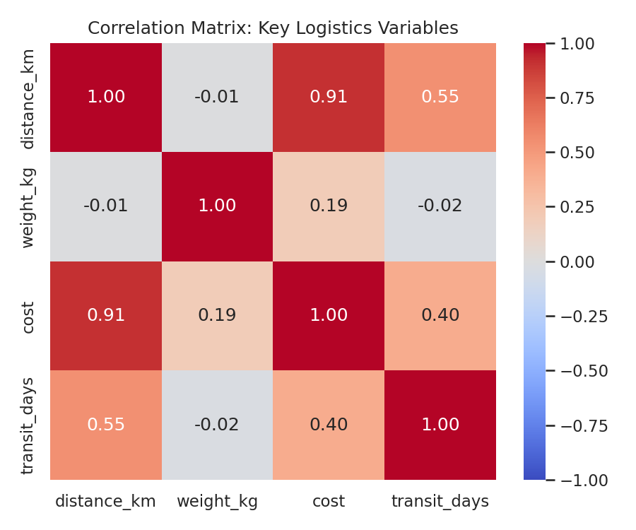
Figure 4: Correlation Matrix of Key Logistics Variables

3.5 Monthly Shipment Volume Trend
A line chart is the standard choice for visualizing a trend over time. Tracking monthly shipment counts helps identify seasonality or growth patterns that would affect staffing and warehouse capacity planning.
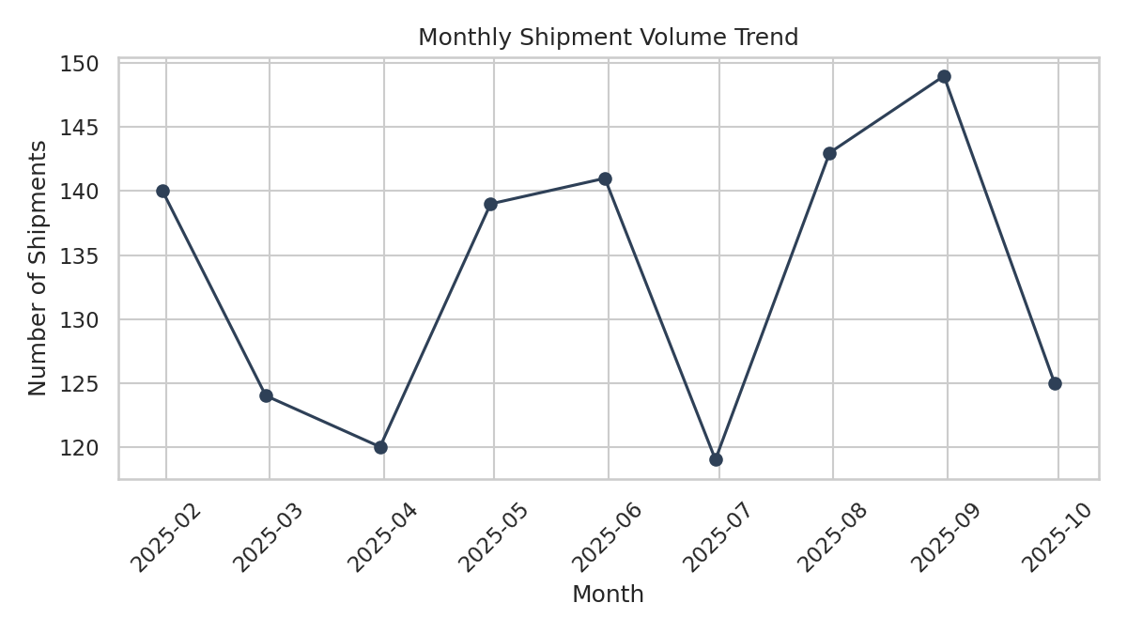
Figure 5: Monthly Shipment Volume Trend

3.6 On-Time Delivery Rate by Warehouse
A bar chart clearly compares a single metric across a small number of categories. Adding a reference line for the 95% target (established in the Week 1 KPI plan) makes the performance gap immediately visible for each warehouse.
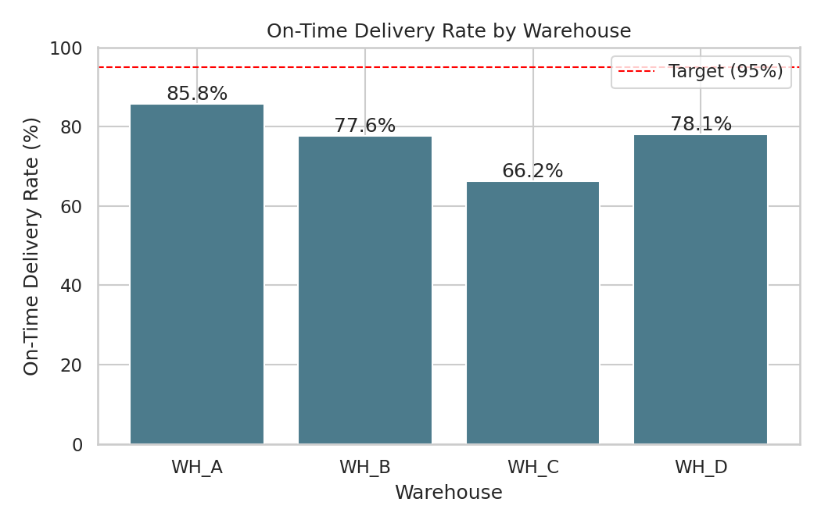
Figure 6: On-Time Delivery Rate by Warehouse, vs. Target

4. Code Documentation
The full analysis and visualization pipeline is provided in the accompanying script (logistics_eda_visualization.py), built with pandas, NumPy, matplotlib, and seaborn. Key excerpts are shown below.

4.1 Data Simulation
def simulate_clean_dataset(n=1200, seed=7):
rng = np.random.default_rng(seed)
warehouses = rng.choice(['WH_A','WH_B','WH_C','WH_D'], size=n,
p=[0.35, 0.25, 0.20, 0.20])
carriers = rng.choice(['FedEx','UPS','DHL','USPS'], size=n)
# distance varies by warehouse; cost driven by distance + weight
# transit_days driven by distance + carrier-specific speed penalty
# ... (see logistics_eda_visualization.py for full logic)
return df

4.2 Exploratory Data Analysis

def run_eda(df):
print(df[['distance_km','weight_kg','cost','transit_days']]
.describe().round(2))
print((df.groupby('carrier')['on_time'].mean() * 100).round(1))
print(df.groupby('warehouse_id')['cost'].mean().round(2))
corr = df[['distance_km','weight_kg','cost','transit_days']].corr()
print(corr.round(2))

4.3 Visualization Generation

# Histogram of transit times
sns.histplot(df['transit_days'], discrete=True, color='#2E4057')

# Boxplot of cost by carrier
sns.boxplot(data=df, x='carrier', y='cost', hue='carrier', palette='Set2')

# Scatter: distance vs cost, colored by carrier
sns.scatterplot(data=df, x='distance_km', y='cost', hue='carrier', alpha=0.6)

# Correlation heatmap
sns.heatmap(corr, annot=True, cmap='coolwarm', vmin=-1, vmax=1)

# On-time delivery rate bar chart by warehouse
plt.bar(otd.index, otd.values, color='#4C7B8C')
plt.axhline(95, color='red', linestyle='--', label='Target (95%)')

5. Analytical Insights and Recommendations

5.1 Cost Drivers
Distance is by far the dominant driver of shipping cost (correlation of 0.91), far outweighing package weight (0.19). This suggests that cost-reduction efforts should prioritize warehouse placement and carrier-zone assignment over packaging or weight-based interventions.

5.2 Carrier Performance Gaps
FedEx substantially outperforms other carriers on on-time delivery (89.4% vs. a 67-79% range for the others), while DHL is the most expensive per shipment. This creates a clear trade-off: DHL's higher cost is not matched by superior speed reliability, making it a candidate for renegotiation or reduced volume allocation in future carrier contracts.

5.3 Warehouse Bottlenecks
Warehouse WH_C shows both the highest average shipping cost ($140.60) and the lowest on-time delivery rate (66.2%), well below the 95% target. Because WH_C also serves the longest average distances, this warehouse is the clearest candidate for either a new regional hub closer to its customer base or a shift of some of its volume to a better-positioned facility.

5.4 Recommendations
- Reassess carrier contracts, shifting volume away from DHL on high-distance routes where its cost premium is not justified by delivery performance.
- Investigate a new or relocated warehouse to reduce the long average shipping distance currently served by WH_C.
- Set carrier-specific on-time delivery targets, using FedEx's 89.4% performance as an internal benchmark for other carriers.
- Continue monitoring monthly shipment volume to anticipate capacity needs ahead of demand increases.

6. Conclusion
This exploratory analysis and set of visualizations translate raw shipment data into actionable operational insight. By quantifying the relationship between distance, cost, and delivery performance, and by comparing carriers and warehouses against the KPI targets set in Week 1, this report identifies concrete, prioritized opportunities to reduce cost and improve delivery reliability across the distribution network.

