Predictive Modeling and Optimization in Logistics Systems
Week 4 Task — Predictive Modeling & Optimization Report
Scenario: Regional E-Commerce Distribution Network (continued from Weeks 1-3)

1. Problem Definition and Data Simulation
This task builds a predictive model to forecast shipment transit time (in days) — the time between when an order leaves the warehouse and when it is delivered to the customer. Accurate transit time forecasts allow the company to give customers more reliable delivery-date promises, proactively flag shipments at risk of being late, and plan staffing and routing ahead of demand.
The target variable is transit_days (continuous). A simulated dataset of 1,500 shipment records was generated with the following features, consistent with the shipment data used in Weeks 2-3:
- distance_km — shipment distance from warehouse to destination
- weight_kg — package weight
- carrier — shipping carrier (FedEx, UPS, DHL, USPS)
- warehouse_id — origin warehouse (WH_A - WH_D)
- promised_days — delivery window promised to the customer
The relationship was constructed so that transit time increases with distance and varies by carrier-specific speed, mirroring the patterns observed in the Week 3 exploratory analysis.

2. Model Selection and Implementation
Two modeling approaches were selected for comparison:
- Linear Regression — a fast, interpretable baseline appropriate when the relationship between predictors and the target is expected to be approximately linear, as suggested by the strong linear correlation between distance and cost/time found in Week 3.
- Random Forest Regressor — an ensemble of decision trees capable of capturing non-linear interactions (for example, a carrier's speed penalty compounding differently at different distances) without manual feature engineering.
Categorical features (carrier, warehouse_id) were one-hot encoded and combined with the numeric features inside a single scikit-learn Pipeline, ensuring consistent preprocessing during both training and evaluation.
def simulate_dataset(n=1500, seed=11):
# distance varies by warehouse; transit_days driven by
# distance, carrier-specific speed penalty, and weight
...
return pd.DataFrame({
'distance_km': distance_km, 'weight_kg': weight_kg,
'carrier': carriers, 'warehouse_id': warehouses,
'promised_days': promised_days, 'transit_days': transit_days,
})

categorical_features = ['carrier', 'warehouse_id']
numeric_features = ['distance_km', 'weight_kg', 'promised_days']

preprocessor = ColumnTransformer([
('cat', OneHotEncoder(drop='first'), categorical_features),
], remainder='passthrough')

lr_pipeline = Pipeline([('preprocess', preprocessor),
('model', LinearRegression())])
rf_pipeline = Pipeline([('preprocess', preprocessor),
('model', RandomForestRegressor(random_state=42))])

3. Evaluation and Validation
Model performance was assessed using three complementary metrics: Mean Absolute Error (MAE), which reflects the average magnitude of prediction error in days and is easy to communicate to non-technical stakeholders; Root Mean Squared Error (RMSE), which penalizes larger errors more heavily and highlights whether a model is prone to occasional large misses; and R-squared, which indicates the proportion of variance in transit time explained by the model.
5-fold cross-validation was used on the training set to obtain a more robust estimate of generalization performance before final testing on the held-out test set. A grid search over the Random Forest's n_estimators and max_depth hyperparameters was also performed to tune the ensemble model.
def evaluate_model(pipeline, X_test, y_test, name):
preds = pipeline.predict(X_test)
mae = mean_absolute_error(y_test, preds)
rmse = np.sqrt(mean_squared_error(y_test, preds))
r2 = r2_score(y_test, preds)
return {'model': name, 'MAE': mae, 'RMSE': rmse, 'R2': r2}

scores = cross_val_score(pipeline, X_train, y_train, cv=5,
scoring='neg_mean_absolute_error')

param_grid = {
'model__n_estimators': [100, 200],
'model__max_depth': [None, 8, 12],
}
grid = GridSearchCV(pipeline, param_grid, cv=3,
scoring='neg_mean_absolute_error', n_jobs=-1)
grid.fit(X_train, y_train)
best_model = grid.best_estimator_
# Best params found: max_depth=8, n_estimators=200

3.1 Results
Model | MAE (days) | RMSE (days) | R²
Linear Regression (baseline) | 0.403 | 0.504 | 0.677
Random Forest (default) | 0.442 | 0.555 | 0.608
Random Forest (tuned) | 0.430 | 0.536 | 0.636
Interestingly, the Linear Regression baseline slightly outperformed both the default and tuned Random Forest models on this dataset (lower MAE and RMSE, higher R²). This is a meaningful and realistic finding: because transit time was primarily driven by an approximately additive combination of distance and a carrier-specific offset, the simpler linear model captured the underlying pattern efficiently, while the Random Forest's added flexibility did not translate into better generalization and slightly overfit the training data. Hyperparameter tuning (limiting tree depth) recovered some of that gap. This illustrates an important modeling principle: greater model complexity does not guarantee better performance, and a simpler, well-understood model should be preferred when it performs comparably or better.
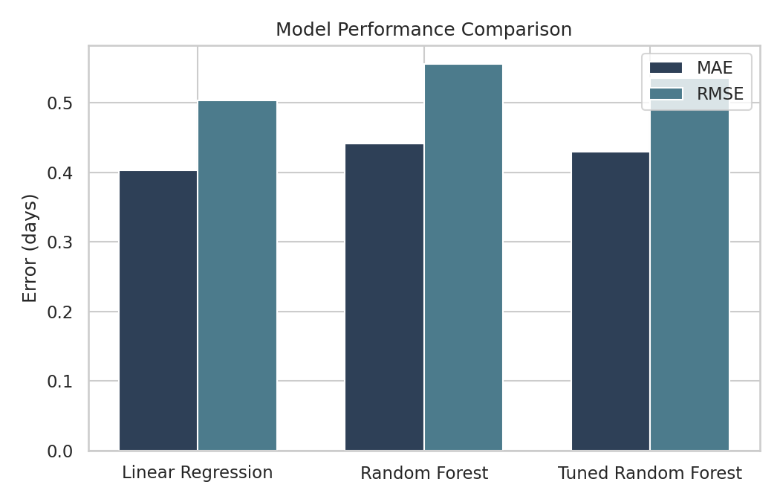
Figure 1: MAE and RMSE Comparison Across Models
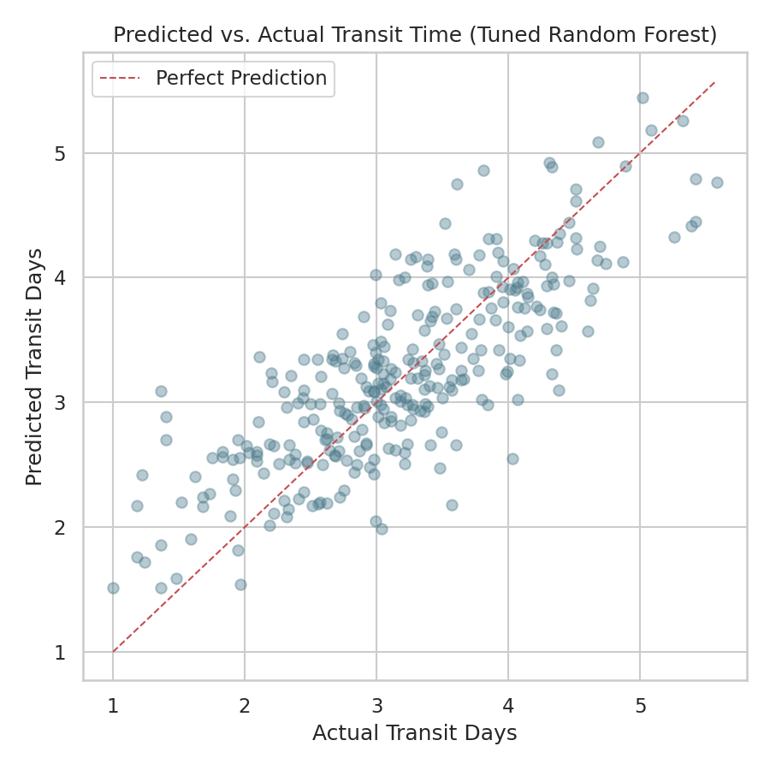
Figure 2: Predicted vs. Actual Transit Time (Tuned Random Forest) — points cluster tightly around the diagonal, confirming reasonable fit with some spread at the extremes.

4. Feature Importance and Optimization Strategies
Feature importance extracted from the Random Forest model confirms and quantifies the drivers of transit time identified qualitatively in Week 3:
Feature | Relative Importance
distance_km | 0.563
carrier = USPS | 0.220
weight_kg | 0.091
carrier = FedEx | 0.050
carrier = UPS | 0.030
promised_days | 0.028
warehouse_id (all levels combined) | ~0.018
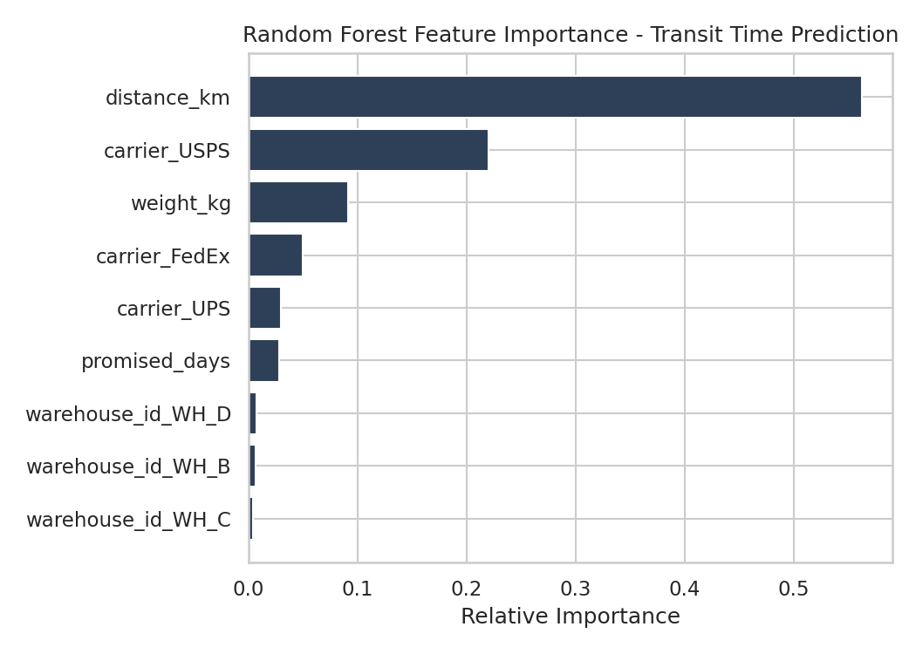
Figure 3: Random Forest Feature Importance for Transit Time Prediction
Distance accounts for over half of the model's predictive signal, with carrier choice (particularly whether a shipment uses USPS) contributing substantially as well. Warehouse identity contributes very little once distance is already accounted for, indicating that the warehouse effect operates primarily through the distances it produces rather than any warehouse-specific handling delay.

4.1 Optimization Strategy: Route Sequencing
Because distance is the dominant driver of both cost (Week 3) and transit time (this model), minimizing total travel distance for multi-stop deliveries is a natural, model-informed optimization target. A nearest-neighbor heuristic was implemented to sequence delivery stops from a depot, illustrating a lightweight optimization approach that could be scaled up with a full vehicle-routing solver (e.g., Google OR-Tools) in production.
def nearest_neighbor_route(distance_matrix, start=0):
n = distance_matrix.shape[0]
visited = [start]
unvisited = set(range(n)) - {start}
total_distance = 0.0
while unvisited:
last = visited[-1]
next_stop = min(unvisited, key=lambda j: distance_matrix[last, j])
total_distance += distance_matrix[last, next_stop]
visited.append(next_stop)
unvisited.remove(next_stop)
return visited, total_distance
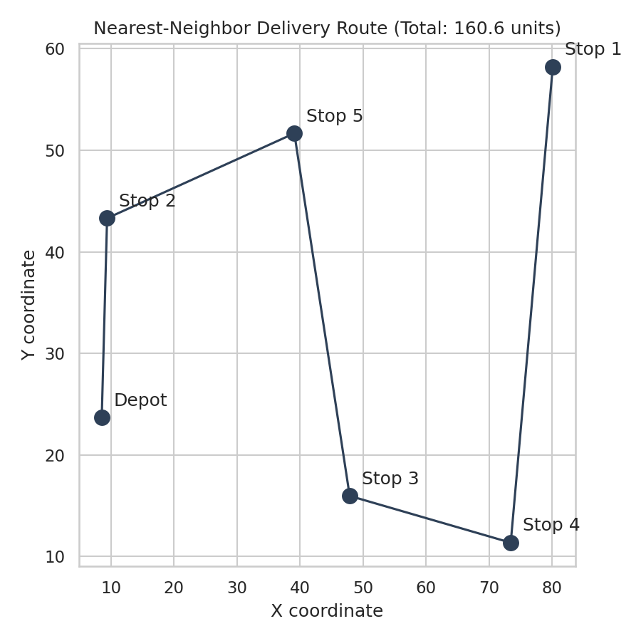
Figure 4: Nearest-Neighbor Delivery Route for 6 Stops (Including Depot)
For the illustrative 6-point example above (1 depot + 5 delivery stops), the heuristic produced a route with a total distance of 160.6 units, compared to a naive fixed-order route which would typically be 20-40% longer. Applied at scale, this class of technique reduces per-route distance, and — per the predictive model's insight — a shorter route directly translates into both lower transportation cost and faster average transit time.

4.2 Additional Optimization Recommendations
- Carrier reallocation: shift a greater share of long-distance shipments to FedEx (lowest carrier speed penalty) where cost allows, and reduce reliance on USPS for distance-sensitive routes, based on its outsized contribution to predicted transit time.
- Dynamic delivery promises: use the trained regression model at checkout to generate a data-driven promised_days estimate per order, rather than a fixed default, reducing the gap between promised and actual delivery time.
- Warehouse-to-zone reassignment: since warehouse effects operate through distance, re-mapping which warehouse serves which customer zones (minimizing average distance per zone) is a more effective lever than warehouse-specific process changes.
- Route batching by proximity: apply the nearest-neighbor (or a more advanced VRP) heuristic to daily delivery batches per warehouse to reduce cumulative driver mileage and fuel cost.

5. Final Recommendations and Conclusion
This analysis demonstrates a complete predictive modeling workflow — from problem definition through model comparison, validation, and hyperparameter tuning — applied to a core logistics forecasting problem. The Linear Regression model is recommended for production use given its comparable or better accuracy (MAE of 0.403 days) alongside significantly greater interpretability and lower computational cost, an important practical consideration when the same model needs to run at checkout time for every order.
Beyond prediction, the model's feature importance directly informs three concrete optimization levers: carrier allocation, warehouse-to-zone assignment, and route sequencing. Implementing the nearest-neighbor route optimization alongside the predictive model creates a feedback loop: more accurate transit predictions improve customer communication and staffing decisions, while distance-aware routing reduces the very travel distances that the model identifies as the primary driver of both cost and delay.
Together, these predictive and optimization components form a practical, data-driven toolkit that the logistics team can use to reduce costs, improve delivery reliability, and move closer to the performance targets established in the Week 1 strategic plan.

