**1 . INTRODUCTION**

Attendance Management System is a software developed for daily student attendance in schools, collages and institutes**.**

If facilitates to access the attendance information of a particularstudent in a particular class. The information **is** sorted by the operators, which will be provided by the teacher for class. This system will also help in evaluating attendance eligibility criteria of a student.

* 1. **PROBLEM AND MOTIVATION**
* In most educational institutions the attendance is taken manually. It is not only time consuming, but it is also unsecure and unreliable and it can be lost .
* Some institutions are using punch card for attendance while this will be difficult for teachers to keep track of the large number of students .
* To overcome these problems I have developed a better system which is Web based; it is fully responsive where a user can use in mobile, tablets and different computersystems .
* In this system records are kept safe and secure and the attendance information of particular or all students of particular class can be accessed easily and without time consuming .
  1. **OVERVIEW**

Attendance Management System basically has two main modules for proper functioning.

* First module is admin which has right for creating space for new batch. Any entry of new faculty Updation in subject if necessary, and sending notice.
* Second module is handled by the user which can be a faulty or an operator. User has a right of making daily attendance, generating report. Updation in subject if necessary, and sending notice.

Attendance can be taken in two ways:

* On the basis of Subject and month.
* On the basis of Class.
  1. **OBJECTIVE**
* Eliminate duplicate data entry and errorsin time and attendance entries.
* Eliminate paperwork and save time.
* Automatic calculation of attendance ¬
* To Increase security.

The main characteristics of my developed system is that it is web based , fully responsive and flexible .It can be accessed from any computer no matter where you are.

Its purpose is to make a attendance software for where register the student details, their subjects, teachers, and related field. The daily attendance of students are taken automatically by selecting student name and subject, If the student was present then the present check box is clicked similarly if the student was absent then the absent check Box is clicked instead of the present check box, and by clicking the save button information will be stored in database.

* 1. **Requirement Analysis**
     1. **Hardware**
* Computer System with minimum 4GB RAM
* 10GB of available disk space minimum
  + 1. **Software**
* **System Software**
* Windows 10
* **Application software**
* Xampp Server
* MySQL
* Web Browser

**2. Tools and Technologies**

**2.1 XAMPP Server**

* WAMP is installed as a software bundle and stands for “Windows, Apache, MySQL, and PHP.”XAMPP is often used for web, development and internal testing, it also can be used for serving live websites
* Now, visually, a brief description of downloading and installation of XAMPP server, from sources where I have used is shown below step by step.

1. Go to <https://www.apachefriends.org/download.html> , website

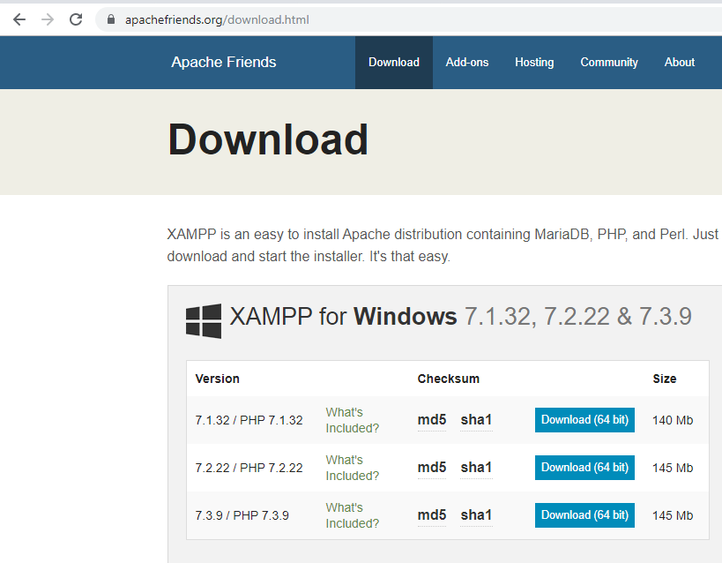

1. Select XAMPP SERVER 32 BITS OR XAMPP SERVER 64 BITS according to requirement In my case WAMP SERVER 64 BITS .
2. Click the download label

**2.2 Apache**

* The Apache HTTP Server, informally called Apache, is the world’s most popular web server software that in 2009 it became the first web server software to serve more than 100 million websites. The Apache development began in early 1995 and originally based on the NCSA HTTPd server.
* Apache is developed and maintained by an open community of developers under the patronage of the Apache Software Foundation. Mostly used on a Unix-like system, the software is also available for a vast variety of operating systems, including Microsoft Windows, Open VMS, eComStation, NetWare and TPF.
* Apache is open source software, as on November 2015, it was estimated to serve 50% of all active websites and 37% of the top servers across all domains. The released version of Apache is shown below

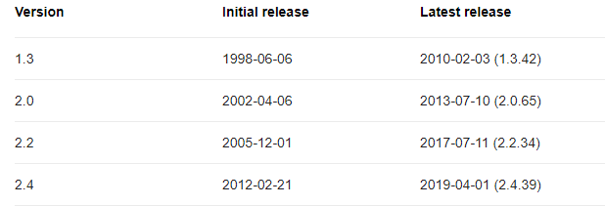

**2.3 MySQL**

* SQL stands for Structured Query Language. MySQL is an open source Relational Database Management System (RDBMS); it is a popular database for use in web applications, and is a central part of the greatly used LAMP (Linux, Apache, MySQL, Perl/PHP/Python) open-source web application software stack.
* MySQL is used by many applications like, WordPress, Joomla, TYPO3, Drupal, MyBB, phpBB, MODX and other software. Numerous large scale websites including Google, YouTube, Facebook, Twitter, and Flickr are also using MySQL.
* On all platforms excluding Windows, MySQL sends with no GUI (Graphical User Interface) to administer MySQL databases or managing the data held within the databases. Users may install MySQL Workbench by downloading separately or simply may use the command line tools. Numbers of third party GUI tools are also available. The released version of MySQL is shown below

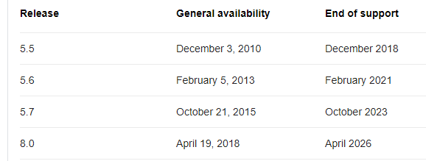

**2.4 PHP**

* It stands for PHP: Hypertext Preprocessor but, originally stood for Personal Home Page. Is a server side scripting language that designed for web development, as well as used for general purpose language. It was created in 1994 by Rasmus Lerdorf, in the present time the reference execution of PHP is produced by the PHP group.
* In January 2013, PHP was installed on more than 240 million websites, and 2.1 million web servers. The PHP code can be combined with several web frameworks and templating engines or simplyit can be mixed with HTML code.
* The PHP code is generally processed by a PHP interpreter, which is commonly executed as native module of web server or a Common Gateway Interface (CGI) executable. After interpretation and execution of the PHP code, the results will be sent by web server to its client.
* There are many versions of the PHP, and the version, I have used for my application is the PHP version 7.0 . Currently supported versions of the PHP are following,

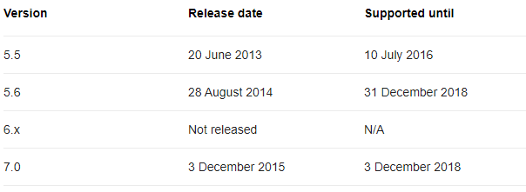

**2.5 PhpMyAdmin**

It is an open source tool and also, it is free written in PHP, XHTML, CSS, and JavaScript planned to manage the administration of MySQL by using of a web. It is able to perform various missions like creating, modifying databases, tables, fields, executing SQL statements or managing and supervise users.

PhpMyAdmin is being translated into 72 languages in order to make the usage easy to a wide domain of people and it supports both LTR and RTL languages. Following is some features of the phpMyAdmin,

* It is web interface
* It administrates multiple severs
* It is able to create PDF graphics of the database layout
* Importing data from SQL and CSV
* Export data to different formats such as SQL, PDF, CSV, XML and others
* It works with various Operating Systems

**2.6 HTML AND CSS**

* HTML stands for Hypertext Markup Language and CSS stands for Cascading Style Sheets are the crucial technologies for creating web pages. HTML supplies the structure of the page, and CSS the layout, for diversity of devices. Together with scripting and graphics, HTML and CSS are the fundamental of building Web Applications and Web pages.
* HTML provides designers and developers the following facilities,
* To design forms for directing transactions with remote services, for use in making reservation,searching for information, ordering products, and others .
* Retrieving online information through hypertext links.
* To include video and sound clips, spread sheets, and other applications straight in their documents.
* Designer can publish online documents with text, headings, tables, photos and others.
* CSS describes the Web pages presentation, involving layout, colors, and fonts. It enables the designer to adjust the presentation to various types of devices, like a small screens, large screens, or printers.
* CSS isseparate from HTML, and their separation makes it easy to preserve and maintain sites, share style sheets across pages, and accommodate pages to various environments.

**3.0 PROPOSED SYSTEM (FRONT- END DESIGN)**

**3.1 Introduction**

* This is the Home screen of the proposed system which consists of seven buttons. In order to go to the desired screen; the users just have to click the related button.
* By clicking the Home, Students, Teachers, Subjects, Monthly Report, Overall Report, Do Attendance, and the Log Out buttons, their respective screens will appear.
* In home screen there is also a sidebar where users may do new entries or take attendance by clicking the Do Attendance button. The sidebar is shown below .

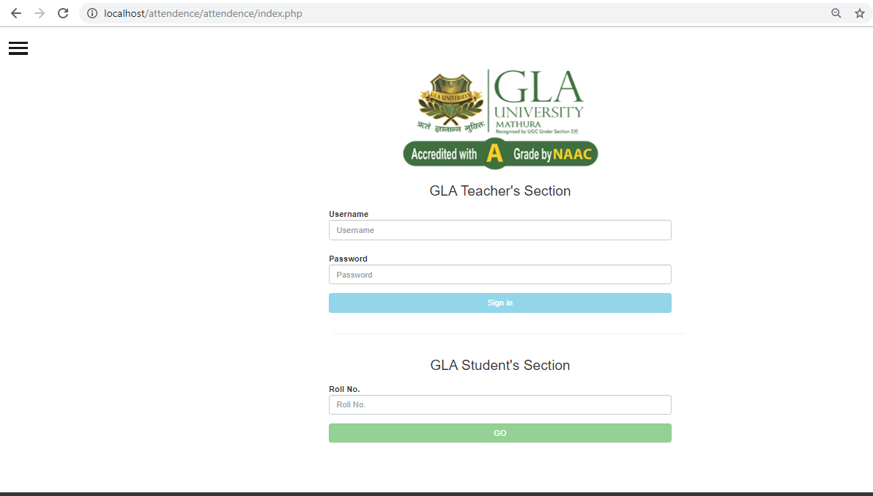

**3.2 Log in**

* Before entering into the system (home page), the user must login, for this purpose the log in page is created.
* This log in form is made for security purpose i.e. only authenticated users have access into the system, i.e. either administrator or the user.

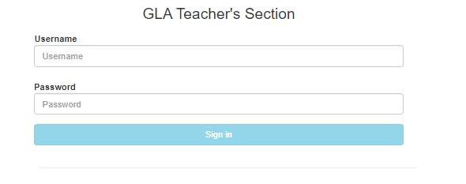

**3.3 Log out**

By clicking the Log Out button the user is redirected into the Login page, which has describe

**3.4 Students**

* This is the student screen which provides information about student’s data such as Student Name, DOB, Gender, Email, Phone, Address, Session, Program, and Semester in the form of rows and columns.
* The Insert button enables the user to enter new entries similarly Update button enables the user to edit / modify, whereas, Delete button is used for deleting the record.

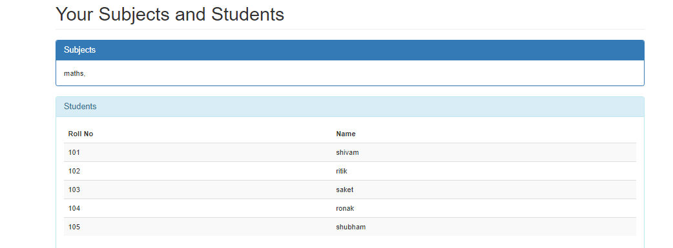

**3.4.1 NewRegistration**

New registration can be done through filling the following form.

**3.5 Do Attendance**

This is the screen for Attendance purpose, the name and the program is automatically retrieved from the database. If the student was present then the present check box is clicked similarly if the student was absent then the absent check box is clicked instead of present check box, by clicking the save button information will be stored.

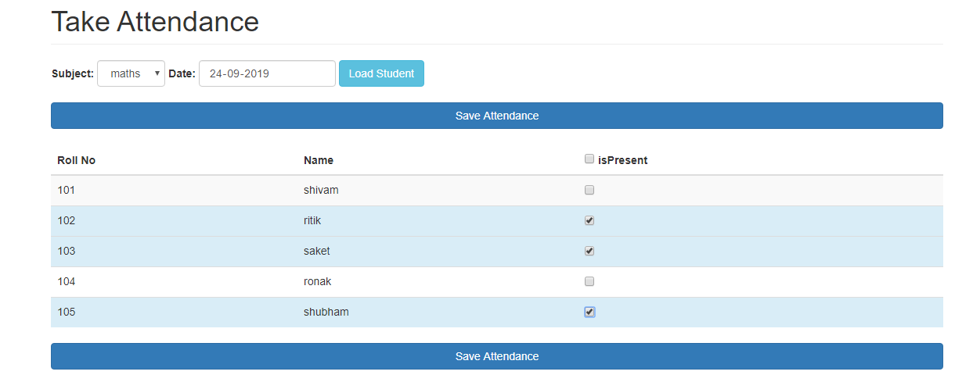

**4.0 PROPOSED SYSTEM (BACK- END DESIGN)**

**4.1 Introduction**

To achieve the flow of data and data processing task, I have created a database named Attendance_db and inside this database five entities have been created, mentioned below, Attendance Database is:

**4.2 Attendance Database**

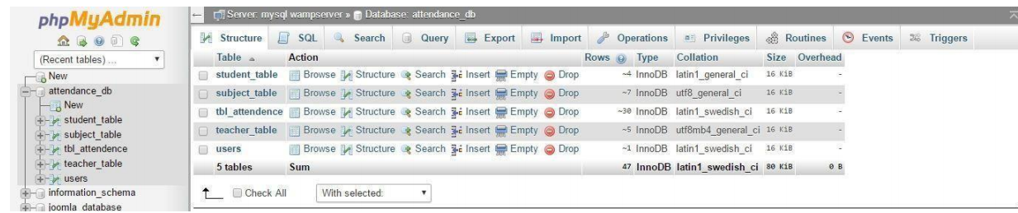

**4.2.1 Student Entity**

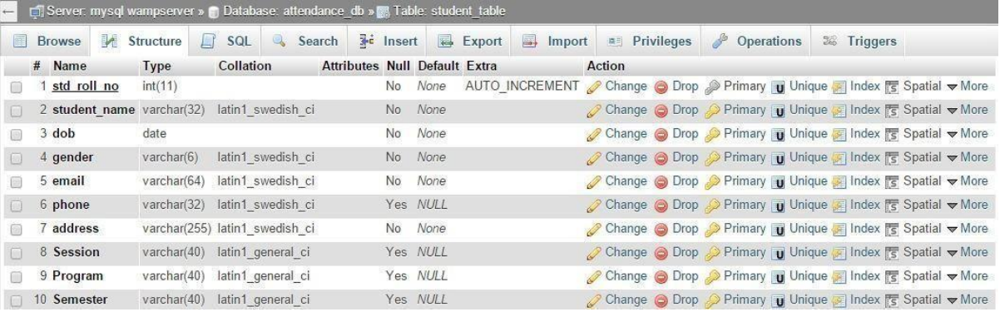

**4.2.2 Subject entity**

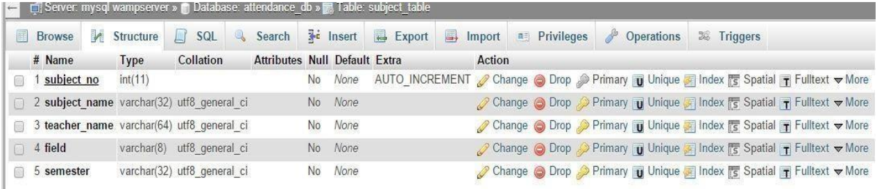

**4.2.3 Users entity**

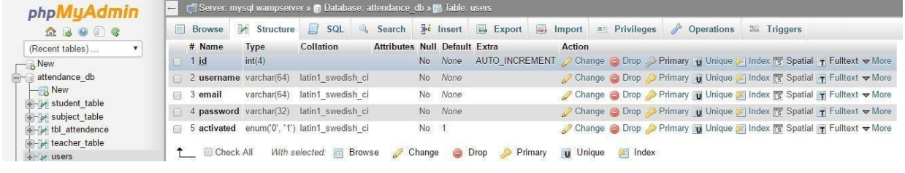

**4.3 DATA FLOW DIAGRAM**

**0-level DFD:**

User/Administrator

System

Output

**1-level DFD:**

Login

Process

Report

Generation

Attendance

Entry

Student

Entry

Teacher

Entry

**2-level DFD:**

**2.1**

Studen

t

Login

After login

Data Stored

Data Stored

After login

Data Entry Data Entry

Administrator

Login

Process

Teacher

Entry

Student

Entry

Administrator

**2.2**

Attendan

Login

After_ login

Attendance

Data Stored

Report

After login

Data Entry

Login

Process

Attendance

Entry

Report

Generation

User

User

**4.3 ER Diagram**

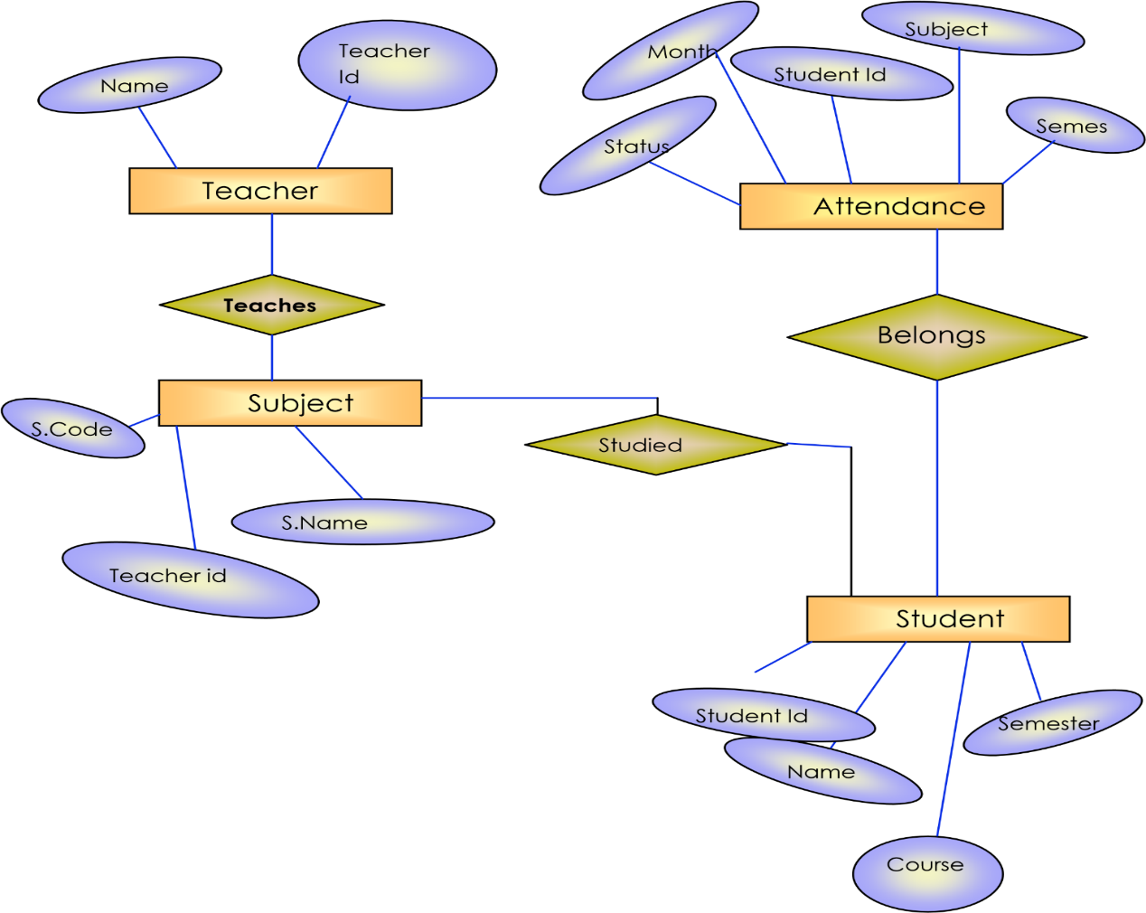

**5.0 Conclusion**

* In this work , the web based attendance management system is developed using PHP server-side scripting language and CSS,HTML ,JavaScript for designing which is fully meet the system’s goals.
* The system Ihave developed isfullyresponsive which can be used in mobile, tablets and different operating systems. Some other benefits are.
* Automated and web-based for easy accessibility
* It is a dynamic and flexible system
* It excludes paperwork and the possibility of making mistakes while using paper for taking attendance
* It is very user friendly and handy