MINI PROJECT

(2019-20)

**ELECTION VOTING PORTAL**

**(Web Development)**

SYNOPSIS

**Department of Computer Engineering & Applications**

**Institute of Engineering & Technology**



**Submitted to:** **Submitted by:**

Mr.Sharad Gupta Shivam Singh (171500323)

(Assistant Professor) Sakshi Gupta (171500283)

**ACKNOWLEDGEMENT**

It is our pleasure to acknowledge the assistance of a number of people without whose help this project would not have been possible. First and foremost, We would like to express our gratitude to **Mr. Sharad Gupta**, Assistant professor of department CEA, our project guide for providing invaluable encouragement, guidance and assistance.

We would like to thank the group member for the operation extended to us thought out the project. After doing this project we can confidently say that this experience has not only enriched us with technical knowledge but also has unparsed the maturity of thought and vision. The attributes required being a successful professional.

Shivam Singh (171500323)

Sakshi Gupta (171500283)

**PROJECT DESCRIPTION**

(Election Voting Portal)

**Election Voting Portal** is a computer technology based on web server. In case of current Election System the voting is manual. People go to the Polling booths allocated by the Election Commission of India in every area.

Online Election System would have Candidate registration. Admin Login which will be handled by Election Commission .Candidate Login which will be handled By Candidate, Voters will get Unique ID and Password, Using which they can vote for a Candidate only once per Election.

The project is beneficial for Election Commission, Voters as the can get to know the candidate background and choose wisely. The software system allows the Candidate to login in to their profiles and upload all their details including their previous milestone onto the system. The admin can check each Candidate details and verify the documents, only after verifying Candidate’s ID and Password will be generated.

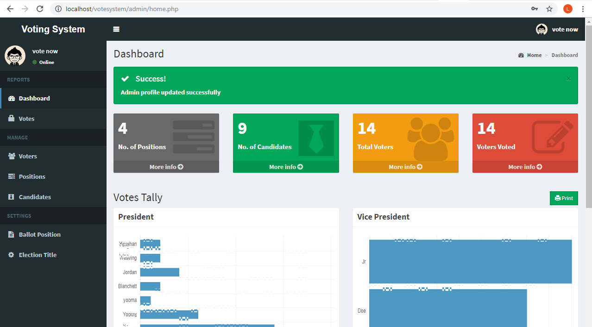

**TABLE OF CONTENT**

**Abstract……………………………………………………….…….i**

**Certificate…………………………………………………….……. ii**

**Acknowledgement…………………………………………….….... iii**

1. **Introduction**……………………………………….….... 1
   1. Overview……….…………………………….....................2
   2. Motivation……………………………………………....... 3
   3. Problem Statement…………………………………….......4
   4. Objective……………………………………………….… 5
   5. Challenges………………………………………………... 6
2. **Software Requirement Analysis……...……………...... 7**
   1. System Analysis……………………………….………….. 7
   2. Role of System Analysis…...………………………………8
   3. Classification..………………..…………………………... 9
   4. Create Database……………………..….………................10
   5. Connect Database….…………….……..............................11
3. **Software Design………………………………….……..12**

3.1 Data Flow Diagram…………………………………………...12

3.1.1 Level Zero DFD…………………………………………….13

3.1.2 Level One DFD……………………………………………..14

1. **Requirement……………………………………………………..15**
   1. Hardware……………………………………………….....16
   2. Software………………………………………………..…16
   3. Operating System……………………………....................17
   4. Application…………………………………………….….17
   5. Technology…………………………………..…………....18
2. **Experimental Results………………………………....................19**

4.1 Poll or Election Result…………………………......................19

4.2 Implementation Details………………………..………………20

**5. Approach………………………………………………21**

5.1 Bibliography ………………………………………………..22

**PROJECT ANALYSIS**

* 1. **Purpose**

The main purpose of this study is some people hesitate to vote due to weather conditions in different areas during the election, youngsters of age group 18 – 24 having no charm to cast the vote. People who are outside of their town/city don’t want to come to their area for just casting the votes due to the expenses and trouble of transportation. Same situation is also for those who are on duty during the election, they don’t have any interest to cast their vote during job or they don’t have facility to submit their vote.

* 1. **Objective**

The aim of the study is to analyze the current election system and suggest an online election system which will allow people to cast votes in a more convenient way, by using available resources which could facilitate the voters during elections.

In this **Project** we will try to find out the answers or learn the following things

* Is an online voting system a better replacement of current manual system
* Better for other manual and long procedure.
  1. **Technology Used**

1. **HTML:** It is used for giving eye catching look to the website and also providing easy to use GUI.
2. **CSS:** CSS is cascading style sheet which is used to give designer look to HTML using the external file.
3. **PHP**: It is use for perform some logical operation in HTML and also use for connecting HTML page to Database.
4. **MySQL**: MySQL is a relational database management system based on **SQL** – **S**tructured **Q**uery **L**anguage. The application is used for a wide range of purposes, including data warehousing and logging applications. The most common use for MySQL however, is for the purpose of a web database. It can be used to store anything from a single record of information

**REQUIREMENT:**

**Hardware Requirement:**

1. Computer system with minimum 8GB RAM
2. 10 GB of available disk space minimum

3) Camera

4) 1280x800 minimum screen resolution

**Software Requirement:**

1) Visual Studio Code

2) Notepad++

3) Sublime Text Editor

**i) Operating System:** Windows 10

**Application :**

1. Election Voting
2. Conducting Poll
3. University Election
4. Society Election

**Technology Used:**

1. HTML
2. CSS
3. PHP
4. MySQL

**Approach:**

**Respected Faculty Guidelines:**

1. Mr. Pankaj Kapoor
2. Mr. Manish Rai

**References Websites:**

1. [www.geeksforgeeks.com](http://www.geeksforgeeks.com)
2. [www.udemy.com](http://www.udemy.com)
3. [www.javatpoint.com](http://www.javatpoint.com)
4. [www.youtube.com](http://www.youtube.com)
5. [www.w3school.com](http://www.w3school.com)

**Book References:**

1. HTML and CSS: Design and build Websites book by Jon Duckett
2. Learning MySQL by Robin Nixon
3. HTML 5 by DT Editorial