Assignment -14

Problem Statement 1:

Is gender independent of education level? A random sample of 395 people were surveyed and each person was asked to report the highest education level they obtained. The data that resulted from the survey is summarized in the following table:

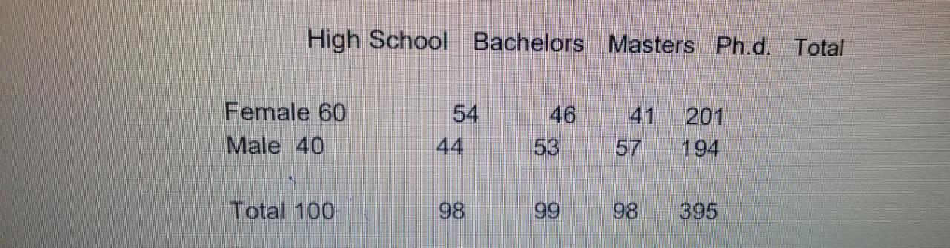

Question: Are gender and education level dependent at 5% level of significance? In other words, given the data collected above, is there a relationship between the gender of an individual and the level of education that they have obtained?

Solution :

Ho – The Education level not depends on Gender

Ha - The Education level depends on Gender

Expected o/p

Female = 50.8, 49.8, 50.3, 49.8

Male  = 49.1 , 48.1,48.6, 48.1

X2 =8.06

N -1 = 4-1 = 3

X2 (0.05) = 7.82

So, we accept the alternative hypothesis Ha that means the education level is not depends on gender.

Problem Statement 2:

Using the following data, perform a oneway analysis of variance using α=.05. Write up the results in APA format.

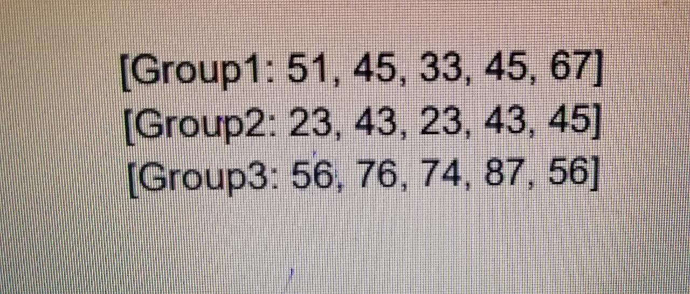

Solution :-

H0= μ1 = μ2 = μ3  
Ha = μ1 ≠ μ2 ≠ μ3

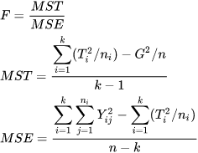

Sum =

group 1 = 241

group 2 = 177

group 3 = 349

mean =

group 1 = 48.2

group 2 = 35.4

group 3 = 69.8

total sum = 767

total mean = 51.19

ssw = 1860.8

ssb = 3022.9

sst = 4883.7

dfb = 2

dfw = 12

msw =1511.2

msb = 155.07

MSbetween = 3022 / 2

= 1511.2

MSwithin = 1860 / 12

= 155.07

F = MSbetween / MSwithin

= 1511.47/ 155.07

= 9.75

F (0.05)

= 3.89

So , we accept the alternative hypothesis Ha .

Problem Statement 3:

Calculate F Test for given 10, 20, 30, 40, 50 and 5,10,15, 20, 25. For 10, 20, 30, 40, 50:

Solution :