Connected to my EC2 and installed docker and docker compose

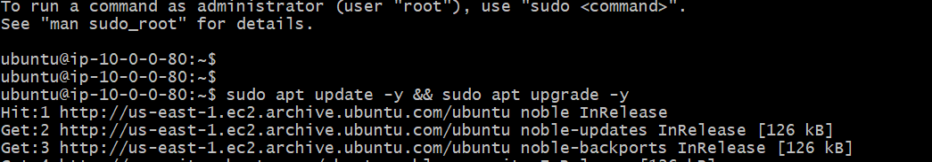



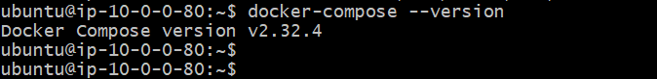

Clone the repo and start creating Docker file for each node js app

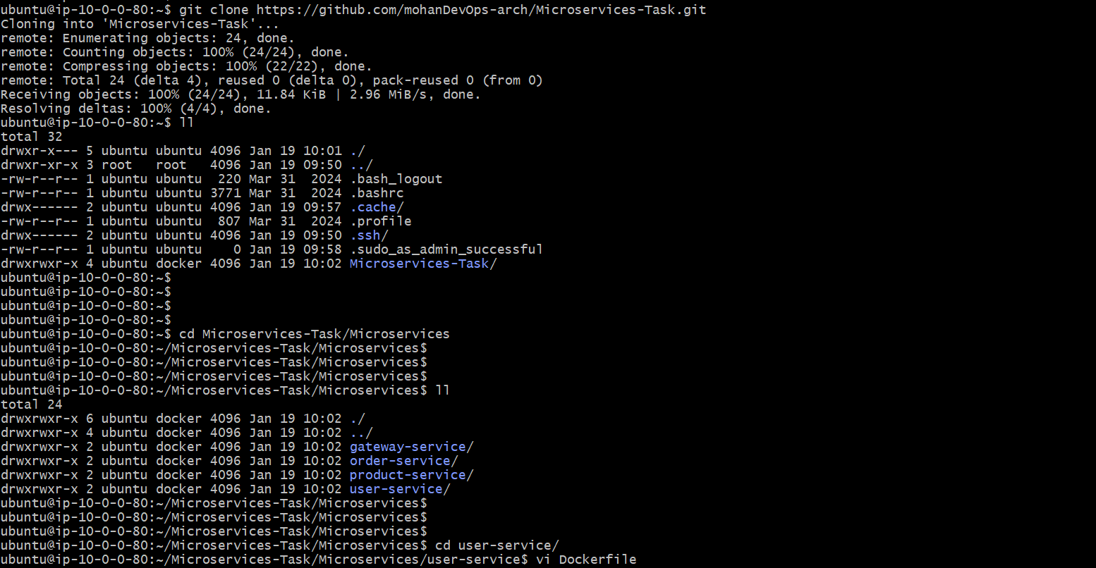

Dockerfile for user-service

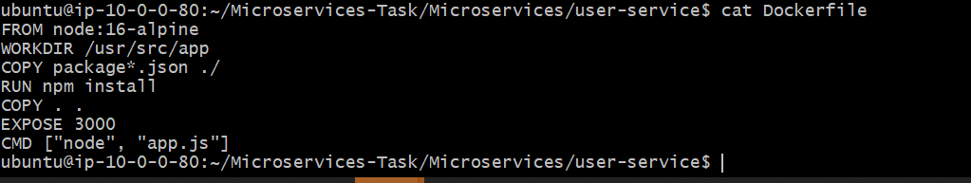

Create a docker compose file in the main directory of the project

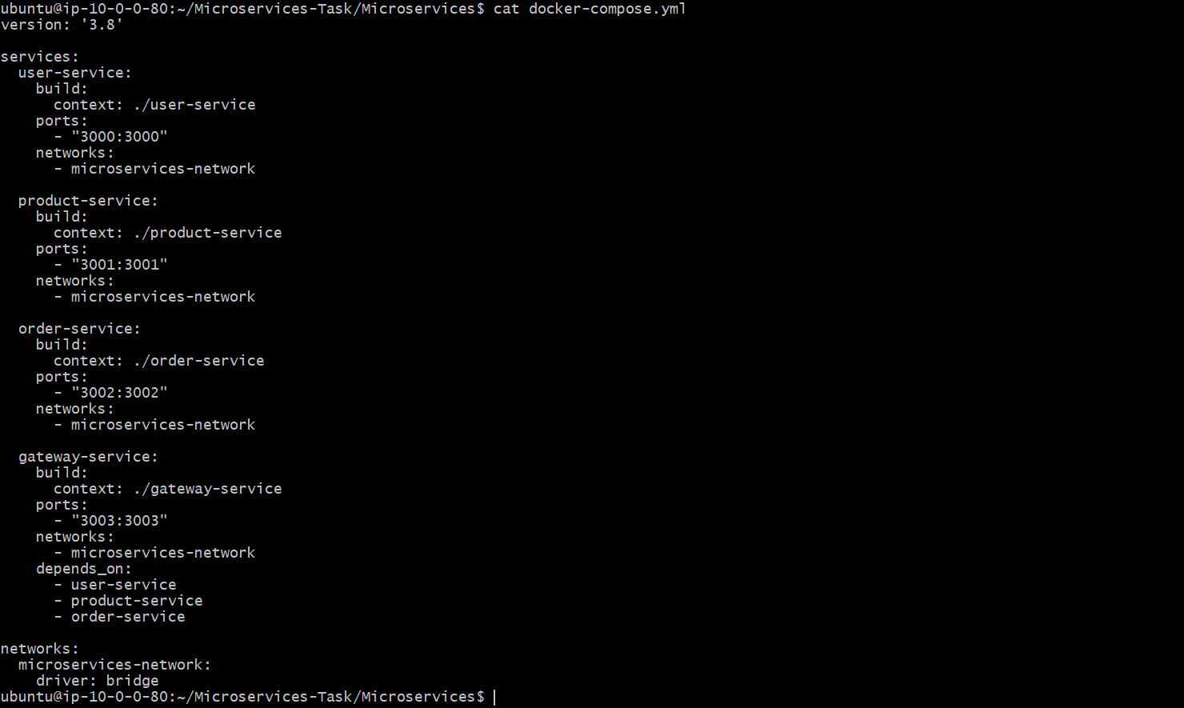

Run docker compose build command to start the containers  
  
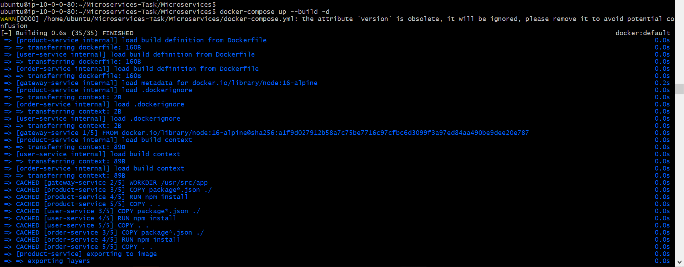

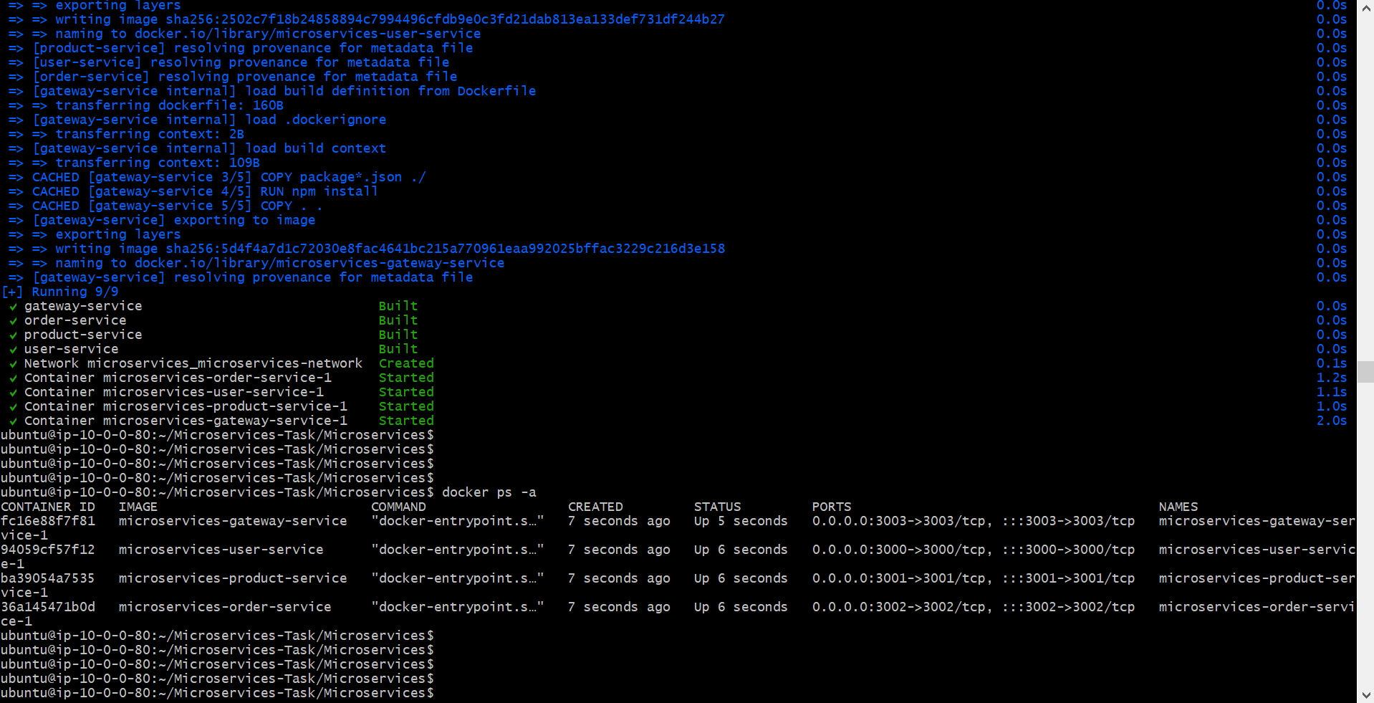

All 4 containers are in running state  
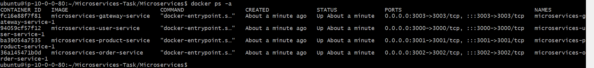

Access the application on

• **User Service**: http://23.23.31.214:3000/health

• **Product Service**: http://23.23.31.214:3001/health

• **Order Service**: http://23.23.31.214:3002/health

• **Gateway Service**: <http://23.23.31.214:3003/health>

