Customer Shopping Behaviour Analysis
Project Report
This report presents a complete end-to-end Data Analyst project focused on Customer Shopping Behaviour Analysis. The project includes data cleaning using Python, exploratory data analysis (EDA), SQL-based business problem solving, and dashboard creation in Power BI. The objective of the project is to identify customer trends, purchasing patterns, sales performance, and customer preferences to support business decision-making.

About the Dataset
The dataset contains customer shopping behaviour information such as customer demographics, purchase details, product categories, review ratings, payment methods, and purchase frequency. The dataset was used to analyze customer purchasing behaviour and business performance.

Data Dictionary

Column Name | Description
customer_id | Unique ID assigned to each customer
age | Age of customer
gender | Gender of customer
category | Product category purchased
item_purchased | Specific item purchased
purchase_amount | Amount spent by customer
review_rating | Customer review rating
payment_method | Method used for payment
subscription_status | Subscription membership status
frequency_of_purchases | Frequency of customer purchases
location | Customer location/city
season | Season in which purchase occurred
color | Preferred product color
size | Product size selected
previous_purchases | Number of previous purchases

3. Data Cleaning Process Using Python
The dataset contained missing values, inconsistent records, duplicate values, and formatting issues. Python and Pandas libraries were used to clean and prepare the dataset before analysis.
- Correct Mapping of Item Purchased and Category Columns
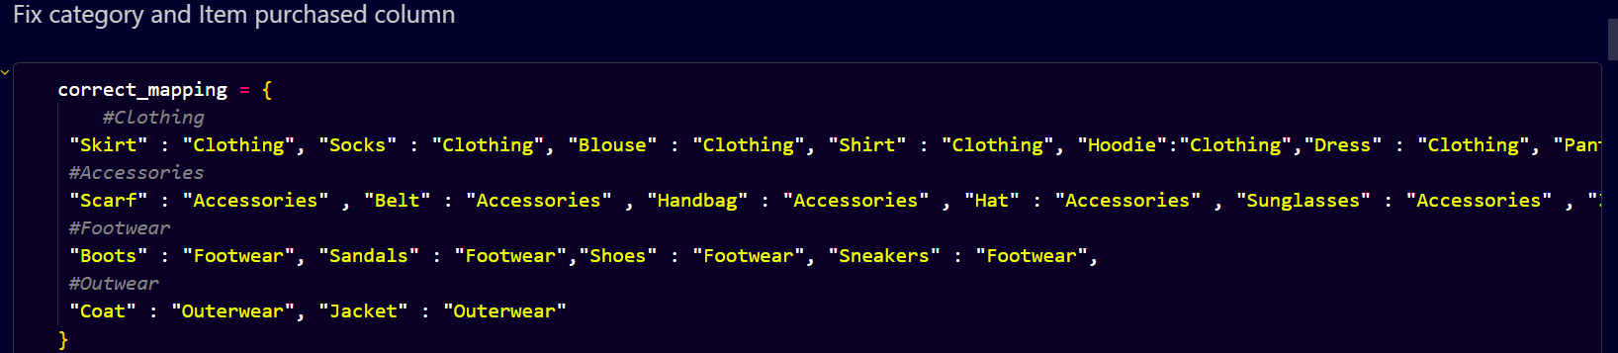

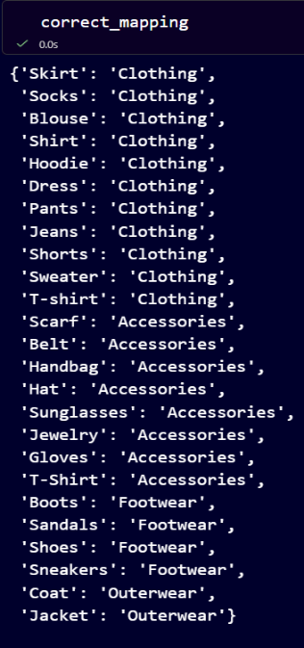

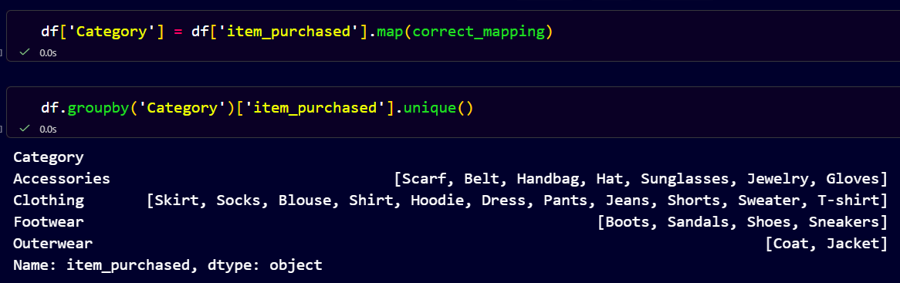

- Treating Missing Values
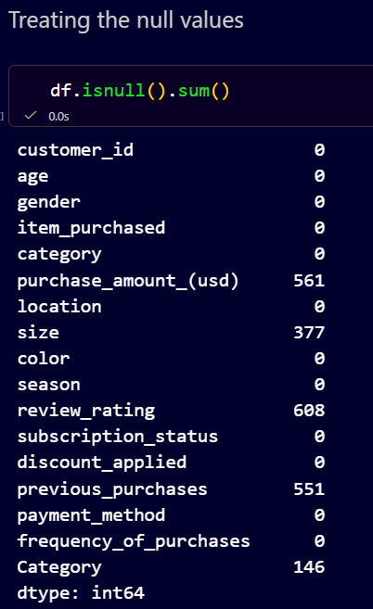

(a) Size Column
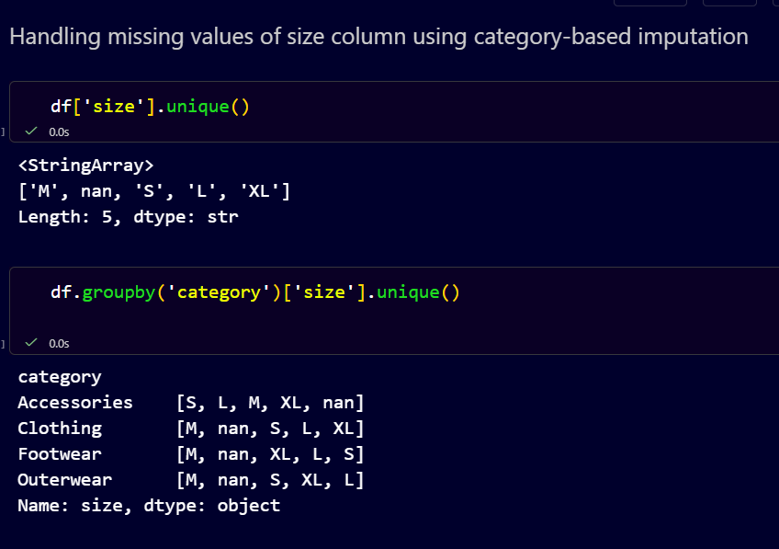

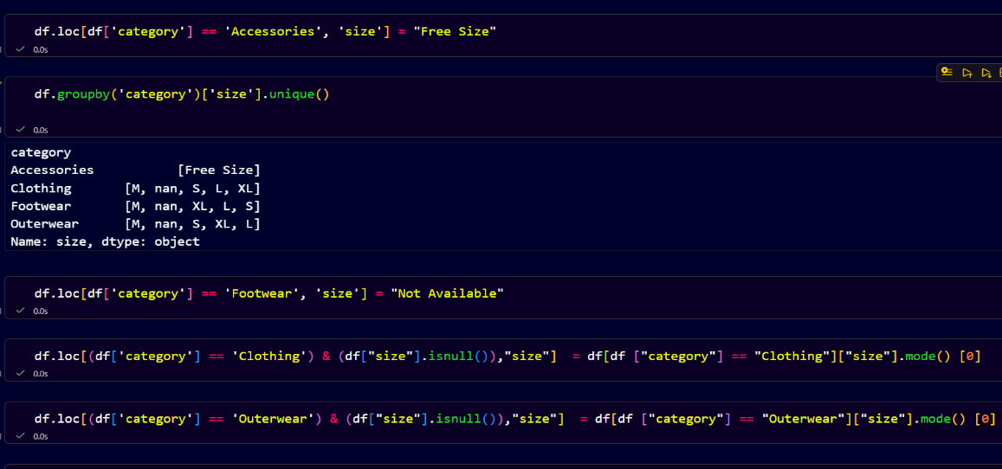

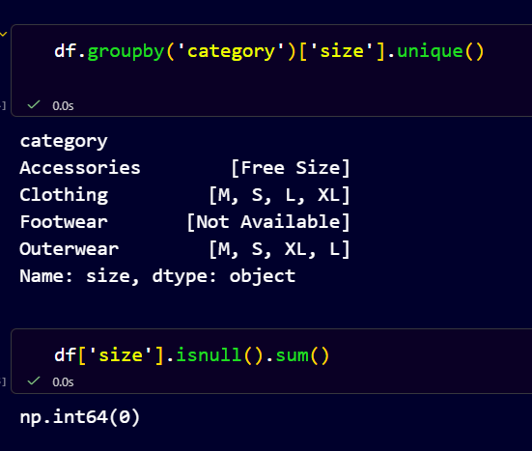

(b) Category Column
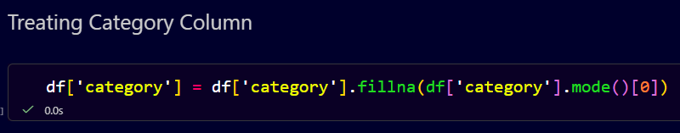

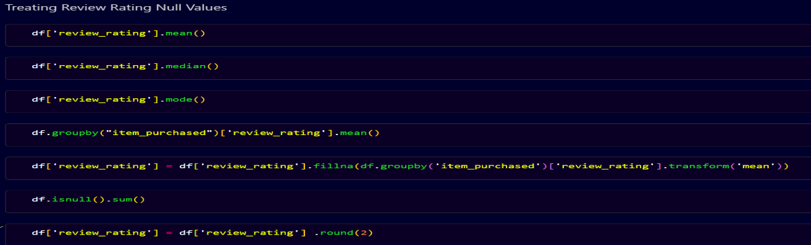
(c ) Review Rating Column

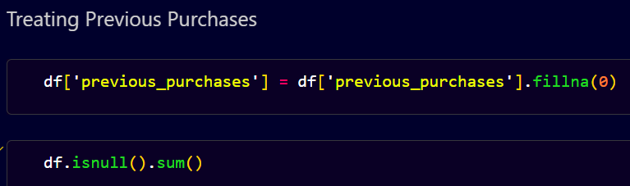
(d) Previous Purchases Column

(e ) Purchase Amount(USD) Column
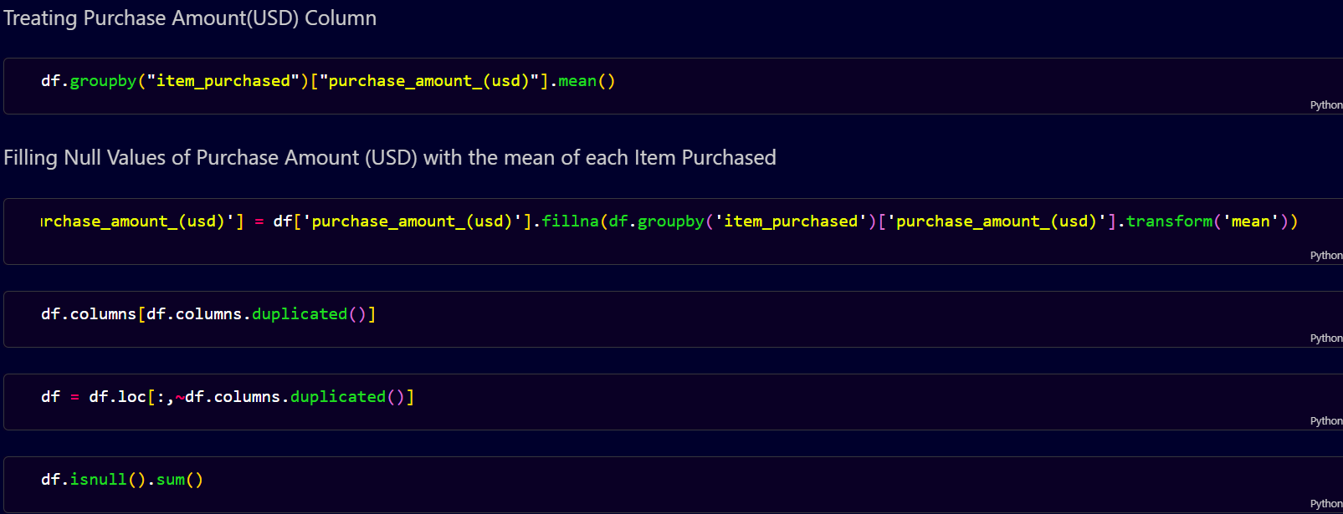

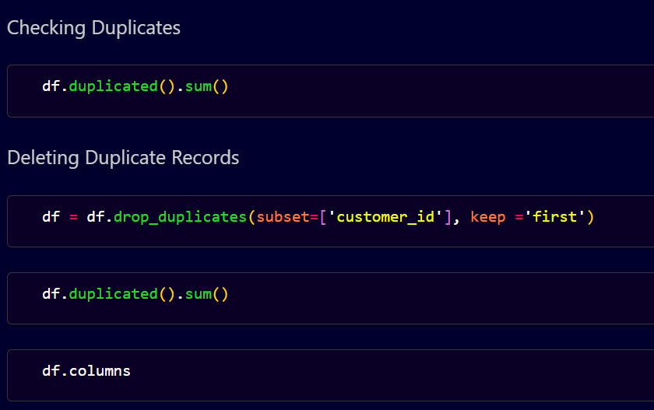
- Checking and Removing Duplicates

- Renaming purchase_amount_(USD) column
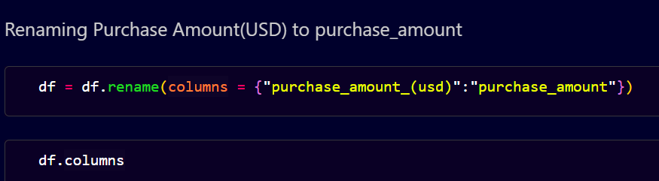

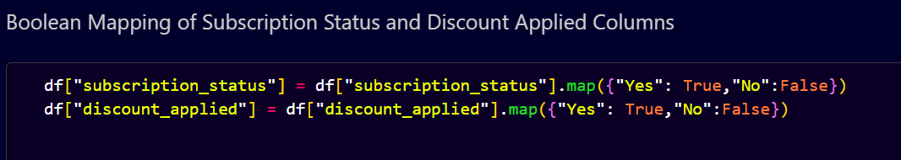
- Boolean Mapping of Subscription Status and Discount Applied Columns

4. SQL Business Questions
SQL was used to answer important business questions and generate insights from the cleaned dataset.
1. Which product category generates the highest Sales?
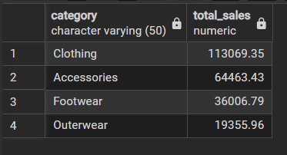
2. Which gender contributes more to overall sales?
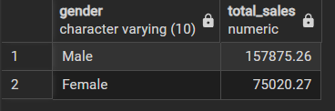

3. How are customers distributed across different age groups?
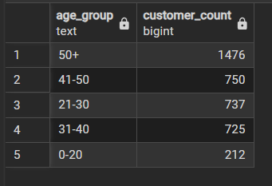

4. Which season records the highest sales?
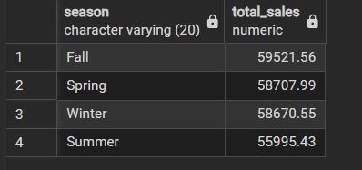

5. Which cities have the highest number of customers?
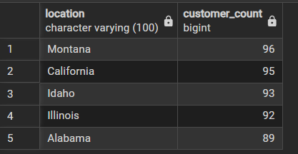

6. Which payment method is most preferred by customers?
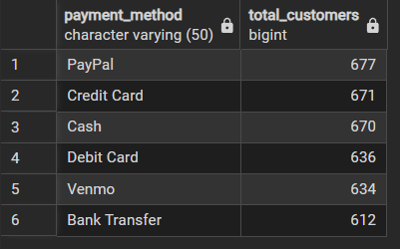

7. What percentage of customers are subscribed?
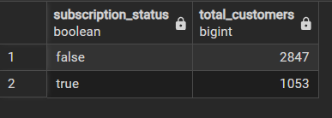

8. Which product categories receive the highest average customer review ratings?
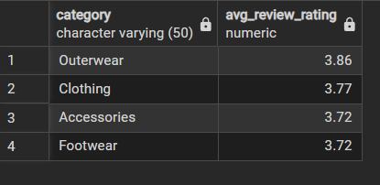

9. Which purchase frequency is most common among customers?
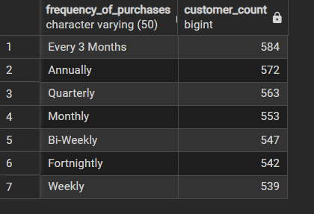

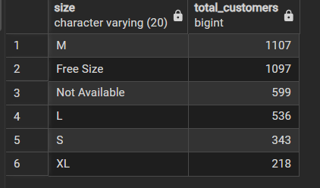
10. Which product size is most preferred by customers?

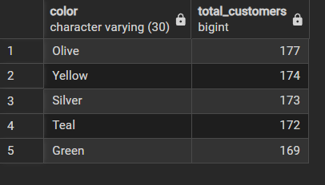
11. Which product colors are most preferred?

12. Which payment methods generate the highest sales revenue ?
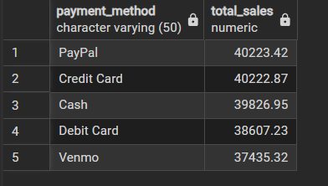

13. Which age groups contribute the highest sales revenue?
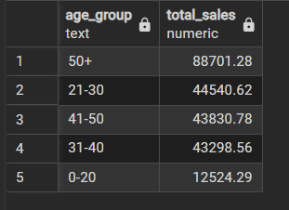

14. How many total customers are present in the dataset?
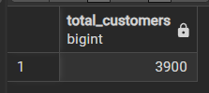

15. How many unique products/items are available?
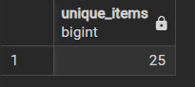

16. What is the average customer review rating?
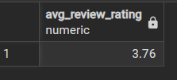

17.What is the total sales revenue generated by the business?
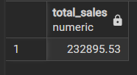
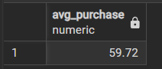
18. What is the average purchase amount per transaction?

5. Power BI Dashboard
An interactive Power BI dashboard was created to visualize customer shopping behaviour and business performance. The dashboard contains charts and KPIs that help identify trends and business opportunities.
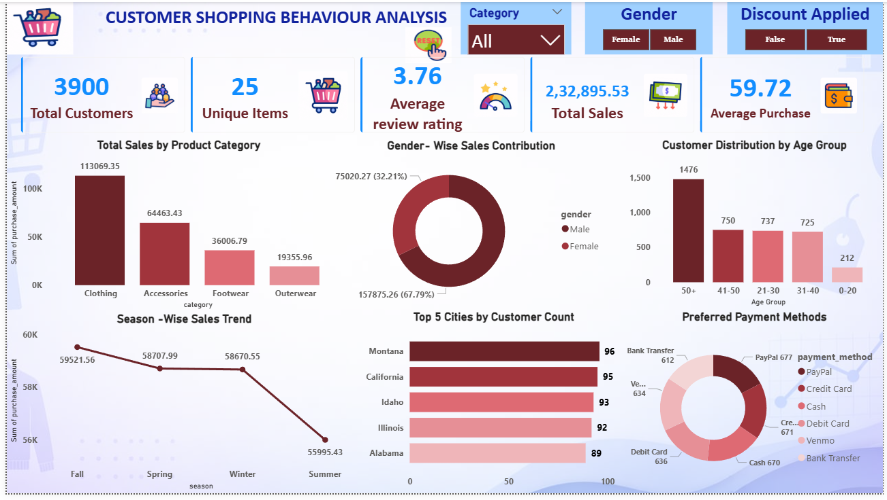
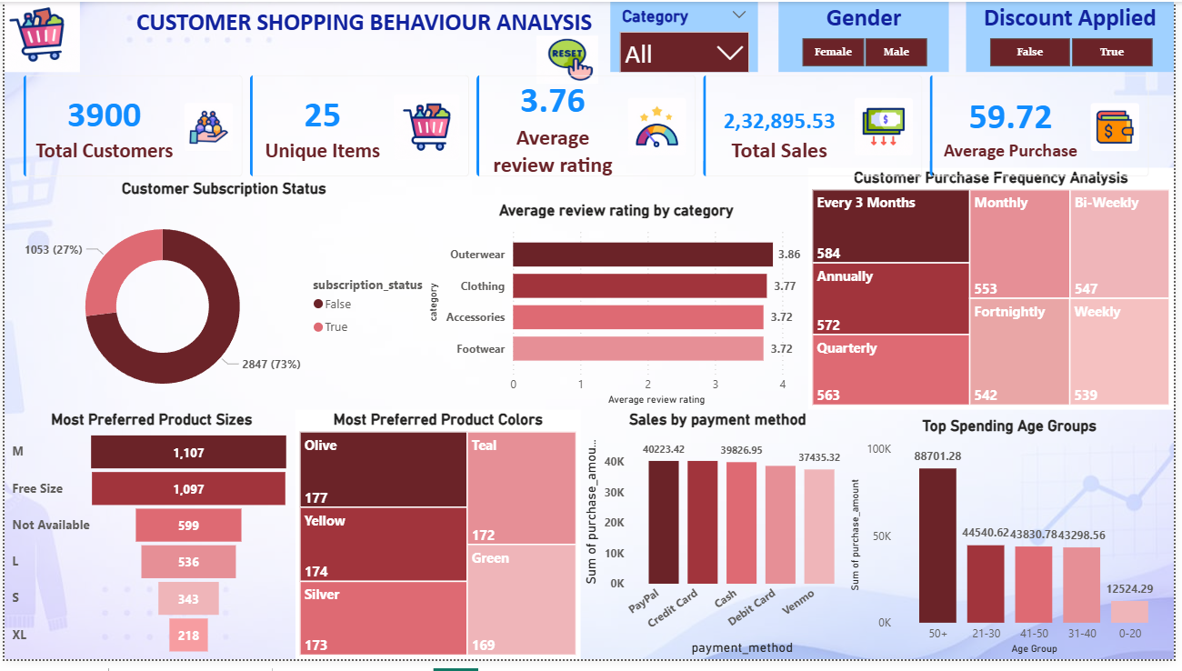

1. Total Sales by Product Category

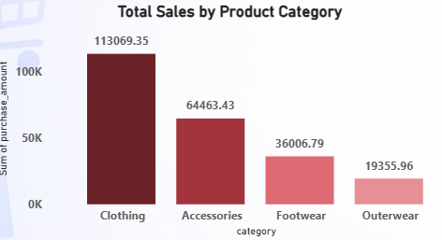

Business Insight
Clothing is the highest-selling category, showing strong customer demand and major contribution to total sales. Outwear has the lowest sales performance.

Business Impact
The company should focus more on Clothing products to increase revenue and improve marketing strategies for low-performing categories like Outerwear.
2. Gender – Wise Sales Contribution
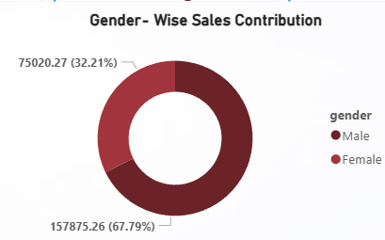

Business Insight
Male customers contribute the highest sales revenue, accounting for around 68% of total sales compared to female customers.
Business Impact
The business can target male customers with personalized marketing and product strategies while improving campaigns to increase female customer engagement and sales.

3. Customer Distribution by Age Group

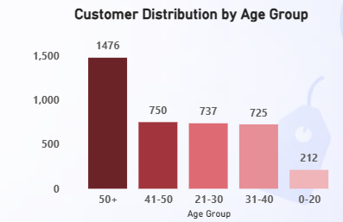

Business Insight
Customers aged 50+ represent the largest customer group, while the 0–20 age group has the lowest customer count.
Business Impact
The business should focus more on older customers through targeted products and marketing strategies while creating attractive offers to engage younger customers.

4. Season – Wise Sales Trend
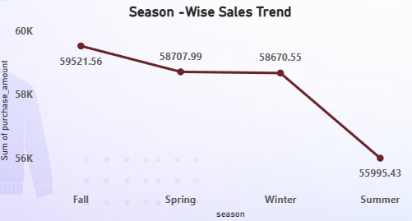

Business Insight
Sales are highest during the Fall season, while Summer records the lowest sales performance.
Business Impact
The business can maximize profits during high-sales seasons and introduce seasonal promotions or discounts in Summer to improve sales.
5. Top 5 Cities by Customer Count
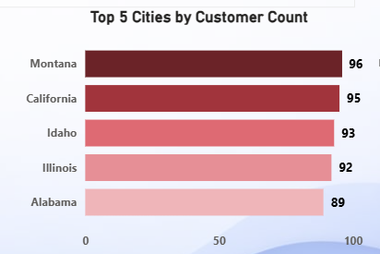

Business Insight
Montana and California have the highest customer count, showing strong customer presence in these locations.
Business Impact
The business can focus marketing campaigns and store expansion in high-performing locations to increase customer engagement and sales growth.

6. Preferred Payments Methods

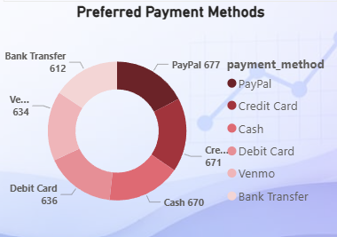

Business Insight
PayPal and Credit Card are the most preferred payment methods among customers.
Business Impact
The business should optimize digital payment options and offer payment-related rewards to improve customer convenience and increase sales.

7. Customer Subscription Status
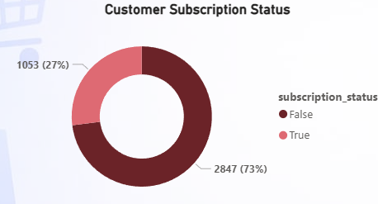

Business Insight
Most customers are non-subscribers, while only 27% customers have active subscriptions.
Business Impact
The business can increase customer loyalty and recurring sales by promoting subscription benefits and membership offers.
8. Average review rating by category
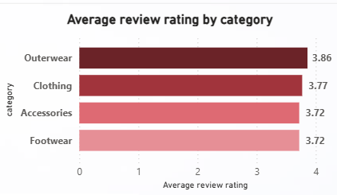

Business Insight
Outerwear has the highest average customer review rating, showing better customer satisfaction compared to other categories.
Business Impact
The business can maintain product quality in high-rated categories and improve customer experience in lower-rated categories to increase satisfaction and sales.

9. Customer Purchase Frequency Analysis
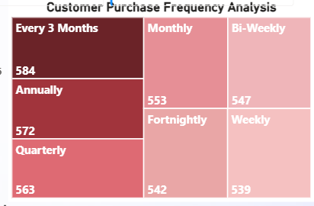

Business Insight
Most customers make purchases every 3 months, showing a moderate repeat purchase pattern.
Business Impact
The business can increase repeat purchases by offering loyalty programs, reminders, and personalized promotions to encourage more frequent shopping.
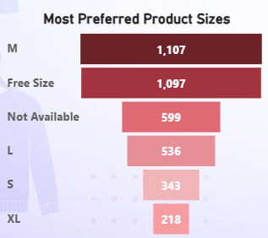
10. Most Preferred Product Sizes

Business Insight
Medium (M) and Free Size products are the most preferred sizes among customers.
Business Impact
The business should maintain higher inventory for popular sizes to meet customer demand and reduce stock shortages.
11. Most Preferred Product Colors
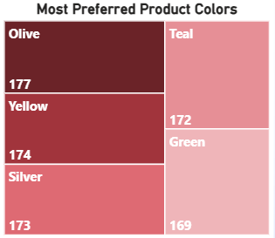

Business Insight
Olive and Yellow are the most preferred product colors among customers.
Business Impact
The business should stock more products in popular colors to match customer preferences and improve sales performance.
12. Sales by payment Method
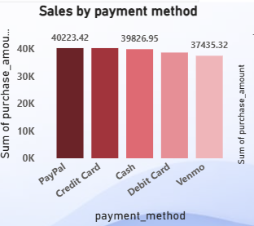

Business Insight
PayPal and Credit Card generate the highest sales revenue among all payment methods.
Business Impact
The business should strengthen digital payment options and offer payment-based rewards to improve customer experience and boost sales.

13. Top Spending Age Groups
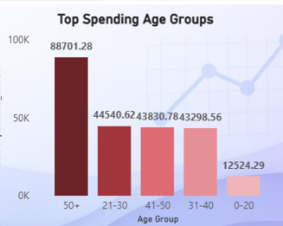

Business Insight

Customers aged 50+ contribute the highest sales revenue, while the 0–20 age group contributes the least.

Business Impact

The business should focus marketing and premium product strategies on high-spending older customers to maximize revenue growth.

6. Key Business Insights
- Clothing is the highest-selling category, showing strong customer demand and major contribution to total sales. Outwear has the lowest sales performance.
- Male customers contribute the highest sales revenue, accounting for around 68% of total sales compared to female customers.
- Customers aged 50+ represent the largest customer group, while the 0–20 age group has the lowest customer count.
- Sales are highest during the Fall season, while Summer records the lowest sales performance.
- Montana and California have the highest customer count, showing strong customer presence in these locations.
- PayPal and Credit Card are the most preferred payment methods among customers.
- Most customers are non-subscribers, while only 27% customers have active subscriptions.
- Outerwear has the highest average customer review rating, showing better customer satisfaction compared to other categories.
- Most customers make purchases every 3 months, showing a moderate repeat purchase pattern.
- Medium (M) and Free Size products are the most preferred sizes among customers.
- Olive and Yellow are the most preferred product colors among customers.
- PayPal and Credit Card generate the highest sales revenue among all payment methods.
- Customers aged 50+ contribute the highest sales revenue, while the 0–20 age group contributes the least.

7. Business Recommendations

1. Increase the stock of Clothing products because they have the highest sales and customer demand.

2. Improve Outerwear sales by offering discounts and attractive product designs.

3. Focus more on male customers because they generate the highest sales revenue.

4. Provide special offers and personalized products for customers aged 50+.

5. Use social media marketing to attract younger customers (0–20 age group).

6. Run Summer season offers to increase sales during low-performing months.

7. Expand marketing activities in Montana and California because these locations have the highest customer count.

8. Encourage more customers to take subscriptions by giving exclusive discounts and rewards.

9. Continue supporting PayPal and Credit Card payment methods because customers prefer them the most.

10. Keep more stock of Medium (M) and Free Size products because they are highly preferred by customers.

11. Increase the availability of Olive and Yellow colored products due to high customer preference.

12. Improve product quality in other categories by using the positive feedback from the Outerwear category.

13. Create loyalty and reward programs to encourage repeat purchases from customers.

8. Conclusion
This project successfully demonstrated the complete Data Analyst workflow including data cleaning, EDA, SQL analysis, and dashboard visualization. The project helped generate valuable business insights related to customer behaviour, sales trends, and purchasing patterns. The analysis can support better business decision-making, customer targeting, inventory planning, and marketing strategies.

9. Tools & Technologies Used

- Python (Pandas, NumPy)
- Jupyter Notebook
- SQLPower BI
- CSV Dataset

