Sales Analytics Project Report

1. About the Dataset
The dataset used in this project is a Sales Dataset containing information about sales transactions, customers, products, discounts, and sales. It helps in analyzing product performance, customer analysis , sales team performance, and store analysis. The dataset is useful for generating insights and supporting better business decisions.

2. Data Dictionary
Column Name | Description
Transaction_ID | Unique transaction identifier
Customer_Name | Customer full name
Product_Category | Category of the product
Product_Name | Name of the product
Store_Location | Store city location
Date | Transaction date
Units_Sold | Number of units sold
Unit_Price | Price per unit
Discount_% | Discount percentage
Sales_Representative | Sales representative handling sale
Discount_Amount | Discount value
Gross_Sale | Gross sale amount
Total_Sales | Final sales amount after discount
Month | Month of transaction
Year | Year of transaction

3. Business Questions

1. How much gross sales revenue is generated by each product?
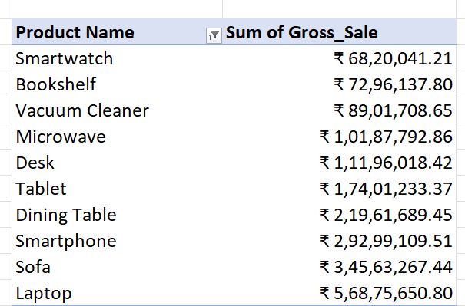

2. How much total sales revenue is generated by each product?
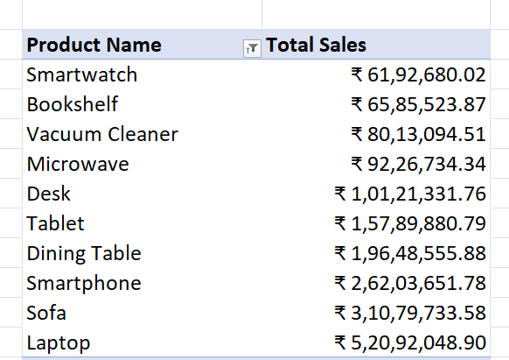

3. How much gross sales amount is generated by each sales representative?
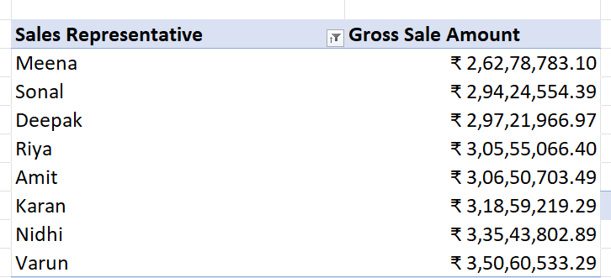

4. How much does each product category contribute to total revenue?
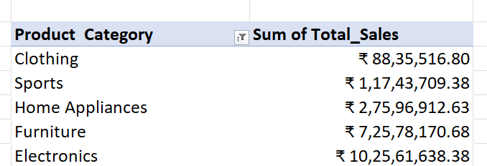

5. How many do different products contribute to total units sold?
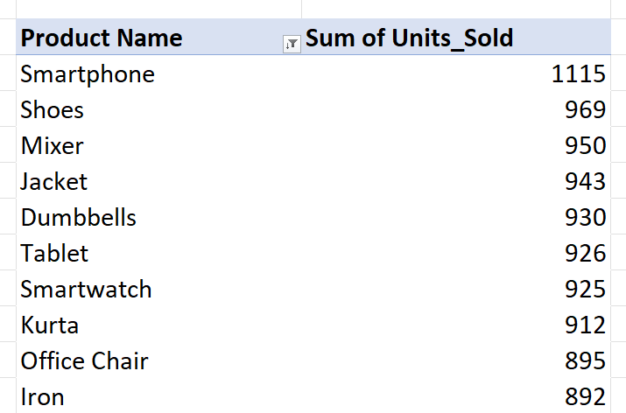

6. How much average discount is offered across different products?
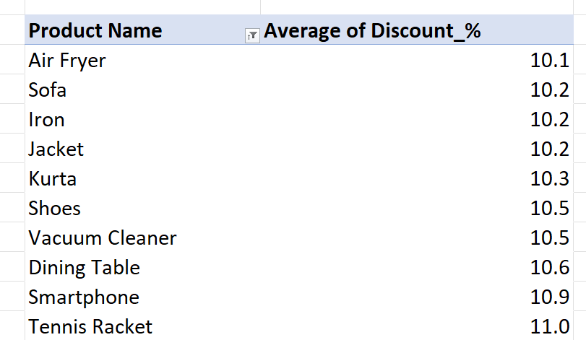

7. How much sales revenue is generated by each store location?
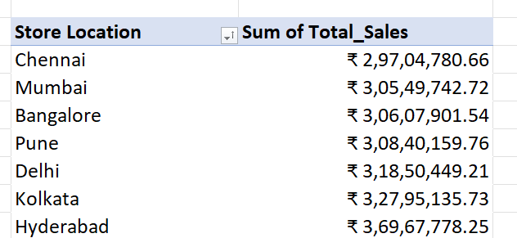

8. How many units are sold across different store locations?
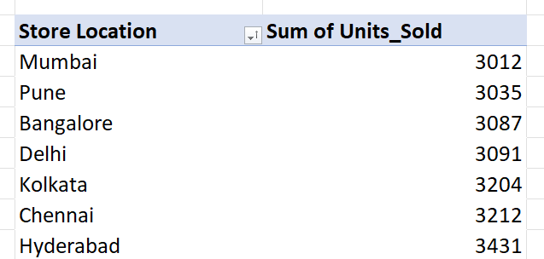

9. Which store locations provide the highest average discounts?
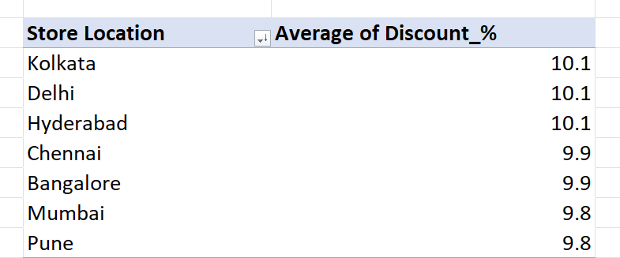

10. Which sales representative generated the highest total sales?
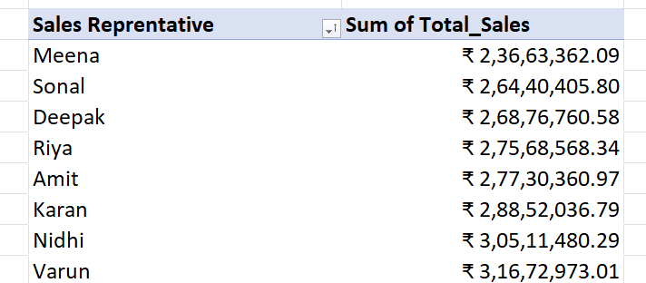

11. Which sales representative sold the highest number of units?
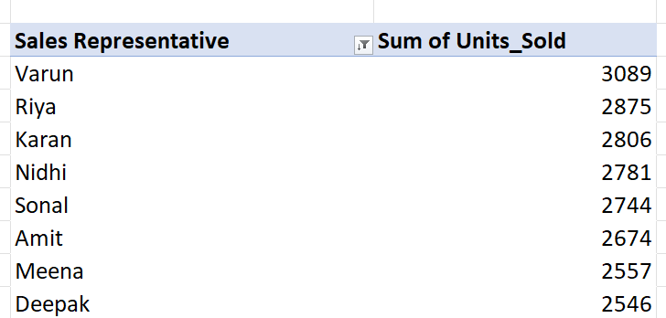

12. Which sales representative offers the highest average discount?

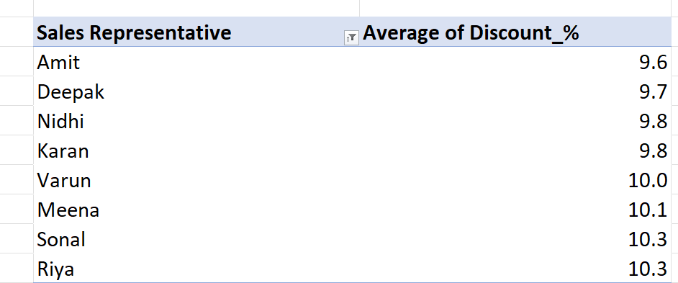

13. Which customers generated the highest total sales revenue?
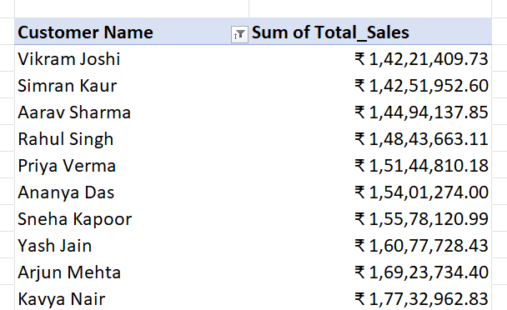

14. Which customers have the highest average order value?
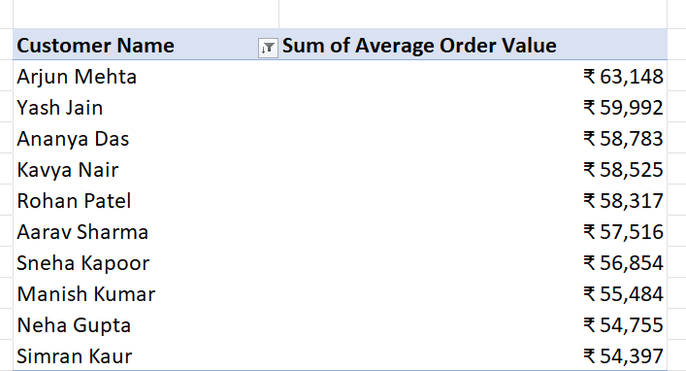

15. Which customers receive the highest average discount?
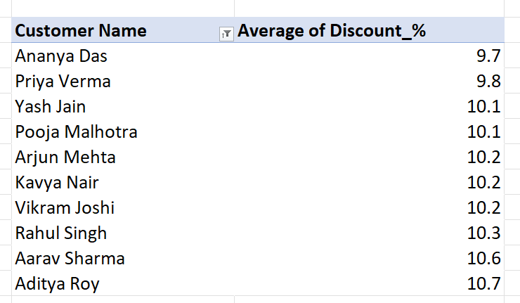

4. Excel Dashboard
Dashboard :- Overview

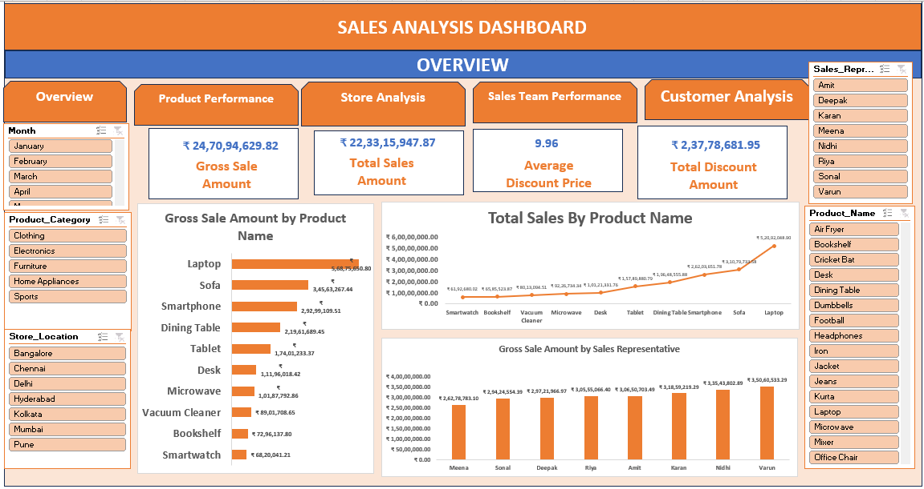

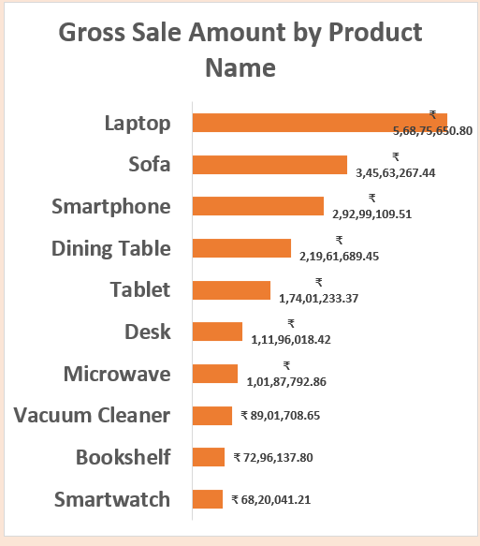
1.

Business Insight:

Laptop generated the highest gross sales amount, while Smartwatch contributed the lowest sales among all products.

Business Impact:

The company should focus more on high-performing products like laptops to maximize revenue and improve marketing strategies for low-selling products.

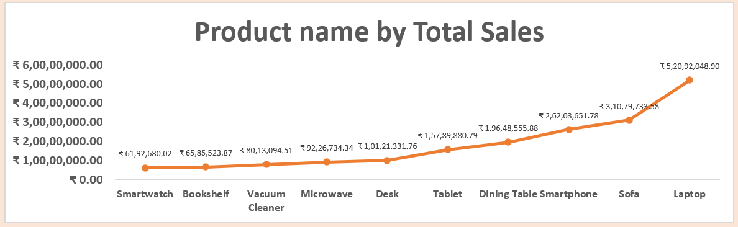
2.

Business Insight:

Laptops generated the highest total sales, while Smartwatches recorded the lowest sales among all product categories.

Business Impact:

Focusing on high-demand products like laptops and improving sales strategies for low-performing products can enhance overall revenue growth and market performance.

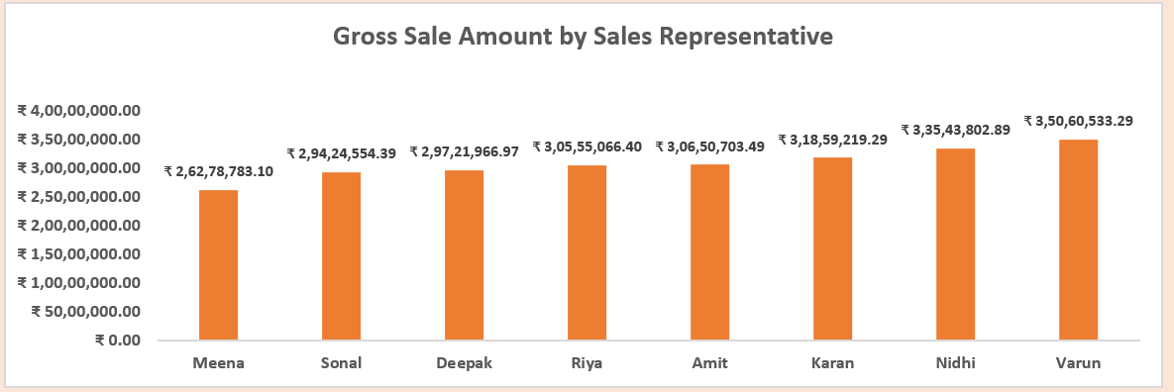
3.

Business Insight:

Varun achieved the highest gross sales amount, while Meena recorded the lowest sales performance among all sales representatives.

Business Impact:

Identifying the strategies of top-performing representatives like Varun and applying them across the sales team can improve overall sales productivity and revenue growth.

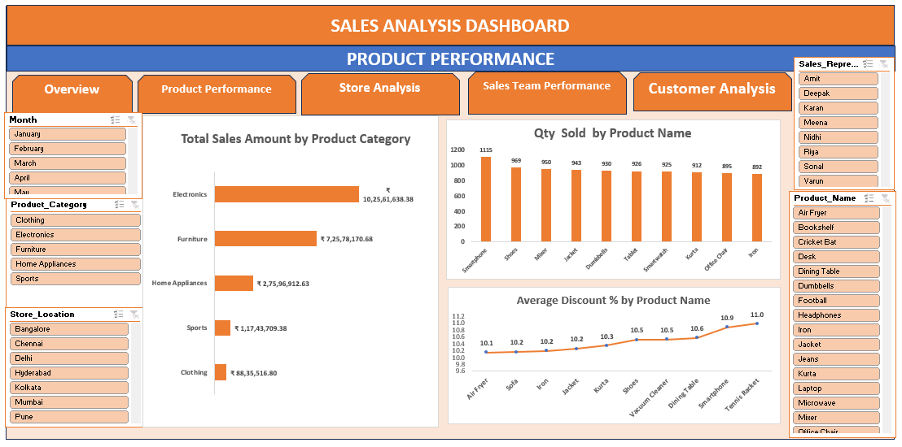
Dashboard :- Product Performance

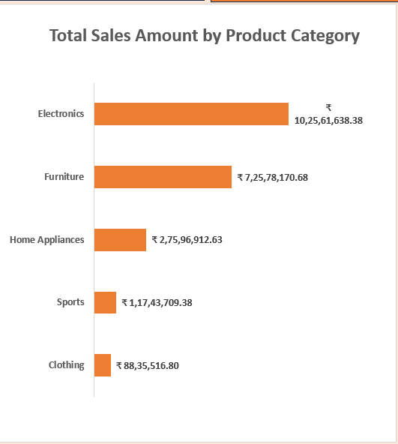
4.

Business Insight:

The Electronics category generated the highest total sales amount, while the Clothing category contributed the lowest sales among all product categories.

Business Impact:

Prioritizing high-performing categories like Electronics and improving marketing strategies for low-performing categories can help increase overall sales and profitability.
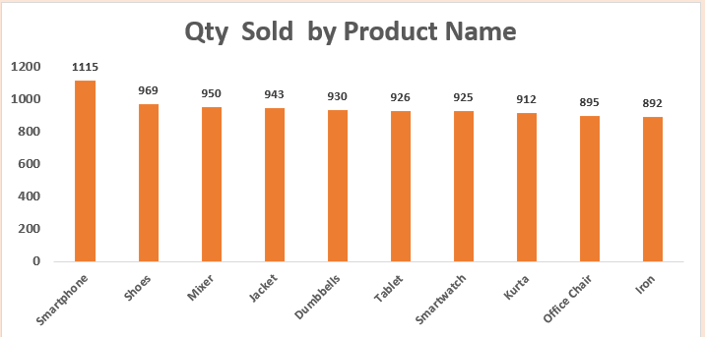
5.

Business Insight:

Smartphones recorded the highest quantity sold, while Iron had the lowest sales among the top products.

Business Impact:

Focusing on high-demand products like Smartphones and improving promotions for low-selling products can help increase overall sales and business growth.
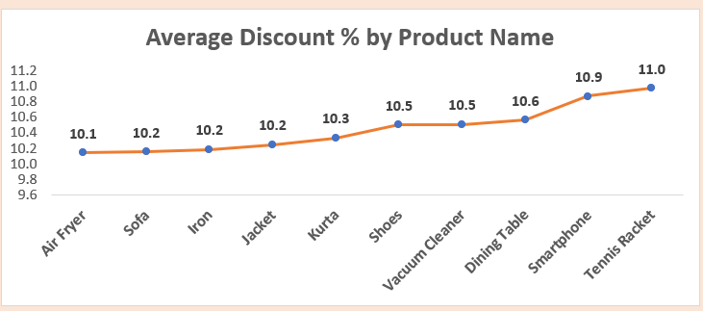
6.

Business Insight:

Tennis Racket and Smartphone received the highest average discount percentages, while Air Fryer had the lowest average discount among the products.

Business Impact:

Analyzing discount patterns can help the business optimize pricing strategies, improve customer attraction, and maintain better profit margins across products.
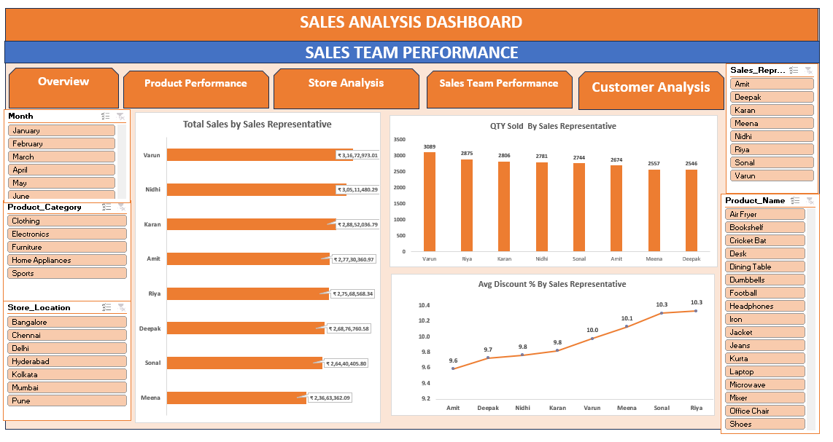
Dashboard :- Sales Team Performance

Dashboard :- Store Analysis

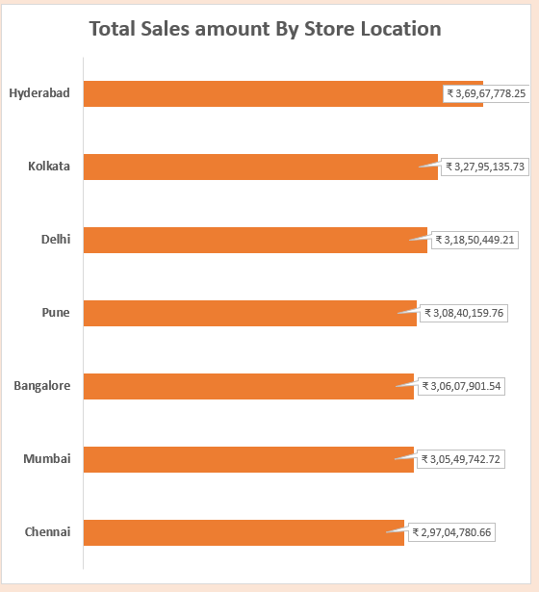
7.

Business Insight:

Hyderabad generated the highest total sales amount, while Chennai recorded the lowest sales among all store locations.

Business Impact:

Identifying high-performing locations can help the business focus on successful sales strategies, while improving operations and marketing in low-performing cities can increase overall revenue growth.

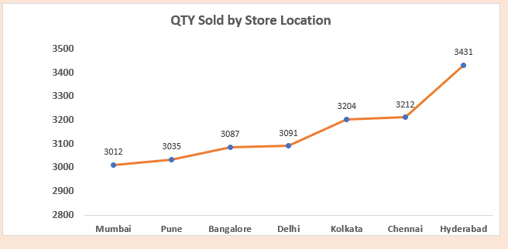
8.

Business Insight:
Hyderabad recorded the highest quantity sold, while Mumbai had the lowest sales quantity among all store locations.
Business Impact:
Understanding sales performance by location helps the business optimize inventory distribution, improve regional marketing strategies, and increase overall sales efficiency.

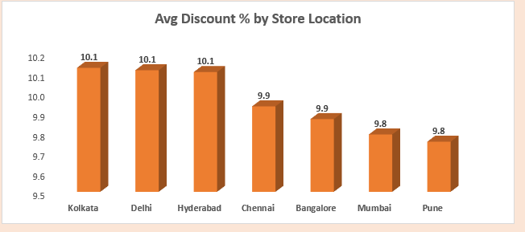
9.

Business Insight:

Kolkata, Delhi, and Hyderabad offered the highest average discount percentages, while Mumbai and Pune had the lowest average discounts among store locations.

Business Impact:

Comparing discount strategies across locations can help the business balance profitability, attract more customers, and improve sales performance in different markets.

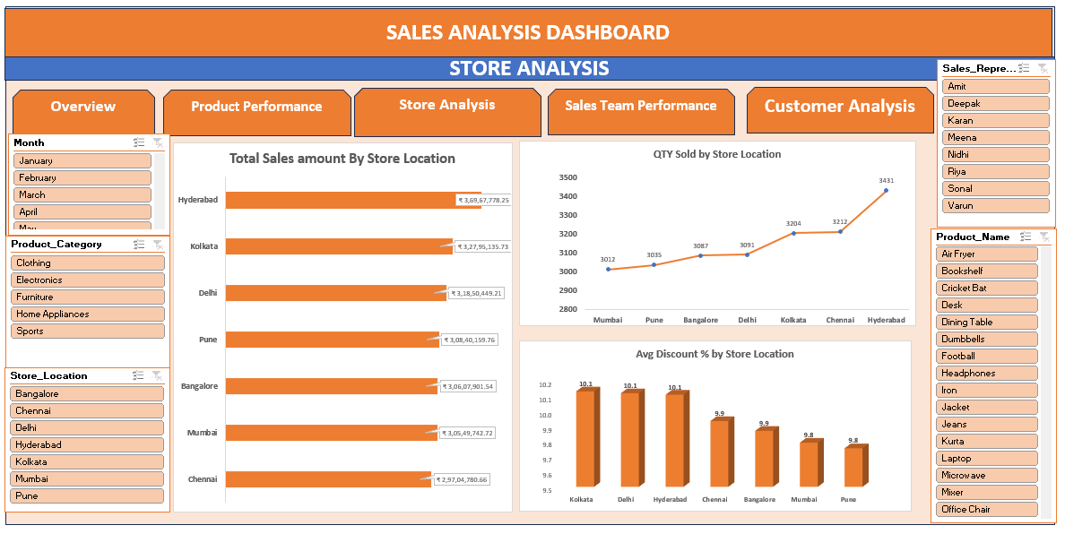
Dashboard :- Store Analysis

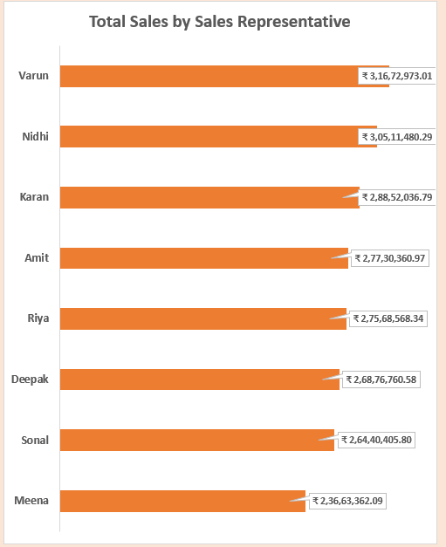
10.

Business Insight:
Varun and Nidhi generated the highest total sales among all sales representatives, while Meena recorded the lowest sales performance. Overall, the sales distribution among representatives remained relatively close, showing balanced team performance.
Business Impact:
Identifying top-performing sales representatives can help the business understand successful sales strategies, improve team training, and increase overall revenue performance. Monitoring lower-performing representatives also helps management provide targeted support and performance improvement plans.
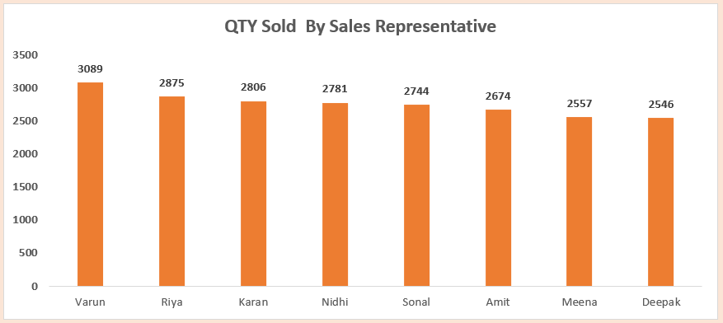
11.

Business Insight:
Varun sold the highest quantity of products, while Deepak and Meena recorded the lowest quantity sold among all sales representatives.

Business Impact:
Analyzing product quantity sold by representatives helps the business measure sales productivity, improve inventory planning, and identify opportunities to enhance overall sales performance.

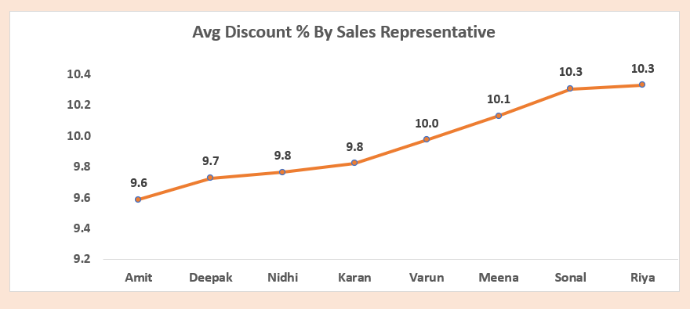
12.

Business Insight:
Riya and Sonal offered the highest average discount percentages, while Amit provided the lowest average discount among all sales representatives.
Business Impact:
Monitoring discount percentages helps the business maintain profitability, evaluate sales strategies, and ensure discounts are effectively used to attract customers without reducing revenue margins excessively.

Dashboard :- Customer Analysis
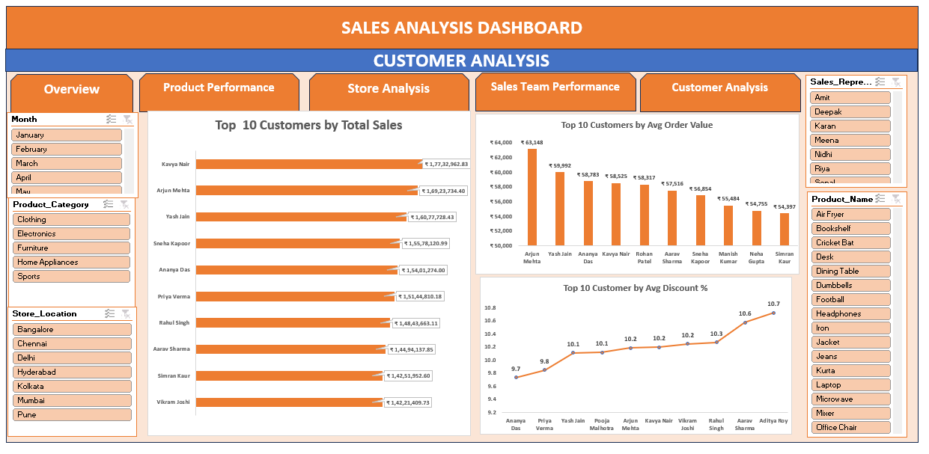

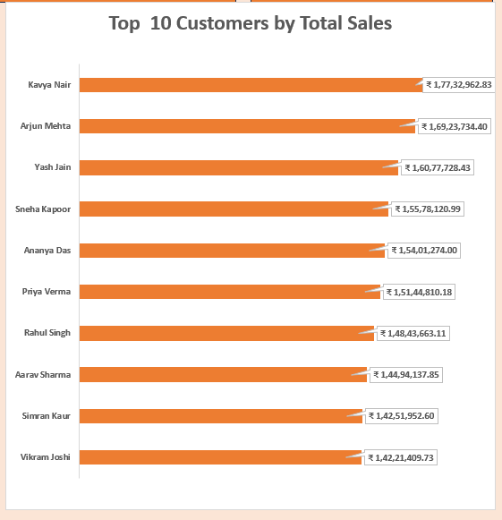
13.

Business Insight:
Kavya Nair and Arjun Mehta generated the highest total sales among the top customers, while Vikram Joshi recorded the lowest sales within the top 10 customer group.

Business Impact:
Identifying high-value customers helps the business strengthen customer relationships, improve retention strategies, and focus on personalized marketing to drive long-term revenue growth.

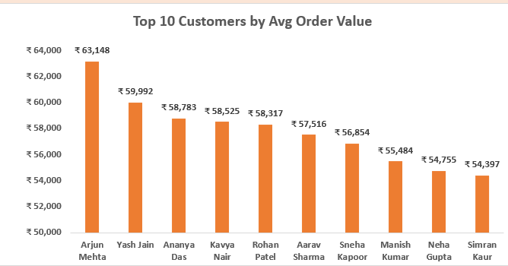
14.

Business Insight:
Arjun Mehta recorded the highest average order value, while Simran Kaur had the lowest average order value among the top 10 customers.
Business Impact:
Analyzing average order value helps the business identify high-spending customers, improve premium sales strategies, and increase overall revenue through targeted upselling and personalized offers.

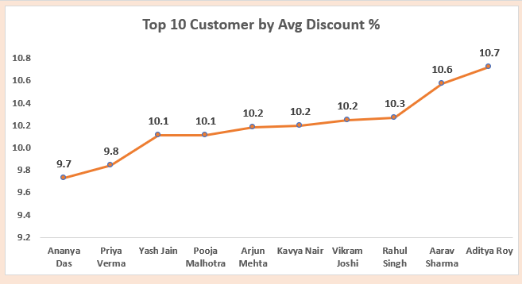
15.

Business Insight:
Aditya Roy received the highest average discount percentage, while Ananya Das received the lowest average discount among the top 10 customers.
Business Impact:
Higher discounts for key customers may help increase customer retention and sales volume, but excessive discounting can reduce profit margins, making it important to balance discounts with profitability.

5. Key Business Insights
1. Laptop generated the highest gross sales amount, while Smartwatch contributed the lowest sales among all products.

2. Laptops generated the highest total sales, while Smartwatches recorded the lowest sales among all product categories.

3. Varun achieved the highest gross sales amount, while Meena recorded the lowest sales performance among all sales representatives.

4. The Electronics category generated the highest total sales amount, while the Clothing category contributed the lowest sales among all product categories.

5. Smartphones recorded the highest quantity sold, while Iron had the lowest sales among the top products.

6. Tennis Racket and Smartphone received the highest average discount percentages, while Air Fryer had the lowest average discount among the products.

7. Hyderabad generated the highest total sales amount, while Chennai recorded the lowest sales among all store locations.

8. Hyderabad recorded the highest quantity sold, while Mumbai had the lowest sales quantity among all store locations

9. Kolkata, Delhi, and Hyderabad offered the highest average discount percentages, while Mumbai and Pune had the lowest average discounts among store locations.

10. Varun and Nidhi generated the highest total sales among all sales representatives, while Meena recorded the lowest sales performance. Overall, the sales distribution among representatives remained relatively close, showing balanced team performance.

11. Varun sold the highest quantity of products, while Deepak and Meena recorded the lowest quantity sold among all sales representatives.
12. Riya and Sonal offered the highest average discount percentages, while Amit provided the lowest average discount among all sales representatives.
13. Kavya Nair and Arjun Mehta generated the highest total sales among the top customers, while Vikram Joshi recorded the lowest sales within the top 10 customer group.

14. Arjun Mehta recorded the highest average order value, while Simran Kaur had the lowest average order value among the top 10 customers.

15. Aditya Roy received the highest average discount percentage, while Ananya Das received the lowest average discount among the top 10 customers.

6. Business Recommendations

- Promote best-selling products like Laptops and Smartphones more to increase sales.
- Improve sales of low-performing products like Smartwatches through offers and advertising.
- Give discounts carefully so profits do not decrease too much.
- Train low-performing sales employees to improve their performance.
- Use Hyderabad’s successful sales strategies in other cities as well.
- Increase marketing in low-performing cities like Chennai and Mumbai.
- Offer personalized deals to high-value customers to increase their spending.
- Create loyalty programs to keep customers coming back without giving heavy discounts.
- Keep enough stock of high-demand products to avoid shortages.
- Use sales data regularly to make better business decisions and improve performance.

7. Conclusion
This project used Pivot Tables and an Excel Dashboard to analyze sales team performance, customer trends, products, and store performance. The dashboard converted raw data into meaningful insights using charts and visual reports, helping in better business understanding and decision-making. Overall, the project shows how Excel can be effectively used for data analysis and business reporting.

8. Tools & Technologies Used
- Microsoft Excel
- Pivot Tables
- Excel Dashboard
- Charts and Graphs

