A PBL REPORT

On

**“DETERMINATION OF BODY MASS INDEX USING FACIAL IMAGES”**

By

Shivam Tikhe SECOD457

Under the Guidance of

Prof. Rahul Pitale

**S.E. (COMPUTER ENGINEERING) 2020-21 (Semester II)**



**DEPARTMENT OF COMPUTER ENGINEERING,**

**PCET’S PIMPRI CHINCHWAD COLLEGE OF ENGINEERING**

Sector No. 26, Pradhikaran, Nigdi,

Pune - 411044



**PCET’S PIMPRI CHINCHWAD COLLEGE OF ENGINEERING**

Sector No. 26, Pradhikaran, Nigdi,

Pune - 411044

**DEPARTMENT OF COMPUTER ENGINEERING**

Certificate

This is to certify that the PBL report entitled

**“DETERMINATION OF BODY MASS INDEX USING FACIAL IMAGES”**

Submitted By

Shivam Tikhe SECOD457

is approved by ***Prof. Rahul Pitale***for submission. It is certified further that, to the best of my knowledge, the report represents work carried out by my students as the partial fulfillment for S.E. Computer Engineering (Semester II) Laboratory Work as prescribed by the Savitribai Phule Pune University for the academic year 2020-21.

|  |  |
| --- | --- |
|  | Prof. Dr. K. Rajeswari |
| Prof. Rahul Pitale | (Head of the Department) |

Place: Pune

Date: 11/6/21

**Acknowledgment**

We express our sincere thanks to our PBL Guide **Professor Rahul Pitale** for his encouragement and support throughout our seminar, especially for the useful suggestions given during Project-Based Learning and for having laid down the foundation for this successful work.

We would also like to thank our Research & Innovation coordinator **Professor Dr. S. V. Shinde,** PBL Coordinator, **Professor Priya. Surana** and PBL Faculties **Prof. Namrata Gawande** and **Prof. Shraddha Ovale** for their assistance, genuine support, and guidance from the early stages ofproject-based learning and during the entire course of this work. We would like to thank **Prof. Dr. K. Rajeswari**, Head of the Computer Engineering Department for her unwavering support during the entire course of this project-based learning. We also thank all the teaching and non-teaching staff members for their help in making our work successful. We also thank all the web communities for enriching us with their immense knowledge.

Shivam Tikhe SECOD457

**Abstract and Keywords**

Abstract—Body Mass Index (BMI) is the most commonly used tool to evaluate an individual’s health. It is used to classify a person as underweight, healthy weight, overweight or obese. BMI is co-related with body fat and is a vital indicator of possible diseases that can transpire with higher body fat ranges. Higher body fat is prevalent these days with a higher calorie diet and a low physical activity lifestyle. On the other end of the spectrum, Adult malnutrition is more common and widespread than we are conscious of these days. The BMI can be used as a measure of adult nutritional status, both of individuals and of communities. Given that people have less time in their busy life and most people dont own a weighing machine and/or a measuring tape, we propose a time and cost efficient method of estimating Height, Weight and BMI from a persons face.

In this report, we use propose a machine learning model to accurate predict a person’s height, weight and Body Mass Index by the use of facial image. We start by detecting the face from an image using a Deep Neural Network architechture – ResNet34. The image is fed to the Feature Extractor model. The extracted features are passed to an Regression model which gives the predicted Height, Weight and BMI values. We have evaluated our model on the “VIP_Attributes” dataset, which contains 1026 subjects with their corresponding Height, Weight, BMI. The best performance for BMI was given by the Support Vector Regressor model with both the basic parameters and with hyper-parameter tuning.

Keywords

1. BMI Body Mass Index
2. ML Machine Learning
3. AI Artifiacial Intelligence
4. DNN Deep Neural Network
5. CNN Convolutional Neural Network
6. ANN Artificial Neural Network
7. OpenCV Open Computer Vision
8. Regression Regression Analysis
9. SVM Support Vector Machine
10. SVR Support Vector Regression

|  |  |  |  |  |
| --- | --- | --- | --- | --- |
| **TABLE OF CONTENTS** | | | | |
|  | | | | |
| **Sr. No.** | **Contents** | | | **Page. No** |
| 1 | **Introduction** | | | 8 |
|  | 1.1 | Problem Definition | | 8 |
|  | 1.2 | Goals and Objectives | | 8 |
|  | 1.3 | Motivation | | 8 |
| 1.4 | Scope of work | | 8 |
| 1.5 | Outcomes | | 9 |
| 2 | **Literature Survey** | | | 10 |
|  | 2.1 | Summary of Literature Review | | 10 |
|  | 2.2 | Comparison of 5 Survey Paper | | 11 |
| 3 | **Software Requirements Specification** | | | 13 |
|  | 3.1 | Functional Requirements | | 13 |
|  | 3.2 | Nonfunctional Requirements | | 13 |
|  |  | 3.2.1 | Performance Requirements | 13 |
|  |  | 3.2.2 | Security Requirements | 13 |
| 4 | **Analysis Models** | | | 14 |
|  | 4.1 | System Design: UML Diagrams | | 14 |
|  | 4.1.1 | Structural Diagram: Class Diagram | | 14 |
|  | 4.1.2 | Behavioral Diagram: Activity Diagram | | 15 |
| 5 | **Algorithmic Survey** | | | 17 |
|  | 5.1 | Study of Algorithms or Techniques | | 17 |
| 6 | **Advantages and Applications** | | | 19 |
|  | 6.1 | Advantages | | 19 |
| 6.2 | Disadvantages | | 19 |
| 6.3 | Applications | | 19 |
| 7 | **Conclusion** | | | 19 |
|  | 7.1 | Conclusion | | 19 |
| 8 | **References** | | | 20 |

**List of Figures**

|  |  |  |  |
| --- | --- | --- | --- |
| **Sr. No.** | **Figure No.** | **Figure name** | **Page No.** |
| 1 | 4.1 | Class Diagram for Project | 14 |
| 2 | 4.2 | Activity Diagram for Training Model | 15 |
| 3 | 4.3 | Activity Diagram for Unknown Image | 16 |
| 4 | 5.1 | Linear Regression | 17 |
| 5 | 5.2 | Support Vector Regression | 18 |

**List of Tables**

|  |  |  |  |
| --- | --- | --- | --- |
| **Sr. No.** | **Table No.** | **Table Name** | **Page No.** |
| 1 | 2.1 | Summary of Reference Paper 1 | 11 |
| 2 | 2.2 | Summary of Reference Paper 2 | 11 |
| 3 | 2.3 | Summary of Reference Paper 3 | 11 |
| 4 | 2.4 | Summary of Reference Paper 4 | 12 |
| 5 | 2.5 | Summary of Reference Paper 5 | 12 |
| 6 | 7.1 | Accuracy Comparison of Regression Models | 19 |

# Introduction

## Problem Definition

### To create an effective way of estimating the height, weight, and Body Mass Index of an individual through facial features using image processing, machine learning, and deep learning models.

## Goals and Objectives

### To research in the domain of Machine Learning and Image Processing.

### Acquire knowledge in how to detect the face and its expression using computer vision.

### Analyse the Facial features and use them in determination of Body Mass Index (BMI), height and weight of human being.

### Collate the four Regression models of supervised learning algorithm of machine learning.

## Motivation

### Weight is a pertinent indicator for health and excessive weight has been associated with obesity, diabetes, and cardiovascular diseases.

### Height and weight are used in surveillance, forensics and image retrieval systems.

### Body weight and height have been soft biometric traits in automated biometric systems.

## Scope of work

### Easy and Effective way to calculate BMI

### Diagnose overweight and obesity.

### Identify different health parameters and future disorders.

### Create soft biometric datasets for security and forensics.

### Fitness tracking of an individual.

## Outcomes

### Thorough research in the domain of Machine Learning and Image Processing.

### Gained insight into facial image processing

### Analyse the Facial features and use them in determination of Body Mass Index (BMI), height and weight of human being.

### Learning and comparing different regression techniques widely used in the machine learning community.

# Literature Survey

## Summary of Literature Review:

### Comparison of our project with existing survey papers:

* In the below-mentioned first paper, they evaluated and compared the performance of five different Convolutional Neural Network architectures i.e., VGG19, ResNet50, DenseNet, MobileNet, and light CNN for BMI inference from facial images. They had used three publicly available
* BMI annotated facial image datasets assembled from social media, namely, VisualBMI, VIP-Attributes, and Bollywood datasets. Suggested the efficacy of the deep learning methods in BMI inference from face images with minimum Mean Absolute Error obtained using ResNet50.
* In the below-mentioned third paper, they developed a new algorithm for the detection of the face and facial features that can localize eyes and mouth very accurately in images. In their method, a combination of luminance, color, and edge properties of the image is used.  This method is implemented and tested on a database containing 103 different images of faces. The method has shown an accuracy of 91%.
* The below-mentioned fourth paper proposed image processing and pattern recognition techniques to extract human faces and facial features from color images. They segmented a color image into the skin and non-skin regions by a Gaussian skin-color model. They applied mathematical morphology and region filling techniques for noise removal and hole filling. They had created an ellipse model to locate eyes and mouth areas roughly, and apply the support vector machine (SVM) to classify them. The algorithm achieved an accuracy rate of 96.7% in face detection and 90.0% in facial feature extraction.
* In the below-mentioned fifth paper, they proposed a novel model using Convolution Neural Networks (CNN) and Artificial Neural Networks (ANN). They had detected the face from an image using the Viola-Jones algorithm. They used the Reddit-HWBMI dataset and the Face-to-BMI dataset. They implemented face extraction using the XceptionNet model and VGG-Face (Resnet model).
* Our project used a face recognition library to recognize faces and extracted facial features using facenet pre-trained architecture. Linear regression, Logistic Regression, and support vector machine (SVM) models have trained with the DigitalDigitalVIP attributes dataset. All models are trained, scripted in the python programming language. The editor used is Jupyter notebook.

### Comparison of 5 Survey Papers:

|  |  |
| --- | --- |
| Reference 1 | AI-based BMI Inference from Facial Images: an application to Weight Monitoring |
| Objectives | Self-diagnostic image-based methods for healthy weight monitoring |
| Proposed  Solution | Used CNN Five architectures, VGG19, ResNet50, DenseNet, MobileNet, and light CNN |
| Results | Experimental investigation on three publicly available facial image datasets obtains overall MAE in the range [1.04, 6.48]. The results varied across datasets due to variance in the BMI annotation and sample size difference. DenseNet and ResNet obtained superior performance over other nets. |
| Advantages | Mean absolute error in a good range. Greater accuracy. |
| Limitations | The time and cost required is more than usual |

Table 2.1- Summary of paper 1

|  |  |
| --- | --- |
| Reference 2 | A novel method to estimate Height, Weight, and Body Mass Index from face images |
| Objectives | A time and cost-efficient method of estimating Height, Weight, and BMI from a person’s face |
| Proposed  Solution | Detecting the face from an image using the Viola-Jones algorithm.  Used CNN and ANN models to estimate height, weight, and BMI. |
| Results | The best performance for BMI was given by the XceptionNet model when used as a Feature Extractor. The XceptionNet also performed best for weight, whereas VGG-Face (Resnet model) performed slightly better than XceptionNet for height. |
| Advantages | A considerable better and accurate method to estimate BMI |
| Limitations | The performance of the models can be tuned. |

Table 2.2- Summary of paper 2

|  |  |
| --- | --- |
| Reference 3 | Facial Recognition using OpenCV |
| Objectives | To improve the accuracy of face detection and recognition techniques. |
| Proposed  Solution | To apply pre-filters before the image is sent for detection and recognition. Using OpenCV apply haar cascade filter which increases the detection quality. |
| Results | Considerable better accurate results were found and appended the authentication of the face in the frame. |
| Advantages | A more accurate way for detection and recognition. |
| Limitations | Need more train images from different angles and hard to synchronize all the images and make a single image per person. |

Table 2.3- Summary of paper 3

|  |  |
| --- | --- |
| Reference 4 | Detection of Face and Facial Features in Digital Images and Video Frames |
| Objectives | To research, detection, and tracking of the face and facial components such as eyes and mouth, use them in Human-Computer Interaction |
| Proposed  Solution | A new algorithm for the detection of the face and facial features is proposed that can localize eyes and mouth very accurately in images. In this method, a combination of luminance, color, and edge properties of the image is used. |
| Results | The experiments were performed on an image database containing 103 images.  show that using edge information in combination with color and intensity values, to detect eyes can make the decision more accurate and robust with an accuracy of 91.6%. |
| Advantages | Very high accuracy of the face and facial expression detections.  Eyes and mouth can be used as soft biometrics. |
| Limitations | The image with low exposure is hardly detected. |

Table 2.4- Summary of paper 4

|  |  |
| --- | --- |
| Reference 5 | Extracting Faces and Facial Features from Color Images |
| Objectives | Proposed image processing and pattern recognition techniques to extract  human faces and facial features from color images. |
| Proposed  Solution | First, segment a color image into the skin and non-skin regions by a Gaussian skin-color model. We determine whether a skin region is a face candidate by its size and shape. Create an ellipse model to locate eyes and mouth areas roughly, and apply the support vector machine (SVM) to classify them. Finally, we develop knowledge rules to verify eyes. |
| Results | Showed that our algorithm achieves an accuracy rate of 96.7% in face detection and 90.0% in facial feature extraction |
| Advantages | detected results in different cases: (a) many faces in an image, (b) faces of different sizes, (c) and (d) faces with pose and orientation variations, and (e) a shadowed face. Note that these faces also  present different expressions. |
| Limitations | Some face regions might not be detected as skin regions due to their color  distortion caused by lighting or shadowing. Some part of the background might be detected as a skin region. If two or more faces are too close to be merged into a connected component, the error may occur. |

Table 2.5- Summary of paper 5

1. **SOFTWARE REQUIREMENTS SPECIFICATION**
   1. FUNCTIONAL REQUIREMENTS:

* User
  + A proper image input, either from a saved file of image capture from the existing hardware
  + Only a single user at a time per system.
* Hardware requirements (Desktop or Laptop of minimum specification)
  + i3 x86/64-bit processor
  + 2 GB RAM
  + 1 GB disk space
* Software requirement
* Python programming language interpreter
* Anaconda platform
* Jupyter notebook
* Sk-learn machine learning models
* Facenet architecture
  1. NON-FUNCTIONAL REQUIREMENTS:
     1. Performance Requirements:
* The ability to correctly estimate the BMI of a given input.
* The response time of the model should be less.
* Faster than complex models which may require more time.
  + 1. Security Requirements
* Image input will be protected in the algorithm and cannot be retrieved by any
* another different user.
* The generated output of the software will be accessed by the current user only.

1. **System Design**

4.1UML Diagrams:

4.1.1: Structural Diagram: Class Diagram

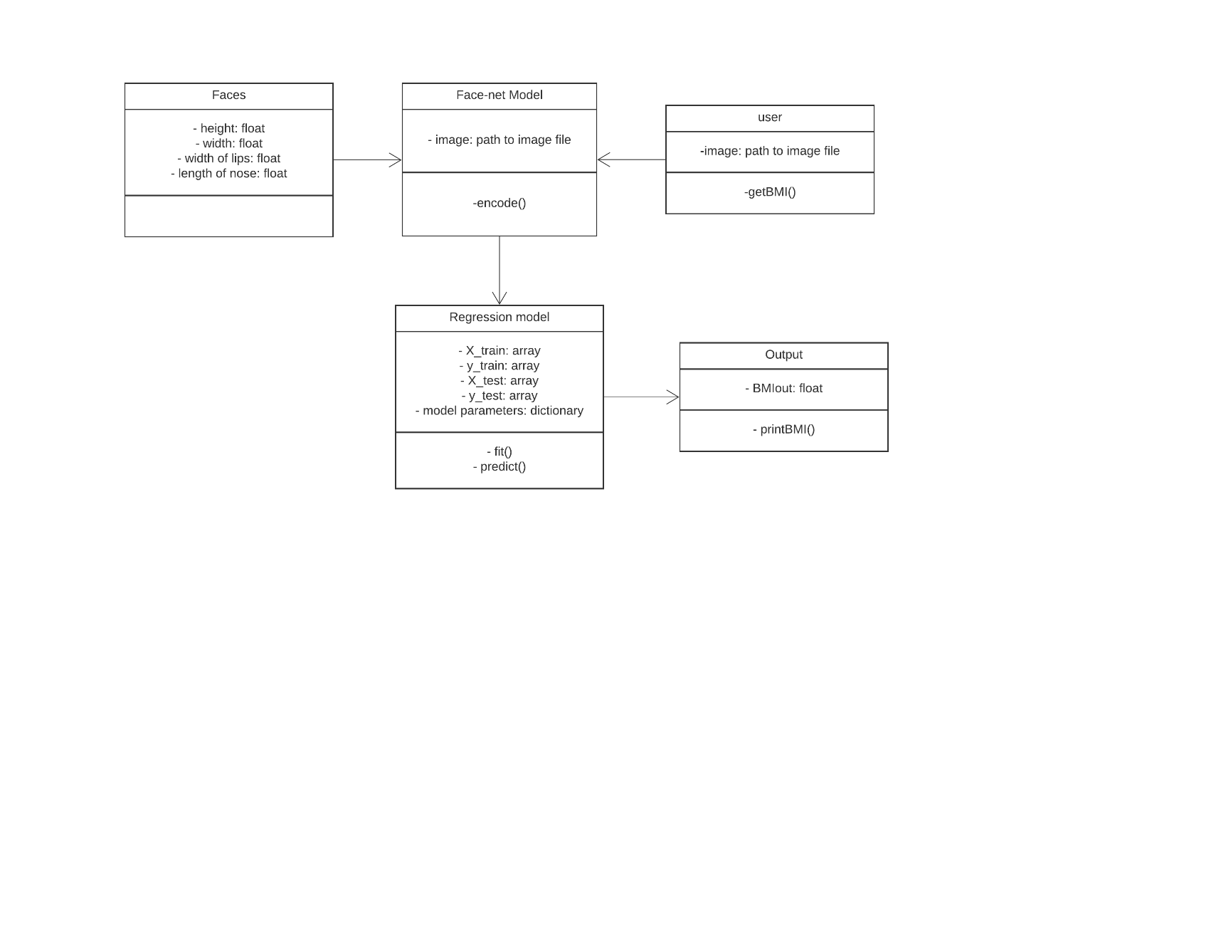

Figure 4.1 Class Diagram for Project

Description of class diagram:

1. Faces

This class stores information of facial images required to train the machine learning model

* 1. attributes
     1. height- stores the height of the face
     2. width- stores the width of the face
     3. width of lips- stores width of lips

(And many features of the face)

1. Face-net model

This class uses information from an image and encode the features into machine-readable language

* 1. attributes
     1. image- stores the path of the facial image
  2. methods
     1. encode ()- encodes the facial features into machine-readable language

1. Regression model

This class employs regression models on the train, test data as well as unknown inputs.

* 1. attributes
     1. X_train- stores training data of encoded image data
     2. y_train- stores independent variables of image data
     3. X_test- stores testing data for regression models
     4. y_test- stores values that will map to testing data
  2. model parameters- stores coefficients of model equations when hyper-parameter tuning is applied
  3. methods
     1. fit ()- trains the model
     2. predict ()- for checking the accuracy and to output values for unknown data

1. user

This class takes user input for an image

* 1. attributes
     1. image- stores image file or path to image file
  2. methods
     1. getBMI()- will get the input from the model

1. Output

This class will output the BMI predicted from the model

* 1. attributes
     1. BMIout- stores the predicted BMI
  2. methods
     1. printBMI()- will print the BMI for the user

4.1.2 Behavioral Diagram: Activity Diagrams

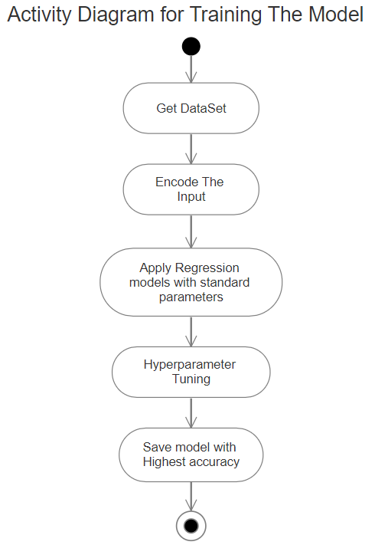

Fig 4.2 Activity Diagram for Training Model

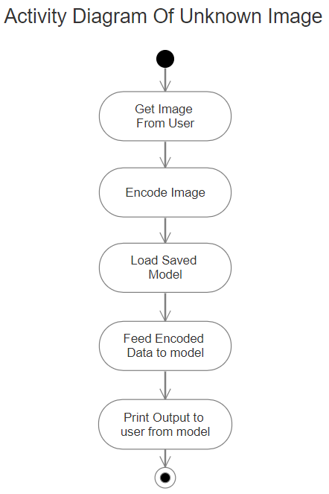

Fig 4.3 Activity Diagram for Unknown Image

1. **Algorithmic Study**
   1. Study of Algorithms:
      1. Linear Regression

Linear Regression is a supervised machine learning algorithm where the predicted output is continuous and has a constant slope.

* + - 1. Simple regression

Simple linear regression uses traditional slope-intercept form, where m and b are the variables our algorithm

Y = mx + b

* + - 1. Multivariable regression

w represents weights of the different independent variables

Y = w1x1+w2x2+w3x3

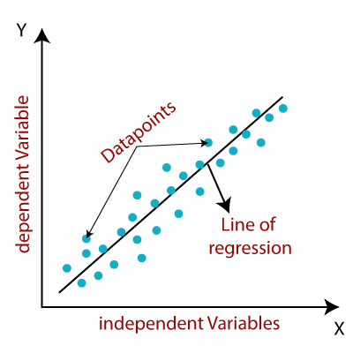

Fig 5.1 Linear Regression

* + 1. Ridge Linear Regression
    - Ridge regression is a model tuning method that is used to analyze any data that suffers from multicollinearity. This method performs L2 regularization.
    - The amount of bias added to the model is known as Ridge Regression penalty. We can compute this penalty term by multiplying with the lambda to the squared weight of each individual features
    - A general linear or polynomial regression will fail if there is high collinearity between the independent variables, so to solve such problems, Ridge regression can be used



* + 1. Lasso Regression
       - Lasso regression is another regularization technique to reduce the complexity of the model.
       - It is similar to the Ridge Regression except that penalty term contains only the absolute weights instead of a square of weights.
       - Since it takes absolute values, hence, it can shrink the slope to 0, whereas Ridge Regression can only shrink it near to 0.
       - It is also called as L1 regularization. The equation for Lasso regression will be



* + 1. Support Vector Regression
    - Kernel: It is a function used to map a lower-dimensional data into higher dimensional data.
    - Hyperplane: In general, SVM, it is a separation line between two classes, but in SVR, it is a line which helps to predict the continuous variables and cover most of the data points.
    - Boundary line: Boundary lines are the two lines apart from hyperplane, which creates a margin for data points.
    - Support vectors: Support vectors are the data points which are nearest to the hyperplane and opposite class.

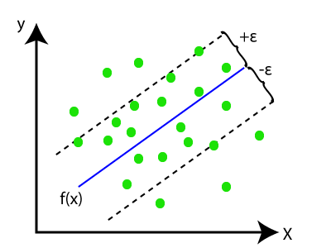

Fig 5.2 Support Vector Regression

1. **Advantages, Disadvantages, and Applications**
   1. Advantages / Merits:
      1. No requirement for actual measurement of body features
      2. Automated method without possibility of human error
      3. Easy creation of soft biometrics through facial features only
      4. Faster than artificial neural networks
   2. Disadvantages:
      1. Cannot achieve more than 99% accuracy
      2. Processing speed dependent on system efficiency
   3. Applications:
      1. Can be extended for use in image retrieval system
      2. Can medical treatments
      3. Can be used in physical fitness training regimes

**7. Conclusion**

* Regression model gives considerable accuracy and faster than complex neural networks.
* The models fail to give the correct height and weight for the dwarf humans.
* We did not observe any significant gender bias in estimating the BMI, height and weight.
* The height, weight and BMI estimator were motivated by the current need for self-diagnostic tools for remote healthcare, as well as for soft biometrics categorization in security applications.
* Support Vector Regression gives highest accuracy.
* Linear Regression performs poorly if no regularization is applied and gives the worst accuracy among all regression techniques which is less than 20%.

|  |  |  |  |  |
| --- | --- | --- | --- | --- |
|  | Linear Regression | Ridge Regression | Laaso Regression | Support Vector Regression |
| Accuracy(in %) | 18.01 | 97.11 | 96.14 | 97.17 |
| After Hyper-Parameter Tuning(in %) | - | 97.15 | 97.11 | 97.21 |

Table 7.1 Accuracy Comparison of Regression Models

**8. References**

[1] H. Siddiqui, A. Rattani, D. R. Kisku, and T. Dean, "Al-based BMI Inference from Facial Images: An Application to Weight Monitoring," 2020 19th IEEE International Conference on Machine Learning and Applications (ICMLA), 2020.

[2] A. Haritosh, A. Gupta, E. S. Chahal, A. Misra, and S. Chandra, "A novel method to estimate Height, Weight and Body Mass Index from face images," 2019 Twelfth International Conference on Contemporary Computing (IC3), 2019, pp. 1-6, DOI: 10.1109/IC3.2019.8844872.

[3] Emami, Shervin & Suciu, Valentin. (2012). Facial Recognition using OpenCV. Journal of Mobile, Embedded and Distributed Systems. 4.

[4] M. Beigzadeh and M. Vafadoost, "Detection of Face and Facial Features in digital Images and Video Frames," 2008 Cairo International Biomedical Engineering Conference, 2008

[5] Shih, Frank & Cheng, Shouxian & Chuang, Chao-Fa & Wang, Patrick. (2008). Extracting Faces and Facial Features from Color Images. IJPRAI. 22. 515-534. 10.1142/S0218001408006296.

[6] K. He, X. Zhang, S. Ren, and J. Sun, “Deep residual learning for image recognition,” in Proceedings of the IEEE conference on computer vision and pattern recognition, 2016, pp. 770–778