**Input Output Screenshots**

**Main Form Module**:

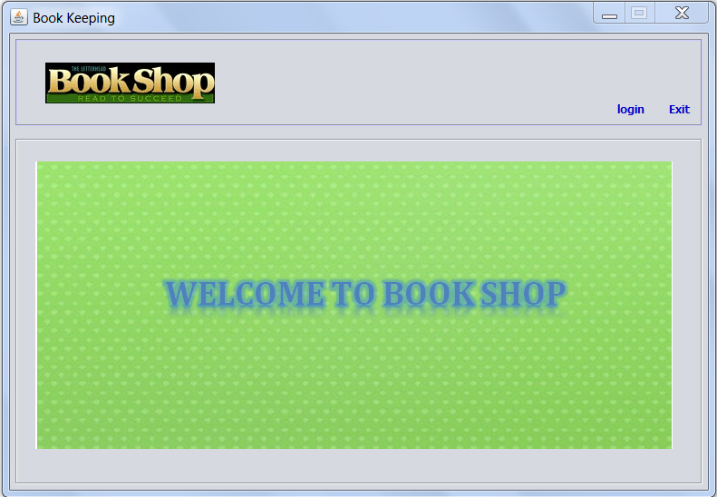

Main Form Interface

In above Interface, two buttons are included: **LOGIN** and **EXIT**.

On pressing **LOGIN** button, **LOGIN** window will be appeared:

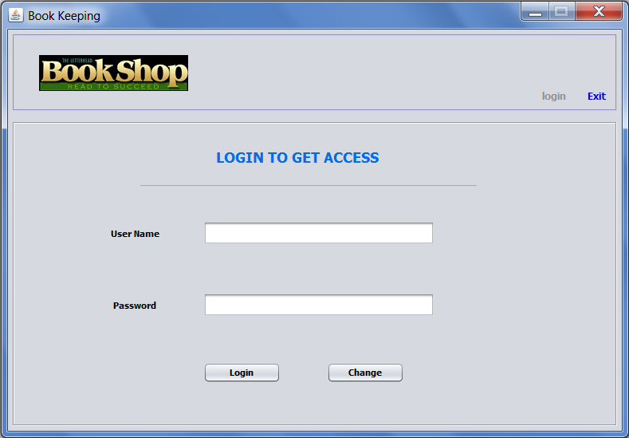

Login Form Window

And on pressing **EXIT** button in **Main Page** Window, a Pop-Up of ‘really want to exit’ appears:

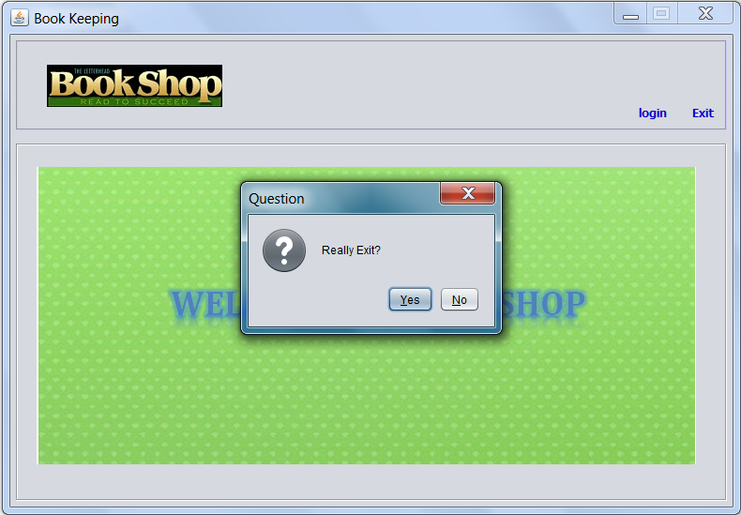

Exit Pop-Up

**Login Form Module**:



Login Form Window

In above login Interface, user will enter his *Username* and *Password*, and press **LOGIN** button for logging in…

if he authorizes successfully **Main Menu Window** will be opened:

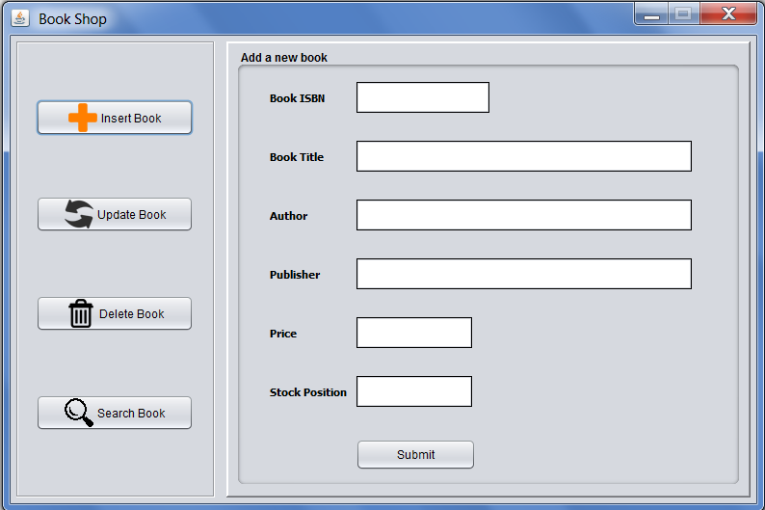

Main Menu Window

And if his authorization fails, ‘*Invalid Login Credentials’* error arises:

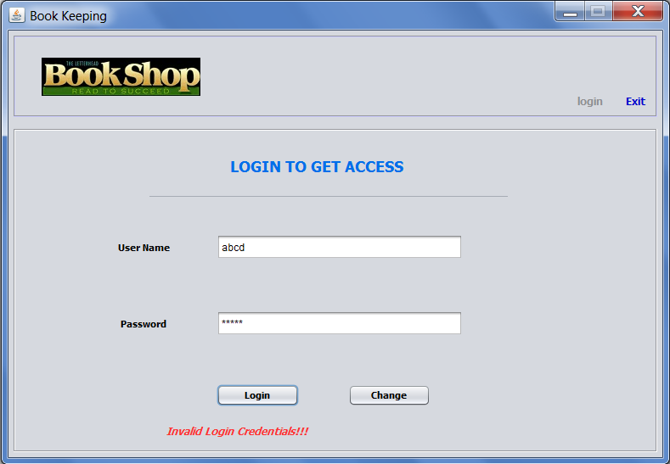

Error

On pressing **Change** button, if login credentials are valid, **Change Password** Window appears:

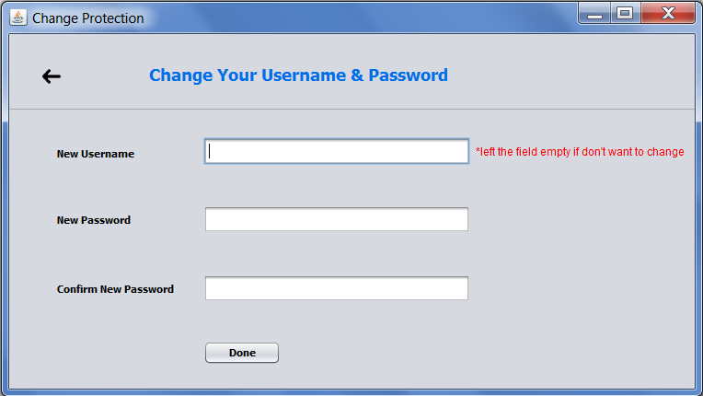

Change Password Window

**Change Auth Module**:



Change Password Window

In above Interface, three fields are there: *Username, Password* and *Confirm Password*.

User will input new username (if needed otherwise field can be left empty), new password and retype his new password in *New Password* field. If password entered matches with retyped password for confirmation and **DONE** button is pressed, username (if mentioned) and password will be changed:

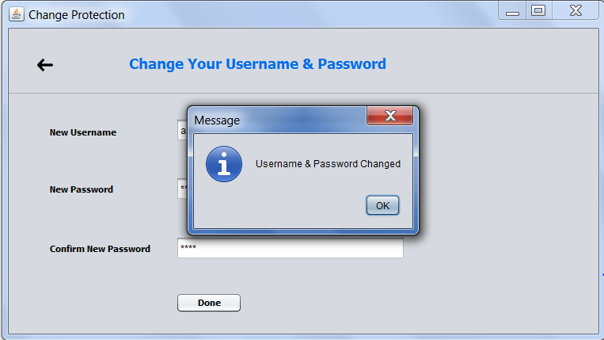

Change Confirmation

And if *Confirm Password* doesn’t match with P*assword* field, error appears:

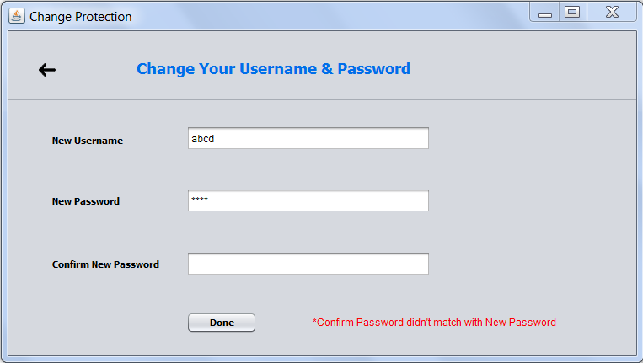

Error

**Main Menu Module**:

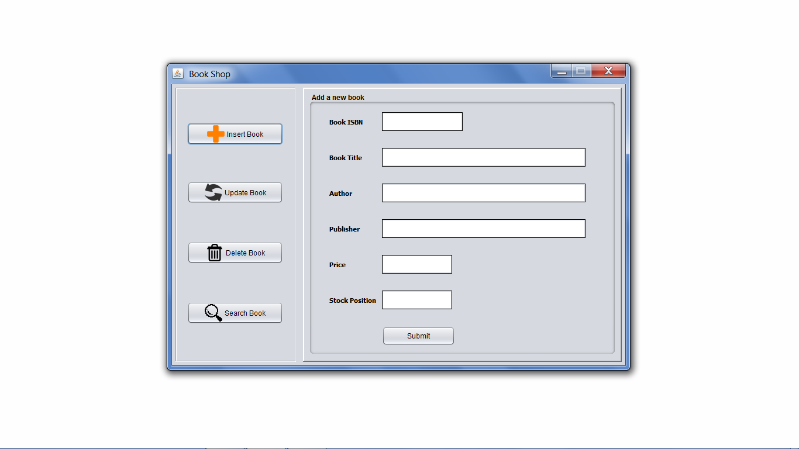

Main Menu Window

In above Interface, the user will input the details of the book to be added. After filling the fields and pressing the **SUBMIT** button, validation of fields will be checked. If validated successfully, Book will be added to database: 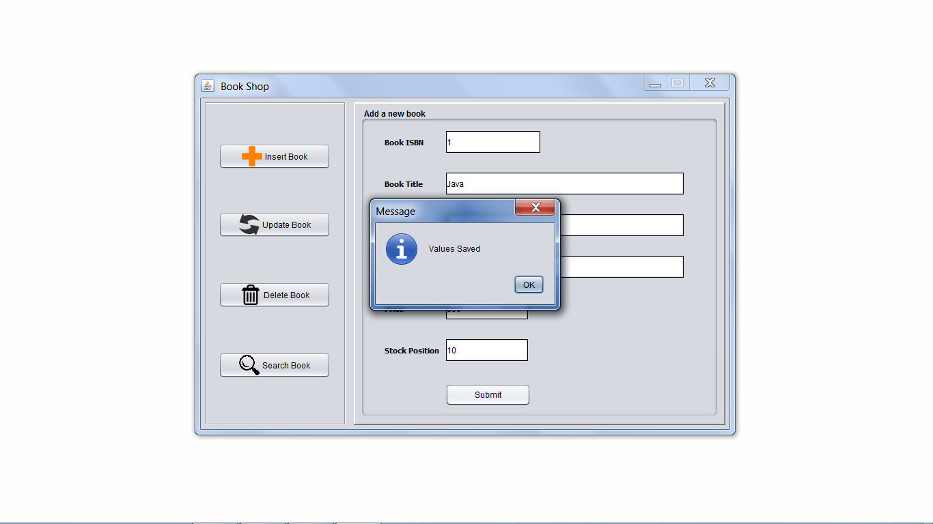

Book Inserted

If book details are found invalid, error will be appeared: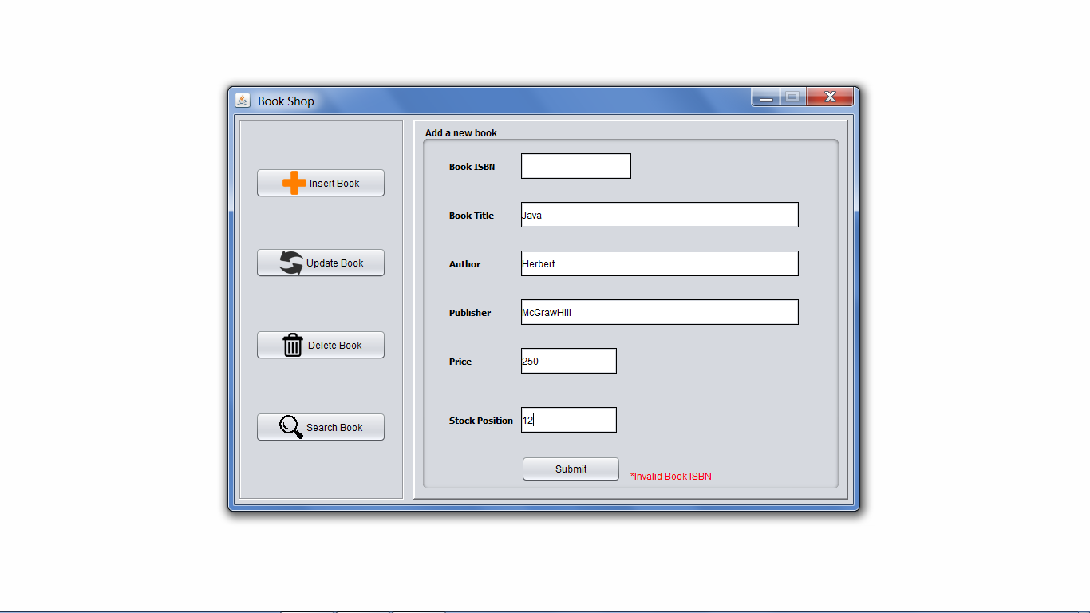

Error

**Update Form Module**:

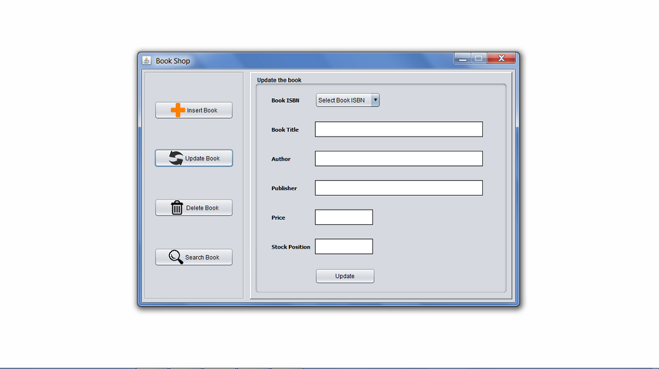

Update Form Interface

In above Interface, the user will select the book isbn from combo box and selective details of book will be displayed in their corresponding fields and after updating the wanted details and pressing the **UPDATE** button, validation of fields will be checked. If validated successfully, book details will be updated:

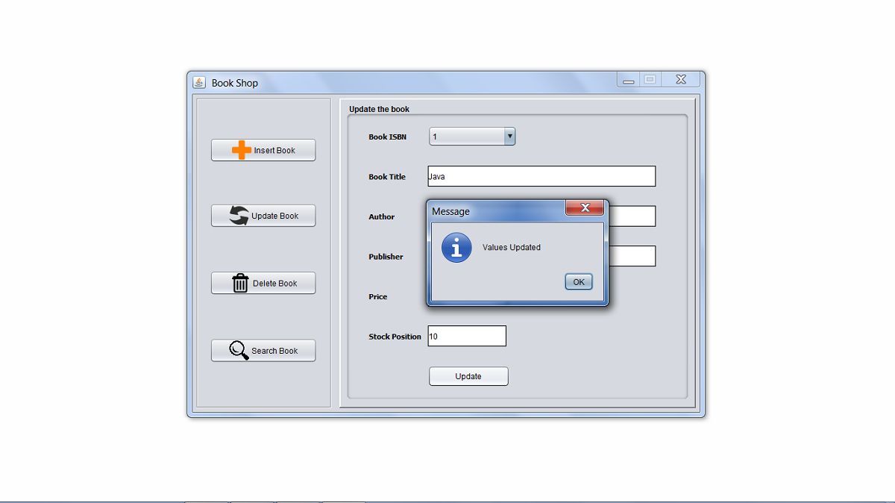

Update Confirmation

If any field updated contains error then error will be displayed: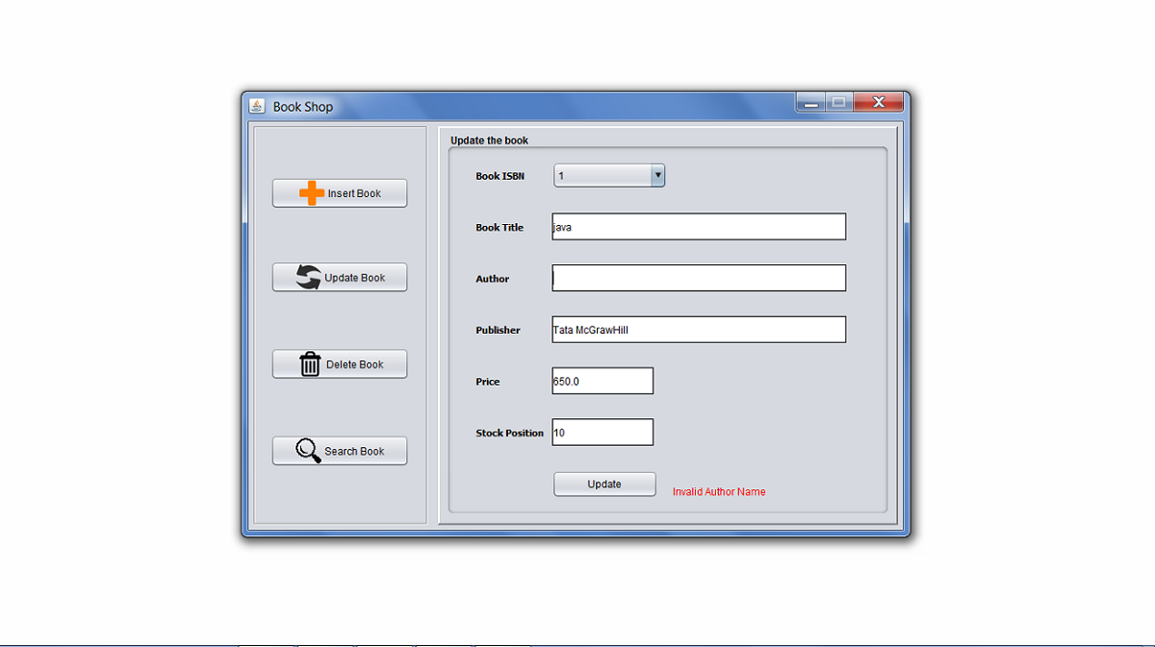

Error

**Delete Form Module**:

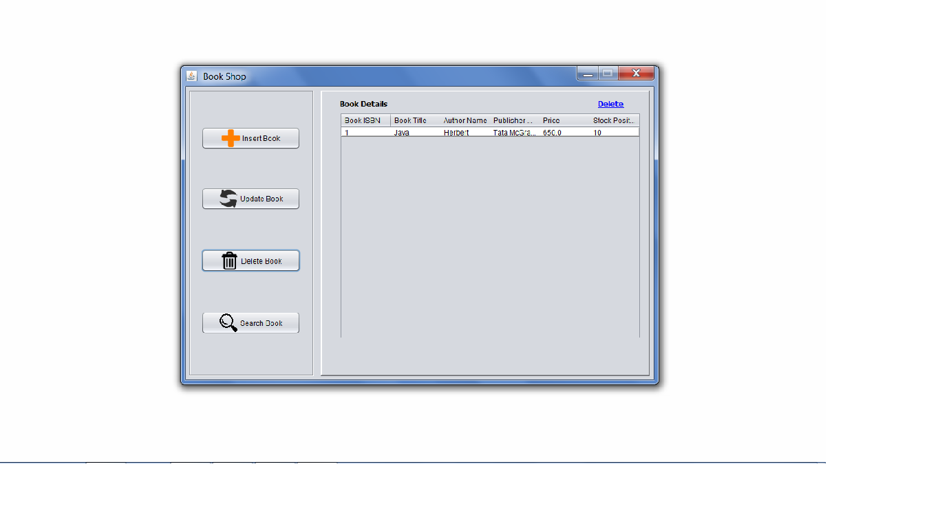

Delete Form Interface

The above interface is DELETE module interface. After clicking on **DELETE BOOK** button, this interface will be appeared. For deleting a row, select that row and press **Delete** button on top-right corner :

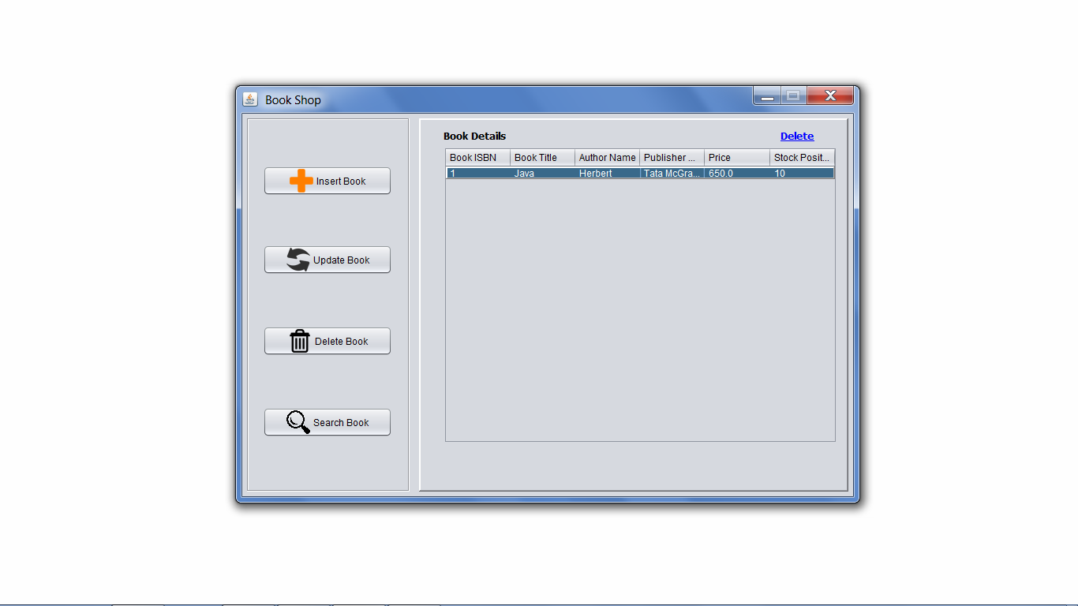

Select row and press Delete

After clicking the **Delete** button, the row will be deleted :

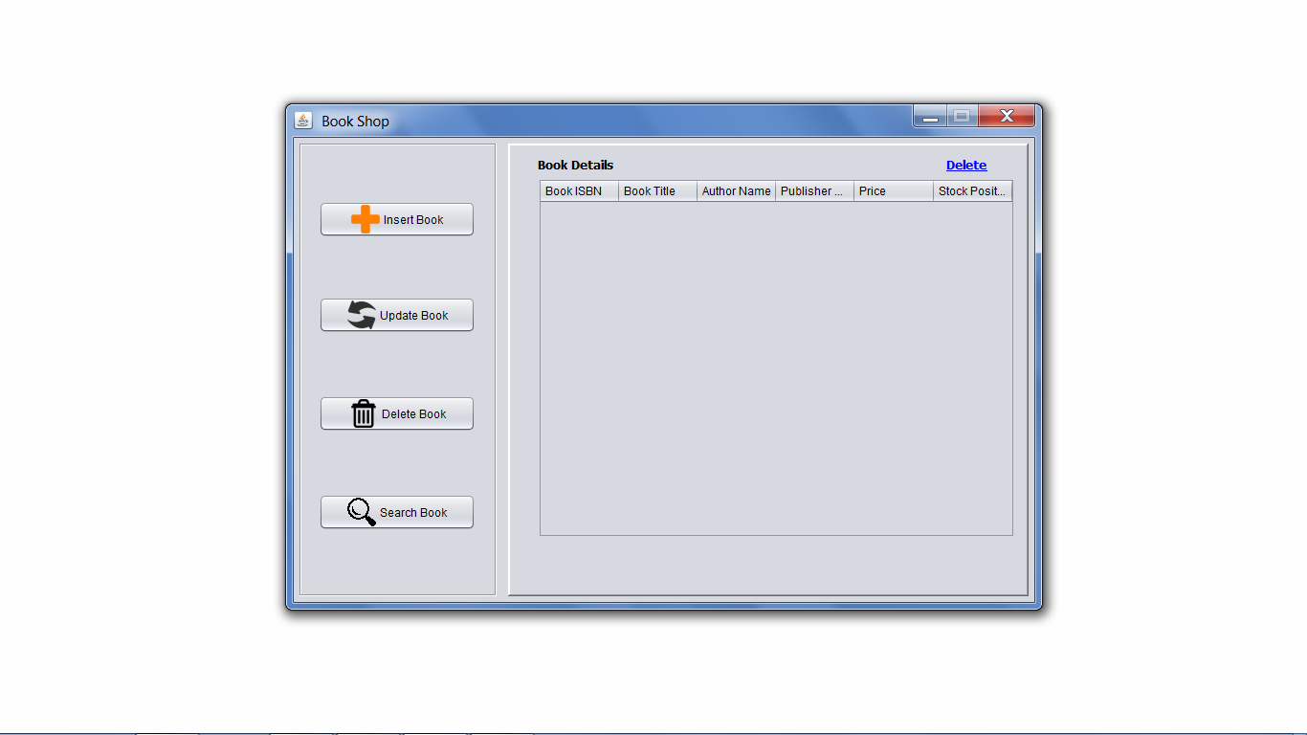

Book Deleted

**Search Form Module**:

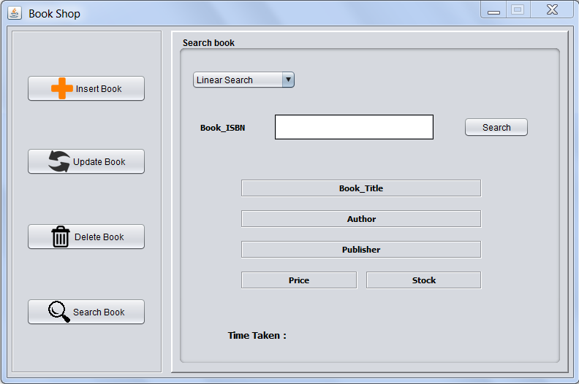

Search Form Window

In above Interface, the user will choose a method among: ***Linear Search***, ***Binary Search*** and ***Compare Complexity.*** If user selects ***Linear Search*** or ***Binary Search*** , after inputting ***ISBN*** of the book to be searched and pressing **SEARCH** button, if book found then :

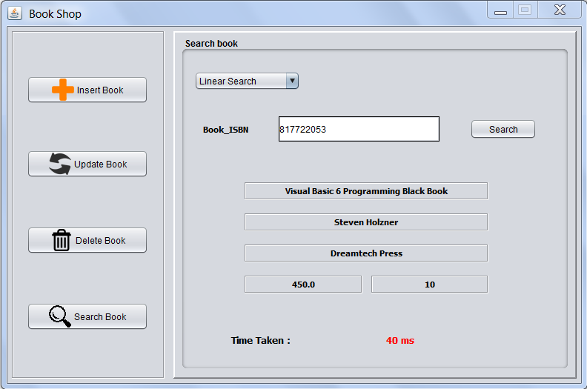

Book Found

If book is not found then fields will show **N/F** that meant ‘Not-Found’:

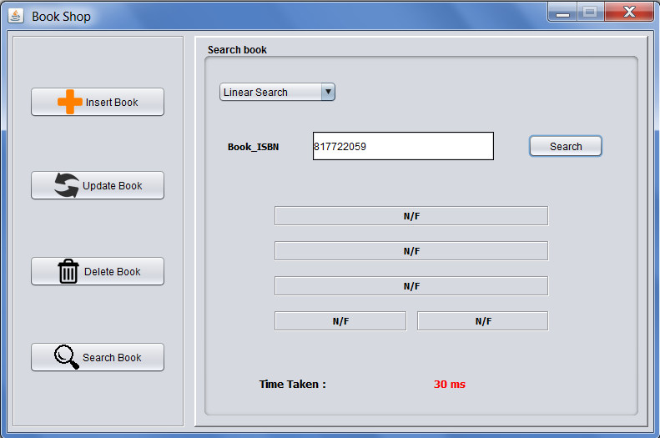

Book Not Found

If user selects *Compare Complexity,* then a new Interface will appear as:

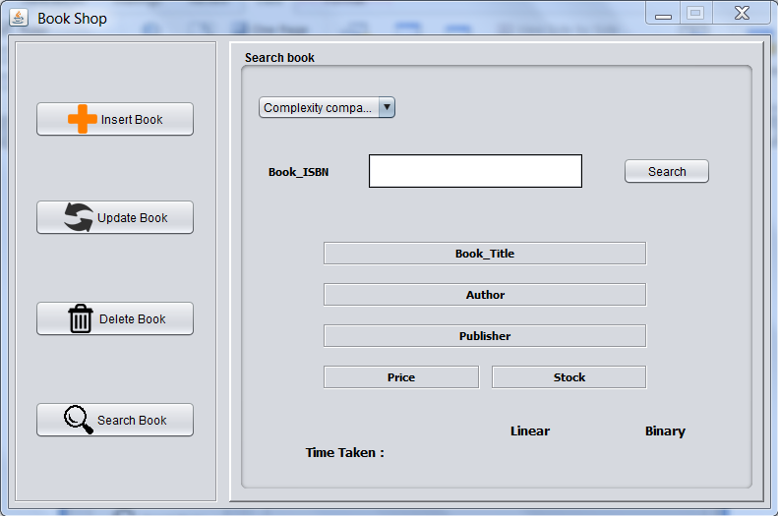

Compare Complexity Interface

And when user will input **ISBN** of book to be searched and press **SEARCH** button and book is found then:

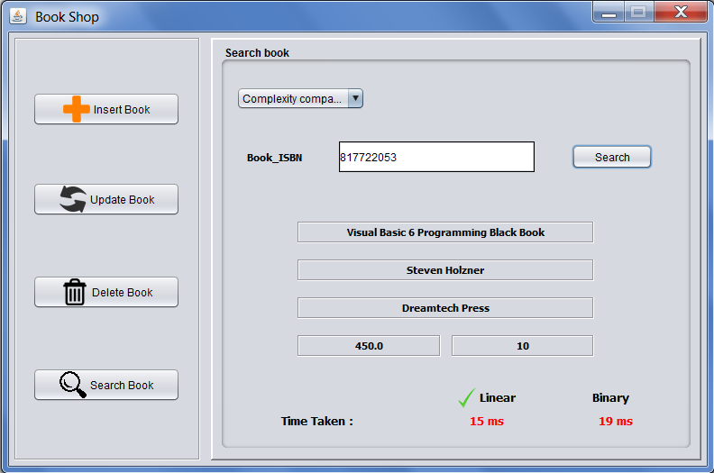

Book Found Using Complexity Comparison

If Book is not found then N/F will be encountered:

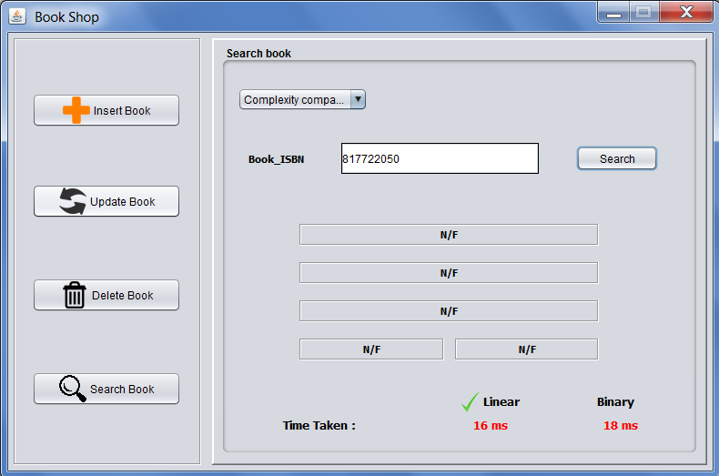

Book Not Found Using Complexity Comparison

If any invalid or null ISBN is entered then following error will be displayed:

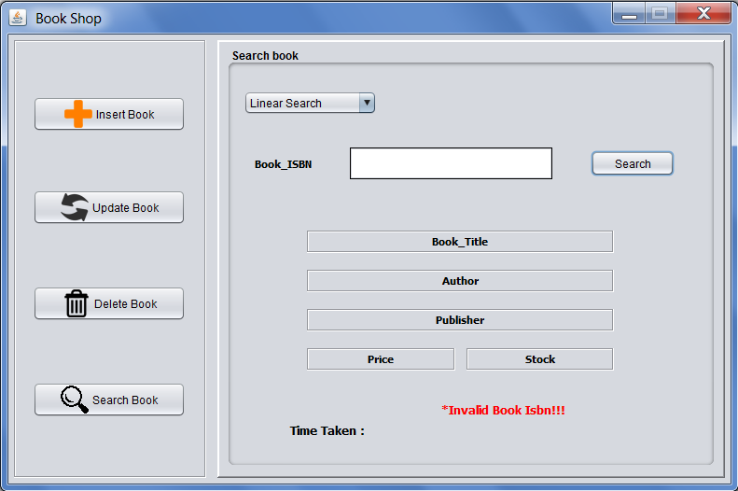

Invalid Book ISBN error