

**Experiment No. 1.2**

**Student Name: Srishti Makkar**

**Branch:** MCA **–** CCD

**UID:** 22MCC20143

**Section/Group:** MCD-1/ Grp B

**Semester:** III

**Subject Name:** Business Analytics

**Subject Code:** 22CAH-703

**Date of Performance:** 28th Aug 23

**1. Aim/Overview of the practical:**

1. Create a Pivot table to quickly summarize large databases, Group within Pivot Tables.
2. Create multiple Pivot Tables on a single worksheet.

**2. Code for practical:**

**a)**

* Creating the Pivot table from following table.

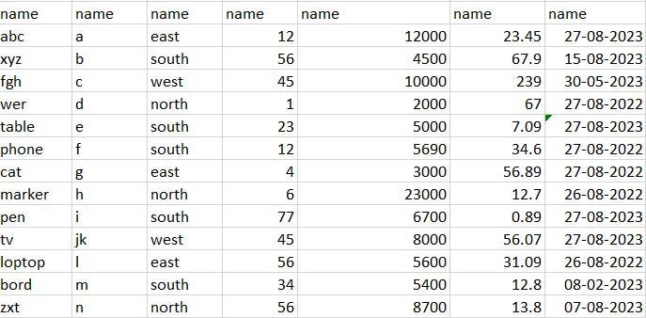

* Highlight the entire dataset, including the headers
* In Excel, go to the "Insert" tab and click on "PivotTable." A dialog box will appear.
* Ensure that the "Select a table or range" option is selected, and the correct range is displayed in the "Table/Range" box. Make sure the "New Worksheet" option is selected.
* Click "OK." A new worksheet will be created with an empty Pivot Table and a PivotTable Field List on the right.



• Drag the fields from the PivotTable Field List to the areas of the Pivot Table:



 Drag the "Date" field to the "Rows" area.



 Drag the "Product" field to the "Columns" area.



Drag the "Sales" field to the "Values" area.



 • Right-click on any date value in the Pivot Table.



 Select "Group" from the context menu.



 Specify the grouping interval (e.g., months, years, etc.) and click "OK."



 • The Pivot Table will now show data grouped by date and product. The "Sales" values will be summarized based on your grouping.





**b)**



 1. Follow steps 1 to 5 from the previous section to insert the first Pivot Table on your worksheet. 



2. After inserting the first Pivot Table, you can insert additional Pivot Tables as follows:



 • Click anywhere inside the first Pivot Table.



 • Go to the "Analyse" or "Options" tab (depending on your Excel version) on the Ribbon.



 • Click on "Insert PivotTable" (or a similar option). This will open the PivotTable Field List  again.



 3. For each additional Pivot Table:



 • Drag different fields to the different areas of the Pivot Table.



* Customize grouping, sorting, and summarization as needed.



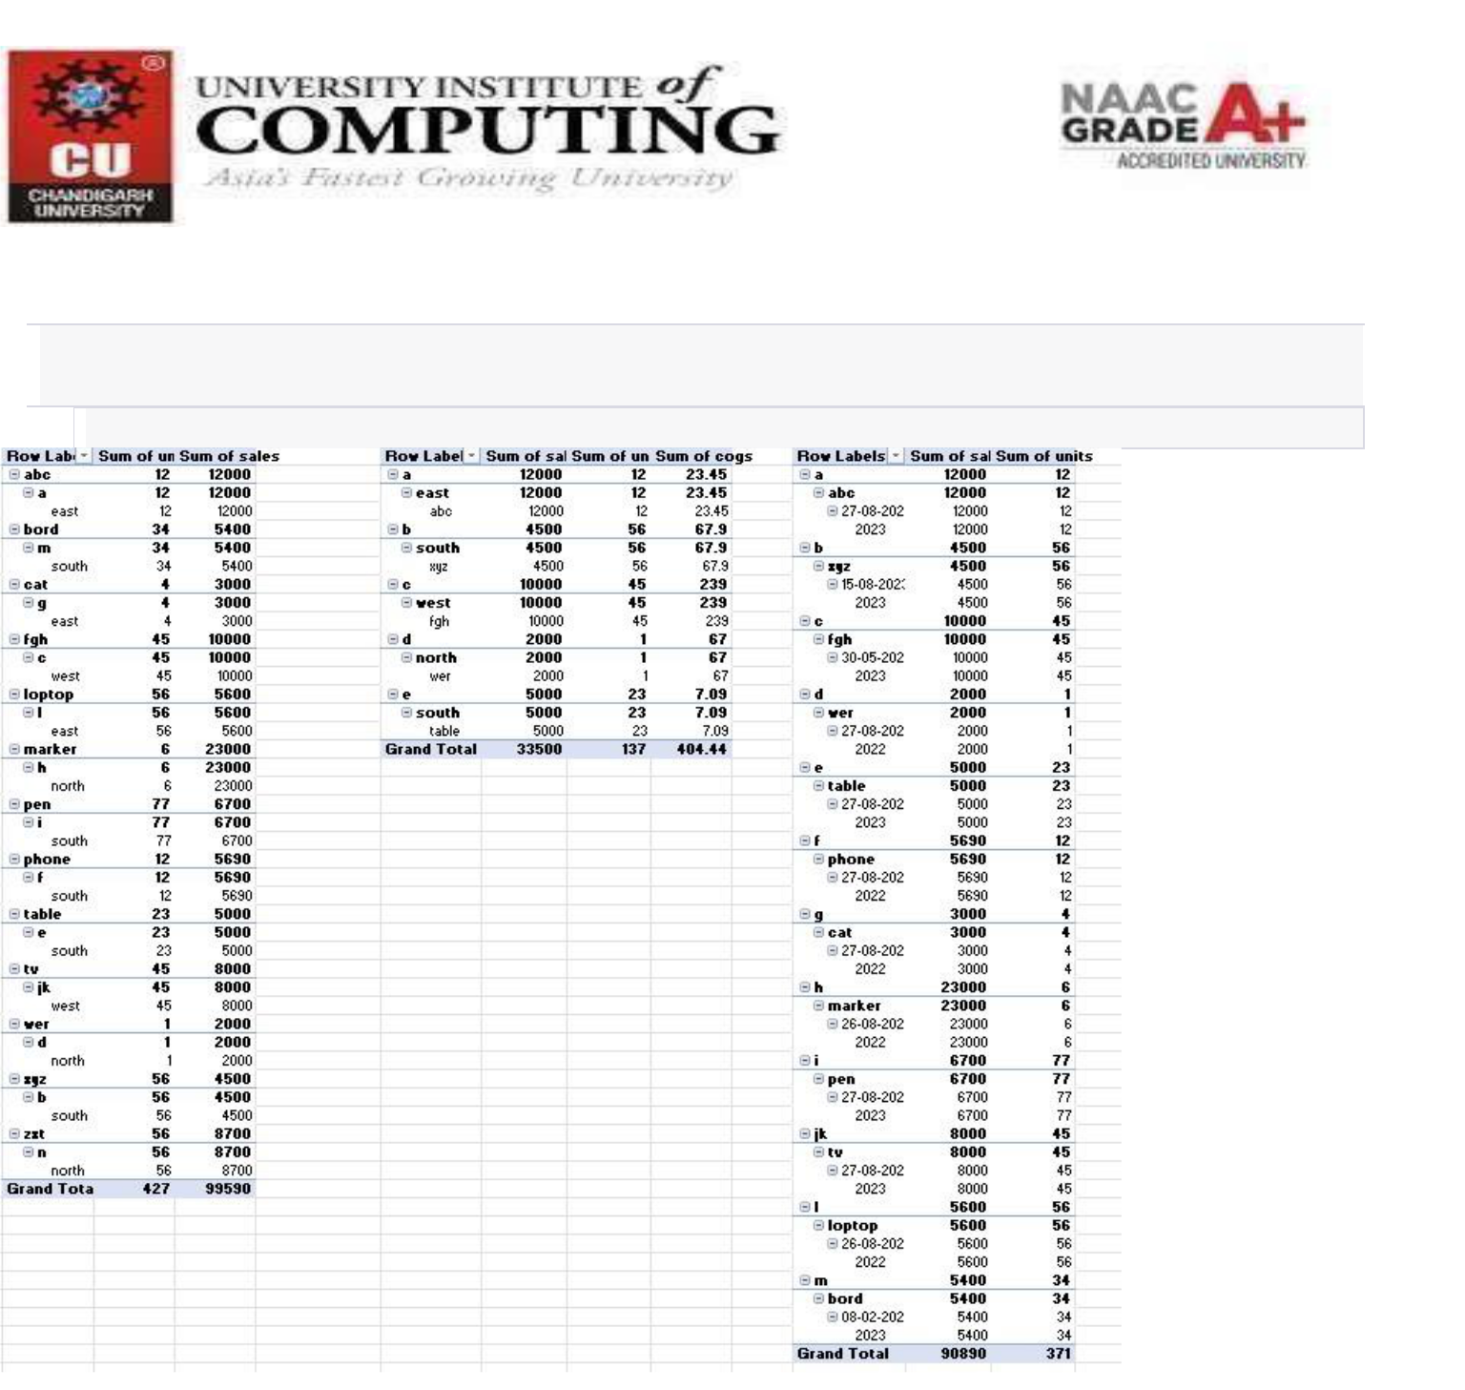

 4. Adjust the layout of your worksheet to accommodate the multiple Pivot Tables. You can resize  and position the Pivot Tables as required. 