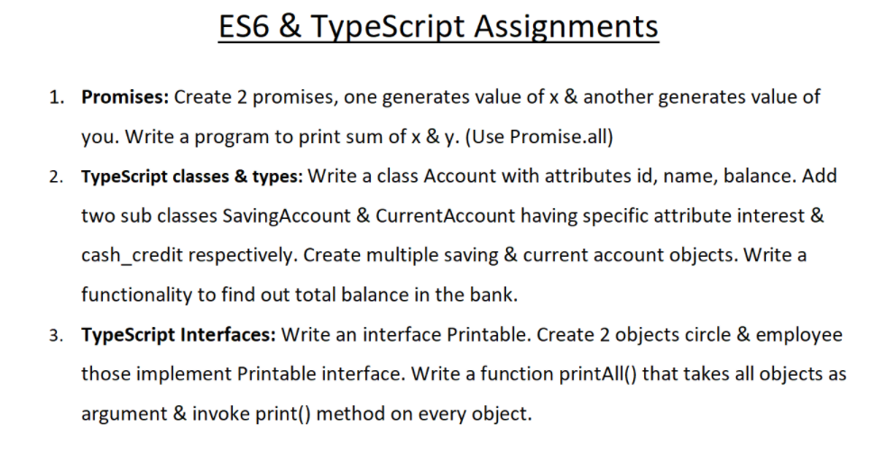

1. var x=0,you=0,sum=0;

const first= new Promise((resolve)=>{

    x=2;

    resolve(x)

}  )

const second= new Promise((resolve)=>{

    you=3;

    resolve(you)

}  )

Promise.all([first,second]).then(() =>{

        sum+=x;

        console.log(x);

    }).then(() =>{

         sum+=you;

        console.log(you);

    }).then(() =>{

        console.log(sum)

    })



2.

class Account {

    constructor(id, userName, balance) {

        this.id = id;

        this.userName = userName;

        this.balance = balance;

    }

}

class SavingAccount extends Account {

    constructor(id, userName, balance, interest) {

        super(id, userName, balance);

        this.interest = interest;

    }

    totalBalance() {

        return (this.balance + this.interest);

    }

}

class CurrentAccount extends Account {

    constructor(id, userName, balance, cash_credit) {

        super(id, userName, balance);

        this.cash_credit = cash_credit;

    }

    totalBalance() {

        return (this.balance + this.cash_credit);

    }

}

let sa1 = new SavingAccount(1, "abhi", 2000, 100);

let sa2 = new SavingAccount(2, "jarvis", 2000, 20);

let ca1 = new CurrentAccount(3, "tonny", 1000, 300);

let ca2 = new CurrentAccount(4, "iron", 4000, 20);

console.log(sa1.totalBalance());

console.log(sa2.totalBalance());

console.log(ca1.totalBalance());

console.log(ca2.totalBalance());

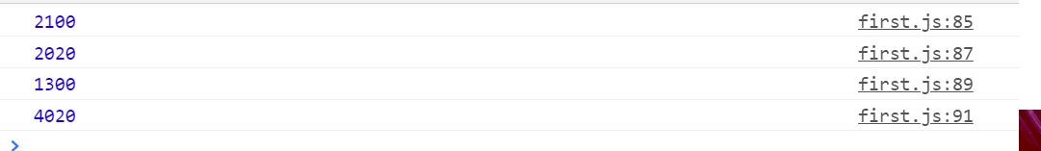

3.

interface Printable{

    empCode: number;

    empName: string;

}

let circle: Printable = { empCode:1, empName:"Steve" };

let employee: Printable = { empCode:2, empName:"max" };

function printAll(){

    console.log(circle.empCode,circle.empName);

    console.log(employee.empCode,employee.empName);

}

printAll();

