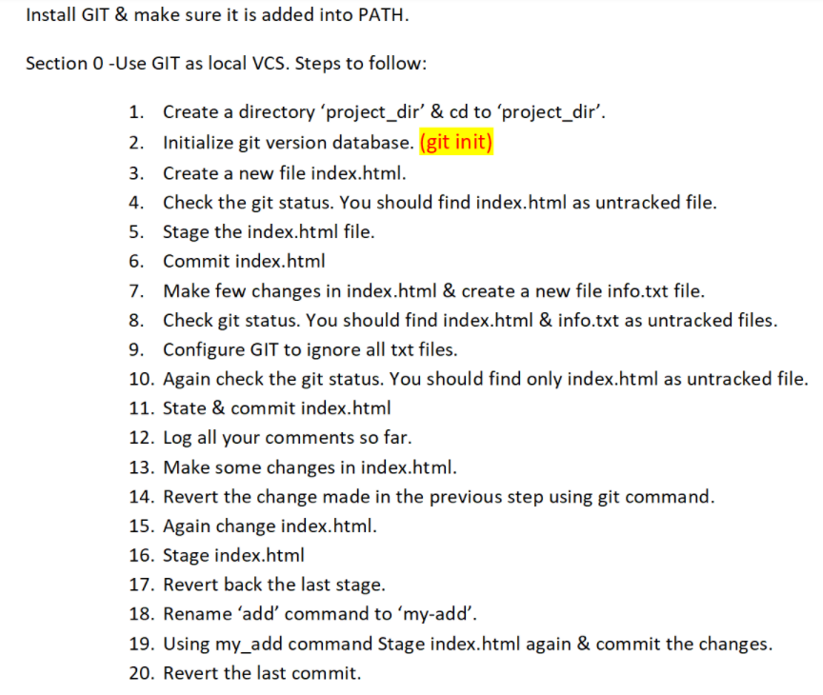

shiva@RYZEN-5 MINGW64 ~

$ cd documents

shiva@RYZEN-5 MINGW64 ~/documents

$ mkdir project_dir

shiva@RYZEN-5 MINGW64 ~/documents

$ cd project_sir

bash: cd: project_sir: No such file or directory

shiva@RYZEN-5 MINGW64 ~/documents

$ cd project_dir

shiva@RYZEN-5 MINGW64 ~/documents/project_dir

$ git init

Initialized empty Git repository in C:/Users/shiva/Documents/project_dir/.git/

shiva@RYZEN-5 MINGW64 ~/documents/project_dir (master)

$ touch index.html

shiva@RYZEN-5 MINGW64 ~/documents/project_dir (master)

$ git status

On branch master

No commits yet

Untracked files:

(use "git add <file>..." to include in what will be committed)

index.html

nothing added to commit but untracked files present (use "git add" to track)

shiva@RYZEN-5 MINGW64 ~/documents/project_dir (master)

$ git add index.html

shiva@RYZEN-5 MINGW64 ~/documents/project_dir (master)

$ git status

On branch master

No commits yet

Changes to be committed:

(use "git rm --cached <file>..." to unstage)

new file: index.html

shiva@RYZEN-5 MINGW64 ~/documents/project_dir (master)

$ git commit -m "new"

[master (root-commit) 7c906d7] new

1 file changed, 0 insertions(+), 0 deletions(-)

create mode 100644 index.html

shiva@RYZEN-5 MINGW64 ~/documents/project_dir (master)

$ touch info.txt

shiva@RYZEN-5 MINGW64 ~/documents/project_dir (master)

$ git status

On branch master

Changes not staged for commit:

(use "git add <file>..." to update what will be committed)

(use "git restore <file>..." to discard changes in working directory)

modified: index.html

Untracked files:

(use "git add <file>..." to include in what will be committed)

info.txt

no changes added to commit (use "git add" and/or "git commit -a")

shiva@RYZEN-5 MINGW64 ~/documents/project_dir (master)

$ git add index.html

shiva@RYZEN-5 MINGW64 ~/documents/project_dir (master)

$ git status

On branch master

Changes to be committed:

(use "git restore --staged <file>..." to unstage)

modified: index.html

Untracked files:

(use "git add <file>..." to include in what will be committed)

info.txt

shiva@RYZEN-5 MINGW64 ~/documents/project_dir (master)

$ git commit -m "2nd"

[master 0720c72] 2nd

1 file changed, 5 insertions(+)

shiva@RYZEN-5 MINGW64 ~/documents/project_dir (master)

$ git log --index.html

fatal: unrecognized argument: --index.html

shiva@RYZEN-5 MINGW64 ~/documents/project_dir (master)

$ git log -- index.html

commit 0720c723b4bc3fc1f95a60cdaacd75efde63b2ad (HEAD -> master)

Author: shivamttl <shivamttl@gmail.com>

Date: Mon May 17 10:18:13 2021 +0530

2nd

commit 7c906d79f7855b523bae0c3656da26367bb7eeed

Author: shivamttl <shivamttl@gmail.com>

Date: Mon May 17 10:10:18 2021 +0530

new

shiva@RYZEN-5 MINGW64 ~/documents/project_dir (master)

$ git status

On branch master

Changes not staged for commit:

(use "git add <file>..." to update what will be committed)

(use "git restore <file>..." to discard changes in working directory)

modified: index.html

Untracked files:

(use "git add <file>..." to include in what will be committed)

info.txt

no changes added to commit (use "git add" and/or "git commit -a")

shiva@RYZEN-5 MINGW64 ~/documents/project_dir (master)

$ git add index.html

shiva@RYZEN-5 MINGW64 ~/documents/project_dir (master)

$ git commit -m "3rd"

[master dd8028d] 3rd

1 file changed, 1 insertion(+), 1 deletion(-)

shiva@RYZEN-5 MINGW64 ~/documents/project_dir (master)

$ git reset --soft HEAD~1

shiva@RYZEN-5 MINGW64 ~/documents/project_dir (master)

$ git status

On branch master

Changes to be committed:

(use "git restore --staged <file>..." to unstage)

modified: index.html

Untracked files:

(use "git add <file>..." to include in what will be committed)

info.txt

shiva@RYZEN-5 MINGW64 ~/documents/project_dir (master)

$ git log -- index.html

commit 0720c723b4bc3fc1f95a60cdaacd75efde63b2ad (HEAD -> master)

Author: shivamttl <shivamttl@gmail.com>

Date: Mon May 17 10:18:13 2021 +0530

2nd

commit 7c906d79f7855b523bae0c3656da26367bb7eeed

Author: shivamttl <shivamttl@gmail.com>

Date: Mon May 17 10:10:18 2021 +0530

new

shiva@RYZEN-5 MINGW64 ~/documents/project_dir (master)

$ git config --global alias .my-add add

error: key does not contain a section: alias

shiva@RYZEN-5 MINGW64 ~/documents/project_dir (master)

$ git config --global alias.my-add add

shiva@RYZEN-5 MINGW64 ~/documents/project_dir (master)

$ git my-add index.html

shiva@RYZEN-5 MINGW64 ~/documents/project_dir (master)

$ git commit -m "3rd"

[master 36bc6f4] 3rd

1 file changed, 1 insertion(+), 1 deletion(-)

shiva@RYZEN-5 MINGW64 ~/documents/project_dir (master)

$ git log -- index.html

commit 36bc6f4cea3aa935495a2232e1dd014550699d70 (HEAD -> master)

Author: shivamttl <shivamttl@gmail.com>

Date: Mon May 17 10:26:52 2021 +0530

3rd

commit 0720c723b4bc3fc1f95a60cdaacd75efde63b2ad

Author: shivamttl <shivamttl@gmail.com>

Date: Mon May 17 10:18:13 2021 +0530

2nd

commit 7c906d79f7855b523bae0c3656da26367bb7eeed

Author: shivamttl <shivamttl@gmail.com>

Date: Mon May 17 10:10:18 2021 +0530

new

shiva@RYZEN-5 MINGW64 ~/documents/project_dir (master)

$ git reset --soft HEAD~1

shiva@RYZEN-5 MINGW64 ~/documents/project_dir (master)

$ git log -- index.html

commit 0720c723b4bc3fc1f95a60cdaacd75efde63b2ad (HEAD -> master)

Author: shivamttl <shivamttl@gmail.com>

Date: Mon May 17 10:18:13 2021 +0530

2nd

commit 7c906d79f7855b523bae0c3656da26367bb7eeed

Author: shivamttl <shivamttl@gmail.com>

Date: Mon May 17 10:10:18 2021 +0530

new

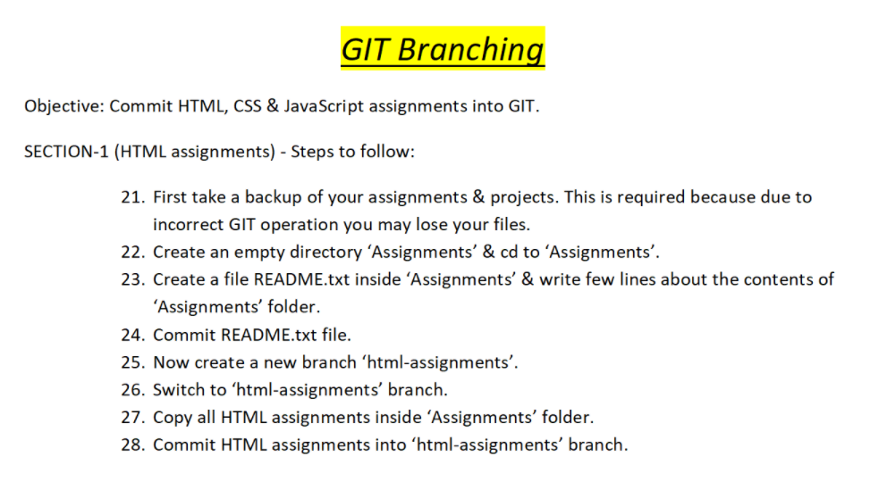

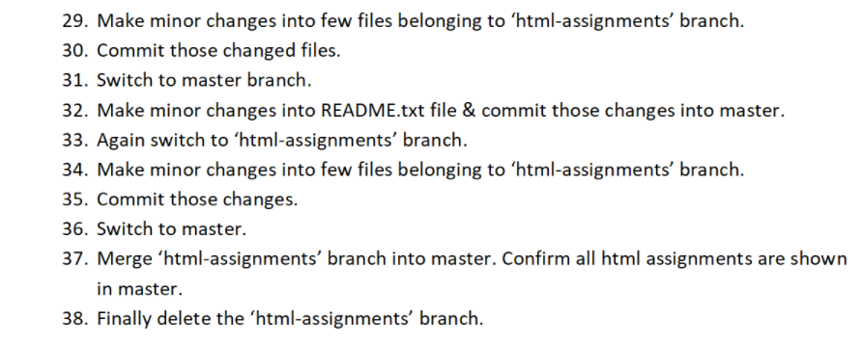

shiva@RYZEN-5 MINGW64 ~/documents

$ mkdir Assignments

shiva@RYZEN-5 MINGW64 ~/documents

$ cd Assignments

shiva@RYZEN-5 MINGW64 ~/documents/Assignments

$ touch README.txt

shiva@RYZEN-5 MINGW64 ~/documents/Assignments

$ git init

Initialized empty Git repository in C:/Users/shiva/Documents/Assignments/.git/

shiva@RYZEN-5 MINGW64 ~/documents/Assignments (master)

$ git add README.txt

shiva@RYZEN-5 MINGW64 ~/documents/Assignments (master)

$ git status

On branch master

No commits yet

Changes to be committed:

(use "git rm --cached <file>..." to unstage)

new file: README.txt

shiva@RYZEN-5 MINGW64 ~/documents/Assignments (master)

$ git commit -m "new"

[master (root-commit) f10ac86] new

1 file changed, 1 insertion(+)

create mode 100644 README.txt

shiva@RYZEN-5 MINGW64 ~/documents/Assignments (master)

$ git branch html-assignments

shiva@RYZEN-5 MINGW64 ~/documents/Assignments (master)

$ git checkout html-assignments

Switched to branch 'html-assignments'

shiva@RYZEN-5 MINGW64 ~/documents/Assignments (html-assignments)

$ git status

On branch html-assignments

Untracked files:

(use "git add <file>..." to include in what will be committed)

New.txt

Text.txt

nothing added to commit but untracked files present (use "git add" to track)

shiva@RYZEN-5 MINGW64 ~/documents/Assignments (html-assignments)

$ git add New.txt Text.txt

shiva@RYZEN-5 MINGW64 ~/documents/Assignments (html-assignments)

$ git status

On branch html-assignments

Changes to be committed:

(use "git restore --staged <file>..." to unstage)

new file: New.txt

new file: Text.txt

shiva@RYZEN-5 MINGW64 ~/documents/Assignments (html-assignments)

$ git commit -m "branch"

[html-assignments c8bb335] branch

2 files changed, 42 insertions(+)

create mode 100644 New.txt

create mode 100644 Text.txt

shiva@RYZEN-5 MINGW64 ~/documents/Assignments (html-assignments)

$ git status

On branch html-assignments

Changes not staged for commit:

(use "git add <file>..." to update what will be committed)

(use "git restore <file>..." to discard changes in working directory)

modified: New.txt

no changes added to commit (use "git add" and/or "git commit -a")

shiva@RYZEN-5 MINGW64 ~/documents/Assignments (html-assignments)

$ git add New.txt Text.txt

shiva@RYZEN-5 MINGW64 ~/documents/Assignments (html-assignments)

$ git commit -m "branch-edit"

[html-assignments 5b986ba] branch-edit

1 file changed, 8 insertions(+)

shiva@RYZEN-5 MINGW64 ~/documents/Assignments (html-assignments)

$ git checkout master

Switched to branch 'master'

shiva@RYZEN-5 MINGW64 ~/documents/Assignments (master)

$ git status

On branch master

Changes not staged for commit:

(use "git add <file>..." to update what will be committed)

(use "git restore <file>..." to discard changes in working directory)

modified: README.txt

no changes added to commit (use "git add" and/or "git commit -a")

shiva@RYZEN-5 MINGW64 ~/documents/Assignments (master)

$ git add README.txt

shiva@RYZEN-5 MINGW64 ~/documents/Assignments (master)

$ git commit -m "master-edit"

[master 0e0745b] master-edit

1 file changed, 4 insertions(+), 1 deletion(-)

shiva@RYZEN-5 MINGW64 ~/documents/Assignments (master)

$ git checkout html-assignments

Switched to branch 'html-assignments'

shiva@RYZEN-5 MINGW64 ~/documents/Assignments (html-assignments)

$ git status

On branch html-assignments

Changes not staged for commit:

(use "git add <file>..." to update what will be committed)

(use "git restore <file>..." to discard changes in working directory)

modified: Text.txt

no changes added to commit (use "git add" and/or "git commit -a")

shiva@RYZEN-5 MINGW64 ~/documents/Assignments (html-assignments)

$ git add Text.txt

shiva@RYZEN-5 MINGW64 ~/documents/Assignments (html-assignments)

$ git commit -m "branch-edit2"

[html-assignments 487c13a] branch-edit2

1 file changed, 1 insertion(+), 1 deletion(-)

shiva@RYZEN-5 MINGW64 ~/documents/Assignments (html-assignments)

$ git checkout master

Switched to branch 'master'

shiva@RYZEN-5 MINGW64 ~/documents/Assignments (master)

$ git merge html-assignments

Merge made by the 'recursive' strategy.

New.txt | 37 +++++++++++++++++++++++++++++++++++++

Text.txt | 13 +++++++++++++

2 files changed, 50 insertions(+)

create mode 100644 New.txt

create mode 100644 Text.txt

shiva@RYZEN-5 MINGW64 ~/documents/Assignments (master)

$ git checkout -d html-assignments

HEAD is now at 487c13a branch-edit2

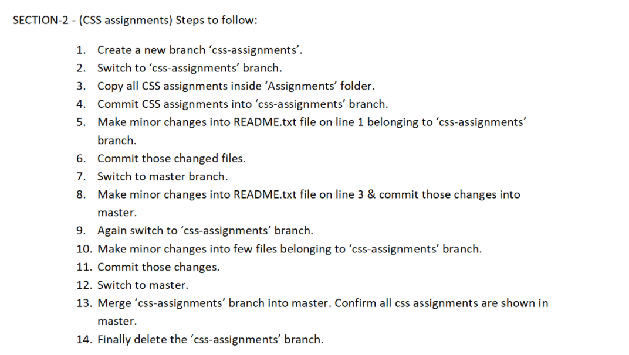

shiva@RYZEN-5 MINGW64 ~/desktop/Assignments (master)

$ git checkout css-assignments

Switched to branch 'css-assignments'

shiva@RYZEN-5 MINGW64 ~/desktop/Assignments (css-assignments)

$ git status

On branch css-assignments

nothing to commit, working tree clean

shiva@RYZEN-5 MINGW64 ~/desktop/Assignments (css-assignments)

$ touch help.txt

shiva@RYZEN-5 MINGW64 ~/desktop/Assignments (css-assignments)

$ add help.txt

bash: add: command not found

shiva@RYZEN-5 MINGW64 ~/desktop/Assignments (css-assignments)

$ git add help.txt

shiva@RYZEN-5 MINGW64 ~/desktop/Assignments (css-assignments)

$ git commit -m "css-branch"

On branch css-assignments

nothing to commit, working tree clean

shiva@RYZEN-5 MINGW64 ~/desktop/Assignments (css-assignments)

$ git status

On branch css-assignments

nothing to commit, working tree clean

shiva@RYZEN-5 MINGW64 ~/desktop/Assignments (css-assignments)

$ git status

On branch css-assignments

Changes not staged for commit:

(use "git add <file>..." to update what will be committed)

(use "git restore <file>..." to discard changes in working directory)

modified: README.txt

no changes added to commit (use "git add" and/or "git commit -a")

shiva@RYZEN-5 MINGW64 ~/desktop/Assignments (css-assignments)

$ git add README.txt

shiva@RYZEN-5 MINGW64 ~/desktop/Assignments (css-assignments)

$ git commit -m "css-branch COMMIT"

[css-assignments cd5008b] css-branch COMMIT

1 file changed, 1 insertion(+), 1 deletion(-)

shiva@RYZEN-5 MINGW64 ~/desktop/Assignments (css-assignments)

$ git checkout master

Switched to branch 'master'

shiva@RYZEN-5 MINGW64 ~/desktop/Assignments (master)

$ git status

On branch master

Changes not staged for commit:

(use "git add <file>..." to update what will be committed)

(use "git restore <file>..." to discard changes in working directory)

modified: README.txt

no changes added to commit (use "git add" and/or "git commit -a")

shiva@RYZEN-5 MINGW64 ~/desktop/Assignments (master)

$ git add README.txt

shiva@RYZEN-5 MINGW64 ~/desktop/Assignments (master)

$ git commit -m "MASTER COMMIT"

[master 490cd77] MASTER COMMIT

1 file changed, 1 insertion(+), 1 deletion(-)

shiva@RYZEN-5 MINGW64 ~/desktop/Assignments (master)

$ git checkout css-assignments

Switched to branch 'css-assignments'

shiva@RYZEN-5 MINGW64 ~/desktop/Assignments (css-assignments)

$ git status

On branch css-assignments

Changes not staged for commit:

(use "git add <file>..." to update what will be committed)

(use "git restore <file>..." to discard changes in working directory)

modified: help.txt

no changes added to commit (use "git add" and/or "git commit -a")

shiva@RYZEN-5 MINGW64 ~/desktop/Assignments (css-assignments)

$ git add help.txt

shiva@RYZEN-5 MINGW64 ~/desktop/Assignments (css-assignments)

$ git commit -m "css-branch COMMIT-2"

[css-assignments a23ebbc] css-branch COMMIT-2

1 file changed, 1 insertion(+), 1 deletion(-)

shiva@RYZEN-5 MINGW64 ~/desktop/Assignments (css-assignments)

$ git checkout master

Switched to branch 'master'

shiva@RYZEN-5 MINGW64 ~/desktop/Assignments (master)

$ git merge css-assignments

Auto-merging README.txt

CONFLICT (content): Merge conflict in README.txt

Automatic merge failed; fix conflicts and then commit the result.

shiva@RYZEN-5 MINGW64 ~/desktop/Assignments (master|MERGING)

$ ^C

shiva@RYZEN-5 MINGW64 ~/desktop/Assignments (master|MERGING)

$ git merge --abort

shiva@RYZEN-5 MINGW64 ~/desktop/Assignments (master)

$ git checkout -d css-assignments

HEAD is now at a23ebbc css-branch COMMIT-2

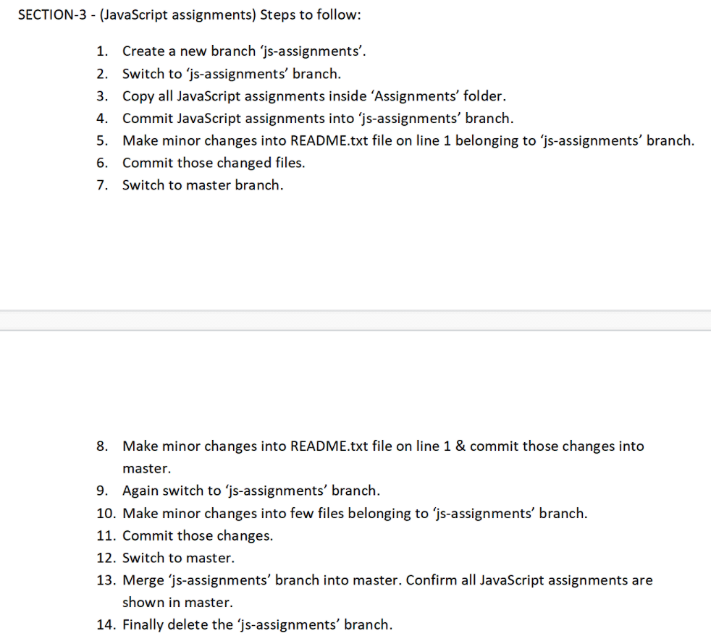

shiva@RYZEN-5 MINGW64 ~/desktop/Assignments (master)

$ git checkout js-assignments

Switched to branch 'js-assignments'

shiva@RYZEN-5 MINGW64 ~/desktop/Assignments (js-assignments)

$ git status

On branch js-assignments

nothing to commit, working tree clean

shiva@RYZEN-5 MINGW64 ~/desktop/Assignments (js-assignments)

$ touch help2.txt

shiva@RYZEN-5 MINGW64 ~/desktop/Assignments (js-assignments)

$ add help2.txt

bash: add: command not found

shiva@RYZEN-5 MINGW64 ~/desktop/Assignments (js-assignments)

$ git add help2.txt

shiva@RYZEN-5 MINGW64 ~/desktop/Assignments (js-assignments)

$ git commit -m "js-branchs"

On branch js-assignments

nothing to commit, working tree clean

shiva@RYZEN-5 MINGW64 ~/desktop/Assignments (js-assignments)

$ git status

On branch js-assignments

nothing to commit, working tree clean

shiva@RYZEN-5 MINGW64 ~/desktop/Assignments (js-assignments)

$ git status

On branch js-assignments

Changes not staged for commit:

(use "git add <file>..." to update what will be committed)

(use "git restore <file>..." to discard changes in working directory)

modified: README.txt

no changes added to commit (use "git add" and/or "git commit -a")

shiva@RYZEN-5 MINGW64 ~/desktop/Assignments (js-assignments)

$ git add README.txt

shiva@RYZEN-5 MINGW64 ~/desktop/Assignments (js-assignments)

$ git commit -m "js-branch COMMITS"

[js-assignments cd5008b] js-branch COMMITS

1 file changed, 1 insertion(+), 1 deletion(-)

shiva@RYZEN-5 MINGW64 ~/desktop/Assignments (js-assignments)

$ git checkout master

Switched to branch 'master'

shiva@RYZEN-5 MINGW64 ~/desktop/Assignments (master)

$ git status

On branch master

Changes not staged for commit:

(use "git add <file>..." to update what will be committed)

(use "git restore <file>..." to discard changes in working directory)

modified: README.txt

no changes added to commit (use "git add" and/or "git commit -a")

shiva@RYZEN-5 MINGW64 ~/desktop/Assignments (master)

$ git add README.txt

shiva@RYZEN-5 MINGW64 ~/desktop/Assignments (master)

$ git commit -m "MASTER COMMITS"

[master 490cd77] MASTER COMMITS

1 file changed, 1 insertion(+), 1 deletion(-)

shiva@RYZEN-5 MINGW64 ~/desktop/Assignments (master)

$ git checkout js-assignments

Switched to branch 'js-assignments'

shiva@RYZEN-5 MINGW64 ~/desktop/Assignments (js-assignments)

$ git status

On branch js-assignments

Changes not staged for commit:

(use "git add <file>..." to update what will be committed)

(use "git restore <file>..." to discard changes in working directory)

modified: help2.txt

no changes added to commit (use "git add" and/or "git commit -a")

shiva@RYZEN-5 MINGW64 ~/desktop/Assignments (js-assignments)

$ git add help2.txt

shiva@RYZEN-5 MINGW64 ~/desktop/Assignments (js-assignments)

$ git commit -m "js-branch COMMITS-2"

[js-assignments a23ebbc] js-branch COMMITS-2

1 file changed, 1 insertion(+), 1 deletion(-)

shiva@RYZEN-5 MINGW64 ~/desktop/Assignments (js-assignments)

$ git checkout master

Switched to branch 'master'

shiva@RYZEN-5 MINGW64 ~/desktop/Assignments (master)

$ git merge js-assignments

Auto-merging README.txt

CONFLICT (content): Merge conflict in README.txt

Automatic merge failed; fix conflicts and then commit the result.

shiva@RYZEN-5 MINGW64 ~/desktop/Assignments (master|MERGING)

$ ^C

shiva@RYZEN-5 MINGW64 ~/desktop/Assignments (master|MERGING)

$ git merge --abort

shiva@RYZEN-5 MINGW64 ~/desktop/Assignments (master)

$ git checkout -d js-assignments

HEAD is now at a23ebbc js-branch COMMITS-2

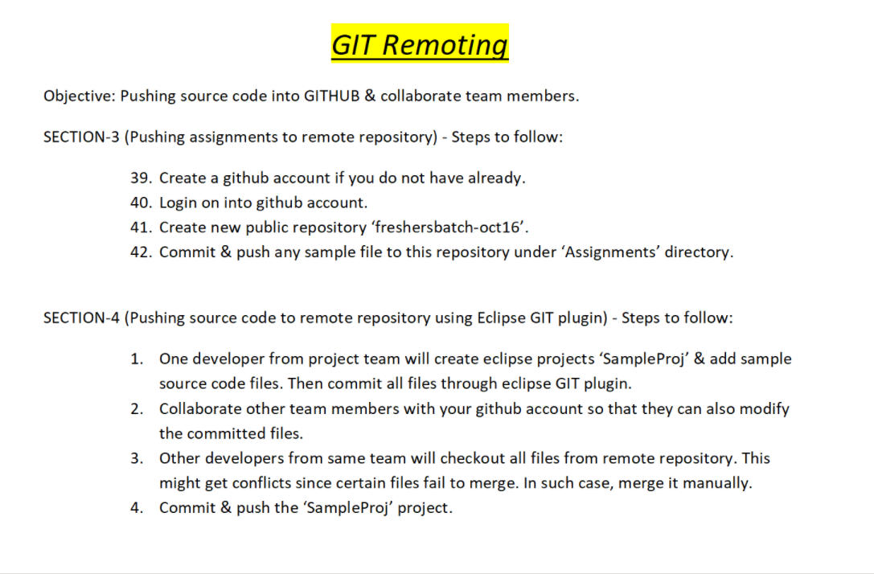

shiva@RYZEN-5 MINGW64 ~/desktop

$ mkdir section

shiva@RYZEN-5 MINGW64 ~/desktop

$ cd section

shiva@RYZEN-5 MINGW64 ~/desktop/section

$ git init

Initialized empty Git repository in C:/Users/shiva/Desktop/section/.git/

shiva@RYZEN-5 MINGW64 ~/desktop/section (master)

$ git remote

shiva@RYZEN-5 MINGW64 ~/desktop/section (master)

$ git remote add origin https://github.com/shivamttl/test2.git

shiva@RYZEN-5 MINGW64 ~/desktop/section (master)

$ touch news.txt

shiva@RYZEN-5 MINGW64 ~/desktop/section (master)

$ git add news.txt

shiva@RYZEN-5 MINGW64 ~/desktop/section (master)

$ git commit -m "new commit"

[master (root-commit) f8ff99a] new commit

1 file changed, 0 insertions(+), 0 deletions(-)

create mode 100644 news.txt

shiva@RYZEN-5 MINGW64 ~/desktop/section (master)

$ git push -u origin master

fatal: unable to access 'https://github.com/shivamttl/test2.git/': SSL certificate problem: unable to get local issuer certificate

shiva@RYZEN-5 MINGW64 ~/desktop/section (master)

$ git config --global user.email 'shivamttl@gmail.com'

shiva@RYZEN-5 MINGW64 ~/desktop/section (master)

$ git config --global user.name 'shivamttl'

shiva@RYZEN-5 MINGW64 ~/desktop/section (master)

$ git push -u origin master

fatal: unable to access 'https://github.com/shivamttl/test2.git/': SSL certificate problem: unable to get local issuer certificate

shiva@RYZEN-5 MINGW64 ~/desktop/section (master)

$ git push -u origin master

Enumerating objects: 3, done.

Counting objects: 100% (3/3), done.

Writing objects: 100% (3/3), 205 bytes | 205.00 KiB/s, done.

Total 3 (delta 0), reused 0 (delta 0), pack-reused 0

To https://github.com/shivamttl/test2.git

* [new branch] master -> master

Branch 'master' set up to track remote branch 'master' from 'origin'.

