Does the Goliath Agent push data to the Goliath Server?

**Question**: How does the Goliath Agent and GPM Server communicate? Does the Goliath Agent push data to the GPM server or does the GPM Server pull data from the agent? or Both?

**Answer**: The GPM Server tells the agents what to monitor and collect. For example, when the Goliath Agents initially connects to the GPM Server or if Monitoring Rules change, etc. The Goliath Agents run independently and push data to GPM.

# Can the agent be installed via SCCM?

Yes, the Goliath agent can indeed be installed via SCCM and other automation tools. Please reference article [Silent Agent Installation/Update](https://support.goliathtechnologies.com/hc/en-us/articles/360025012374) for full details.

# What machine name is display in inventory? Vmware VM name or Hostname?

**Question**: I am currently monitoring Vmware Hypervisor. When on the Configure>Inventory page of the technology, is the machine name displayed as it is in vCenter or is it the actual hostname of the machine?

Answer: Goliath will show the machine listed as it is in VMware. For example, if the machine name in Vmware is "PRD.TEST123" and the machines actual hostname if "TEST123", the machine will be listed in Goliath as "PRD.TEST123".

# Why is my Network Latency is blank in the Server Health Report?

**Question**: Why is my Network Latency is blank in the Server Health Report?

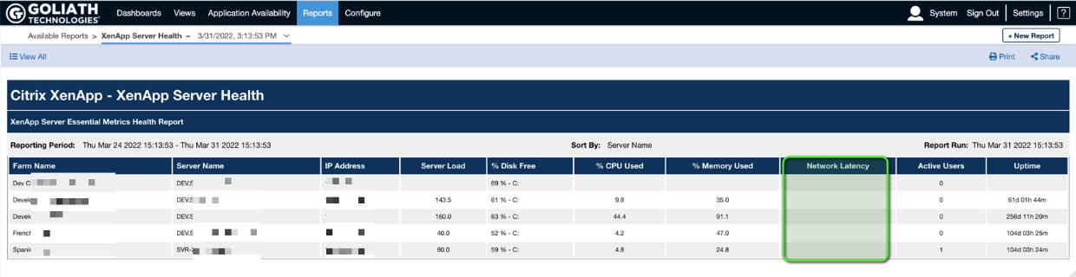

**Answer**: The XenApp Servers Network latency is determined by the response time of a ping check. In order for this metric to appear in the report you must have PING monitoring enabled on your XenApp Servers. See the article [PING Monitoring](https://support.goliathtechnologies.com/hc/en-us/articles/360045916854) for full instructions on how to configure.

# Why is ICA RTT or Network Latency data missing?

On the Citrix Virtual Apps and Desktops session drill drown, Goliath presents the metrics ICA RTT and Network Latency. When these charts are showing no data, this indicates the required end user metrics that are used to calculate activity were not available. This can be due to multiple issues:

* Citrix XenApp/XenDekstop 6.5 does not include End User Experience Metrics and therefore is not supported for the report. Citrix version 7.x or later is required.
* The Citrix Receiver/Workspace version does not support the required metrics, for example older versions of Citrix Receiver/Workspace
* Known issue with later versions of Citrix Workspace App for Mac do not include the end user experience metrics in some cases. This is a known issue that Citrix is aware of. From our experience with customers, we saw that versions 20.0 to 20.06 had issues that were resolved in version 20.07 and newer
* Known issue with versions of Citrix Workspace App for Android & Linux do not include the end user experience metrics in some cases. We recommend opening a ticket with Citrix as ICA RTT data will also be missing in Citrix Director.
* DCR is enabled or when Windows Server 2012 with Legacy Mode is being used.
* The Citrix End User Experience Monitoring Service can become stalled and should be restarted on the Citrix server.
* There was no activity inside the session (for example keyboard & mouse usage)

Why is my interaction time N/A?

The End User Productivity Report tracks end user activity within each session. When **% Interaction** and other values are displayed as N/A, this indicates the required end user metrics that are used to calculate activity were not available. This can be due to one or more of the following:

* Citrix XenApp/XenDekstop 6.5 does not include End User Experience Metrics and therefore is not supported for the report. Citrix version 7.x or later is required.
* The Citrix Receiver/Workspace version does not support the required metrics, for example older versions of Citrix Receiver/Workspace
* Known issue with later versions of Citrix Workspace App for Mac do not include the end user experience metrics in some cases. This is a known issue that Citrix is aware of. From our experience with customers, we saw that versions 20.0 to 20.06 had issues that were resolved in version 20.07 and newer
* Known issue with versions of Citrix Workspace App for Android & Linux do not include the end user experience metrics in some cases. We recommend opening a ticket with Citrix as ICA RTT data will also be missing in Citrix Director.
* DCR is enabled or when Windows Server 2012 with Legacy Mode is being used.
* The Citrix End User Experience Monitoring Service can become stalled and should be restarted on the Citrix server.
* There was no activity inside the session (for example keyboard & mouse usage)

How do I adjust end user activity collection in the End User Productivity Report?

Updated for GPM v11.9

There are three parameters available that you can use to adjust what and how often activity and inactivity is recorded for each session. The parameters are located within a configuration file on the GPM server.

The End User Productivity Report parameters and default values are:

* **XAXDProductivityReport_Threshold_BPS: 2048**  
  Threshold (bits per second) beneath which data must fall to be considered inactive.
* **XAXDProductivityReport_Threshold_VarianceBPS: 512**The range (bits per second) in which data must remain, while beneath the threshold, to be considered inactive
* **XAXDProductivityReport_Threshold_TimeMins: 10**Length of time (minutes) data must remain both below the threshold and within the variance range to be considered inactive.

With the default settings, session metrics that fall below 2kbps and stay within a range of 512bps for at least 10 minutes will be counted as inactivity. So the minimum inactivity time that will be counted is 10 minutes.

All data that falls outside those parameters would indicate user interaction.

**To adjust interaction calculations**

1. On the GPM server, go to the Bin folder within the install directory
   1. This can be**..\Program Files (x86)\MonitorIT\Bin**or **..\Program Files\MonitorIT\Bin**, depending on the Goliath version
2. Using a text editor, open the file **GPMServer.cfg**(for versions earlier than 11.9.x, use GPMSettings.cfg)
3. Change the parameters values and save the file. The next time the report runs, the new parameters will take effect.

What Goliath Server version am I running?

This article includes the steps to follow in order to determine what version of the Goliath Performance Monitor server is running in your environment.

1. Connect to the Goliath console
2. In the top right hand corner, click the **Settings** link
3. Once on the **Settings** page, you will see a section labeled **Licensing & Support**. In that section, click the link for **Version & License Count**
4. A pop-up box will appear listing the version of Goliath that is running
   1. 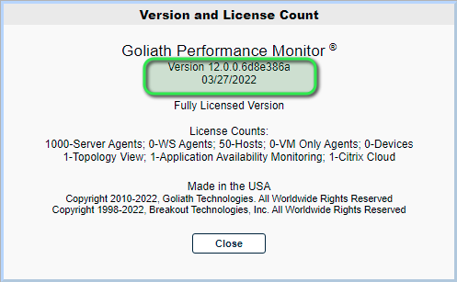

# How is interaction time determined in the End User Productivity Report?

To determine end user activity and inactivity, Goliath analyzes end user experience metrics and applies proprietary calculations to determine user interaction over the course of a session. The parameters used to determine interaction can be adjusted to better represent user's activity in each customer environment by modifying configuration file. For more information on making these adjustment, refer to the article, [How do I adjust end user activity collection](https://support.goliathtechnologies.com/hc/en-us/articles/360047660113).

Understanding interaction and inactivity is subject to each specific work environment. There may be cases where low activity and low % Interaction is expected because users may perform their work outside of the Citrix environment, or within the Citrix environment but with low interaction, (when participating in an online course, for example). In other cases, users may report high interaction, near 100%, because they do all of their work in a specific Citrix published application, (for example a support person working in Zendesk).

**Note:** When **% Interaction** and other values are displayed as N/A this indicates the required end user session metrics were not available for the session.

# Can Goliath Monitor Itself?

**Question**: Can Goliath monitoring Goliath and alert if it is not functioning properly or is down?

**Answer**: At this time, Goliath does not have the ability to monitor itself and send alerts if it is not functioning. However, the following key components can be monitored by other monitoring tools.

### 

### Processes to monitor:

* **RPMCCS.exe** - Default path is "C:\Program Files (x86)\MonitorIT" or "C:\Program Files\MonitorIT" on the Goliath Server, depending on the product version
* **RPMAgent.exe** - Default path is "C:\Program Files (x86)\MonitorIT" or "C:\Program Files\MonitorIT", depending on the product version, for the Goliath Server and monitored systems

### Windows Services to monitor:

* MonitorIT Server Service (MonitorITServer.exe)
* MonitorIT Agent Service (MonitorITAgent.exe)

**Database Connectivity:**

* Network connectivity between Goliath and the SQL Server
* Drive Space of the SQL Server DATA and LOG drive(s)

How to disable Citrix & VMware Server Application/Process Monitoring

While monitoring your Citrix Virtual Apps and Desktops (formerly XenApp & XenDesktop) or VMware Horizon environment(s), Goliath collects current application/process utilization. This is an intensive process and we have seen some customer environments that are not able to handle the load. This collection process can be disabled to improve agent performance/load on the affected machines. Refer to the steps below for instructions on disabling application and processes collection. Please note, the below steps are only applicable for Goliath Agents running v11.8.0 and newer.

**To disable application and process collection**

1. RDP to the Goliath Server.
2. Open Windows File Explorer and Navigate to the "Bin" folder within the Goliath Server install directory. The possible default locations are "C:\Program Files (x86)\MonitorIT\Bin" or "C:\Program Files\MonitorIT\Bin", depending on your Goliath version
3. Sort the folder by File Name in ascending order, near the top you will see a file named "AgentCollectionRates.txt" double click to open the file:   
   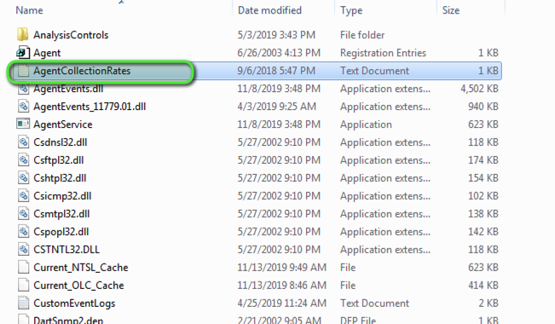
4. Once the file is opened, modify the fourth line "PROCESS_RATE:300" to: "PROCESS_RATE:2147483647".
   1. If there is another number listed besides "300", overwrite that number with "2147483647"
   2. 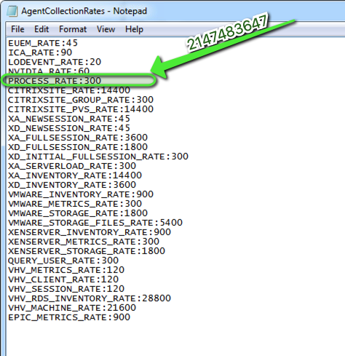
5. Once completed, save and close the file.

Please note, once disabling the metrics the collection will run once more and then stop. Collection will also run once after a MonitorIT Agent restart.

# Why did my Logon Duration time change?

# Issue

After a session is initially added and displayed within GPM's session view page, after a few minutes, the logon time changes.

# Explanation

When GPM first collects metrics from Citrix, if the logon time is not available, GPM will calculate the logon duration using logon event data and display this value. GPM will continue to retry to collect the data using its primary method, though, and when the data is available, the logon time will be updated for the session.

# Does the Goliath Agent continue to gather metrics when not connected to Goliath?

When the Goliath Agent is not connected to the Goliath Server, the Goliath Agent will stop collecting metrics. In the case where the Goliath Agent loses connectivity due to network issues or Goliath Server becomes unavailable for any reason, the Goliath Agent will immediately stop collecting and it will enter a cycle to repeatedly retry to reconnect  to the Goliath Server every 20 seconds. Once the Goliath Agent is reconnected and signed-in to the Goliath Server, it will then start collecting again.

# Why is my logon duration reported as 0 seconds?

In some cases, if the log on duration value is not returned (when querying the Citrix service via ODATA), the GPM interface will display 0 seconds as the value.

This can be misleading as the data is not available and is not in fact 0 seconds. On the next refresh when the data is available, it will be recorded and reported in the interface.

Why do i see no logon duration data?

There are multiple reasons why a session may not be reporting any logon duration data. The most common reasons are the following:

* If any stage or duration took less than .001ms, the measurement does not register a valid value.
* If a substage is not configured as part of log on duration then it will not be displayed.
* Reconnected sessions will not show all stages (because not all stages occur during a reconnect).

**Figure 1 - Example session with no log on duration data - "Summary" tab  
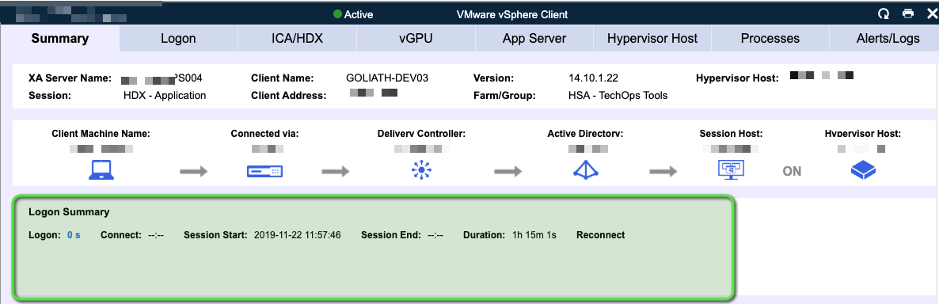**

**Figure 2 - Example session with no log on duration data - "Logon" tab**

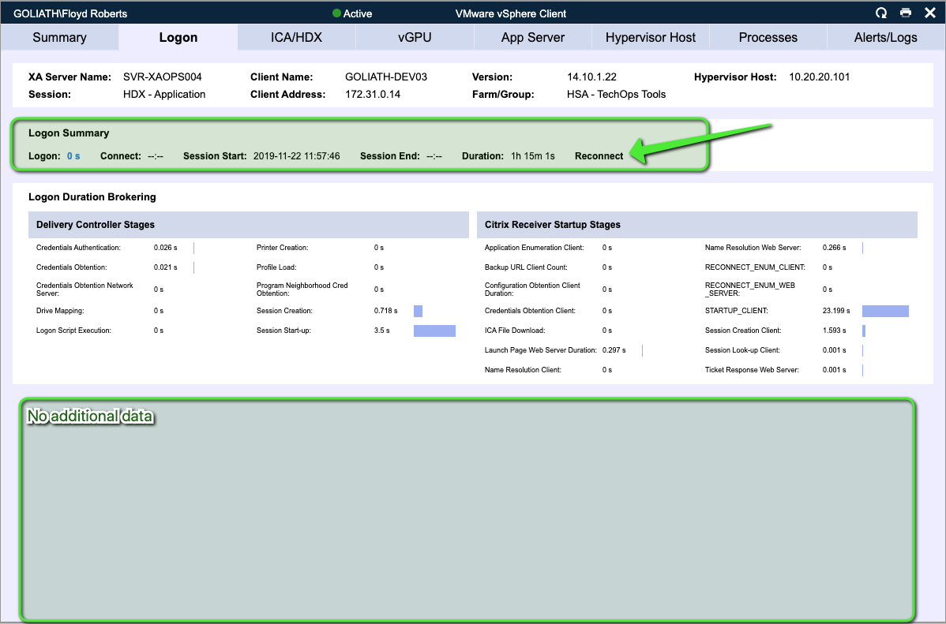

# Why am I getting logged out?

Goliath Performance Monitor refreshes many pages and dialogs automatically, but to refresh a  page manually, use the built-in Refresh option on the page (as seen at the top of the page in the example figure, below).

If you use the browser refresh option, you will be required to log back in to the application.

**Figure 1: Refresh option on the Views - Virtual Apps & Desktops page**   
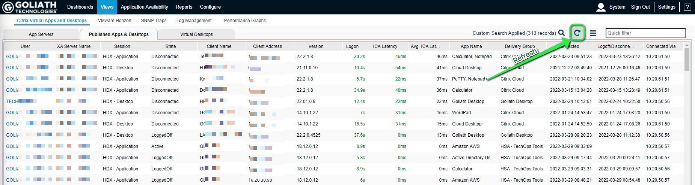

# VMware Horizon: Why am I not seeing RTT and BW in Apps & RDS Desktop session display?

Both Round Trip Time (RTT) and Bandwidth (B/W) are displayed for connected sessions, only. These metrics are not available to be displayed for historical sessions. This can be derived by reviewing the Status column to see if the session is CONNECTED or not. If the session is DISCONNECTED or LOGGED OFF the empty columns are expected.

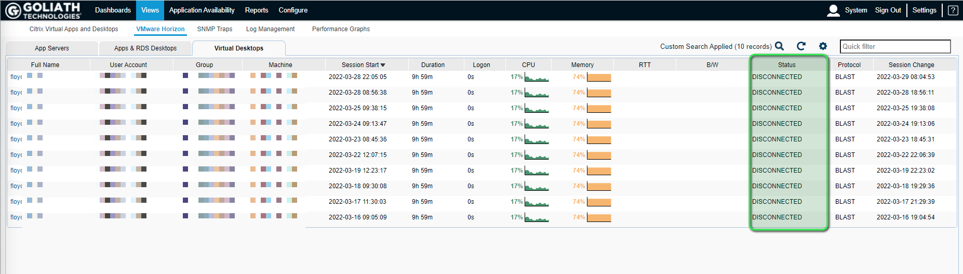

Why does my session have no data?

There are multiple reasons why a session may not be displaying any data. The most common reasons are:

* Limited user interaction during the session or a portion of time during the session causing flatline graph data.
* The Goliath Agent is either not connected or not installed.
* Minimum graph sizing is 1 hour, if a session is under an hour there may be partial graph lines only.
* The session was too short ( < 2 mins) to collect and reports Session RTT, Network Latency, Connection Speed).
* When a session is from a timeframe where the auto purge was run.

**Figure 1 - Session reporting no data  
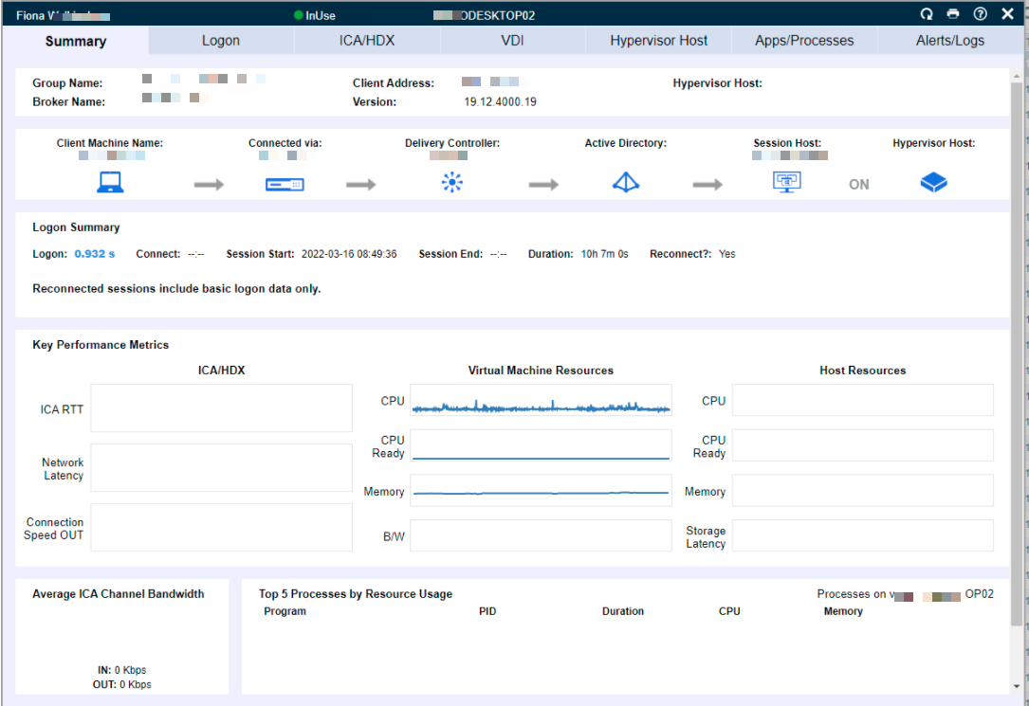**

**Figure 2 - Another example of a session reporting no data  
