Multi-Disease Prediction System with MLOps
A PROJECT REPORT
BY
Shivam Upadhyay (E23CSEU0944)


SUBMITTED TO
Dr. Naween Kumar
SCHOOL OF COMPUTER SCIENCE ENGINEERING AND TECHNOLOGY, BENNETT UNIVERSITY
GREATER NOIDA, 201310, UTTAR PRADESH, INDIA

April 2026

DECLARATION

I/We hereby declare that the work which is being presented in the report entitled “Multi-Disease Prediction System with MLOps”, is an authentic record of my/our own work carried out during the period from JAN 2026 to April 2026 at School of Computer Science and Engineering and Technology, Bennett University Greater Noida.
The matters and the results presented in this report has not been submitted by me/us for the award of any other degree elsewhere.

Signature of Candidate

Shivam upadhyay
(Enroll. No. E23CSEU0944)

TABLE OF CONTENTS

PROBLEM STATEMENT ............................................................................................................ iv
- INTRODUCTION ...................................................................................................................... 1
1.1. Problem Description ............................................................................................................. 1
- PROJECT OUTLINE ................................................................................................................. 3
- IMPLEMENTATION BACKGROUND.................................................................................... 4
- PROJECT DOCUMENTATION................................................................................................ 5
- Result and Discussions................................................................................................................ 10

iii

PROBLEM STATEMENT

The healthcare industry faces significant challenges in the early and accurate diagnosis of chronic diseases due to the sheer volume of patient data and the subtle nature of early-onset symptoms. Furthermore, a major gap exists between machine learning research and real-world clinical application; predictive models often fail to reach production due to complex deployment bottlenecks and a lack of scalable infrastructure. This project aims to bridge this gap by developing a robust,
iv

INTRODUCTION

The advent of artificial intelligence and machine learning (ML) has revolutionized healthcare analytics, offering unprecedented capabilities in predictive diagnostics. Chronic conditions such as diabetes, heart disease, and Parkinson's require early intervention to significantly improve patient survival rates and quality of life. This project presents a comprehensive, cloud-ready multi-disease prediction system designed to assist healthcare professionals in evaluating patient risk based on standard clinical parameters. By integrating modern ML classification algorithms with an intuitive web interface and automated backend pipelines, the system democratizes access to advanced, data-driven diagnostic tools

Problem Description
Currently, many predictive ML models developed for healthcare remain confined to local development environments (such as Jupyter Notebooks). They often focus on a single disease and lack the architectural framework required for real-world software integration. The core problem addressed in this project is twofold:

- Clinical Need: The necessity for a highly accurate, multi-faceted predictive tool capable of diagnosing several distinct chronic diseases from heterogeneous datasets simultaneously.

- Engineering Need: The requirement to establish a reliable DevOps/MLOps architecture—incorporating containerization and continuous integration/continuous deployment (CI/CD)—to transition these diagnostic models from local development scripts into a scalable, production-ready web application.

PROJECT OUTLINE
Purpose of the Project:
The primary purpose of this project is to develop an intelligent system that:
- Predicts the likelihood of multiple chronic diseases (Diabetes, Heart Disease, Parkinson's) based on clinical input parameters.
- Reduces dependency on purely manual, time-consuming diagnostic processes.
- Enhances clinical productivity and speeds up triage.
- Optimizes the deployment lifecycle of medical ML models using MLOps practices.
Motivation:
The motivation behind this project stems from:
- Challenges faced by medical professionals dealing with high patient volumes.
- The critical need for early detection in chronic conditions to improve survival rates.
- The lack of accessible, cloud-deployed technological solutions in standard diagnostic workflows. By integrating machine learning into healthcare infrastructure, this system aims to bridge the gap between predictive data science and clinical application.
Vision:
The vision of this project is to:
- Promote proactive and preventative healthcare.
- Improve diagnostic accuracy and patient outcomes.
- Enable healthcare providers to make informed, data-driven decisions.
- Create a scalable, automated solution usable across different medical facilities.

IMPLEMENTATION BACKGROUND
The system is built using a combination of modern technologies:
- Machine Learning Models: Multiple models such as Logistic Regression, Decision Tree, Random Forest, and Support Vector Machine (SVM) are trained and evaluated.
- Feature Engineering: Input features include vital clinical metrics (Glucose, BMI, Blood Pressure, Cholesterol, Age, and vocal frequency measurements for Parkinson's).
- Model Selection: The best-performing model for each specific disease is selected based on accuracy, precision, and recall metrics.
- Experiment Tracking: MLflow (or equivalent tracking) is used to monitor experiments, compare models, and manage versioning.
- Backend Development: FastAPI / Flask is used to create a high-performance API for real-time predictions.
- Frontend Interface: Streamlit provides an interactive UI for users to input patient data and view diagnostic recommendations.
- Containerization: Docker ensures consistent deployment across different computing environments.
- Cloud Deployment: AWS / Streamlit Cloud is used to host the application, making it accessible remotely.
- CI/CD Pipeline: GitHub Actions automates model testing, application deployment, and continuous updates

PROJECT DOCUMENTATION
The system follows a microservices architecture, divided into:
- Frontend (User Interface)
- Backend (API & Model Inference)
- ML Pipeline (Training, CI/CD & Tracking)
Workflow
- User inputs clinical and demographic parameters.
- Data is validated and sent to the backend API.
- The specific disease model processes the input.
- Predictions are generated.
- The diagnostic result and confidence probability are returned.
Backend Functionality
- Loads the trained model (.pkl) and data scaler.
- Accepts patient input through the API.
- Performs standard preprocessing and prediction.
- Returns the diagnostic risk assessment with probability scores.
Frontend Functionality
- Provides an intuitive input form tailored to each disease.
- Sends requests securely to the backend.
- Displays prediction results and risk alerts clearly.
Key Features
- Accurate multi-disease prediction.
- Real-time inference.
- User-friendly interface for non-technical clinical staff.
- Scalable and isolated deployment via Docker.
- Automated updates via CI/CD pipelines.

Results and Discussion
- Random Forest performed the best among all models across the datasets.
- High accuracy and recall were achieved, ensuring false negatives were minimized.
- Metrics such as Glucose (Diabetes), Chest Pain Type (Heart Disease), and MDVP:Fo (Parkinson's) were found to be the most influential features.
- The system successfully predicts disease presence with high confidence scores.
Glucose vs BMI Analysis (Diabetes)
- Explanation: This graph shows the relationship between Glucose levels and BMI for female patients.
- Conclusion: Distinct clusters indicate that higher combinations of BMI and Glucose strongly correlate with positive diabetes diagnoses, aiding model prediction.
Target Class Distribution
- Explanation: This graph represents the number of positive vs. negative samples available for each disease.
- Conclusion: The datasets were balanced (using techniques like SMOTE where necessary), ensuring unbiased model training and evaluation.
Cholesterol Level by Age (Heart Disease)
- Explanation: Boxplot showing the variation of serum cholesterol levels across different age brackets.
- Conclusion: Older demographics show different cholesterol risk baselines, making age combined with cholesterol a strong predictive feature.
Vocal Fundamental Frequency (MDVP:Fo) Analysis (Parkinson's)
- Explanation: Scatter plot showing the baseline vocal frequencies of patients.
- Conclusion: Patients with Parkinson's form distinct clusters showing restricted vocal frequency variations, highlighting the importance of biomedical voice measurements.
Blood Pressure Distribution
- Explanation: Distribution of resting blood pressure values across the patient datasets.
- Conclusion: Elevated blood pressure serves as a useful overlapping feature that contributes to both Heart Disease and Diabetes risk models.

WorkFlow Diagram
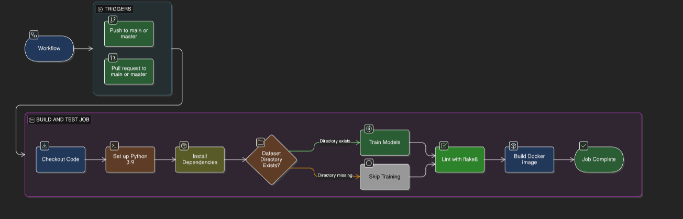

Model Accuracy Comparison
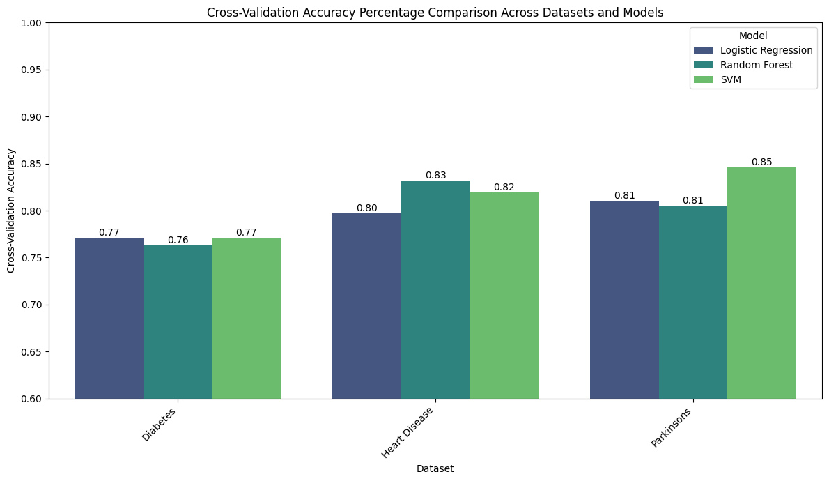
- Explanation: Comparison of different machine learning models (Logistic Regression, SVM, KNN, Random Forest).
- Conclusion: Random Forest achieved the highest overall accuracy (above 88% on average) and was selected as the final production model.

Confusion Matrix

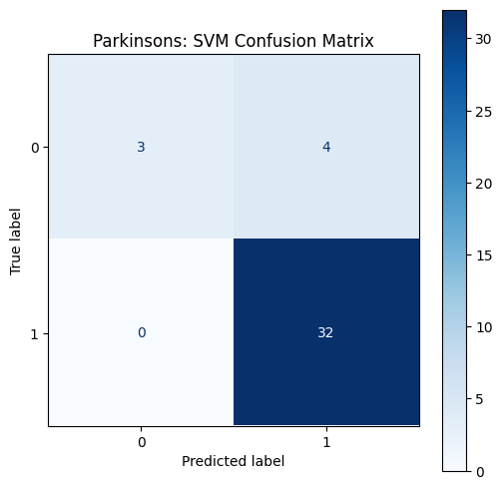
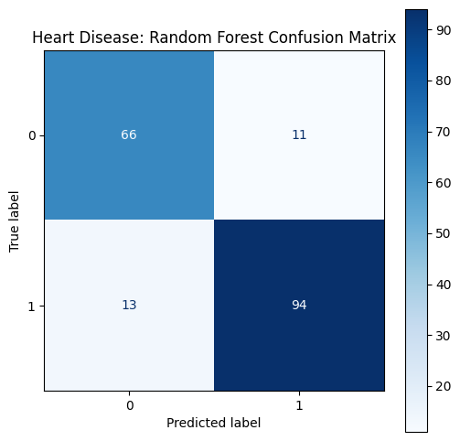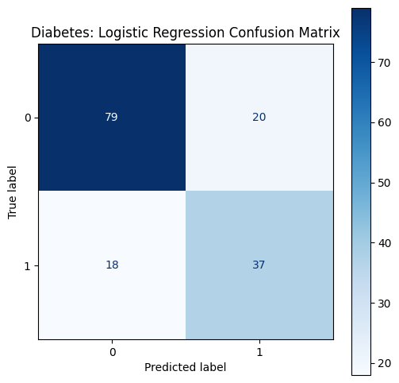
- Explanation: Matrix showing predicted vs actual diagnostic values for the test sets.
- Conclusion: High diagonal values indicate excellent model performance with minimal classification errors, specifically maintaining a low rate of false negatives.

Feature Importance
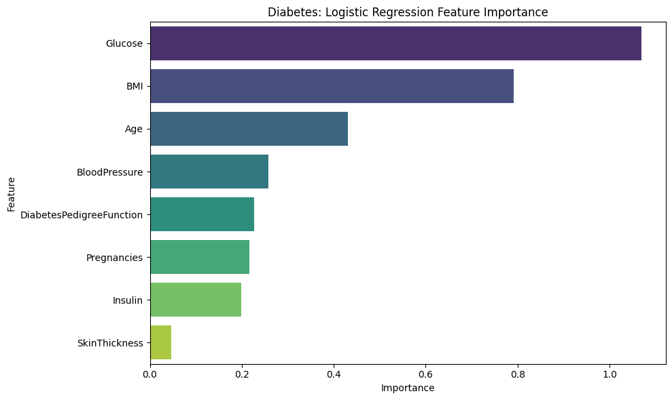
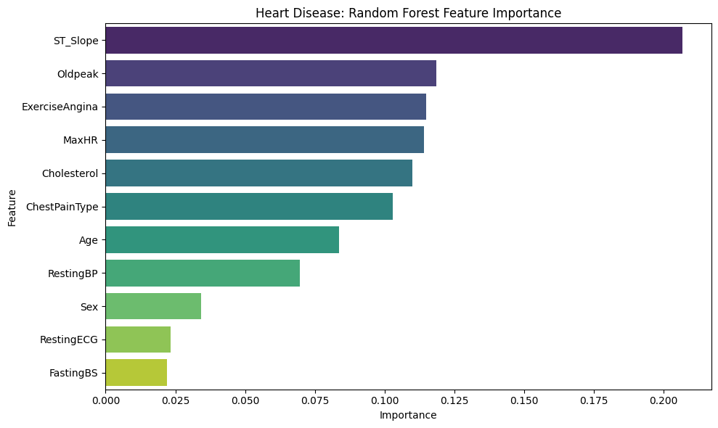
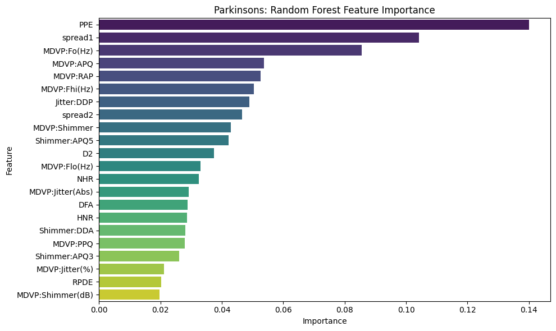

- Explanation: Shows the statistical importance of individual clinical input features.
- Conclusion: Glucose and Age are the most influential for Diabetes; Chest Pain Type and Max Heart Rate for Heart Disease; and Shimmer/Jitter for Parkinson's.

Conclusion

The Multi-Disease Prediction System demonstrates how machine learning can significantly improve clinical decision-making. By analyzing diverse physiological and environmental parameters, the system provides accurate and reliable diagnostic risk assessments, reducing uncertainty and improving patient triage times. The integration of MLOps ensures scalability, maintainability, and real-world applicability. This project highlights the massive potential of combining AI and DevOps engineering to create sustainable and efficient healthcare solutions.

Future Scope
- Integration with Electronic Health Records (EHR) via real-time APIs (e.g., FHIR).
- Mobile application dedicated to patient self-assessment.
- Advanced data privacy implementations (HIPAA compliance and encryption).
- Expansion to include deep learning models for medical imaging (X-Rays, MRIs).
- Automated model retraining loops based on live clinical feedback (Active Learning).

.

