This UI/UX is final
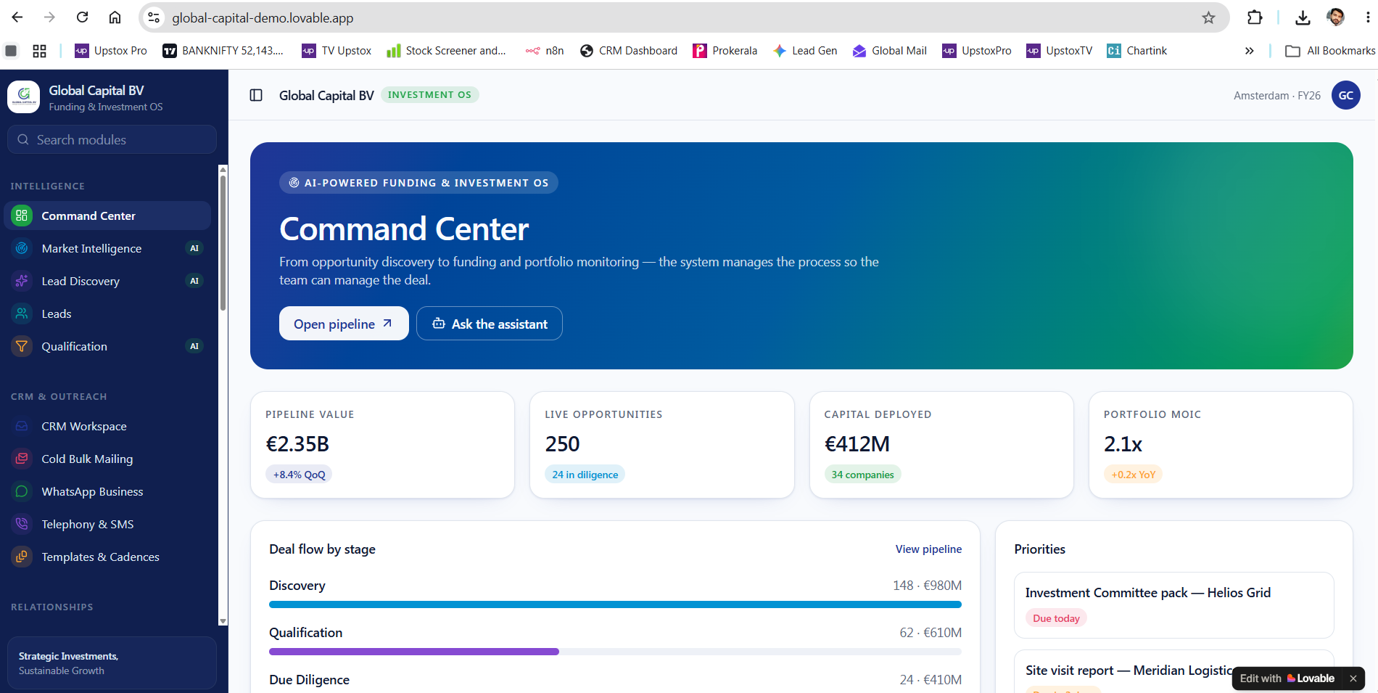

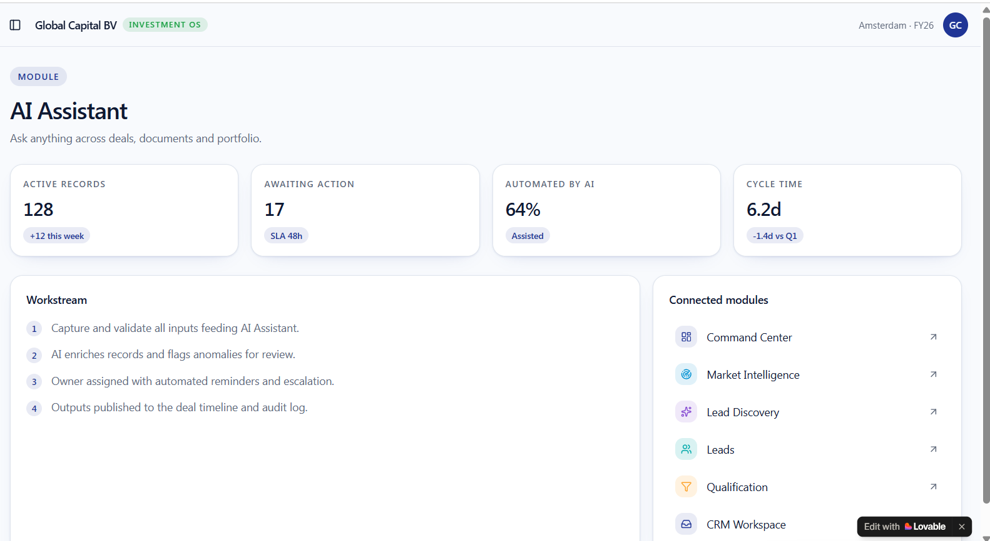
Only the query or chat window is expected her to ask the questions along with sample questions

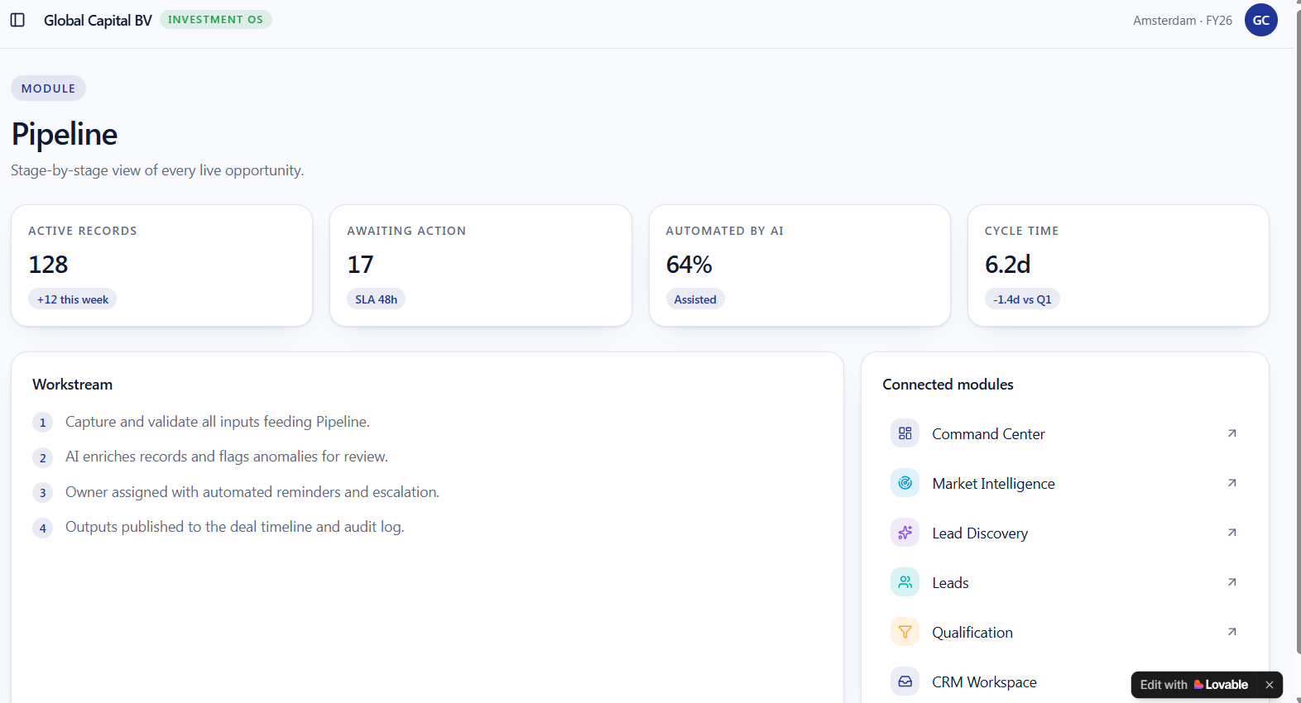

Leads Contacted -> Interest Shown -> NDA Signed -> Zoom 1 Done -> IOI Signed -> Zoom2 -> Visits Planned -> Term Sheet Signed -> Funding Deployed

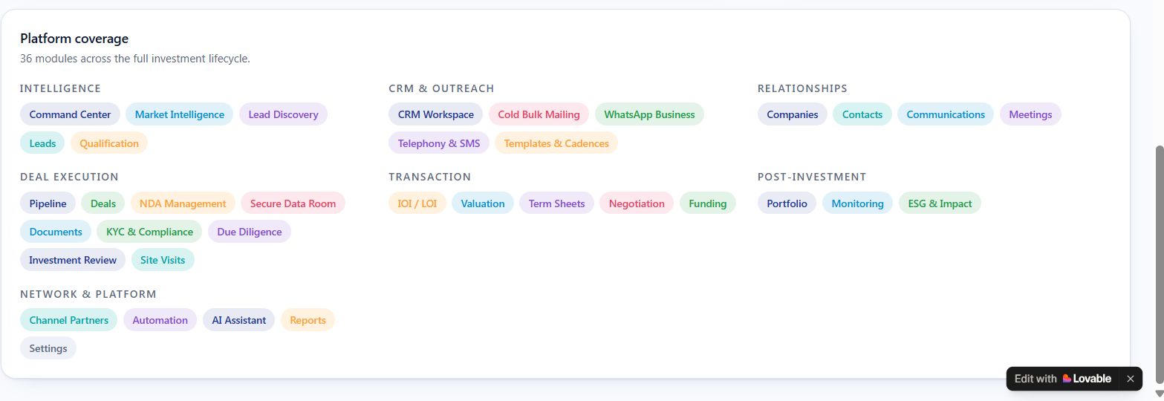
Remove this Platform

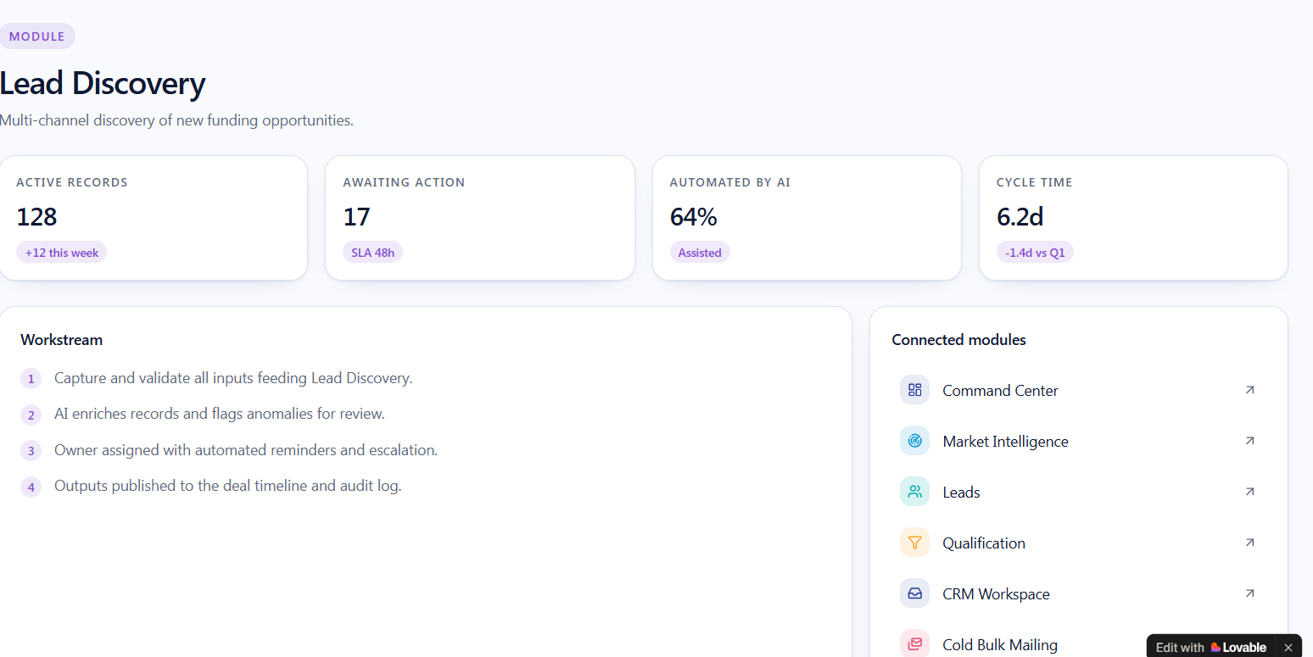
All the Logos of Data Tools will be displayed here
Once any one clicks on any logo then data filtering options will appear
Extract Data File

Remove Modules:
Leads
Qualification

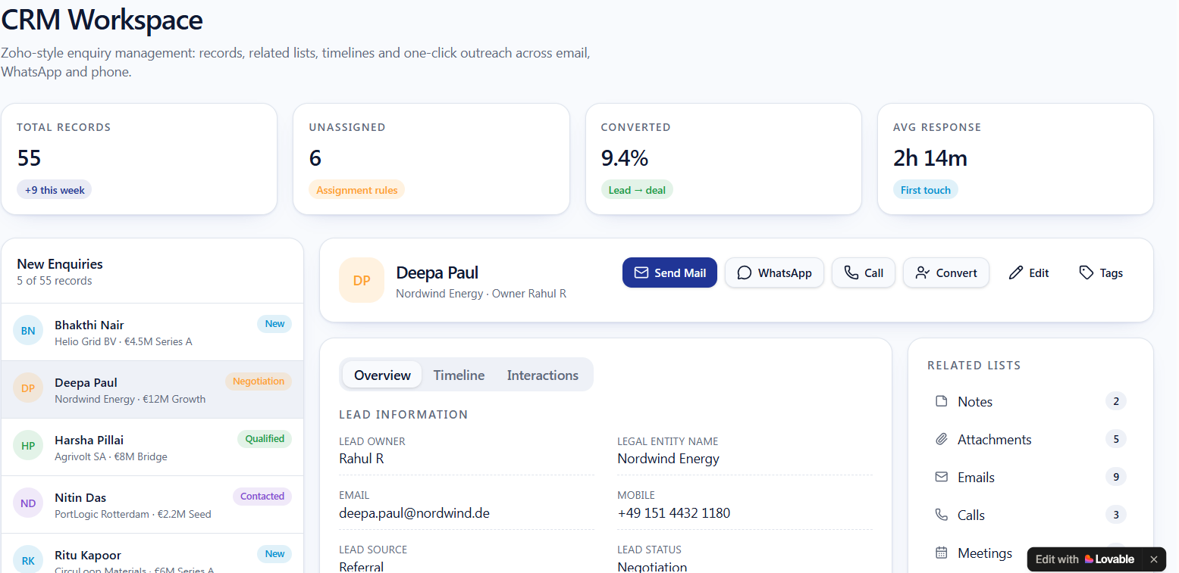
Graphs of Email Marketing & Whats App Marketing , New enquiries on Left BAR
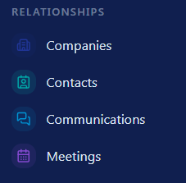
Remove this entire

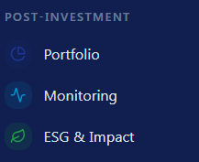
Remove this entire

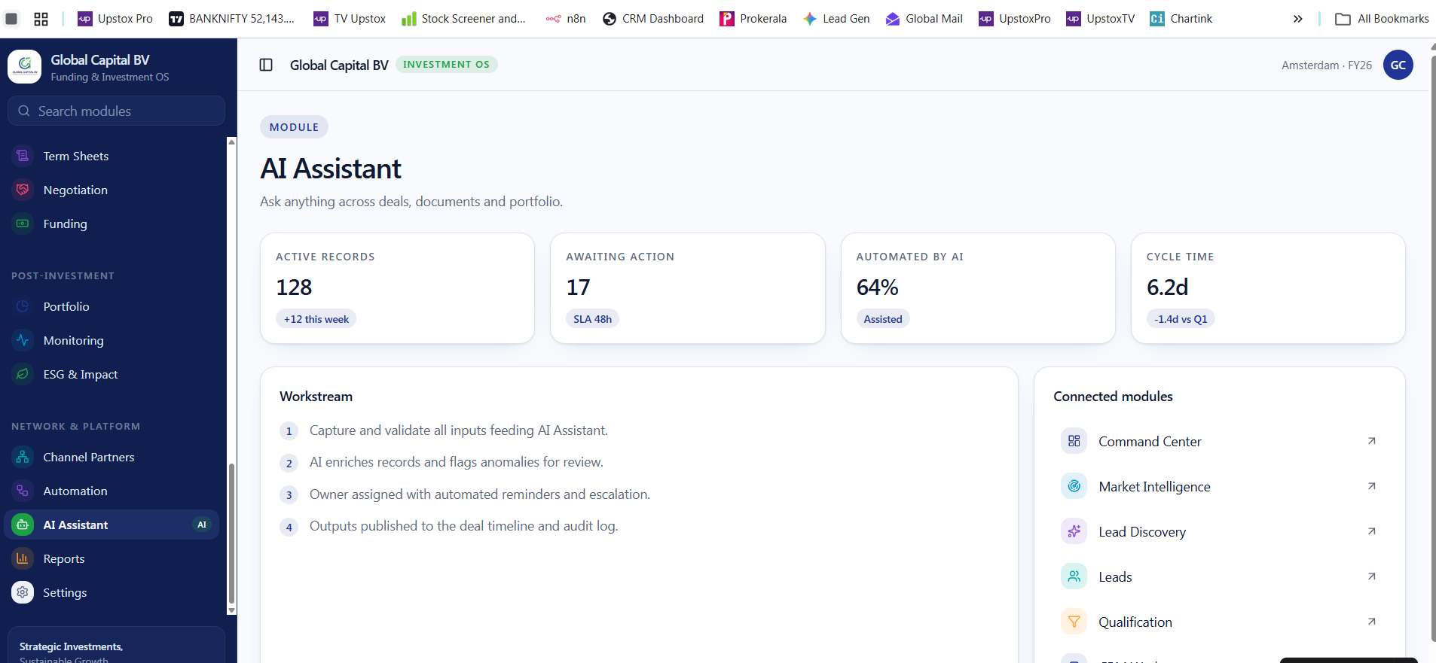
Remove AI Assistance

