EXPERIMENT 01
Create a Basic HTML Webpage

Aim
To write the basic HTML5 document structure and implement all six heading tags (<h1> to <h6>) with sample text.

Source Code
<!DOCTYPE html>
<html>
<head>
<title>2610997065 - Practical 1</title>
</head>
<body>
<h1>This is Heading 1</h1>
<h2>This is Heading 2</h2>
<h3>This is Heading 3</h3>
<h4>This is Heading 4</h4>
<h5>This is Heading 5</h5>
<h6>This is Heading 6</h6>
</body>
</html>

Output
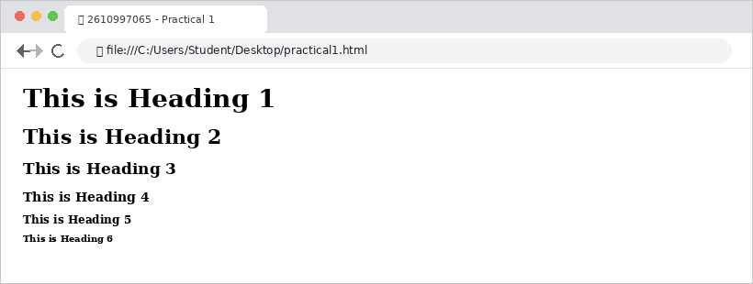

Result
The HTML page was created successfully, and all six heading levels were properly displayed in the browser.

EXPERIMENT 02
Paragraph and Text Formatting

Aim
To implement paragraphs and various text formatting tags such as bold, strong, underline, italic, and emphasis.

Source Code
<!DOCTYPE html>
<html>
<head>
<title>2610997065 - Practical 2</title>
</head>
<body>
<p>This is a simple paragraph to show text formatting.</p>
<p>This text is <b>bold</b> and this text is <strong>strongly important</strong>.</p>
<p>This text is <u>underlined</u> and this text is <i>italicized</i>.</p>
<p>This text has <em>emphasis</em> applied to it.</p>
</body>
</html>

Output
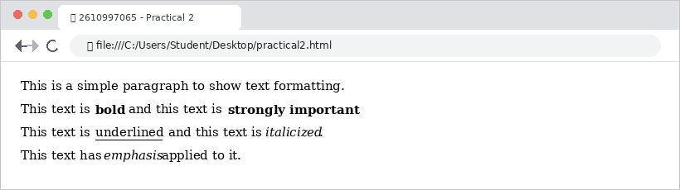

Result
The HTML page was created successfully, and paragraph text with different formatting styles was properly displayed in the browser.

EXPERIMENT 03
Recipe Ingredients and Steps

Aim
To create ordered and unordered lists in HTML by implementing a recipe with ingredients and preparation steps.

Source Code
<!DOCTYPE html>
<html>
<head>
<title>2610997065 - Practical 3</title>
</head>
<body>
<h2>Tea Recipe</h2>
<h3>Ingredients (Unordered List):</h3>
<ul>
<li>Water</li>
<li>Milk</li>
<li>Tea leaves</li>
<li>Sugar</li>
</ul>
<h3>Steps to Prepare (Ordered List):</h3>
<ol>
<li>Boil water in a pan.</li>
<li>Add tea leaves and sugar.</li>
<li>Add milk and boil for 2 minutes.</li>
<li>Strain into a cup and serve hot.</li>
</ol>
</body>
</html>

Output
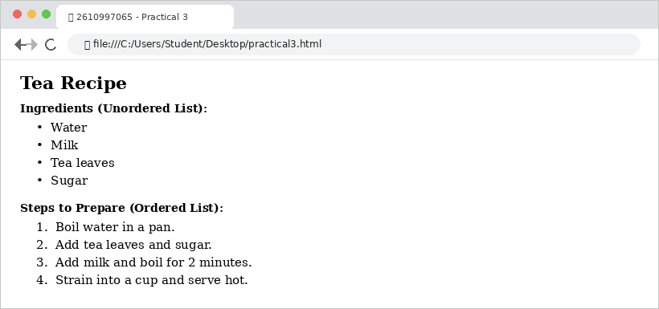

Result
The HTML page was created successfully, and both unordered and ordered lists were properly displayed in the browser.

EXPERIMENT 04
Nested Book Hierarchy

Aim
To implement nested lists in HTML by creating a hierarchical book categorization using combined ordered and unordered lists.

Source Code
<!DOCTYPE html>
<html>
<head>
<title>2610997065 - Practical 4</title>
</head>
<body>
<h2>Book Hierarchy</h2>
<ul>
<li>Science
<ul>
<li>Physics Part 1
<ol>
<li>Motion</li>
<li>Force and Gravity</li>
</ol>
</li>
<li>Chemistry Part 1
<ol>
<li>Matter and Atoms</li>
<li>Chemical Reactions</li>
</ol>
</li>
</ul>
</li>
<li>Mathematics
<ul>
<li>Algebra Basics
<ol>
<li>Linear Equations</li>
<li>Polynomials</li>
</ol>
</li>
</ul>
</li>
</ul>
</body>
</html>

Output
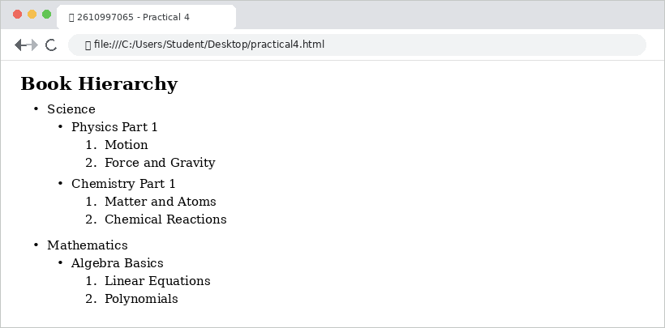

Result
The HTML page was created successfully, and the nested list structure was properly displayed in the browser.

EXPERIMENT 05
Image with Attributes

Aim
To embed an image in an HTML webpage and utilize various image attributes such as source, alt text, width, height, and title.

Source Code
<!DOCTYPE html>
<html>
<head>
<title>2610997065 - Practical 5</title>
</head>
<body>
<h2>Image Example</h2>
<img src="flower.jpg" alt="A beautiful sunflower in the sky" width="400" height="200" title="Sunflower Image">
</body>
</html>

Output
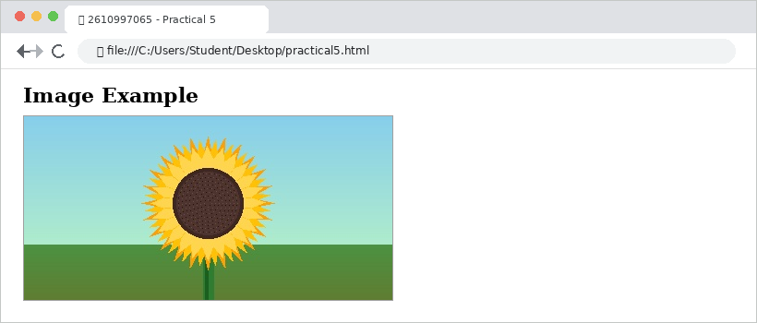

Result
The HTML page was created successfully, and the specified image along with its attributes was properly displayed in the browser.

EXPERIMENT 06
Background Image in Body

Aim
To set a background image for an HTML webpage using the background attribute within the body tag.

Source Code
<!DOCTYPE html>
<html>
<head>
<title>2610997065 - Practical 6</title>
</head>
<body background="background.jpg">
<h2>Webpage with Background Image</h2>
<p>This page has a background image set directly in the body tag.</p>
<p>Notice how the image repeats automatically across the page.</p>
</body>
</html>

Output
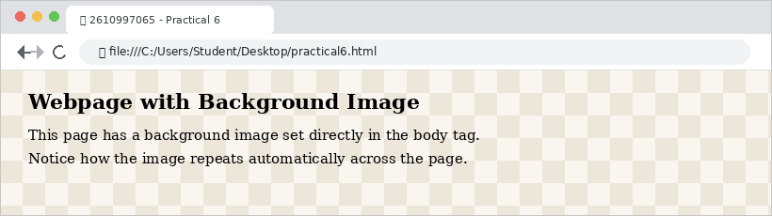

Result
The HTML page was created successfully, and the background image was properly displayed and repeated across the browser window.

EXPERIMENT 07
Internal and External Links

Aim
To create hyperlinks in an HTML document, including internal navigation links using IDs and an external link opening in a new tab.

Source Code
<!DOCTYPE html>
<html>
<head>
<title>2610997065 - Practical 7</title>
</head>
<body>
<h2>Internal and External Links</h2>
<!-- Navigation Links -->
<p><a href="#sec1">Go to Section 1</a></p>
<p><a href="#sec2">Go to Section 2</a></p>
<p><a href="https://chitkara.edu.in" target="_blank">Visit University Website</a></p>
<!-- Sections -->
<h3 id="sec1">Section 1</h3>
<p>This is the first section of the page.</p>
<h3 id="sec2">Section 2</h3>
<p>This is the second section of the page.</p>
</body>
</html>

Output
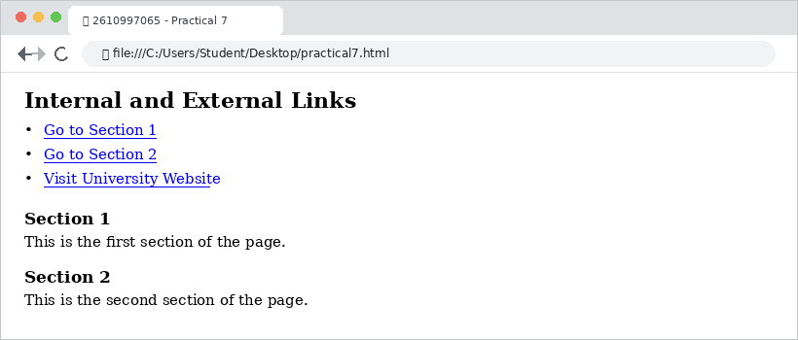

Result
The HTML page was created successfully, and both internal page anchors and external web links functioned and displayed properly in the browser.

EXPERIMENT 08
Image Map with Clickable Regions

Aim
To design an HTML webpage with an interactive image map containing clickable regions using the <map> and <area> tags.

Source Code
<!DOCTYPE html>
<html>
<head>
<title>2610997065 - Practical 8</title>
</head>
<body>
<h2>Interactive Image Map of India</h2>
<img src="india_map.jpg" width="520" height="420" usemap="#map">
<map name="map">
<area shape="circle" coords="150,59,18"
href="https://en.wikipedia.org/wiki/Jammu_and_Kashmir"
alt="Jammu and Kashmir">
<area shape="circle" coords="159,93,16"
href="https://en.wikipedia.org/wiki/Punjab,_India"
alt="Punjab">
<area shape="circle" coords="186,79,16"
href="https://en.wikipedia.org/wiki/Himachal_Pradesh"
alt="Himachal Pradesh">
<area shape="circle" coords="140,146,28"
href="https://en.wikipedia.org/wiki/Rajasthan"
alt="Rajasthan">
<area shape="circle" coords="231,142,26"
href="https://en.wikipedia.org/wiki/Uttar_Pradesh"
alt="Uttar Pradesh">
<area shape="circle" coords="112,201,24"
href="https://en.wikipedia.org/wiki/Gujarat"
alt="Gujarat">
<area shape="circle" coords="170,247,26"
href="https://en.wikipedia.org/wiki/Maharashtra"
alt="Maharashtra">
</map>
</body>
</html>

Output
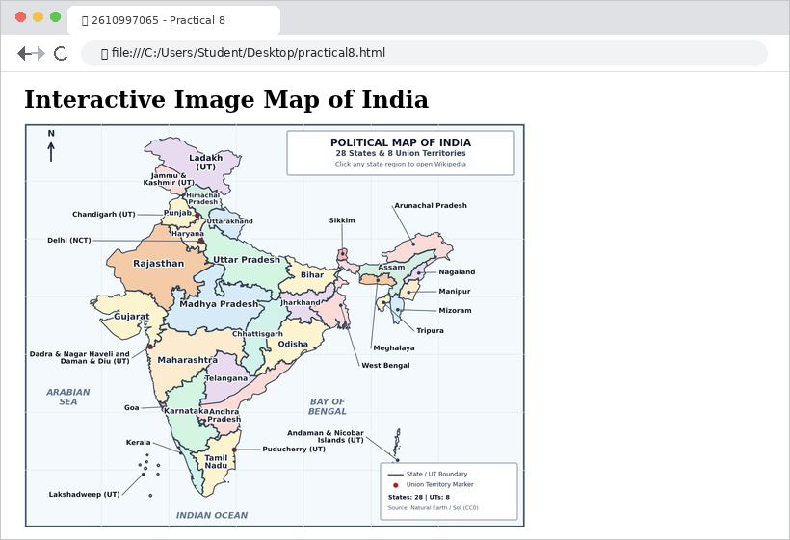

Result
The HTML page was created successfully, and the interactive image map with clickable state regions was properly displayed in the browser.

EXPERIMENT 09
Student Marksheet Table

Aim
To build a student marksheet table in HTML using table tags (<table>, <tr>, <th>, and <td>) and table formatting attributes.

Source Code
<!DOCTYPE html>
<html>
<head>
<title>2610997065 - Practical 9</title>
</head>
<body>
<table border="1" bordercolor="blue" align="center"
cellspacing="5" cellpadding="10">
<tr>
<th>SR. No.</th>
<th>Student Roll No.</th>
<th>Student Name</th>
<th>Subjects</th>
<th>Student Marks</th>
</tr>
<tr>
<td>1</td><td>7065</td><td>Aarav</td>
<td>Maths</td><td>94</td>
</tr>
<tr>
<td>2</td><td>7066</td><td>Diya</td>
<td>Maths</td><td>89</td>
</tr>
<tr>
<td>3</td><td>7067</td><td>Kabir</td>
<td>Maths</td><td>92</td>
</tr>
<tr>
<td>4</td><td>7068</td><td>Meera</td>
<td>Maths</td><td>85</td>
</tr>
<tr>
<td>5</td><td>7069</td><td>Rohan</td>
<td>Maths</td><td>97</td>
</tr>
</table>
</body>
</html>

Output
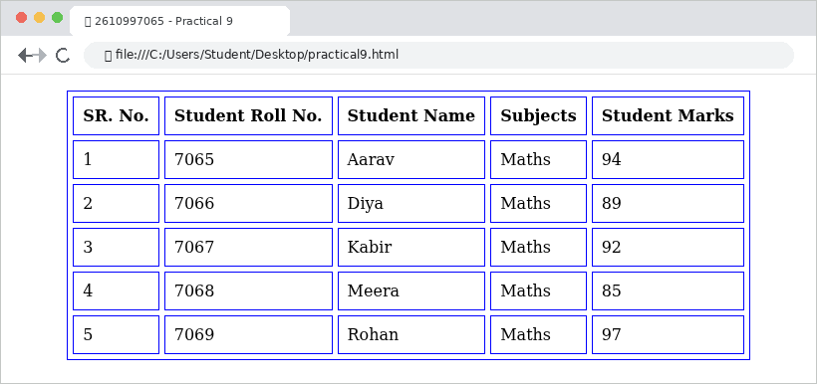

Result
The HTML page was created successfully, and the student marksheet table was properly formatted and displayed in the browser.

EXPERIMENT 10
Nested Table Layout

Aim
To create a nested table in HTML by embedding an inner table inside a cell of an outer table.

Source Code
<!DOCTYPE html>
<html>
<head>
<title>2610997065 - Practical 10</title>
</head>
<body>
<table border="1" align="center" cellspacing="4" cellpadding="7">
<tr><td colspan="2" align="center"><b>MY DAY</b></td></tr>
<tr>
<td>1. Wake up early
<ul type="circle"><li>6:00 AM</li></ul>
- Morning walk<br>- Yoga &amp; Jogging</td>
<td rowspan="3">
<table border="1" align="center" cellpadding="6">
<tr><td colspan="2" align="center">
<b>Things to Watch</b></td></tr>
<tr>
<td><img src="thumb1.png" width="90"></td>
<td><img src="thumb2.png" width="90"></td>
</tr>
<tr>
<td><img src="thumb3.png" width="90"></td>
<td><img src="thumb4.png" width="90"></td>
</tr>
</table>
</td>
</tr>
<tr><td>2. Breakfast
<ul type="square"><li>8:00 AM</li></ul>
- Oats &amp; Toast<br>- Fresh Juice</td></tr>
<tr><td>3. Go to Chitkara University
<ul type="square"><li>9:00 AM</li></ul>
- Attend BCA Lectures<br>- Web Designing Lab</td></tr>
</table>
</body>
</html>

Output
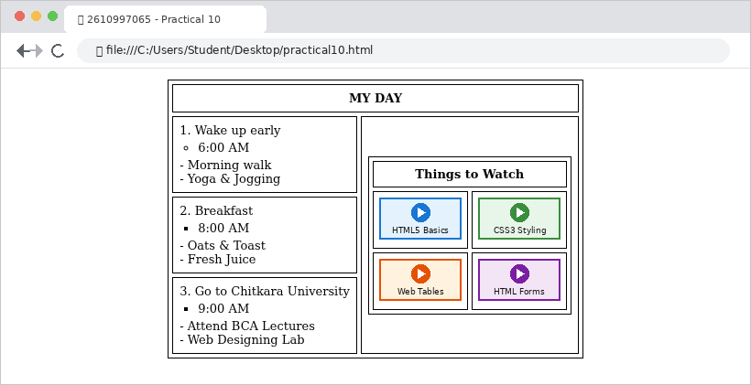

Result
The HTML page was created successfully, and the nested table structure was properly displayed in the browser.

EXPERIMENT 11
Table Using Colspan and Rowspan

Aim
To design a weekly class timetable in HTML demonstrating the use of colspan and rowspan attributes.

Source Code
<!DOCTYPE html>
<html>
<head>
<title>2610997065 - Practical 11</title>
</head>
<body>
<table border="1" bordercolor="pink" align="center"
cellspacing="4" cellpadding="6">
<tr>
<th>Day</th><th>1 (9:00)</th><th>2 (9:55)</th>
<th>3<br>10:50-11:45</th><th>4<br>11:45-12:40</th>
<th>5<br>12:40-1:35</th><th>6<br>1:35-2:30</th>
<th>7<br>2:30-3:25</th>
</tr>
<tr>
<th>Monday</th><td>Stat. Maths</td><td>PC (HS)</td>
<td colspan="2" bgcolor="pink">UIDW - Lab (TG-518)</td>
<th rowspan="5" bgcolor="pink">L<br>U<br>N<br>C<br>H</th>
<td>Basic - CS</td><td>Library</td>
</tr>
<tr>
<th>Tuesday</th>
<td colspan="2" bgcolor="pink">UIDW - Lab (TG-518)</td>
<td>PC (HS)</td><td>Stat. Maths</td>
<td colspan="2">PC - Lab (DM-212)</td>
</tr>
<tr>
<th>Wednesday</th><td>Basic - CS</td><td>Stat. Maths</td>
<td colspan="2">Basic-CS - Lab (DM-212)</td>
<td>PC (HS)</td><td>Sports</td>
</tr>
<tr>
<th>Thursday</th>
<td colspan="2" bgcolor="pink">UIDW - Lab (TG-518)</td>
<td>PC (HS)</td><td>Basic - CS</td>
<td colspan="2">PC - Lab (DM-211)</td>
</tr>
<tr>
<th>Friday</th><td>Stat. Maths</td><td>Basic - CS</td>
<td>PC (HS)</td><td>Seminar</td>
<td colspan="2" bgcolor="pink">UIDW - Lab (TG-518)</td>
</tr>
</table>
</body>
</html>

Output
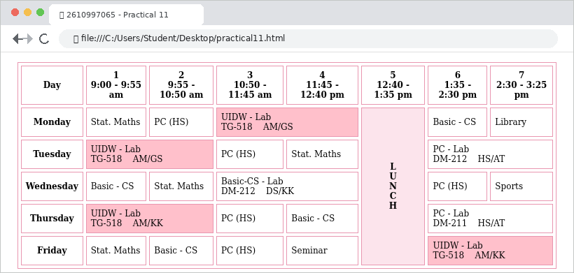

Result
The HTML page was created successfully, and the timetable utilizing colspan and rowspan attributes was properly displayed in the browser.

EXPERIMENT 12
Registration Form Using GET Method

Aim
To build a student registration form in HTML using the GET method and standard form input controls.

Source Code
<!DOCTYPE html>
<html>
<head>
<title>2610997065 - Practical 12</title>
<style>body { background-color: pink; }
h3 { text-align: center; text-decoration: underline; }</style>
</head>
<body>
<h3>STUDENT REGISTRATION FORM</h3>
<form action="register.html" method="get">
<table>
<tr><td>FIRST NAME</td><td><input type="text"></td></tr>
<tr><td>EMAIL ID</td><td><input type="email"></td></tr>
<tr><td>MOBILE NUMBER</td><td><input type="tel"></td></tr>
<tr><td>GENDER</td><td>Male <input type="radio" name="g">
Female <input type="radio" name="g"></td></tr>
<tr><td>ADDRESS</td><td><textarea></textarea></td></tr>
<tr><td>CITY</td><td><input type="text"></td></tr>
<tr><td>PIN CODE</td><td><input type="text"></td></tr>
<tr><td>STATE</td><td><input type="text"></td></tr>
<tr><td>COUNTRY</td><td><input value="India"></td></tr>
<tr><td>HOBBIES</td><td>Drawing <input type="checkbox">
Singing <input type="checkbox">
Dancing <input type="checkbox"></td></tr>
<tr><td>QUALIFICATION</td><td>
<table>
<tr><th>Sl.No</th><th>Exam</th><th>Board</th></tr>
<tr><td>1</td><td>Class X</td><td><input></td></tr>
<tr><td>2</td><td>Class XII</td><td><input></td></tr>
<tr><td>3</td><td>Graduation</td><td><input></td></tr>
</table></td></tr>
<tr><td>COURSES APPLIED</td><td>BCA <input type="radio">
B.Com <input type="radio"> B.Sc <input type="radio">
B.A <input type="radio"></td></tr>
<tr><td colspan="2" align="center">
<input type="submit" value="Submit">
<input type="reset" value="Reset"></td></tr>
</table>
</form>
</body>
</html>

Output
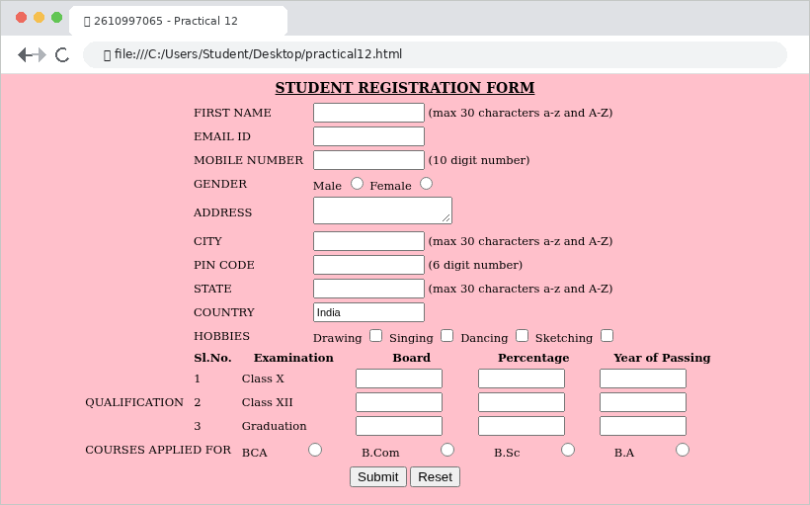

Result
The HTML page was created successfully, and the student registration form using the GET method was properly displayed in the browser.

EXPERIMENT 13
Feedback Form Using POST Method

Aim
To build a product feedback form in HTML using the POST method, fieldset, progress bars, and rating controls.

Source Code
<!DOCTYPE html>
<html>
<head>
<title>2610997065 - Practical 13</title>
</head>
<body bgcolor="lightyellow">
<form action="submit.php" method="post">
<fieldset>
<legend align="center">
<b>TECH WORLD FEEDBACK FORM</b>
</legend>
<table align="center" cellpadding="4">
<tr><td>Name</td><td><input type="text"></td>
<td>Email</td><td><input type="email"></td></tr>
<tr><td>Address</td><td><input type="text"></td>
<td>Postcode</td><td><input type="text"></td></tr>
</table>
<table border="1" align="center" cellpadding="4">
<tr><th>Product</th><th>Product Image</th>
<th>Progress Bar</th><th>Unit Price</th>
<th>Ratings</th></tr>
<tr><td>Laptop</td><td><img src="laptop.png"></td>
<td><progress value="50" max="100"></progress></td>
<td>$900</td><td>****</td></tr>
<tr><td>Keyboard</td><td><img src="keyboard.png"></td>
<td><progress value="75" max="100"></progress></td>
<td>$100</td><td>*****</td></tr>
<tr><td>Mouse</td><td><img src="mouse.png"></td>
<td><progress value="20" max="100"></progress></td>
<td>$55</td><td>*</td></tr>
<tr><td>Powerbank</td><td><img src="pbank.png"></td>
<td><progress value="90" max="100"></progress></td>
<td>$289</td><td>*****</td></tr>
</table>
<p>COMMENT: <textarea rows="2" cols="28"></textarea>
<button type="submit">SUBMIT</button></p>
</fieldset>
</form>
</body>
</html>

Output
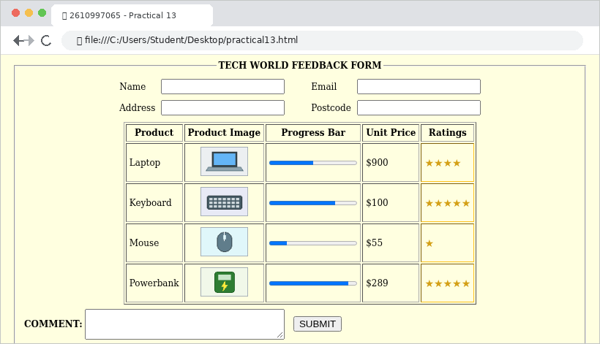

Result
The HTML page was created successfully, and the product feedback form using the POST method was properly displayed in the browser.

EXPERIMENT 14
Comparison of GET and POST Forms

Aim
To compare the GET and POST form methods in HTML and demonstrate working examples of both form submission methods.

Source Code
<!DOCTYPE html>
<html>
<head>
<title>2610997065 - Practical 14</title>
</head>
<body>
<h3 align="center">Comparison Between GET and POST Forms</h3>
<table border="1" align="center" cellspacing="0" cellpadding="6">
<tr><th>FEATURE</th><th>GET FORMS</th><th>POST FORMS</th></tr>
<tr><td>Data Sent</td><td>Appended to URL query string</td>
<td>Sent inside HTTP request body</td></tr>
<tr><td>URL Visibility</td><td>Data is visible in the URL</td>
<td>Data is not shown in the URL</td></tr>
<tr><td>Security</td><td>Less suitable for sensitive data</td>
<td>More secure for sensitive data</td></tr>
<tr><td>Data Size</td><td>Limited by maximum URL length</td>
<td>Can send much larger amounts of data</td></tr>
<tr><td>Typical Use</td><td>Searching and filtering data</td>
<td>Login, registration, uploading data</td></tr>
</table>
<table width="90%" align="center" cellspacing="8" cellpadding="6">
<tr>
<td><b>Example of GET Form (Search):</b>
<form action="search.html" method="get">
Course: <input type="text" name="q"><br>
Semester: <input type="text" name="sem">
<input type="submit" value="Search (GET)">
</form>
</td>
<td><b>Example of POST Form (Login):</b>
<form action="login.php" method="post">
Student ID: <input type="text" name="id"><br>
Password: <input type="password" name="pwd">
<input type="submit" value="Login (POST)">
</form>
</td>
</tr>
</table>
</body>
</html>

Output
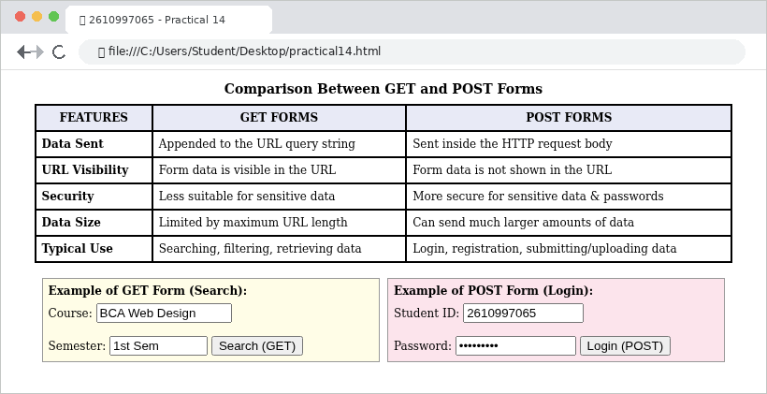

Result
The HTML page was created successfully, and the comparison between GET and POST forms with working examples was properly displayed in the browser.

EXPERIMENT 15
Frameset with Navigation and Content Frames

Aim
To create an HTML frameset layout dividing the browser window into a navigation frame and a content frame displaying a university portal form.

Source Code
<!-- Main Frameset: practical15.html -->
<!DOCTYPE html>
<html>
<head>
<title>2610997065 - Practical 15</title>
</head>
<frameset cols="24%, 76%">
<frame src="nav.html" name="navFrame">
<frame src="content.html" name="contentFrame">
</frameset>
</html>
<!-- Content Frame: content.html (with nav.html sidebar) -->
<html>
<body bgcolor="pink">
<fieldset>
<legend align="center"><b>Fill This Form</b></legend>
<table bgcolor="silver" bordercolor="red" width="100%">
<tr><td colspan="2"><marquee bgcolor="mediumspringgreen">
LOGIN TO CHITKARA UNIVERSITY</marquee></td></tr>
<tr><td>Please Fill your Information</td>
<td>For More Information
<a href="https://www.chitkara.edu.in/">Click Here</a>
</td></tr>
</table>
<table bgcolor="pink" border="1" width="100%" cellpadding="4">
<tr><td>*Visit No:</td><td><input type="number"></td></tr>
<tr><td>*Name :</td><td><input type="text"></td></tr>
<tr><td>*Age :</td><td><input type="number"></td></tr>
<tr><td>*Recommend Chitkara to a friend?</td>
<td><input type="checkbox"> Definitely<br>
<input type="checkbox"> Maybe</td></tr>
<tr><td colspan="2"><button>SUBMIT</button></td></tr>
</table>
</fieldset>
</body>
</html>

Output
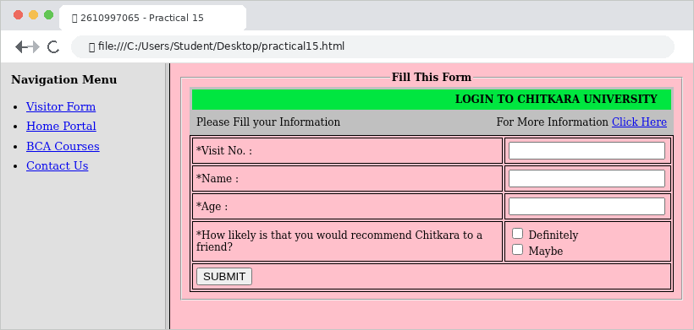

Result
The HTML frameset page was created successfully, and both the navigation frame and content frame were properly displayed in the browser.

