Support Specific

Tentative Service Execution Plan
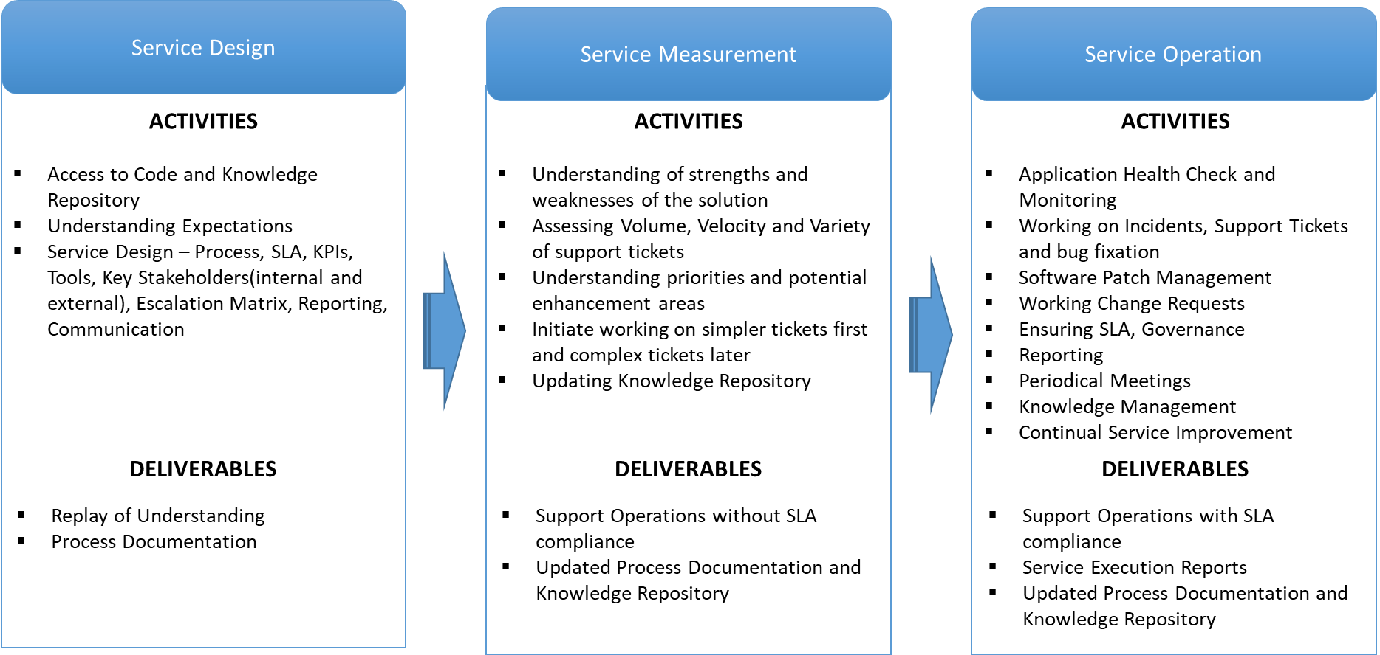

Support Window
- In office Support for Severity 1 to Severity 4: Monday to Friday – 09:00 AM to 06:00 PM
- Out of Office On call support for Severity 1 &2 tickets:
  - Week Days – 06:00 PM to 090:00 AM
  - Weekends/Holidays - 24 Hours

Production Support
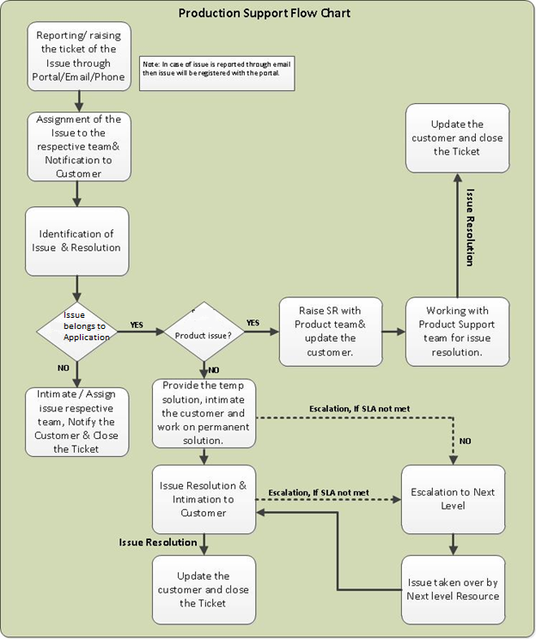

Reporting of Support Tickets to Client

Weekly Status Report:
- The Daffodil Software Ltd. to provide the client with a weekly status report that gives an overall summary of the following:
  - Project health
  - On-going activities
  - Completed tasks
  - Bug fixes
  - Action items across different application areas

Monthly Review Meeting:
- Daffodil Software Ltd. will track, summarize and discuss the following in a monthly review meeting with Client:
- Project health
- On-going activities
- Completed tasks
- Bug fixes
- Action items across different application areas Tracking unresolved issues from maintenance projects which impact the Support Plan
- Updating maintenance project progress and resolving critical issues
- Capturing agreements and disagreements and items needing escalation
- Analyze impact on the Support team size based on total volume of support tickets reported

Suggested Service Level Agreement
Following table depicts the indicative service levels proposed for resolution of the Support Requests assigned to Vendor support team.
Severity | Criteria | Response Time | Resolution Time
Critical (1) | Complete shutdown production/ Major impact | ONE HOUR | TWO HOUR
High (2) | Failure of critical functionality but not affecting operations or more than 10% users not able to use the application. | TWO HOUR | ONE DAY
Medium (3) | Failure/error in functionality which  doesn’t affect business operation in general but affects some users in the usage of the application | SIX HOURS | THREE DAYS
Low (4) | Failure/error in functionality which  doesn’t affect business operation in general and doesn’t affect users in the usage of the application since workaround is available | ONE DAY | FIVE DAYS

Escalation Matrix
LEVEL | Role
Level 1 | Operations Manager
Level 2 | Account Manager
Level 3 | COO

