Nodey Housing Market Project
Capstone Project (Data Analytics) · Assessment 2 portfolio · Team of two
We helped a company called Nodey find out where houses built on site are growing in value across the United States. We used a public set of home loan records from 2018 to 2025.
Links: See the code on GitHub · Read the notebook

About the project

Nodey creates tools to design family houses' structure. They were looking to understand where the market is expanding and thus what to target.
The challenge was to get the data. It contains millions of records of loans – these are divided into a large file for each year. This is a lot of information to follow by hand. It was our task to make it "straight answers.
Attempts were made to provide answers to five questions:
1. Have you seen a rise or fall in home sales, and in home prices?
2. Which states and cities will be growing at the fastest rate?
3. Are houses constructed on site different from manufactured homes?
5. Does there seem to be a relationship between loans denied and increases in price?
6. What are the opportunities for the areas that are likely to expand during the next 2-3 years?
We two were the pair. One cleaned the data for 2018-21, and created the price models. The other cleaned 2022 to 2025 and created the dashboards/report. We did the questions on our own and then we checked our answers.
What we built
1. Clean, smaller data. We only retained the columns that we required and only owner lived-in houses built on site. Next we created summary tables (small) for each year, state and city.
2. Python notebook to validate data, create charts, perform tests on four different price models and provide a basic prediction.
3. Two dashboards. That's one of a custom website built using an AI platform called Base44. The other one is in Power BI. Both enable you to filter and compare locations.
You can use custom website (Base44) in Dashboard 1.
This is the recommended dashboard to use for this. It provides answers in one place to all 5 questions. It features year buttons at the top, headline numbers, a summary in plain English (invest vs. avoid: best state: Idaho, best city: Boise City, worst: Illinois) and a map of home values, plus a forecast to 2028.

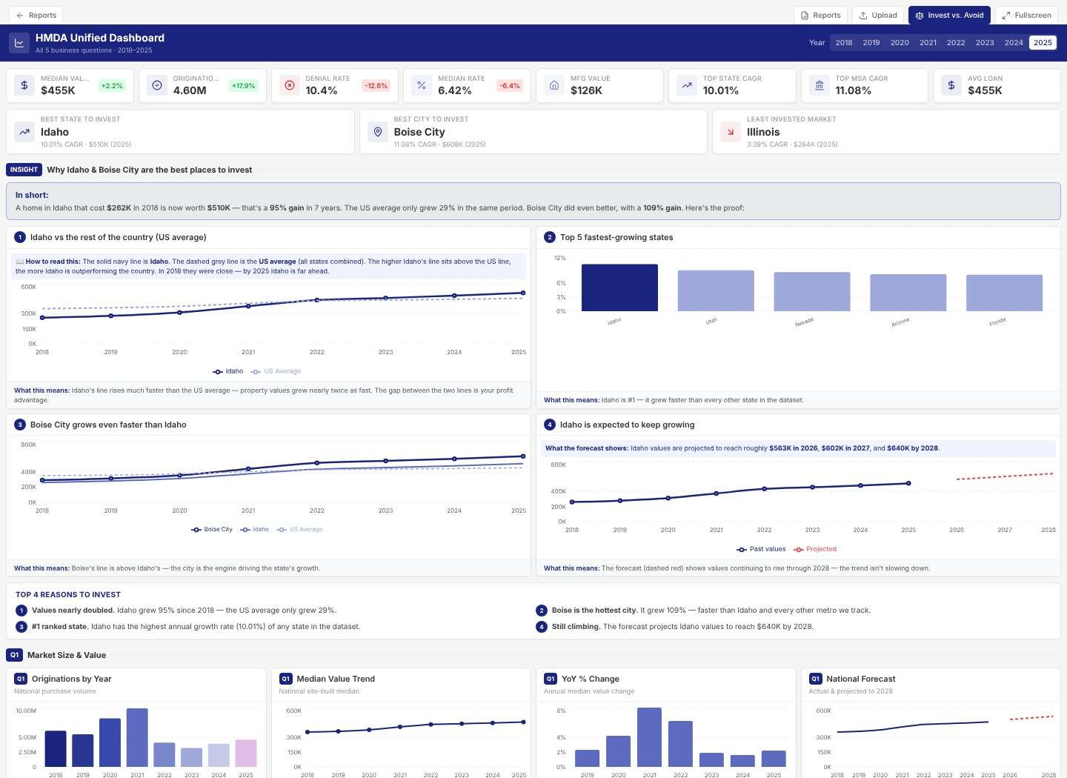
Top of the Base44 dashboard: headline numbers and the invest summary.
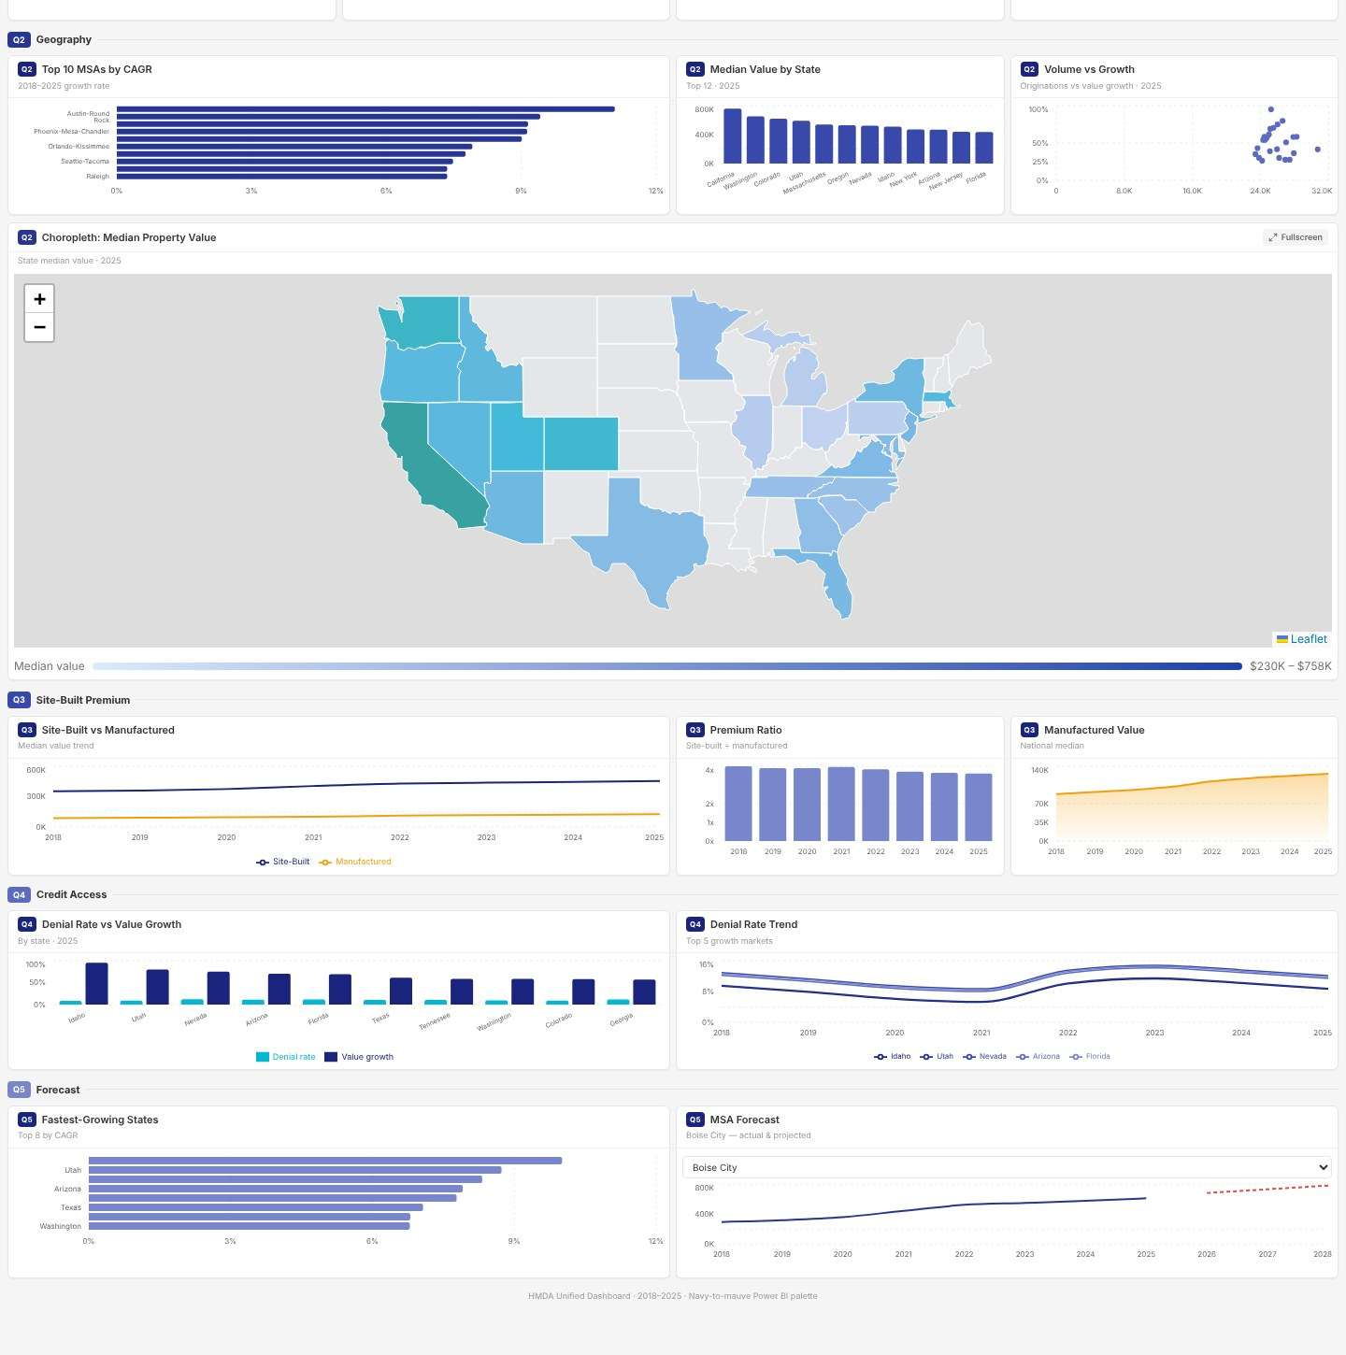
Lower part: top cities, the value map, site-built vs manufactured, loan denials and the forecast.

Dashboard 2: Power BI

This was created to compare to the custom dashboard. It addressed the same questions, but some of the charts were flat, or had strange labels (e.g. “Median of action_taken”), and some of the numbers on the charts did not match those in the Base44 Dashboard. Hence our lack of trust in it at this time.
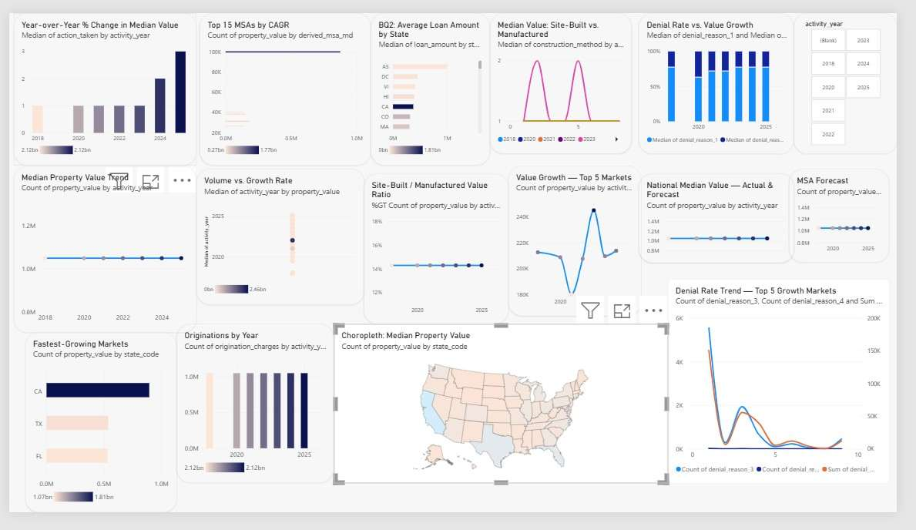
The Power BI dashboard.
A note on the data. We left out 2017 because the file has no column names and we did not want to guess.

Main results
The big numbers below come from the full data in our dashboard. The notebook uses a smaller sample of 70,000 loans, so its numbers are only a rough guide.
Prices are up about 30%  Since 2018, but growth has slowed to about 2% a year. | Fewer homes are being bought  From about 10 million in 2021 down to 4.6 million in 2025.
Boise City grew fastest  About 11% a year, while the whole country grew 3.8%. Phoenix, Nashville and Raleigh also did well. | Site-built homes cost more  $455K compared with $126K for manufactured homes in 2025. The gap is slowly getting smaller.
About 1 in 10 loans was turned down  The fewest was in 2021 and the most was around 2023. | Growth is expected to stay slow  We show future prices as a range, not one exact number.

What this means for Nodey

The selection of site is more important than the overall situation. First, check out Boise City, Phoenix, Nashville and Raleigh. • Access our customized dashboard. We believe it more than did Power BI, which gave us varying results.

Price models
We taught four computer models to guess the price of a house. We then tested them on houses they had never seen. A score closer to 1 is better, and a smaller error is better.
Model | Score | Typical mistake
XGBoost | 0.71 | $94,453
Decision Tree | 0.70 | $97,706
Random Forest | 0.69 | $98,710
Linear Regression | 0.10 | $196,727

- XGBoost was the best, but only a little better than the next two.
- Linear Regression was the worst. It guessed about $400K for almost every house.
- The size of the loan and the buyer’s income were the clues that mattered most.
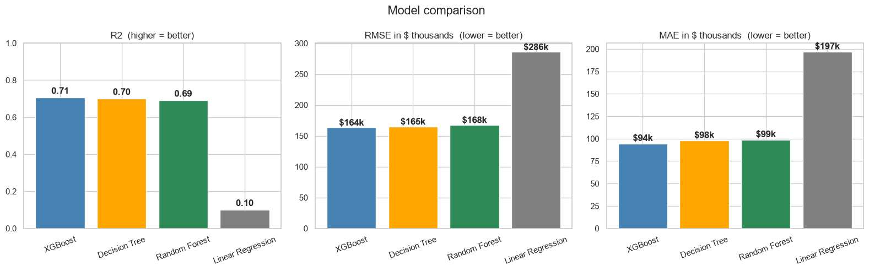
The four models side by side.
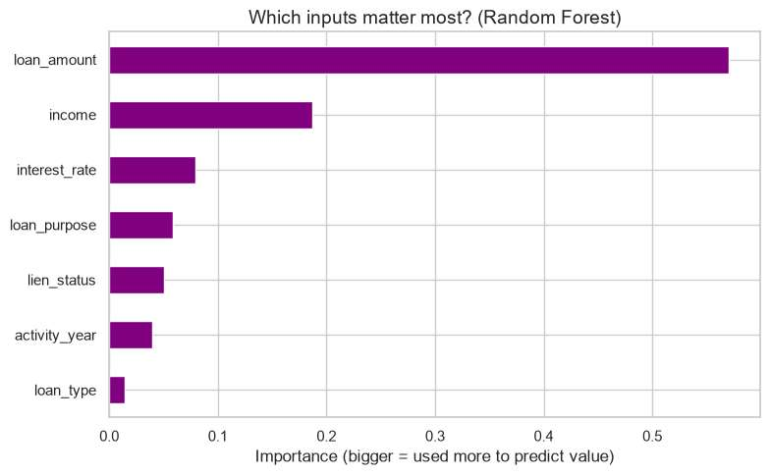
Which clues helped most: loan size (57%) and income (19%).

Where is it growing?
These lists come from the small sample, so use them as a rough guide only. Some places have just a few loans each year, so a minus sign does not mean prices really fell.
Fastest states | Growth | Fastest cities | Growth
Connecticut | +7.3% | Miami | +10.3%
Colorado | +6.3% | New York City | +8.6%
Tennessee | +6.0% | Denver | +6.9%

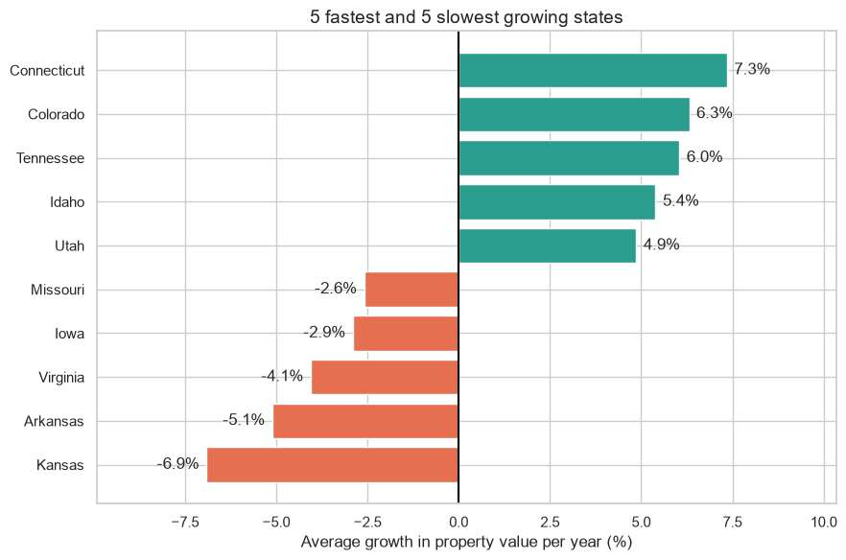
The 5 fastest and 5 slowest growing states.
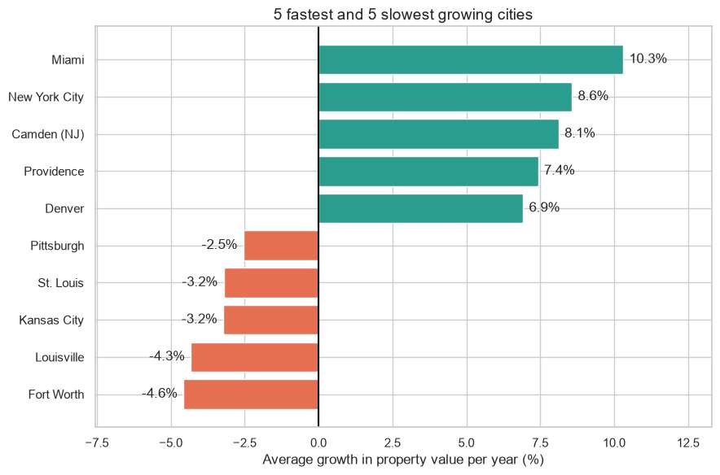
The 5 fastest and 5 slowest growing cities.

Forecast
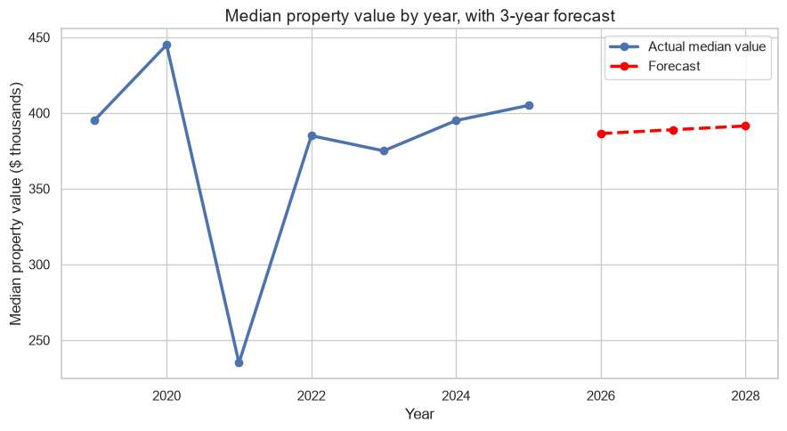
The dip in 2021 happens because the sample has a different mix of states each year.
We took a straight line through the typical prices for each of the years and extended it into the next three years. It points to about $386K in 2026, $389K in 2027 and $391K in 2028. This is an increment of around $2500/year.

Project plan

The project was carried out over a period of 16 weeks: 6 July – 16 November 2026. Each of us worked about 20 hours a week. We had a weekly meeting with our supervisor and a meeting with Nodey every 2 weeks and we met each other several times per week.
They include Weeks 1-4 as proposal and reading on the topic.
Weeks 5 – 8: downloading and cleaning of data.
Week 9-12: Development of the models and dashboards.
Week 13-16: testing, report writing and reporting handing in.

Problems we had
The 2017 file did not contain any column names, so we omitted them.
The large files didn't work well with Power BI and provided different numbers than our custom dashboard.
We had no information on the data about a lack of payments on loans, so we didn't predict that as we originally planned.

What's the difference between the proposal

•We used 2018 to 2025 instead of 2017 to 2025.
We took 4 price models instead of 1.
We have created a Base44 web site and Power BI rather than Tableau.
The group or the loan approval model (K-means or logistic regression) were not created.
T
This edition focuses on the ethics of New Zealanders.This issue is about Kiwi ethics!
Our data is open and from the USA. It doesn't contain any NZ personal information and no Māori data. We checked our work against New Zealand rules however.
•Privacy Act 2020. Only used the columns necessary and used summary tables. Copies of the data and code will be removed after we submit and give it back to Nodey. To improve: make groups of very few people (or even none) in the dashboard so that no one can be recognized.
Data on Māori and data about the
te Tiriti o Waitangi. No Māori data were used. To improve: if this is to be used for New Zealand houses, the working is needed to be done in consultation with Māori groups from its inception.
This is an algorithm charter designed for Aotearoa New Zealand. We have described our procedures and limitations, and provided a range of forecasts. To improve: Determine the reasons for the difference between Power BI and our dashboard.
Codes of conduct for professionals. We made it clear about the weaknesses, identified our sources and explained that we applied AI to create the dashboard. Suggest improvement: ask Nodey if it is ok to make this portfolio public.
Fairness. The information in a loan can be a representation of an inequitable treatment of certain groups. No personal data (race) was used so the denial percentages are simply a marker of the market. Never they should be considered for making loan decisions.
What I learned
The data was shortened early and was easier and quicker to check.
If you do not trust the numbers, then it's not a good-looking tool (Power BI).
Unlike many apps that are developed with AI, you will need to review them before accepting them at face value, such as our Base44 dashboard.
•Forecasts are guesses. Displaying them as ranges will be more honest.
Limits of our work
Only data relating to houses purchased with a mortgage is included.
Associations between two phenomena do not imply that one phenomenon leads to the other.
We will be using a sample, not all the data, in our notebook.
Next steps
•Run the notebook on all the data.
•Add 2017 back in.
Make sure Power BI is in line with the custom dashboard.
Code and files
Notebook that contains the final code for the Capstone.
•this site is /docs/.
The summary tables are in the data/ folder.
The final report is in the report/ directory.
Install the packages of python that the notebook requires (pandas, numpy, matplotlib, seaborn, scipy, scikit-learn and xgboost). Next, edit the second cell to the location of your data file.
Data source: FFIEC Home Mortgage Disclosure Act (HMDA) loan data.

