HW 08

DWBI

Shivam Verma

Create Table command for staging table

CREATE TABLE [dbo].[Health_Care_Provider_Data_staging](

[CredentialNumber] [varchar] (255) NULL,

[LastName] [varchar] (255) NULL,

[FirstName] [varchar] (255) NULL,

[MiddleName] [varchar] (255) NULL,

[CredentialType] [varchar] (255) NULL,

[Status] [varchar] (255) NULL,

[BirthYear] [varchar] (255) NULL,

[CEDueDate] [varchar] (255) NULL,

[FirstIssueDate] [varchar] (255) NULL,

[LastIssueDate] [varchar] (255) NULL,

[ExpirationDate] [varchar] (255) NULL,

[ActionTaken] [varchar] (255) NULL

) ON [PRIMARY]

GO

Create Table command for Destination table

CREATE TABLE [dbo].[Health_Care_Provider_Data_destination](

[CredentialNumber] [varchar] (255) NULL,

[LastName] [varchar] (255) NULL,

[FirstName] [varchar] (255) NULL,

[MiddleName] [varchar] (255) NULL,

[CredentialType] [varchar](255) NULL,

[Status] [varchar] (255) NULL,

[BirthYear] [varchar] (255) NULL,

[CEDueDate] [varchar] (255) NULL,

[FirstIssueDate] [varchar] (255) NULL,

[LastIssueDate] [varchar] (255) NULL,

[ExpirationDate] [varchar] (255) NULL,

[ActionTaken] [varchar] (255) NULL

) ON [PRIMARY]

GO

Create Table command for Error table

CREATE TABLE [dbo].[Health_Care_Provider_Data_destination](

[CredentialNumber] [varchar] (255) NULL,

[LastName] [varchar] (255) NULL,

[FirstName] [varchar] (255) NULL,

[MiddleName] [varchar] (255) NULL,

[CredentialType] [varchar](255) NULL,

[Status] [varchar] (255) NULL,

[BirthYear] [varchar] (255) NULL,

[CEDueDate] [varchar] (255) NULL,

[FirstIssueDate] [varchar] (255) NULL,

[LastIssueDate] [varchar] (255) NULL,

[ExpirationDate] [varchar] (255) NULL,

[ActionTaken] [varchar] (255) NULL

) ON [PRIMARY]

GO

Screenshot of control flow

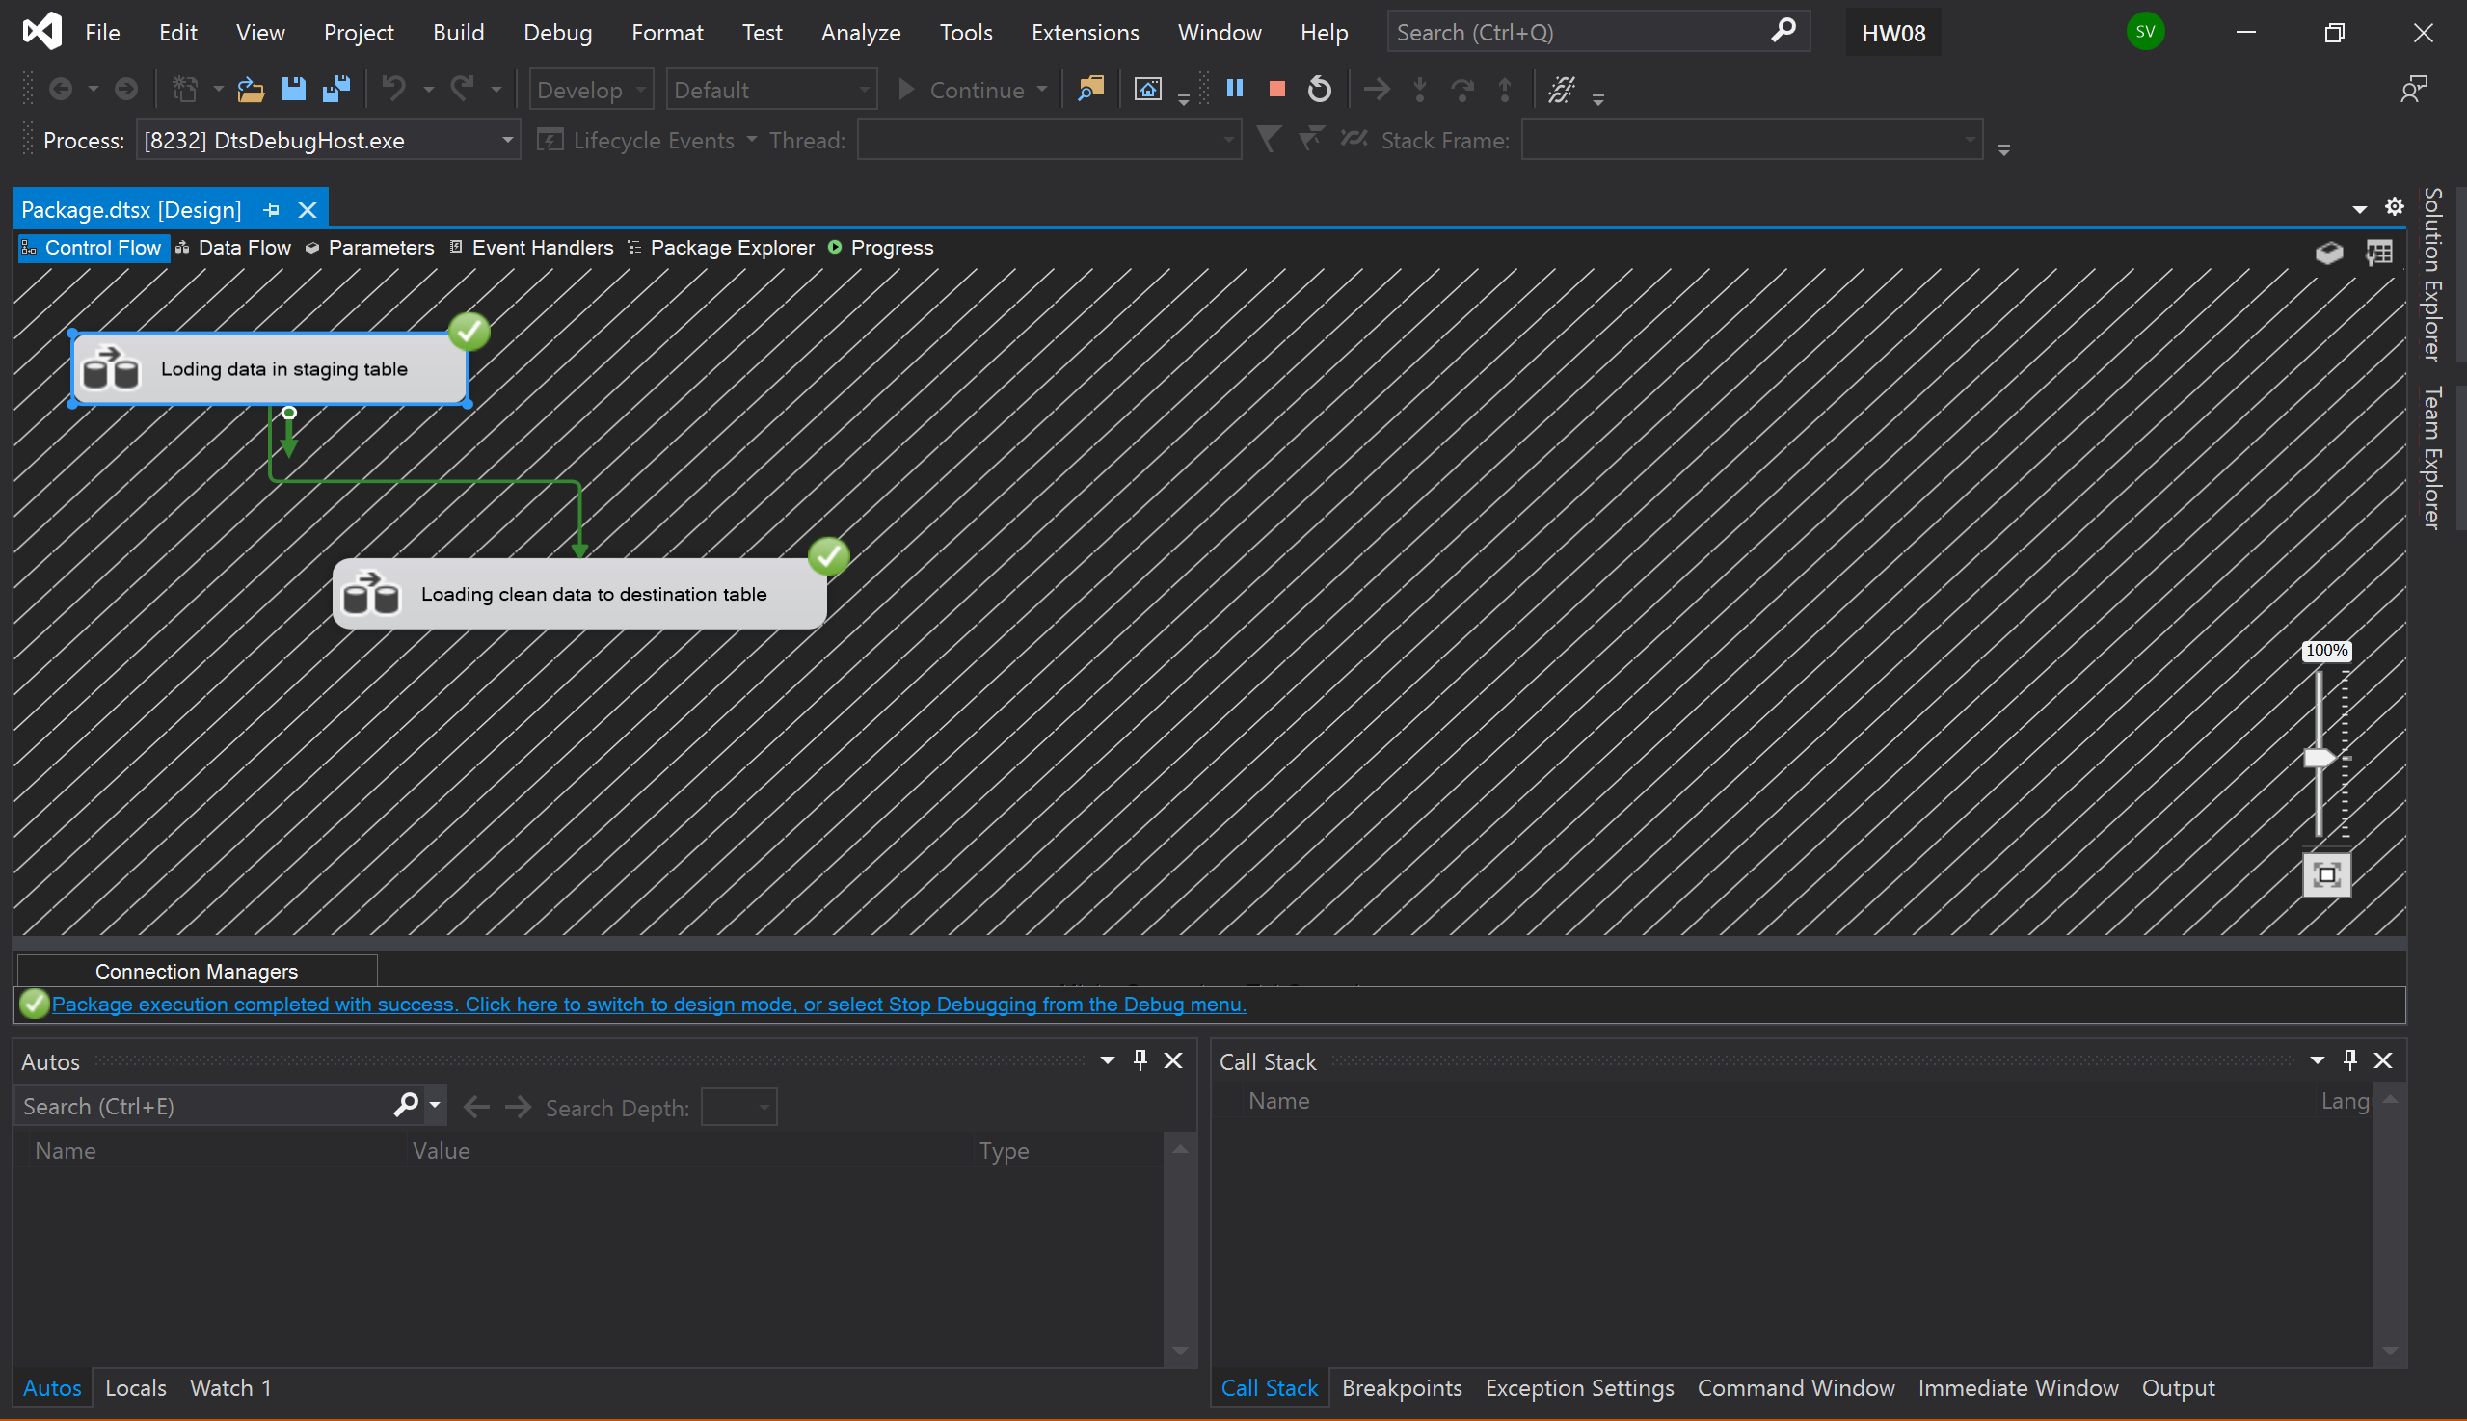

Screenshot of data flow (Loading data in staging table)

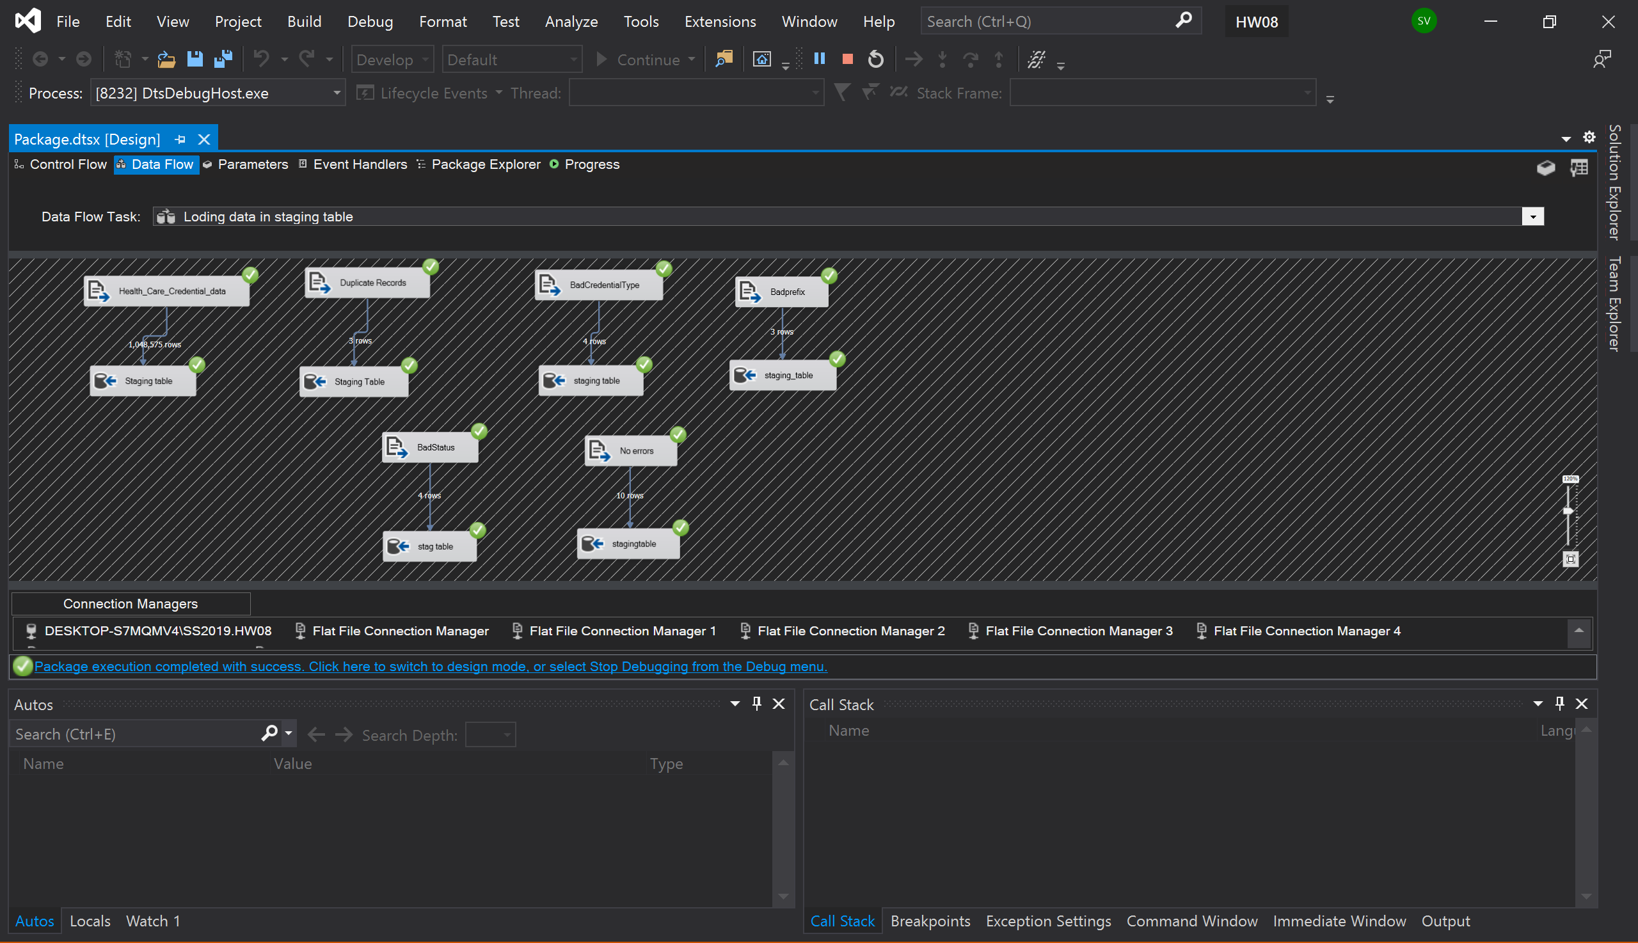

Screenshot of data flow (Loading error free data in destination table)

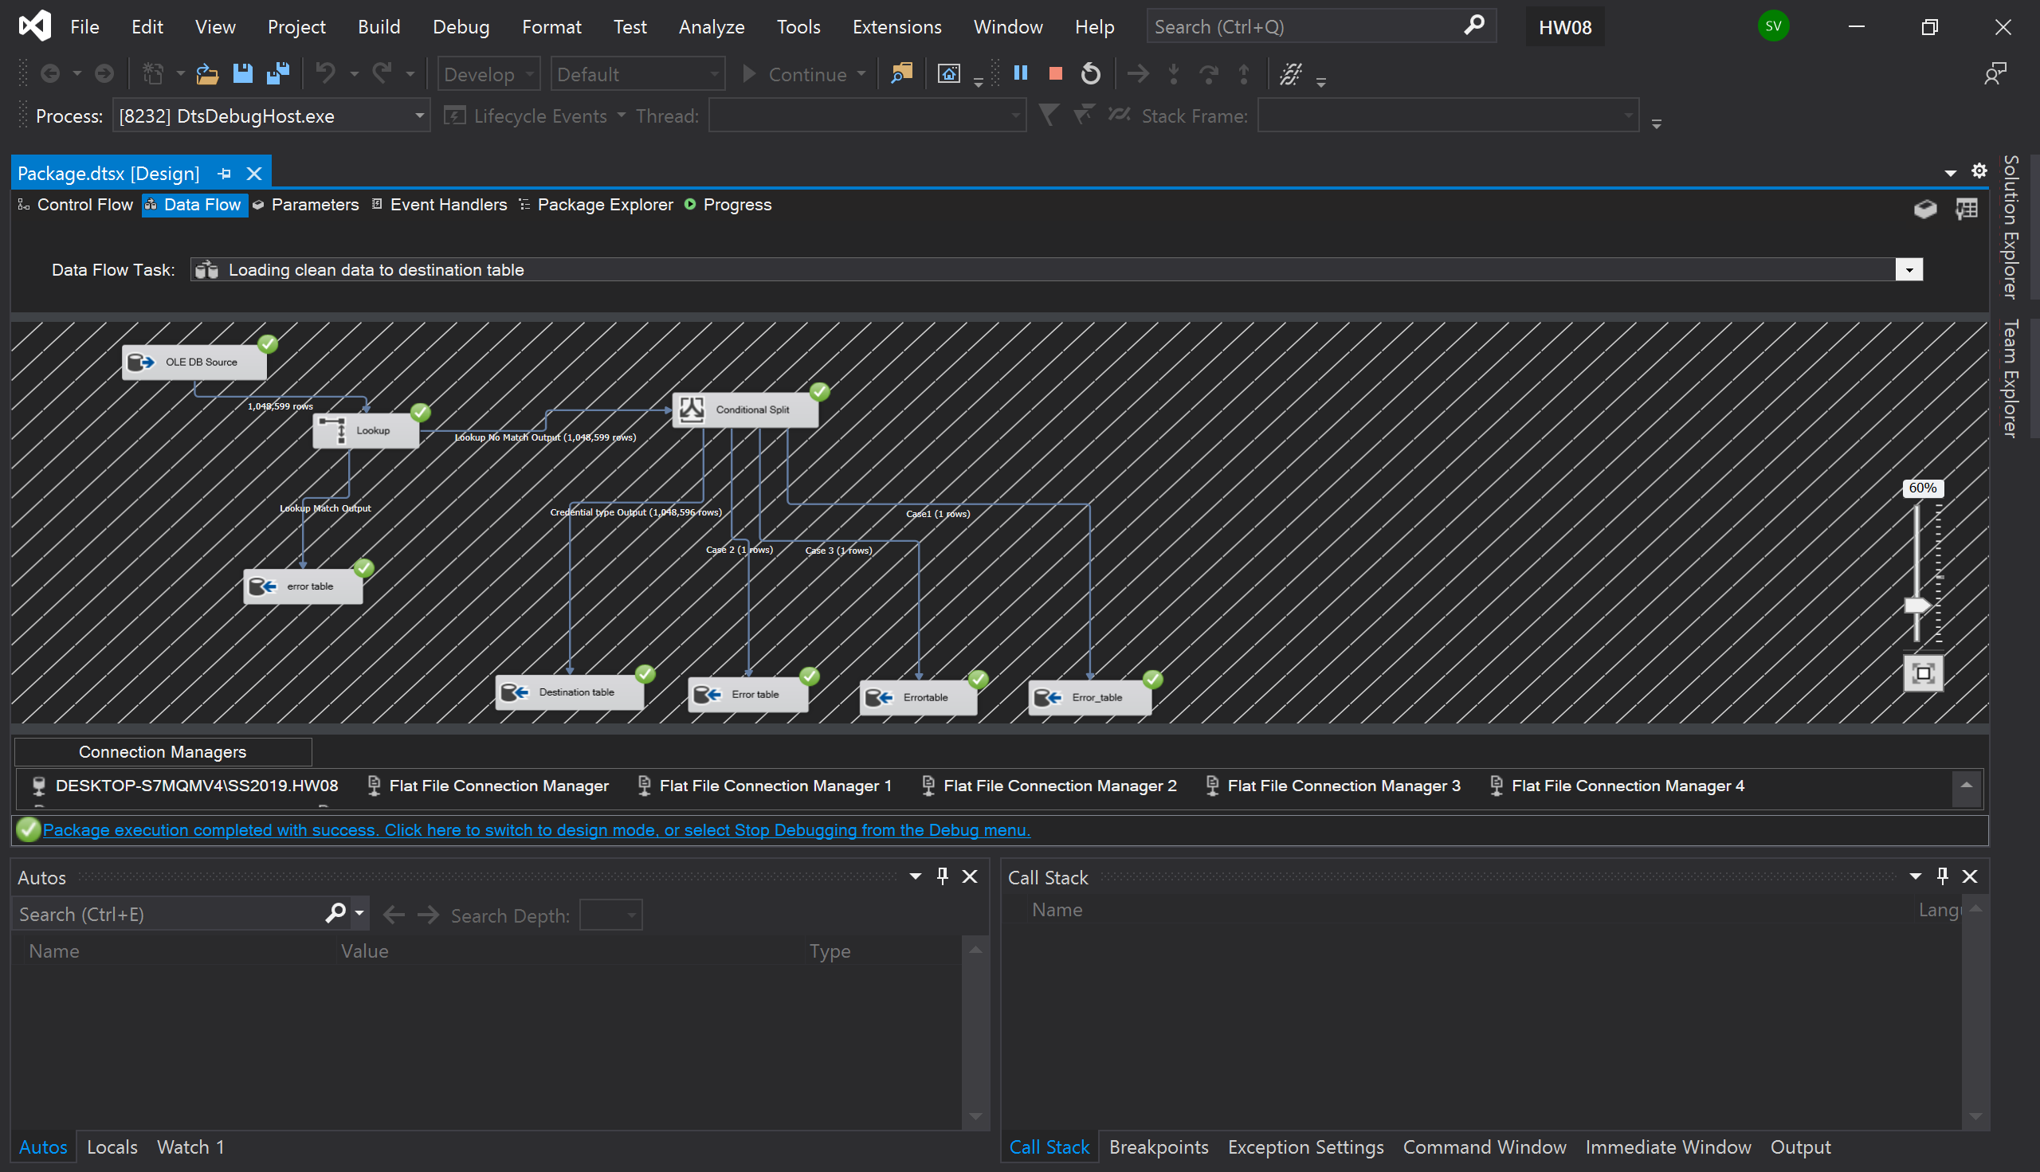

Screenshot of lookup

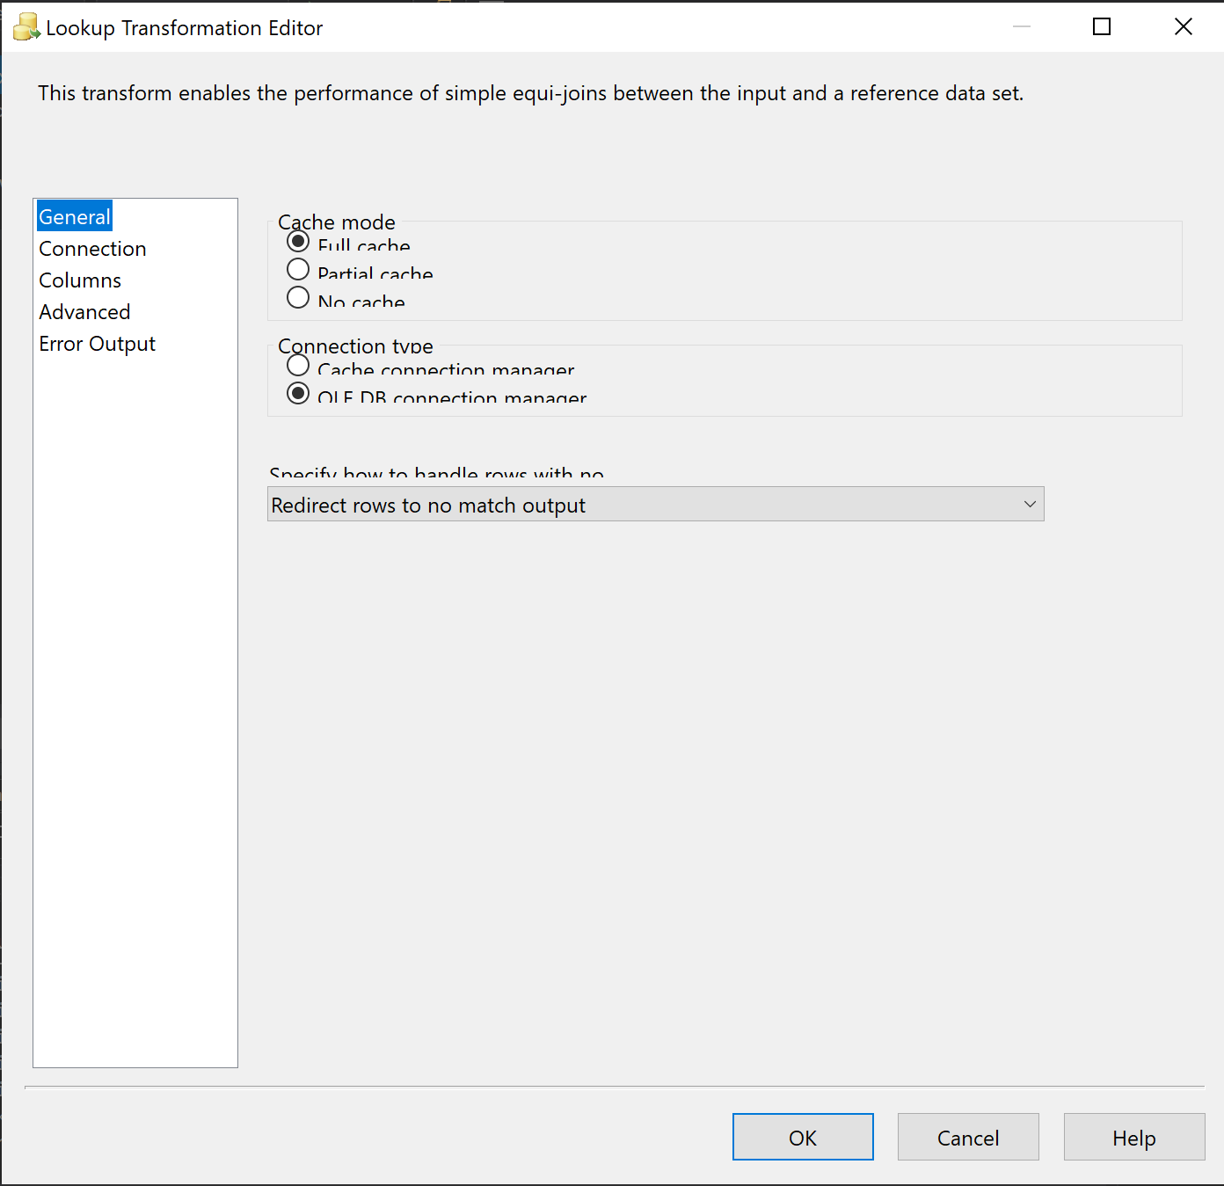

Screenshot of Conditional Split

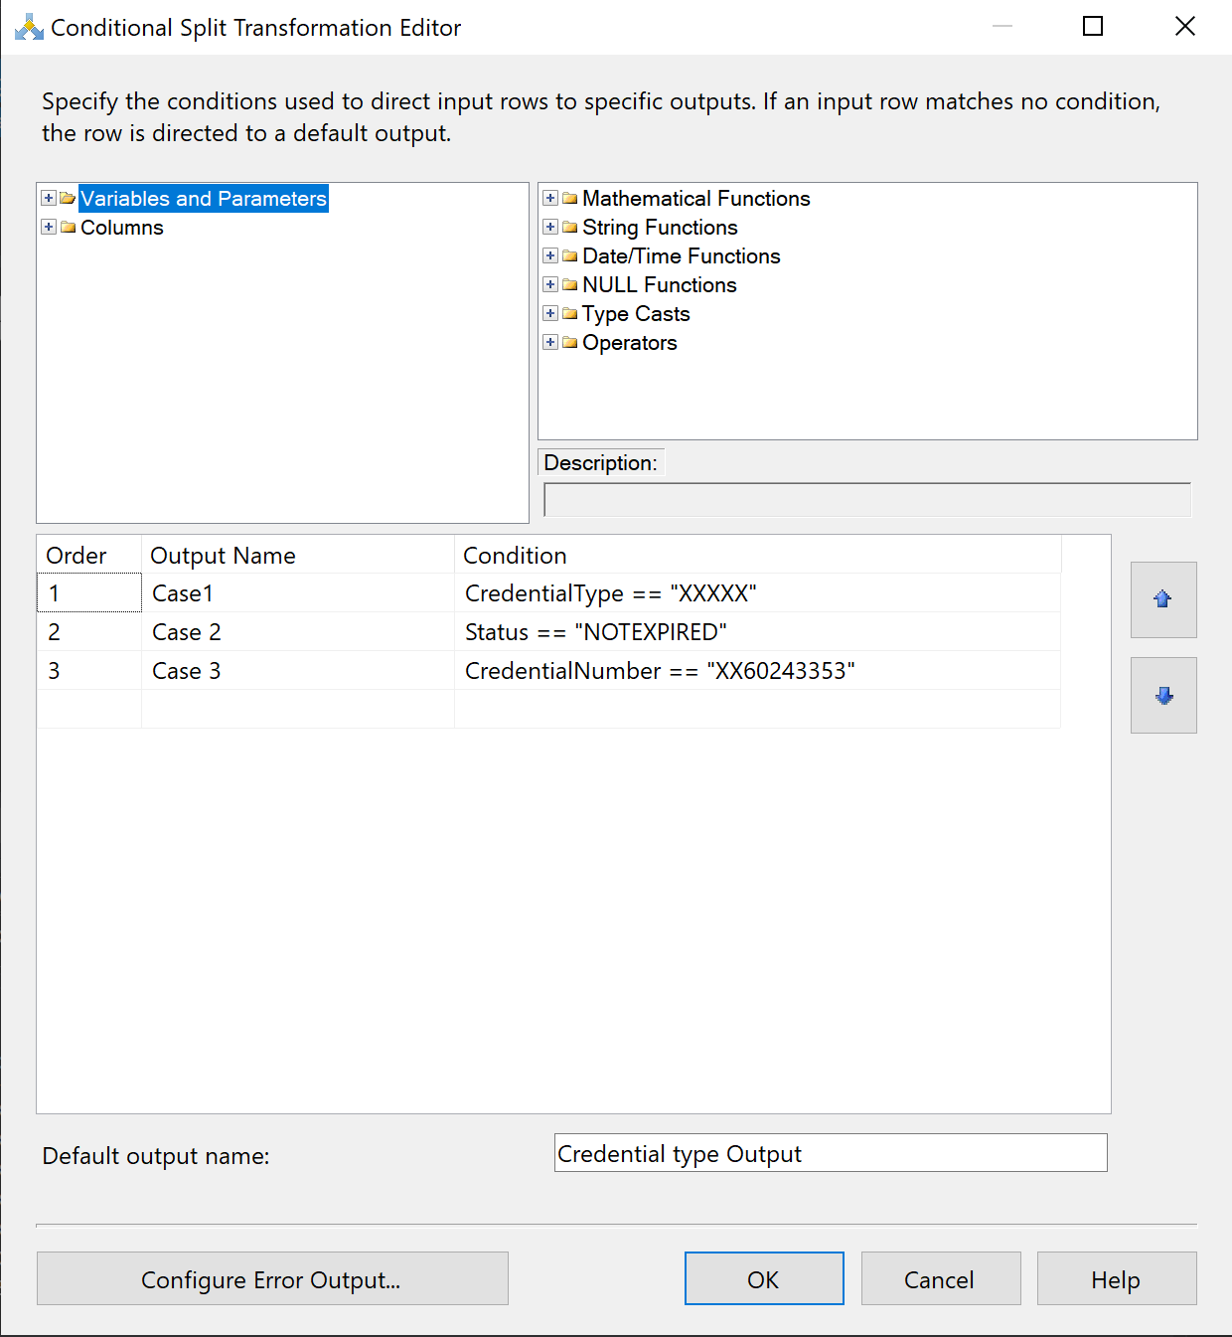

Screenshot of data populated into staging table

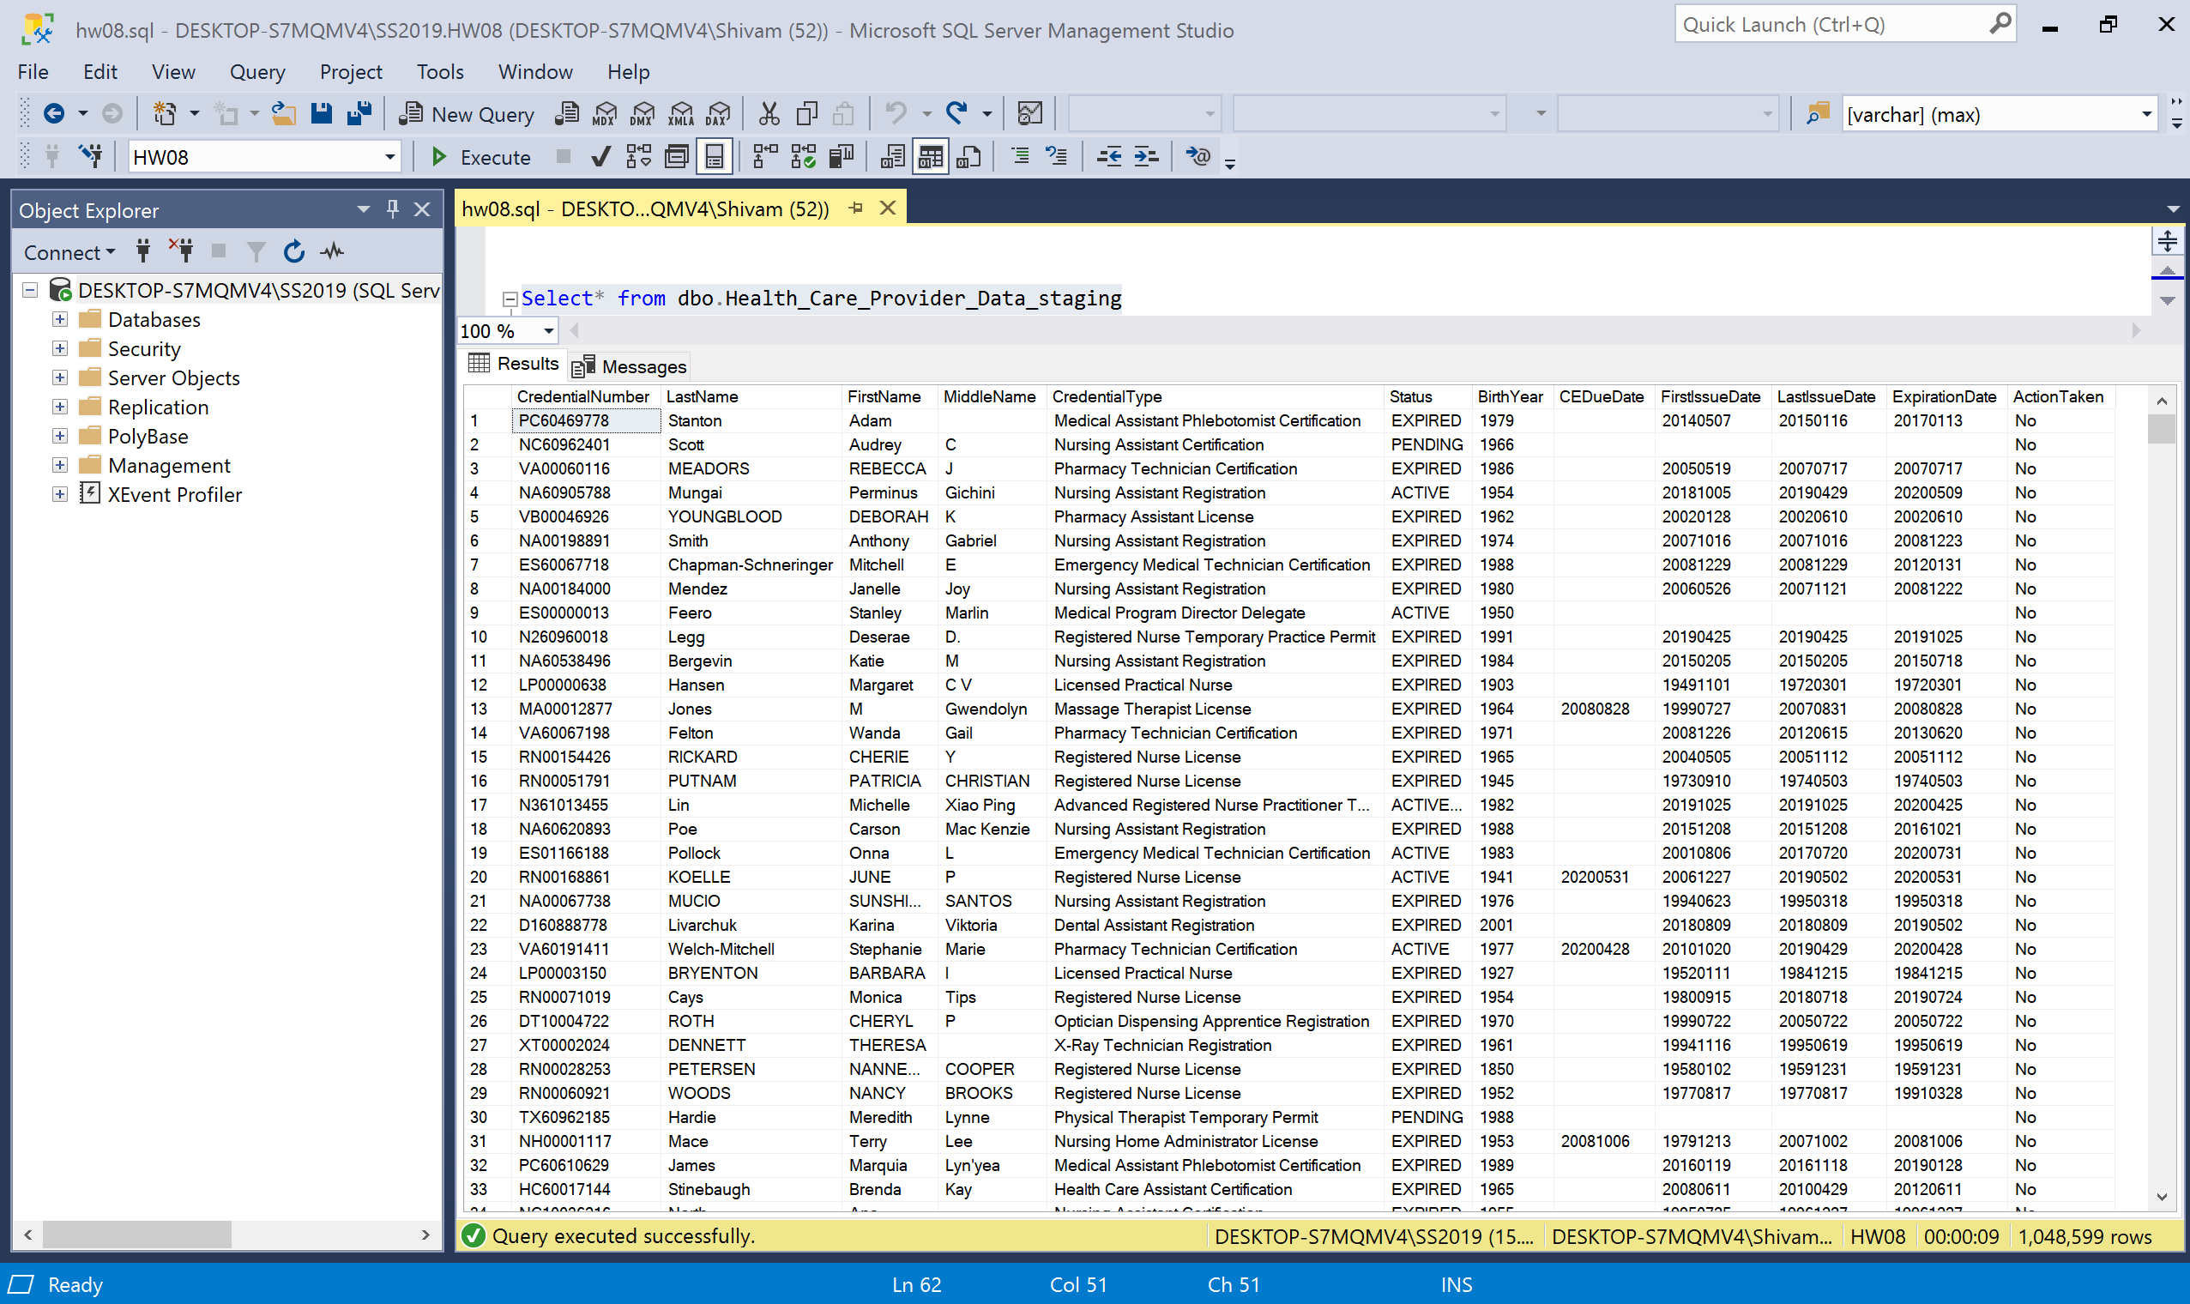

Screenshot data populated into destination table

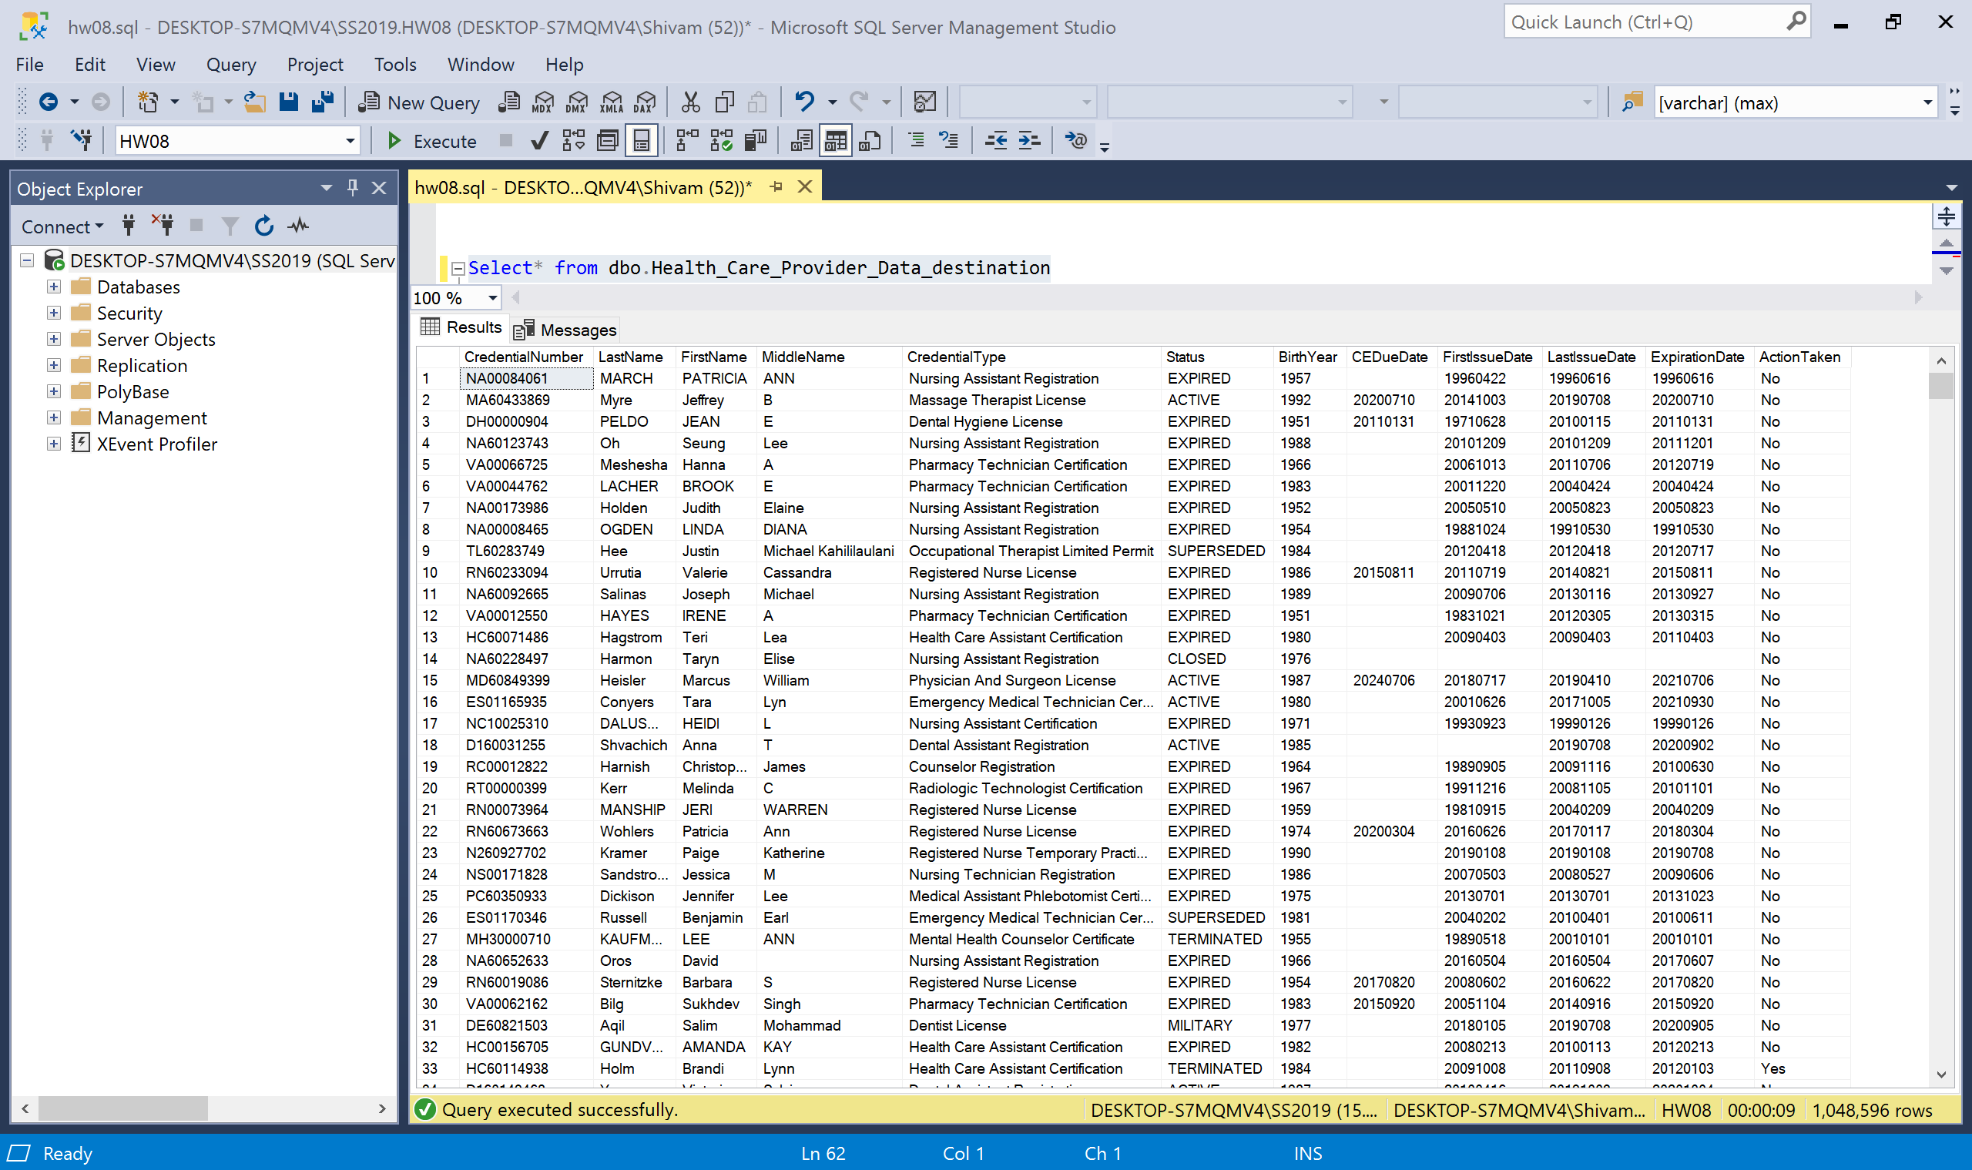

Screenshot of data populated into error table

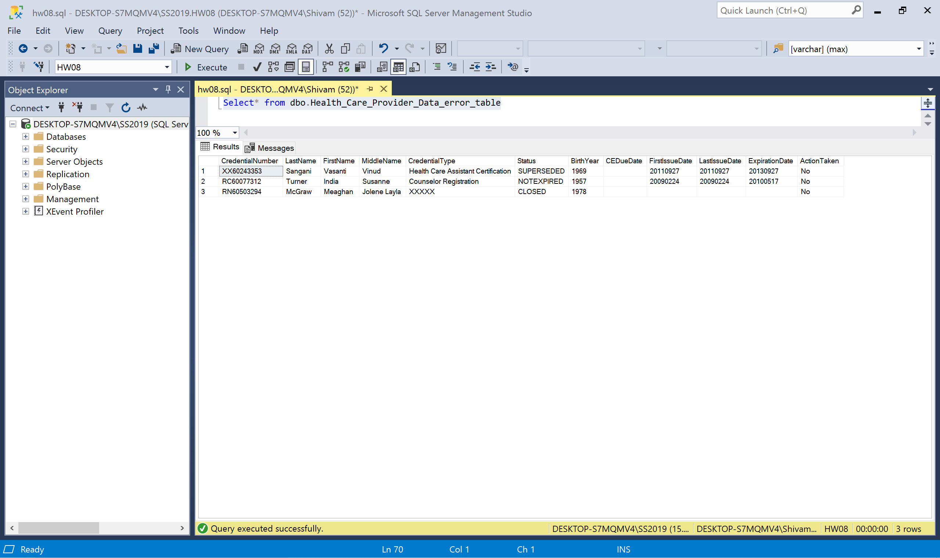

Duplicate rows not in error table because package needs to run at least twice so that it can compare rows.