HW 12 SSAS

DWBI

Shivam Verma

Screenshot of Cube structure with FactInternetSales as Fact table

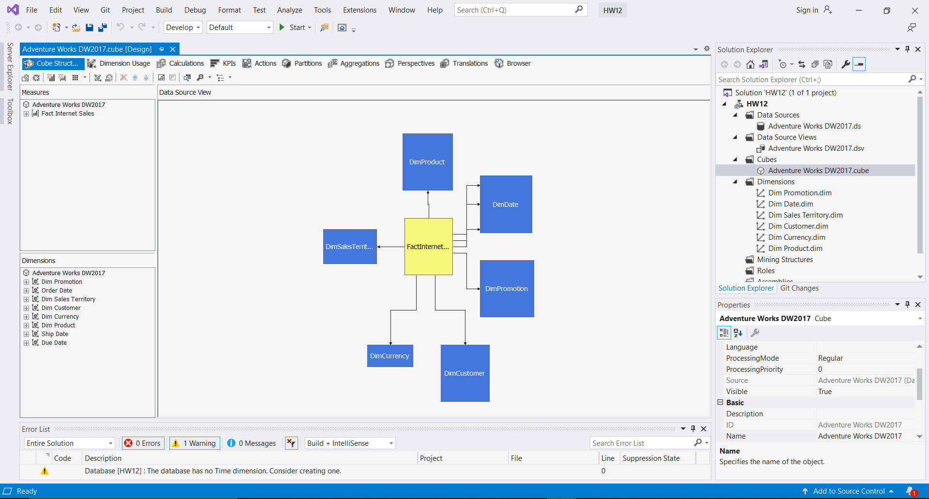

Cont.

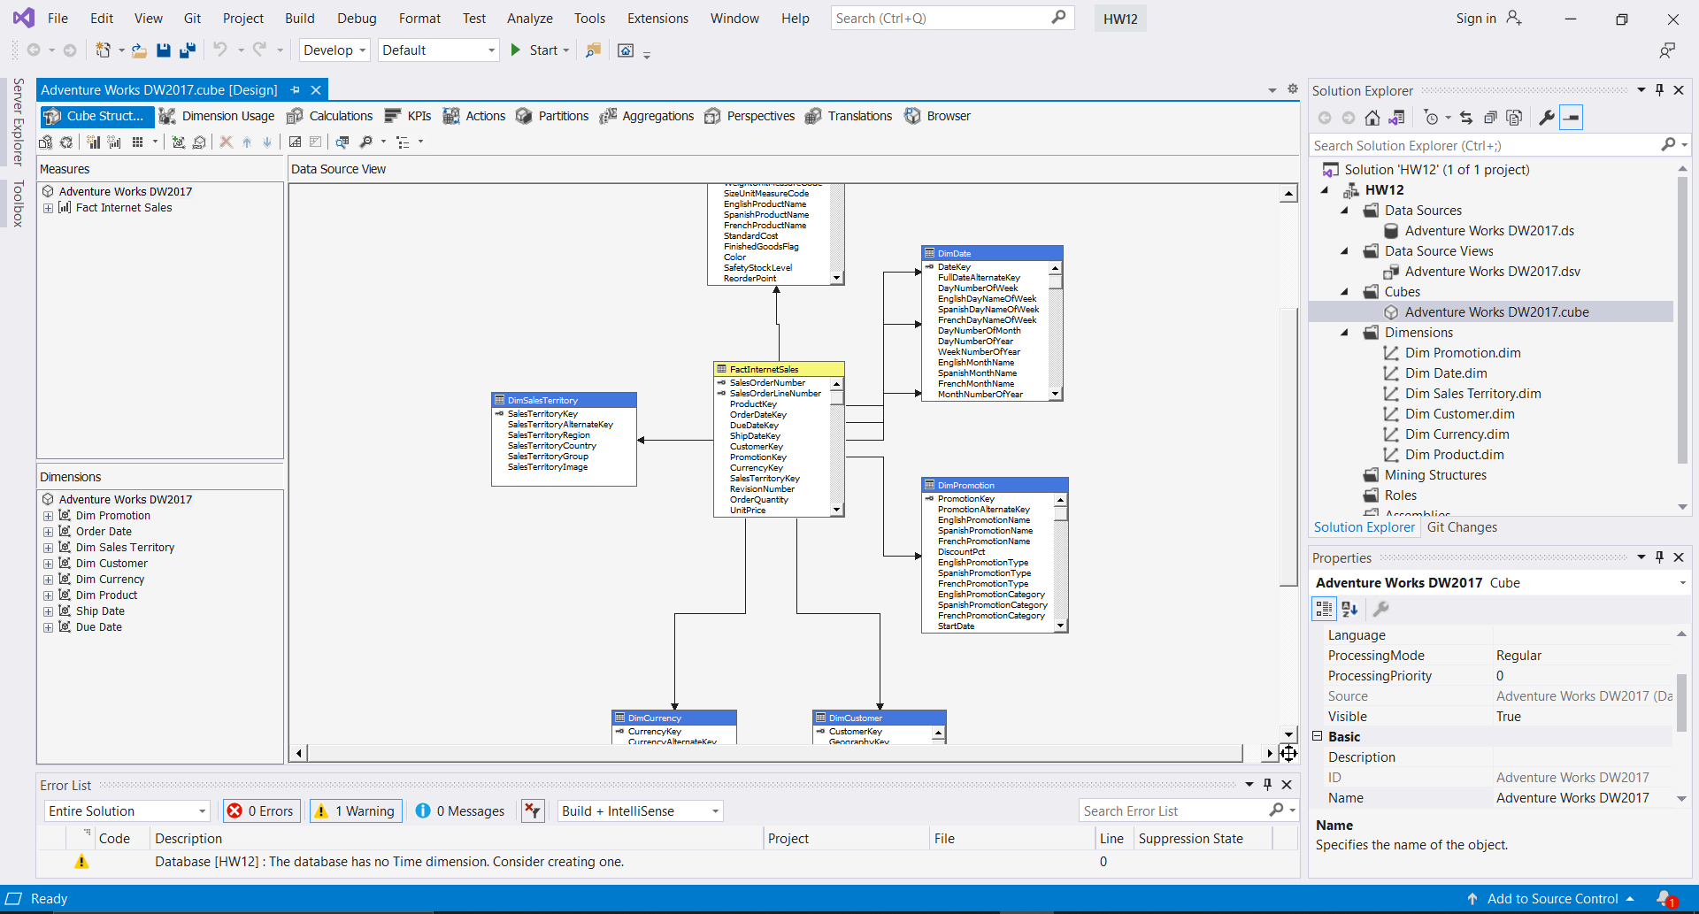

Screenshot of successful deployment of the project

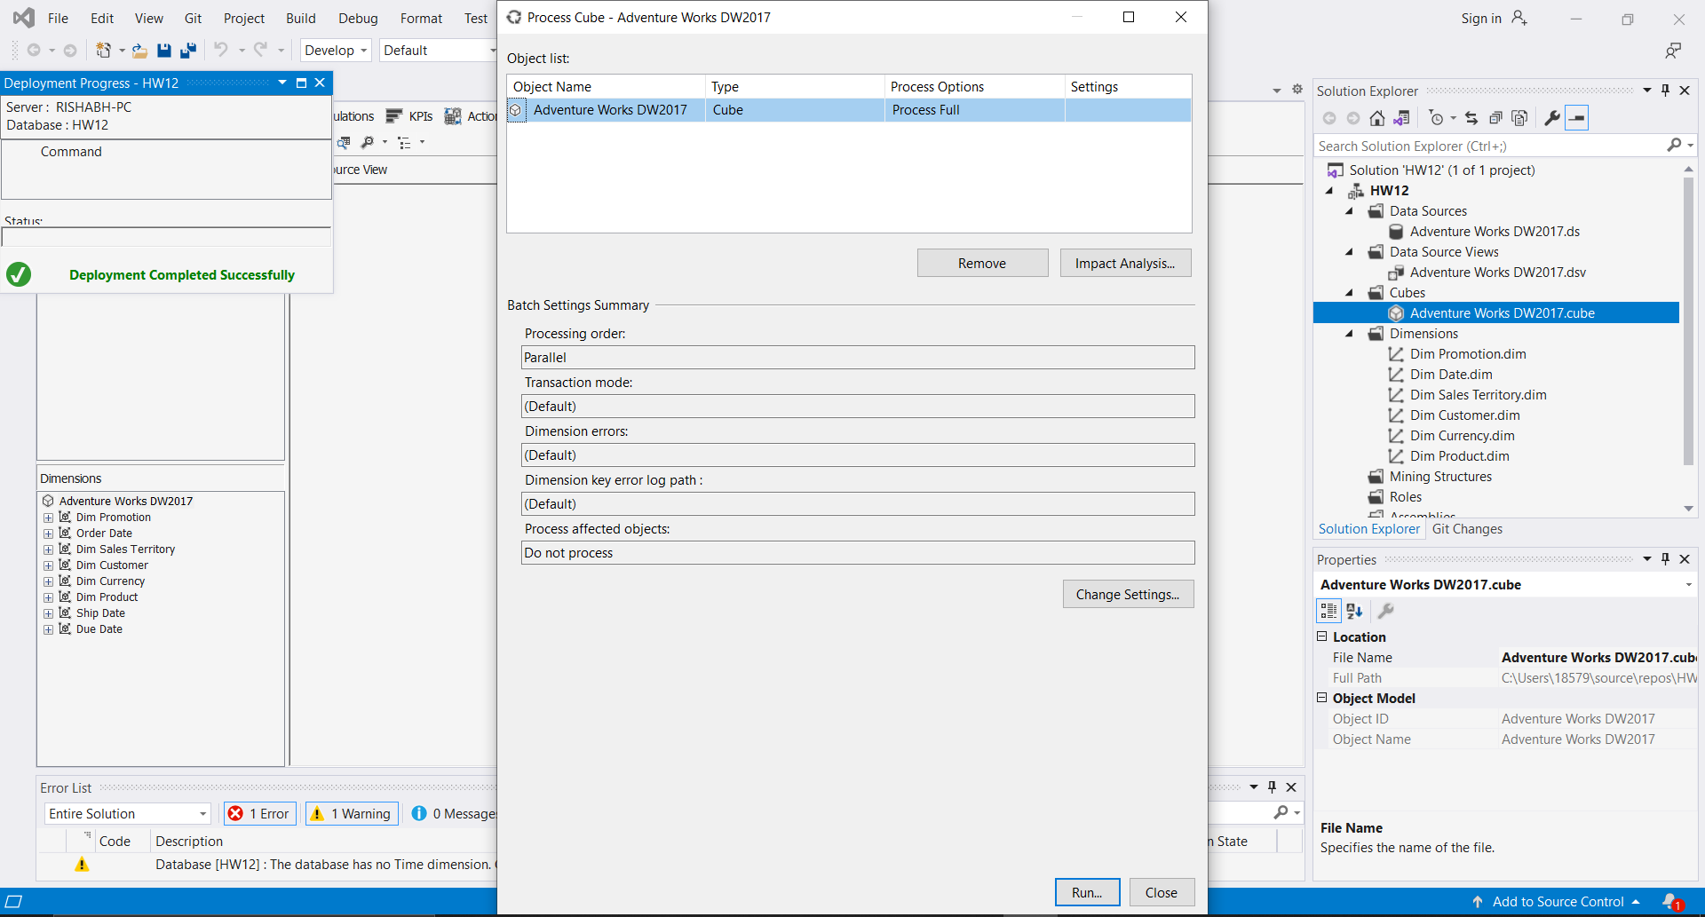

Screenshot of cube browser with analysis of the Sales Amount to the corresponding date.

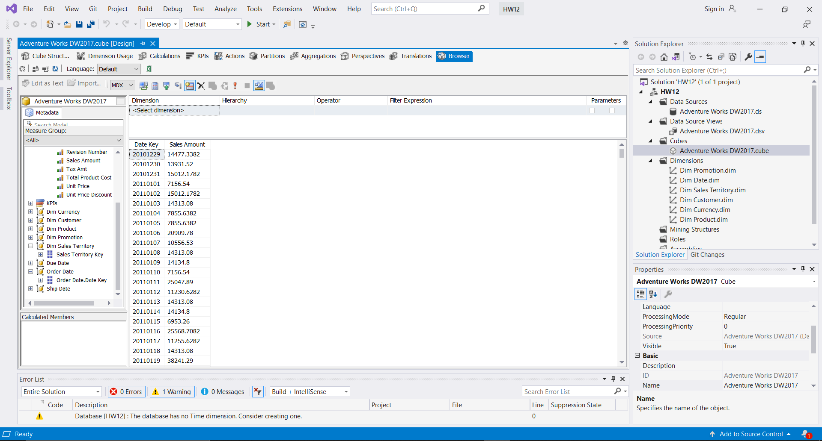

Screenshot to show hierarchy for DimDate with the following sequence Year-Quarter-Month-Date

