1. Prompt for amount, interest rate and no. of years and calculate simple interest.

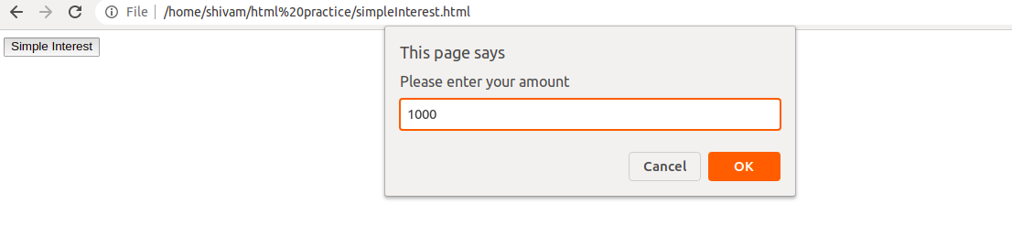

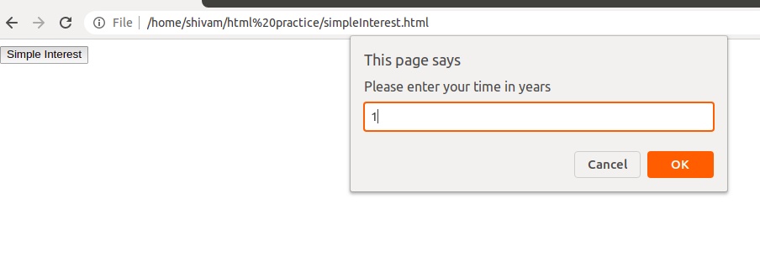

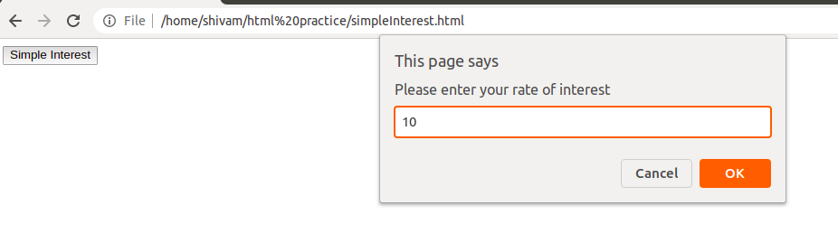

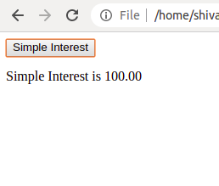

1. is palindrome string

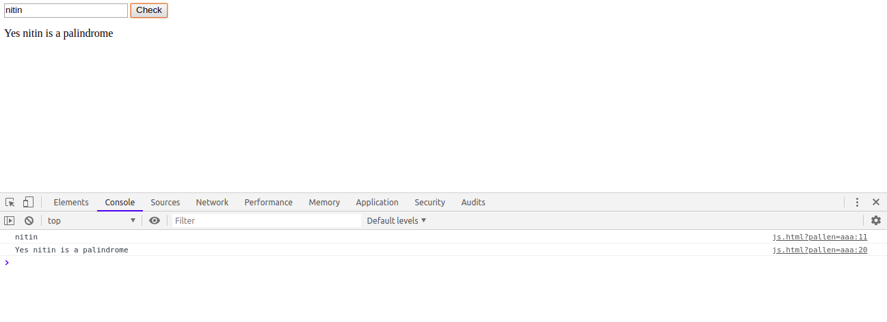

1. Area of circle

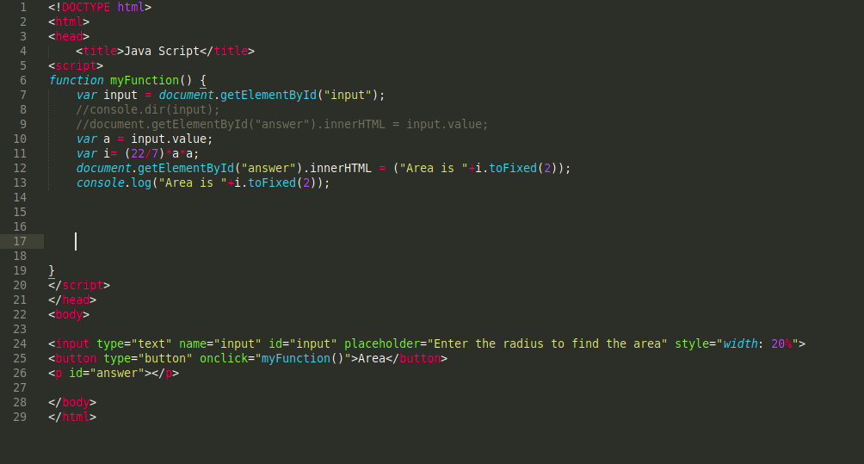

1. Copy information of one object to another and log it to console.

Object_name = Object.assign( TargetObject, SouceObject );

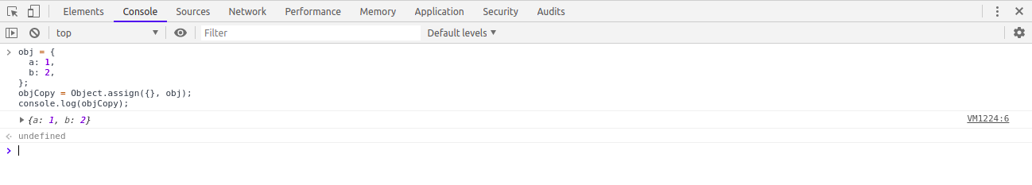

1. Create a list of objects of Employee with info as follow :

* Name, age, salary ,DOB

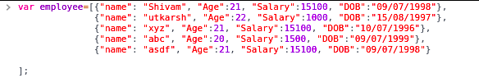

* filter all employees with salary greater than 5000

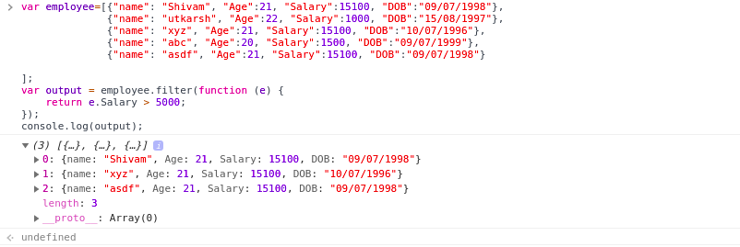

* fetch employees with salary less than 1000 and age greater than 20. Then give them an increment 5 times their salary

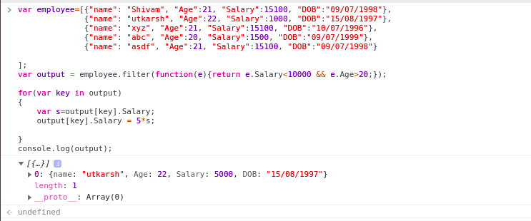

***Extra Efforts - taking input of employe and presenting it in the form of table and display the filtered data also in tabular form

