PROJECT – 2

**STATIC HOSTING WEBSITE on AWS**

Object: Creating a static website and deploy it using AWS services. A static website is a site that consists of HTML, CSS, and JavaScript files, and it doesn't require server-side processing or a database.

* Log-in to AWS Management Console.
* Set your location to your nearest area/continent “Mumbai”.
* Go to the search bar and type “S3”.
* Go to the “Buckets” section and click on “Create bucket”.

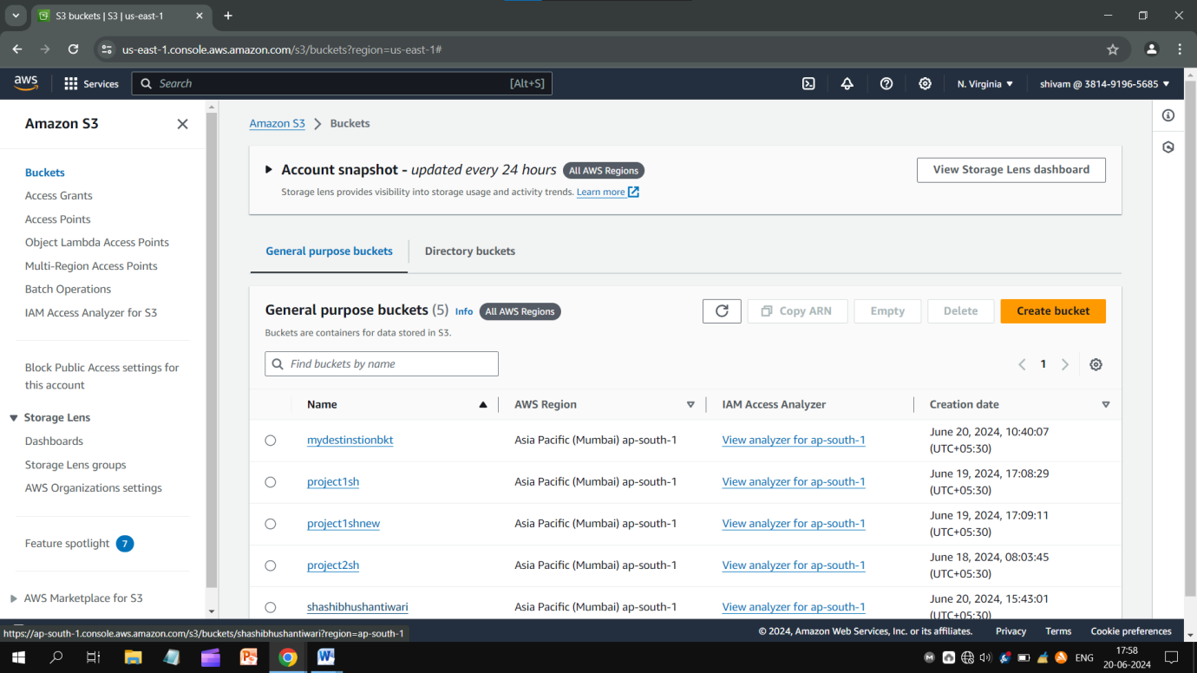

* Write a unique bucket name, unblock “all public access”
* Enable “ACLs” and accept the “I acknowledge that…….public” notice.
* Let other settings be as they are.
* Just click on “Create bucket” and go ahead.....

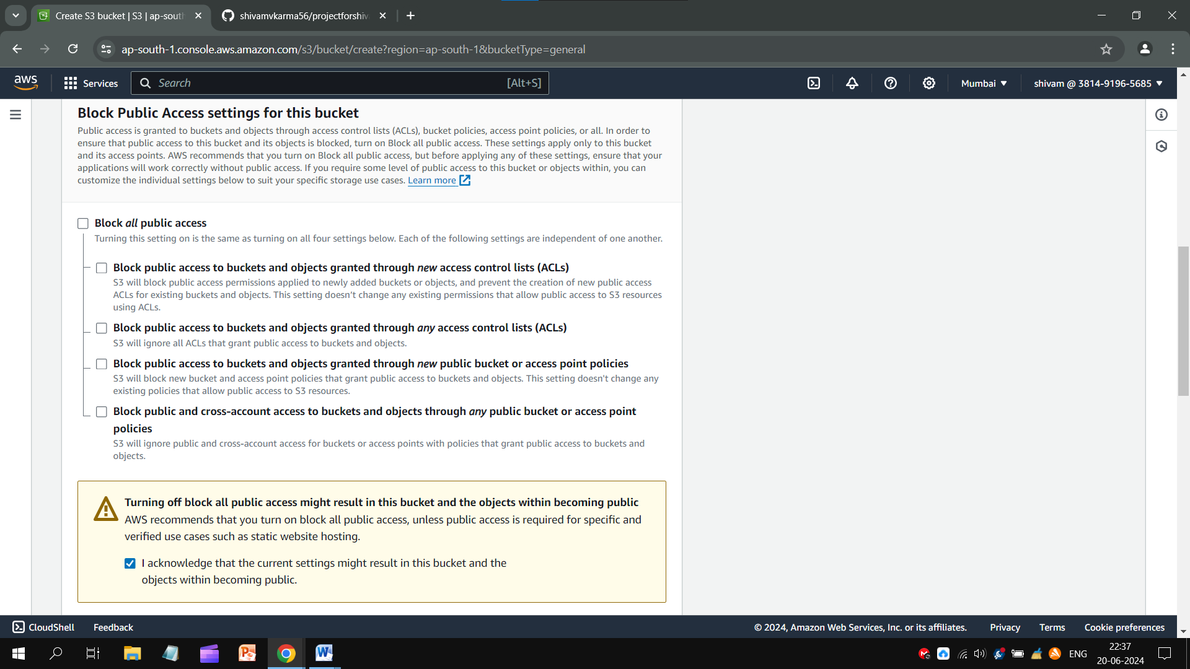

**Creating An HTML File**

An HTML code is given here:

<!DOCTYPE html>

<html>

<body>

<h1>Type Your Title Here</h1>

<p>Type Your Content Here</p>

</body>

</html>

* Copy it and paste to the Notepad.
* Save the text on Notepad with *.htm* extension. Extension should be HTML type.

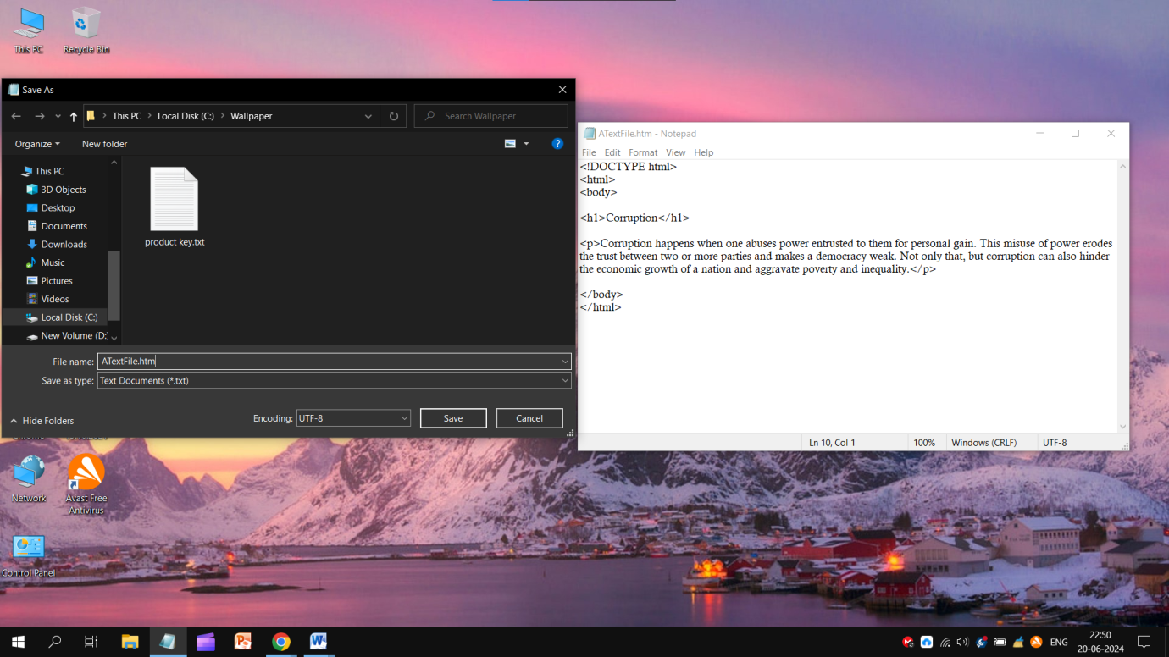

* Open the bucket you created recently.
* Click on bucket’s name, click **Upload** and **Add files**.
* Select that “HTML file”and click **Upload** bottom given below. **Close** it.

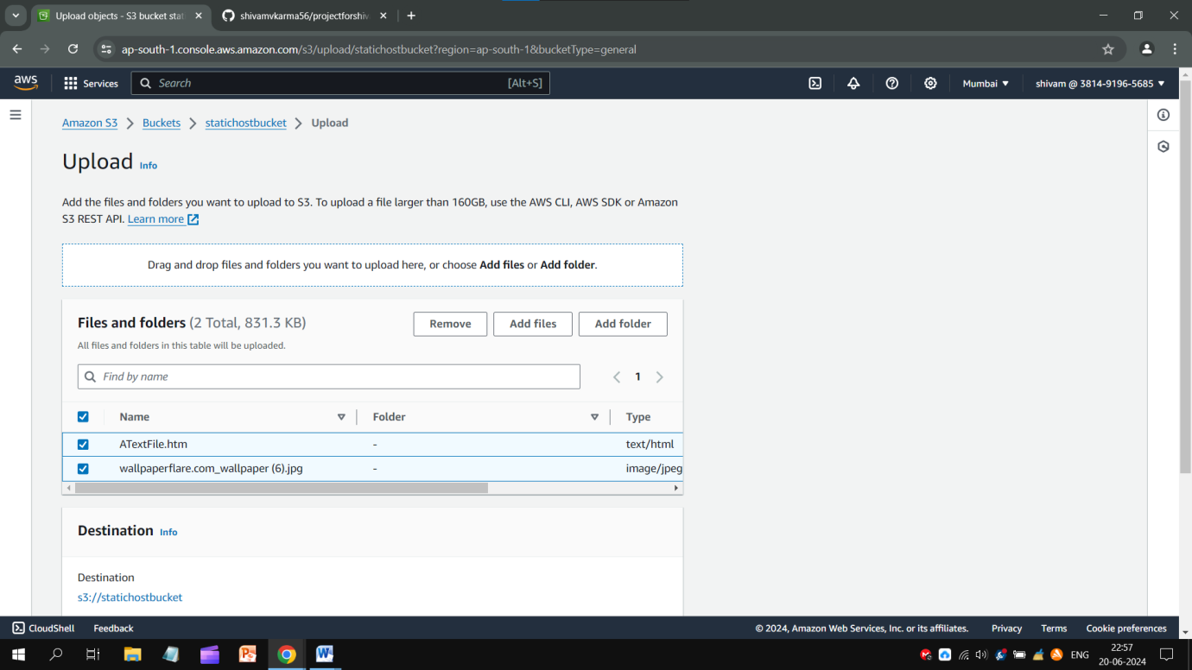

Check the following status:-

* In Permission section, *all* public access should be unblocked.
* In Object Ownership, ACLs should be enabled.

If they are correct, go into Object tab, select all files and open **Actions** script. Click on “**Make public using ACLs**”.

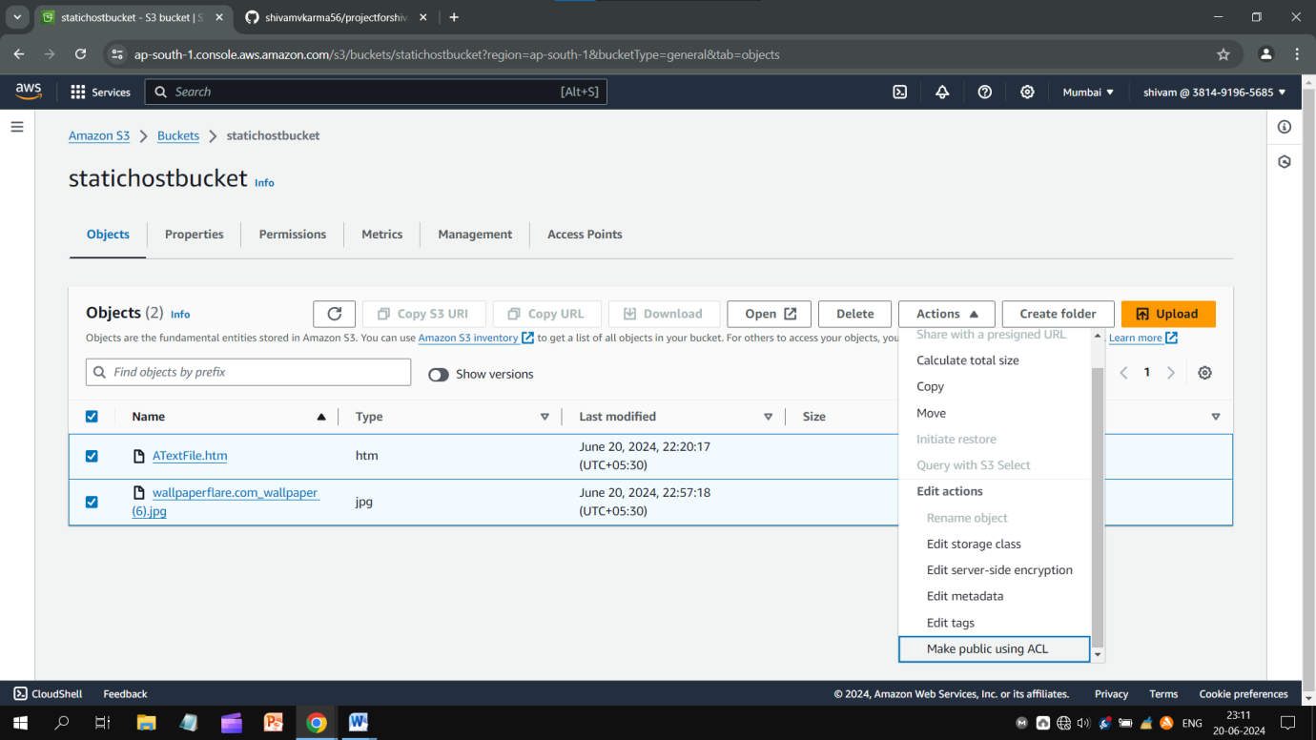

* When everything’s done, click on your name and open its Properties tab.
* Copy Object URL and check it out by pasting it on browser.

Your Website will be available in public and you could successfully host your site by **AWS Management Console**.

Thank You!

Source of Info : <https://www.geeksforgeeks.org/how-to-host-static-website-using-aws-s3/>

**Conclusion:** Static sites enable you to decouple your content repository and front-end interface, giving you greater flexibility in how your content is served. Cost-efficiency is another reason companies migrate to a static site because static files are lightweight and often faster and cheaper to serve.