PROJECT – 3
LINUX SERVER INTEGRATION

Object: Integrate Grafana with Linux Server for high cpu utilization and create a graph in Grafana.

Implementation Steps:
- Create an EC2 instance
- Install Prometheus
- Install Node Exporter
- Install Grafana
- View Dashboard using Stress



  - Grafana is a multi-platform open source analytics and interactive visualization web application. It can produce charts, graphs, and alerts for the web when connected to supported data sources.
To integrate Grafana with Linux Server, We’ll need to use the AWS, Grafana Faro and Prometheus.
Step-1: Creating an EC2 instance
- Login to AWS console and search “EC2”.
- Create an EC2 instance.
- Give instance name a unique name (eq: grafana-linux-server).
- Select instance type “Ubuntu Linux”.
- Create key pair, leave others as they are.
- Click on “Create instance”.
- Click on your instance name and go to security and select security group.
- Edit the “Inbound rule”. Delete “Predefined rule”
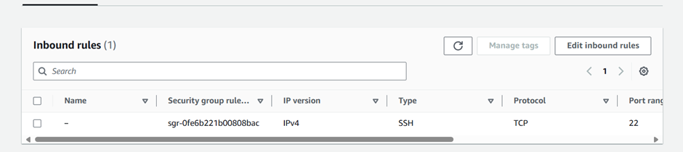
- Add a new rule and select Type- All traffic.
- And source- IPv4. Save changes.

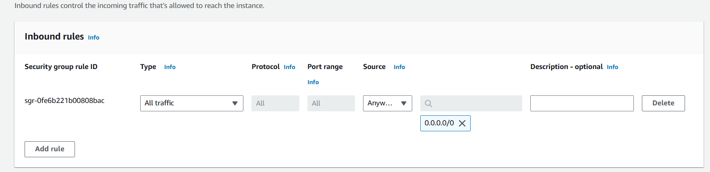
- Save else as default.
- Login to your instance in putty.
- Switch to root user using – sudo –i

Step-2: Installing Prometheus
- Install Prometheus using these commands.
- https://github.com/prometheus/prometheus/releases/download/v2.53.0/prometheus-2.53.0.linux-amd64.tar.gz
- To view installation run “ls” command.
- This command - tar xzf prometheus-2.53.0.linux-amd64.tar.gz, creates file
- Check file is created by “ls” command.
- Move the file using -mv prometheus-2.53.0.linux-amd64 /etc/prometheus
- Run -nano /etc/systemd/system/prometheus.service
- Enter this into file.
[Unit]
Description=Prometheus
Wants=network-online.target
After=network-online.target
[Service]
ExecStart=/etc/prometheus/prometheus --config.file=/etc/prometheus/prometheus.yml
Restart=always
[Install]
WantedBy=multi-user.target
- Save it using crtl+O, press enter and exit using Ctrl+X.
- Run these commands- systemctl daemon-reload, systemctl restart prometheus and systemctl enable prometheus
- Check status using- systemctl status prometheus
- Make sure the status is Active.
- Open the web UI using public IP with 9090 port. http://intsanceip:9090
- Prometheus UI will appear.

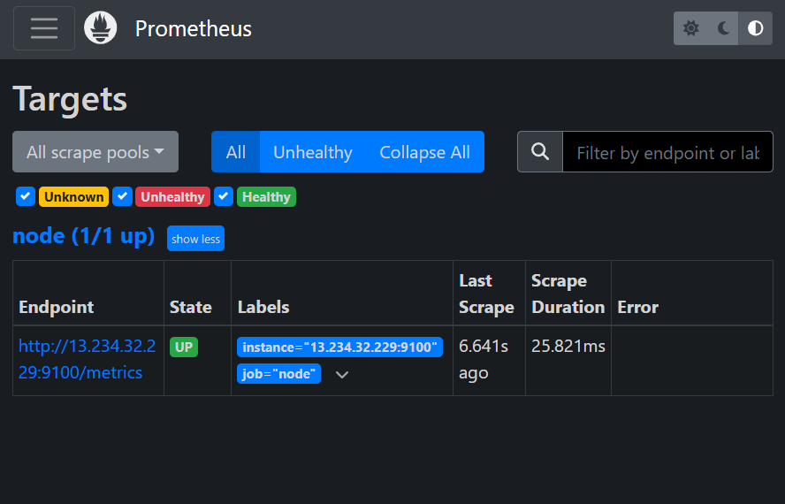

- Make sure the state is showing “UP”.

Step-3: Installing Node Exporter
- Install node exporter using this-https://github.com/prometheus/node_exporter/releases/download/v1.8.1/node_exporter-1.8.1.linux-amd64.tar.gz
- Run these commands - ls
tar xzf node_exporter-1.8.1.linux-amd64.tar.gz
ls
mv node_exporter-1.8.1.linux-amd64 /etc/node_exporter

nano etc/systemd/system/node_exporter.service

mv node_exporter-1.8.1.linux-amd64 /etc/node_exporter

nano etc/systemd/system/node_exporter.service

- Enter this in file
[Unit]
Description=Node Exporter
Wants=network-online.target
After=network-online.target
[Service]
ExecStart=/etc/node_exporter/node_exporter
Restart=always
[Install]
WantedBy=multi-user.target
- Restart and enable node exporter. Check status is active
systemctl daemon-reload

systemctl restart node_exporter

systemctl enable node_exporter

systemctl status node_exporter
- Enter Prometheus scrap file using-
rm –rf/etc/prometheus/prometheus.yml
nano /etc/prometheus/prometheus.yml
- Enter this in file.
global:
scrape_interval: 15s

scrape_configs:
- job_name: node
static_configs:
- targets: ['localhost:9100']
- Replace local host with your IP. Save and exit.
- check status is active.
systemctl restart prometheus
systemctl status prometheus
- In Prometheus web Ui you’ll see in target section 1 node with “UP” state.

Step-4: Installing Grafana
- Install Grafana using these commands.
sudo apt-get install -y software-properties-common
sudo add-apt-repository "deb https://packages.grafana.com/oss/deb stable main"
sudo apt-get install -y gnupg2
sudo apt-key adv --fetch-keys https://packages.grafana.com/gpg.key
sudo apt update
sudo apt install grafana
- Enable and check status.
sudo systemctl start grafana-server
sudo systemctl enable grafana-server
systemctl status grafana-server
- Open Grafana web ui using ip address with 3000 port. http://instanceip:3000



- You will see this window in web.
- Enter email and password admin.
- Set new password.
- Click on menu in the top left corner.
- Go to the “Connections” and add new connections search prometheus data source.
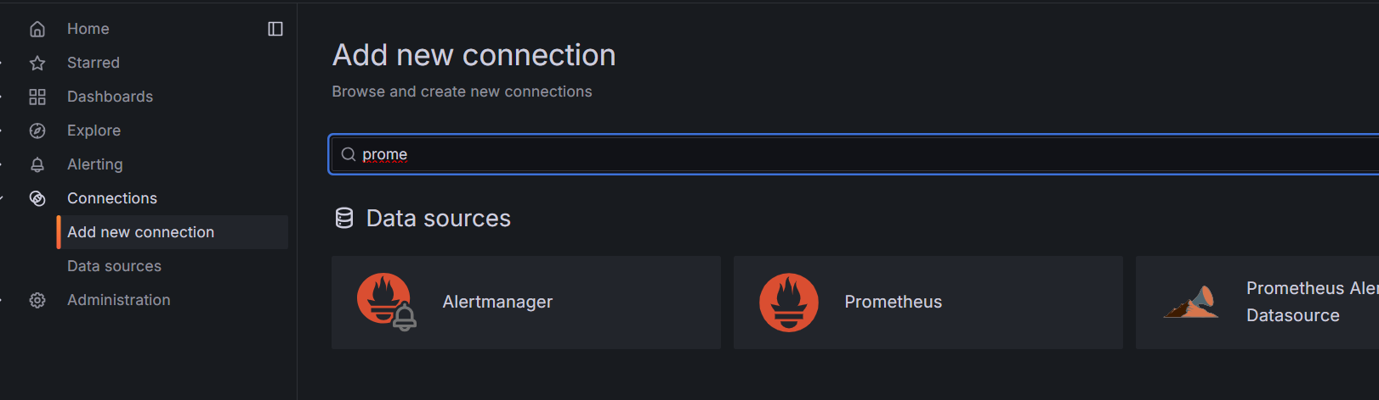

- Paste your prometheus url in url section.
- Leave else as default and save it.

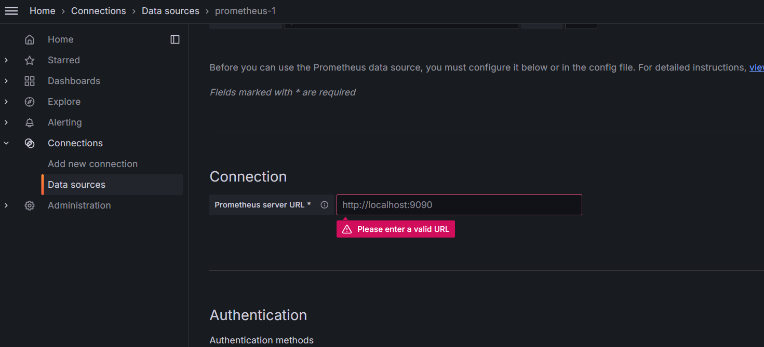

- Now go to the “Dashboards”. Add new Dashboard and enter the same as shown in the image.

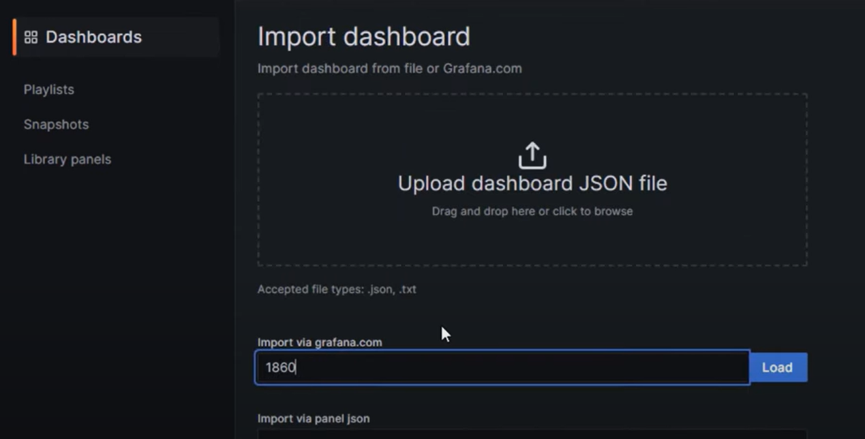

- You will see a new added Dashboard.

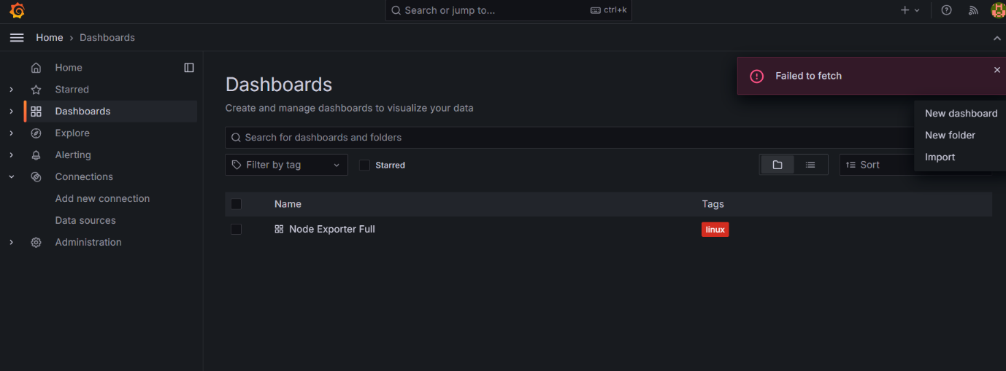

- Go to settings in links section and click on “Add dashboard link”.

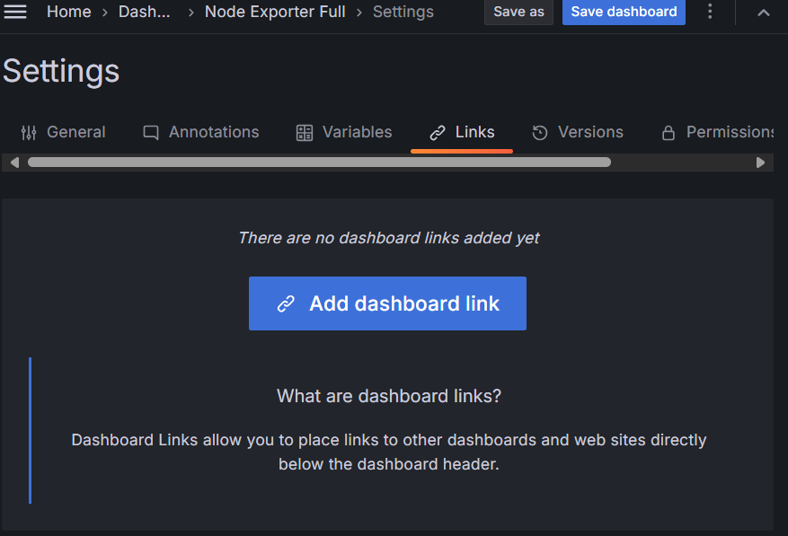

- You will see this dashboard.
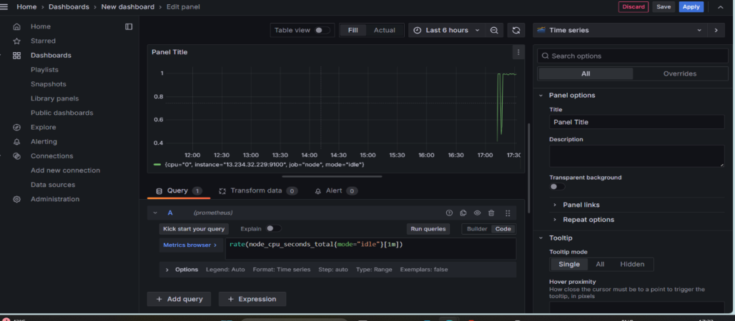
- In query section run this query as shown in image.
- In your linux instance run stress command -
sudo apt install stress
stress --cpu 4 --timeout 300
- You can see graph in Grafana Dashboard.

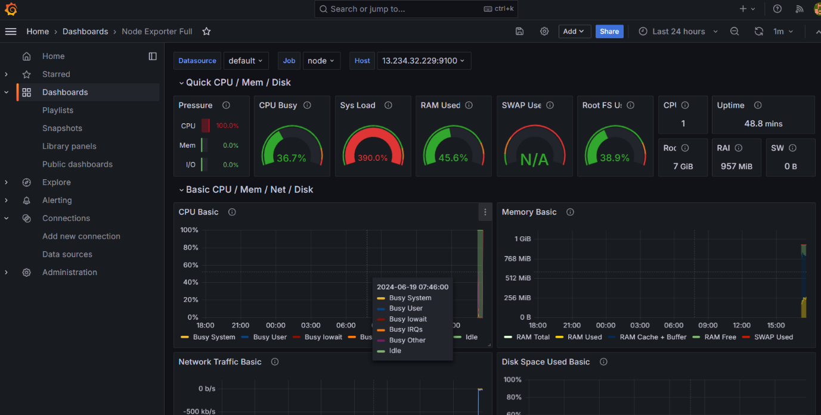

Conclusion:
This integration includes 23 useful alerts and 7 pre-built dashboards to help monitor and visualize Linux Server metrics and logs. Each Linux node being observed must have its dedicated Grafana Alloy running.
If you want to monitor more than one Linux Node with this integration, we recommend you to use the Ansible collection for Grafana Cloud to deploy Grafana Alloy to multiple machines, as described in this documentation.

