Blinkit SQL queries:-

**🔹 Basic-Level Questions:**

1. **What are the distinct item types sold in the stores?**

SELECT distinct`Item Type` from stores;

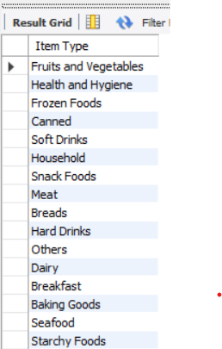

1. **How many stores are there by each outlet type?**

SELECT

`Outlet Type`,

COUNT(DISTINCT `Outlet Identifier`) AS Store_count

FROM

stores

GROUP BY `Outlet Type`

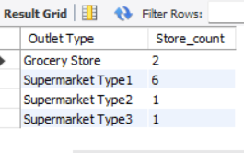

1. **What is the average sales per outlet?**

SELECT

`Item Identifier`, ROUND(AVG(sales), 2) AS avg_salts

FROM

stores

GROUP BY `Item Identifier`

LIMIT 10;

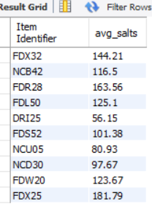

1. **List the top 5 items with the highest total sales.**

SELECT

`Item Type`, round(SUM(sales),2) AS Total_sales

FROM

stores

GROUP BY `Item Type`

ORDER BY Total_sales DESC

LIMIT 5;

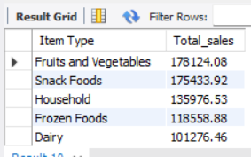

1. **Find the average item weight grouped by item type.**

SELECT

`Item Type`, ROUND(AVG(`Item Weight`), 2) AS avg_weight

FROM

stores

GROUP BY `Item Type`;

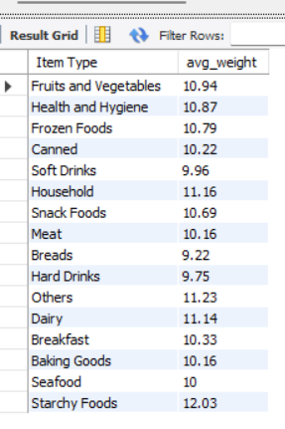

**🔹 Intermediate-Level Questions:**

1. **Which outlet has the highest total sales?**

SELECT

`Outlet Identifier`, round(SUM(Sales),2) AS Total_sales

FROM

stores

GROUP BY `Outlet Identifier`

ORDER BY Total_sales DESC

LIMIT 1;

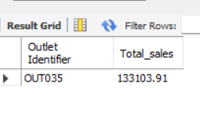

1. **What is the total sales by item fat content type?**

SELECT

`Iteam Fat Content`, ROUND(SUM(sales), 2) AS total_sales

FROM

stores

GROUP BY `Iteam Fat Content`;

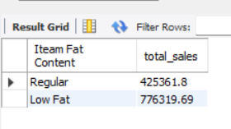

1. **Which outlet size type has the highest average rating?**

SELECT

`Outlet Size`, ROUND(AVG(Rating), 2) AS AVG_Rating

FROM

stores

GROUP BY `Outlet Size`

order by AVG_Rating DESC

LIMIT 1;

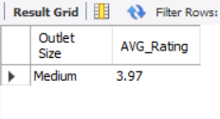

1. **Find the trend of outlet establishment by year — how many outlets were established each year?**

SELECT

`Outlet Establishment Year`,

COUNT(DISTINCT `Outlet Establishment Year`) AS Outlet_Count

FROM

stores

GROUP BY `Outlet Establishment Year`

ORDER BY `Outlet Establishment Year`

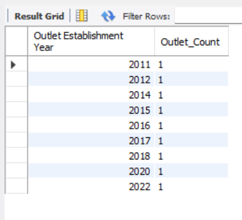

1. **What is the correlation between item visibility and sales? (Group visibility ranges)**

SELECT

CASE

WHEN `Item Visibility` < 0.05 THEN 'Low Visibility'

WHEN `Item Visibility` < 0.15 THEN 'Mid Visibility'

ELSE 'High Visibility'

END AS Visibility_group,

ROUND(AVG(Sales), 2) AS Avg_sales

FROM

stores

GROUP BY Visibility_group;

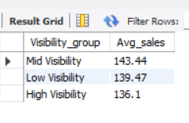

**🔹 Advanced/Analytical Questions:**

1. **Compare sales performance across different outlet location types.**

SELECT

`Outlet Location Type`, ROUND(AVG(Sales), 2) AS Avg_Sales

FROM

stores

GROUP BY `Outlet Location Type`

ORDER BY Avg_Sales DESC;



1. **Find the top-performing item type in each outlet.**

SELECT t.`Outlet Identifier`, t.`Item Type`, t.Total_Sales

FROM (

SELECT `Outlet Identifier`, `Item Type`, SUM(Sales) AS Total_Sales,

RANK() OVER (PARTITION BY `Outlet Identifier` ORDER BY SUM(Sales) DESC) AS rnk

FROM stores

GROUP BY `Outlet Identifier`, `Item Type`

) t

WHERE t.rnk = 1;

