Software Title: Hostel management System

Operations handled by software

1. Login
2. New Hostel Creation
3. New Room Creation
4. Hosteller Entry
5. Fee Registration
6. Fee payment
7. Check out
8. Re-Allocation
9. Hobbies
10. Reports

* Hosteller report
* Fee Payment Report
* Account Report
* Due Amount Report
* Check out Report
* Concession Report
* Refund Report
* Hobbies Report
* Data Backup

1. Tools

* Calculator
* Notepad
* MS Word
* WordPad

1. About.

Working Procedure

1. Login

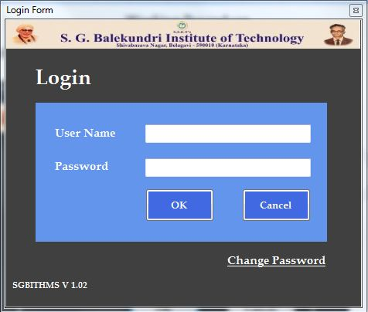

* User is provided with login Id and password
* Only authenticated users allowed for log in
* User can Change existing password by clicking Change Password

1. Main page

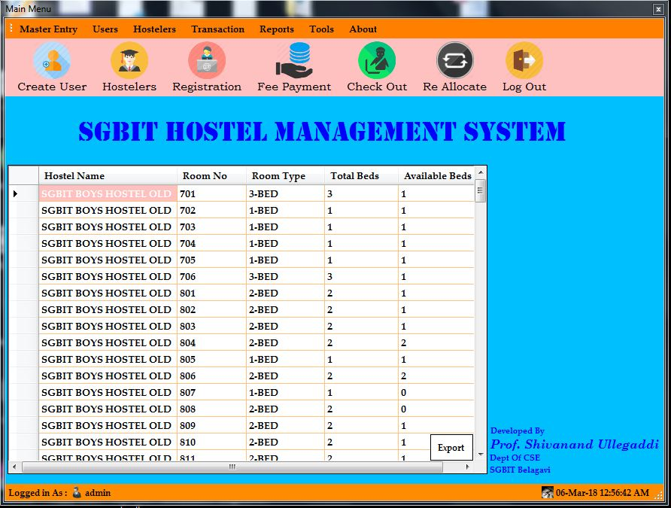

Main page contains Short cut buttons for following operations

* Create User
* Hostellers
* Registration,
* Fee payment,
* Checkout,
* Re-allocation
* Logout
* Hostellers : New Hosteller details entry with all details (New, Save, Update, Delete)

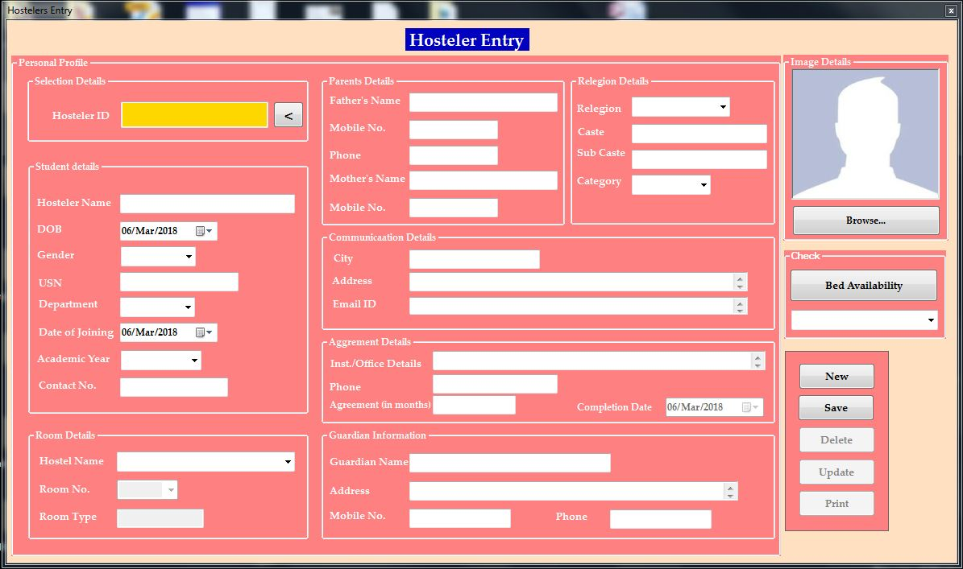

* Once Hosteller Entry, Proceed with Registration.

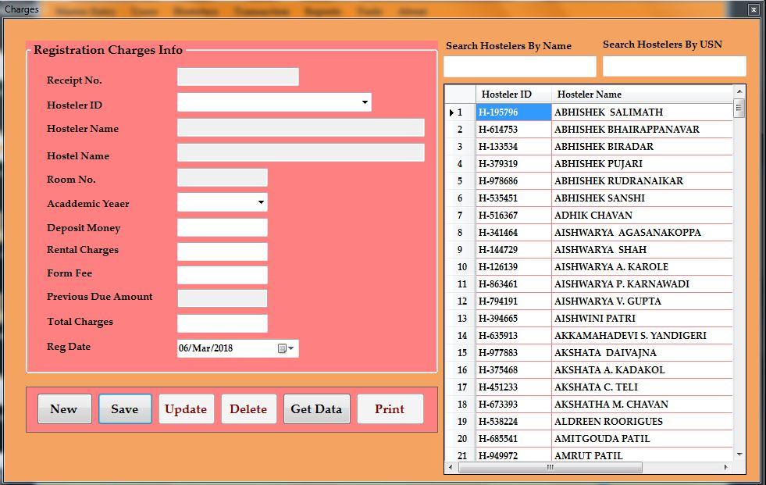

Where admin is going to register the Hosteller with current fee structure

4. Fee Payment

* Select the Student from the table. Enter amount to pay and bank challan number and save, update, delete. And also can view the report of fee payment.

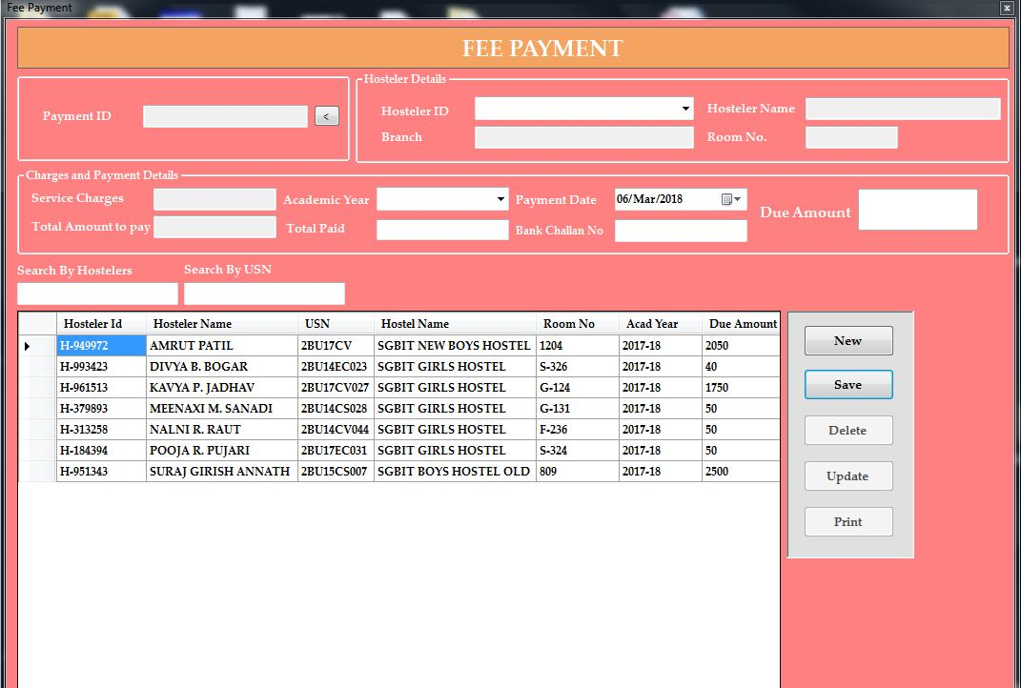

* Check out: By Selecting Hosteller ID. Hosteller is Check out from the academic year

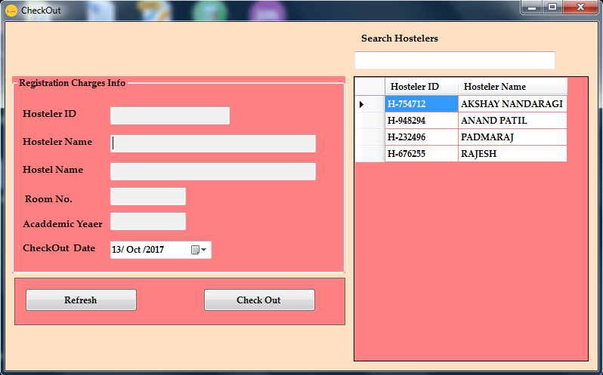

* Re-Allocation for next year

